Mark S. Reynolds
NW Region Vice President, Public Policy
1600 7th Avenue, Room 1506
Seattle, Washington 98191
(206) 345-1568

August 19, 2014

Mr. Steven King
Executive Director and Secretary
Washington Utilities and Transportation Commission
1300 S. Evergreen Park Drive SW
Olympia, WA 98504-7250

RE: Docket No. UT-131949
CenturyLink QC Washington Performance Assurance Plan Compliance Filing

Dear Mr. King:

Pursuant to new requirements in the decision on Docket No. UT-131949, approving Qwest Corporation d/b/a CenturyLink QC’s Petition to modify the Performance Assurance Plan and Performance Indicator Definitions, CenturyLink is supplying the following reports to the Commission:

Non-confidential Reports:
271_exhibit(14_state_pid)_washington_excel_all_jul14 - State aggregate performance report

P271_pap_summary_WA_jun2014 - State aggregate payment report

Please let me know if you have any questions about this information.

Sincerely,
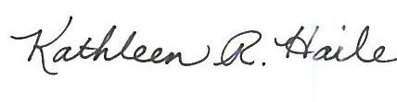
For Mark S. Reynolds
Attachment

