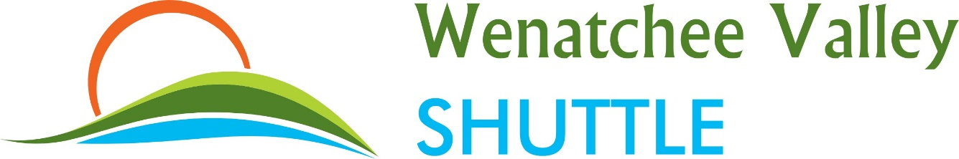
February 21, 2017
Mr. David W. Danner
Washington Utilities and Transportation Commission
1300 S. Evergreen Park DR SW
PO Box 47259
Olympia, WA 98504-7250

BML Investments LLC dba Wenatchee Valley Shuttle, Certificate Number C-64605

Dear Mr. Danner:

The company requests a general fare increase for all routes Wenatchee to Sea-tac as well as Wenatchee to Spokane. This increase is due to increased operating and labor costs. This increased fare, includes wage increases for each employee and driver, due to minimum wage increases. The company will continue to increase wages as state wage increase continues. This fare increase also includes an additional $10,000 per year raise for our manager position, taking it from $40,000 to $50,000 per year.
The company’s maintenance and repair costs will be substantially higher moving forward due to acquiring almost double the number of vehicles we operate, in the past few months. These additional vehicles will allow us to better service our passenger’s needs, but will also increase our insurance, maintenance and labor costs. Attached are numerous documents to support the needs of the company.
The company’s total regulated revenue for 2016 was $717,110. Additional revenue expected to gross due to this increase is $41,447. We seek approval for this fare increase effective March 23, 2017.
The company also submitted a paper file that was received one week prior and has a different effective date. The company has moved the effective date back, and submitted the necessary papers, making the effective date March 23, 2017.

Thank you for your time and consideration,

Byron Lott
byron@wenatcheevalleyshuttle.com
Wenatchee Valley Shuttle
509-699-0197

