Exh. JLB-6
Dockets UE-170033/UG-170034
Witness: Jason L. Ball

BEFORE THE WASHINGTON
UTILITIES AND TRANSPORTATION COMMISSION

WASHINGTON UTILITIES AND TRANSPORTATION COMMISSION,  Complainant,  v.  PUGET SOUND ENERGY,  Respondent. | DOCKETS UE-170033 and  UG-170034 (Consolidated)

EXHIBIT TO
TESTIMONY OF

Jason L. Ball

STAFF OF
WASHINGTON UTILITIES AND
TRANSPORTATION COMMISSION

Third Block Technical Appendix

June 30, 2017

Third Block Technical Appendix

SUMMARY
This technical appendix outlines Staff’s proposed methodology for calculating a third block rate based on the data underlying electric usage. Staff’s methodology is designed based on cost causation principles and the actual dispatch of the Company’s system.
Staff’s proposed third block rate structure is summarized in the table below:
 | Proposed Rate | w/ Basic Charge Excluding Transformers
Basic Charge | $10.88 | $7.80
Block 1 (First 800 kWh’s) | $.082148 | $.085841
Block 2 (Between 800 and 1800 kWh’s) | $.105271 | $.108453
Block 3 (All over 1800 kWh’s) | $.127174 | $.130216

The following sections discuss the various components of Staff’s proposed third block calculation.

BLOCK STRUCTURE
The rate “blocks” establish different rates for different levels of electricity usage. Historically, the first block has been set at 600 kWh, which was based on an equal sharing of the hydro system across all customers. However, the 2014 Electric Cost of Service and Rate Design Collaborative agreed to different block levels. The Company’s third block calculation utilizes the Collaborative block structure. In the interest of simplicity and comparability, Staff’s alternative third block calculation also uses the 2014 Collaborative’ s block structure.

COST ALLOCATION
- Account Allocation
Using the results of the Electric Cost of Service Study, Staff allocated each FERC account to each of the usage blocks. The table below shows the allocation reference for each Group of FERC accounts and the basis of the allocation reference.

 | FERC Account Group | Allocation | Description
Plant-In-Service | Intangible Production and Transmission Plant | Production Plant | Allocated based on Production Plant Assigned to Each Block
 | Intangible General Plant | Direct | Divided equally among all three blocks
 | Production Plant | Resource Dispatch | See Section B. Below
 | Transmission Plant | Production Plant-In-Service | Allocated based on Production Plant Assigned to Each Block
 | Distribution Plant | Distribution Rate | See Section C. Below
 | General Plant | Distribution Rate | See Section C. Below
Accumulated Depreciation | Intangible Plant | Intangible Plant-In-Service | Allocated based on Total Intangible Plant-In-Service in each Block
 | Production Plant | Resource Dispatch | See Section B. Below
 | Transmission Plant | Transmission Plant-In-Service | Allocated based on total Transmission Plant-In-Service in each block
 | Distribution Plant | Distribution Rate | See Section C. Below
 | General Plant | Distribution Rate | See Section C. Below
Working Capital & Other Rate Base Items |  | Distribution Rate | See Section C. Below
O&M Expenses | Production O&M – Fuel | Resource Dispatch | See Section B. Below
 | Production O&M – Purchase Power | Resource Dispatch | See Section B. Below
 | Production O&M – Wheeling | Production O&M – Purchased Power | Allocated based on total Production O&M – Purchased power in each block
 | Production O&M – Other | Resource Dispatch | See Section B. Below
 | Transmission O&M | Transmission Plant-In-Service | Allocated based on total Transmission Plant-In-Service in each block
 | Distribution Expense – Operating & Maintenance | Distribution Rate | See Section C. Below
 | General Expenses | Distribution Rate | See Section C. Below
Depreciation Expense |  | Accumulated Depreciation | Allocated based on total accumulated depreciation in each block
Taxes Other than Income |  | Distribution Rate | See Section C. Below
Other Operating Income | Steam Plant and Ferndale Plant | Production Plant-In-Service | Allocated based on Production Plant-In-Service Assigned to Each Block
 | Non-Core Gas Sales | Production O&M Fuel | Allocated based on Production O&M Fuel Assigned to Each Block
 | All Other Accounts | Distribution Rate | See Section C. Below
Other Non-Firm Revenue |  | Production Plant-In-Service | Allocated based on Production Plant-In-Service Assigned to Each Block
Federal Income Taxes |  | Total Costs | Allocated based on total costs assigned to each block

- Production Costs
As noted in the preceding table, production plant and related expenses were allocated based on the dispatch of PSE’s resources to meet load. However, there is no actual demand available for residential customers that is broken down by block level. Without demand level data for individual customers, the allocation of demand related costs must be based on other information. The tables below are the production allocation matrix for demand and energy related costs.
DEMAND ALLOCATIONS
 | DEM
 | Block 1 | Block 2 | Block 3
Thermal | 76% | 24% | 0%
Hydro | 100% | 0% | 0%
Other | 0% | 75% | 25%
 | DEM
 | Block 1 | Block 2 | Block 3
Purchased Power | 33% | 33% | 33%

- Hydro
Company embedded hydro production assets and expenses were allocated 100% to the first block on both a demand and energy basis. This is consistent with the sharing of the hydro system that created the first block and the dispatch order of PSE’s system.
- Thermal
For the purposes of cost of service, thermal includes only baseload steam generation.
Demand related costs were allocated to the first and second block based on the total billing determinants in each block. Since the first and second block represent collectively 92% of all kWh’s on an annual basis, it is logical to place baseload generation in these blocks. Due to the absence of granular demand data, Staff used the relative size of annual kWh’s for each block to allocate all the costs.
- Purchased Power
Purchased power represents both purchases at Mid-C as well as long-term supply contracts. As shown in the chart below, PSE’s long- and short-term resource adequacy plans include significant amounts of both contracts and market purchases.
//
//
//
//

Given the size of these purchases and their purposes for meeting both peak and baseload needs, Staff allocated an equal percentage of these costs to each block.
- Other Generation
Other generation includes wind, solar, and peaking resources. These units are either dispatched based on their availability, in the case of wind, or to meeting peak load, such as with a combustion turbine. Staff analyzed the generation of PSE owned wind and solar plants and determined that they mostly are not being dispatched to meet peak load.
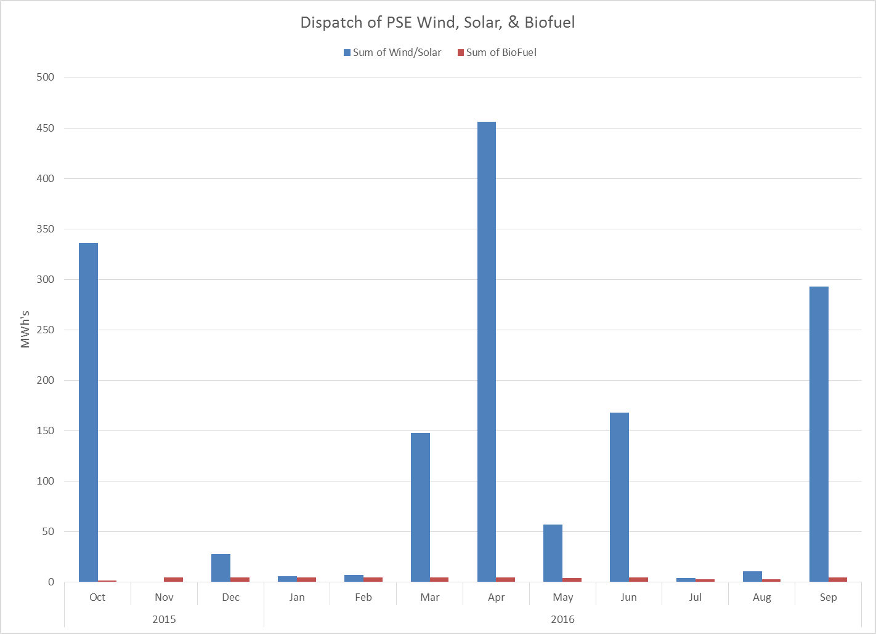
PSE Peak

However, separating these costs proved too challenging to result in meaningful results. To balance the generating characteristics of wind and solar with thermal peaking production, Staff allocated these demand related costs based on the ratio of kWh’s in the second and third blocks.

ENERGY ALLOCATIONS
 | NRG
 | Block 1 | Block 2 | Block 3
Thermal | 70% | 22% | 8%
Hydro | 100% | 0% | 0%
Other | 70% | 22% | 8%
 | NRG
 | Block 1 | Block 2 | Block 3
Purchased Power | 70% | 22% | 8%

- Hydro
The Company’s embedded hydro production assets and expenses were allocated 100% to the first block on both a demand and energy basis. This is consistent with the sharing of the hydro system that created the first block and the dispatch order of PSE’s system.

Thermal, Purchased Power, and Other
On an energy basis, the allocation of costs should follow the use of kilowatt-hours. Consistent with this approach, the costs associated with all thermal, purchased power, and other generating resources were allocated based on the ratio of total kilowatt-hours for each block in the test year.

Distribution Allocation
Distribution related costs were allocated to each block equally through the calculation of a specific distribution rate. As discussed above, certain FERC accounts, including general plant and overhead, were aggregated into a single dollar value. This dollar value was adjusted for the revenue deficiency assigned to the class and a temperature adjustment. The final costs were divided by the total billing determinants for the test year to get a $.020974/kWh rate for distribution related costs. This cost was added to each block to determine a final per kWh rate.

ELASTICITY ADJUSTMENT
Elasticity represents the change in demand due to a change in price. For example, if the price of soda increases at the grocery store due to a soda specific tax, there is a reasonable expectation that people will consume less soda because of the increased price. Electricity experiences the same phenomenon. However, electricity is considered an inelastic good because people are generally less sensitive to the price of electricity then they would be with a discretionary item like soda. A review of regional differences in price-elasticity by the National Renewable Laboratory determined that price elasticity for Washington electric customers was:

 | Washington Only | Staff Adjustment to Billing Determinants
Long-Run Elasticity | (.008) | 10,742,134
Short-Run Elasticity | (.0016) | 3,457,884

Each of these number represents a percentage change in the demand for electricity based on the change in price. Since elasticity’s practical effect is to reduce the number of kWh’s billed during a year as a result of increased price, Staff’s analysis includes an elasticity adjustment. This elasticity adjustment is applied to the calculated per kWh rate for the second and third blocks. No adjustment was applied to the first block since it represents relatively inelastic consumption that is the least sensitive to price changes.
The second block adjustment is based on long-run elasticity. This is because the second block represents usage that could be affected by long-term investments such as energy efficiency upgrades. Additionally, the second block is affected by reduced demand only after there is a reduction in the third block.
The third block adjustment is based on the short-run elasticity. This is because the third block represents the marginal price of electricity for consumers and is the first unit of electricity to be cut out when a consumer reduces their usage.

PSE Confidential Response to Public Counsel Data Request No. 307.
PSE 2015 Integrated Resource Plan, at 1-15 (Executive Summary, Chapter 1).
PSE Confidential Response to Public Counsel Data Request No. 307.
Bernstein, M.A. and J. Griffin, Regional Differences in the Price-Elasticity of Demand for Energy, National Renewable Laboratory, 2006.

