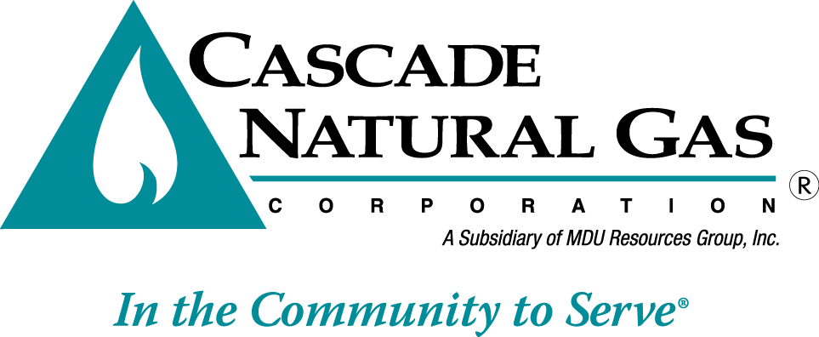 | 8113 W. GRANDRIDGE BLVD., KENNEWICK, WASHINGTON 99336-7166  TELEPHONE 509-734-4500 FACSIMILE 509-737-7166  www.cngc.com

VIA ELECTRONIC MAIL
records@utc.wa.gov

October 13, 2016

Records Center
Washington Utilities and Transportation Commission
1300 S. Evergreen Park Drive SW
Olympia, WA 98504

Re: UG-160967, Informational Filing
Line Extension Data

On July 29, 2016, Cascade Natural Gas Corporation’s (Cascade or Company) submitted Advice No. W16-07-01, docketed as UG-160967, which the Commission approved with an effective date of September 1, 2016.

The filing revised the Company’s line extension policy from offering applicants an upfront credit of either 3.3 times their estimated annual margin to be applied towards the cost of installing a service line, or a credit of 6.6 times estimated annual margin for both a main extension and service line, to offering an upfront allowance based on the perpetual net present value (PNPV) of the revenues generated from that customer.

A PNPV allowance is the annual basic service charge and distribution revenue for the average residential or average commercial customers, as applicable, divided by 7.35%, which is the Company’s rate of return as approved in Commission Order No. 04 issued in UG-152286. This methodology provides an upfront allowance for residential customers not to exceed $3,255 and an allowance of no more than $12,350 for commercial customers.

When the Commission approved the Company’s filing, they expressed an interest in receiving line extension data in order to track the impact of the policy changes. The table below provides a history of the number of new services added per quarter, the total length of new service lines and mains installed, the overall cost, and the average cost per foot of pipe.

Year-Quarter | Number of Services | Total Service Footage | Total Main Footage | Total Footage | Cost | Cost Per Foot
2014 Q3  July thru September | 471 | 26,821 | 35,754 | 62,575 | $573,663.87 | $9.17
2014 Q4  October thru December | 552 | 34,805 | 40,937 | 75,742 | $946,773.45 | $12.50
2015 Q1  January thru March | 523 | 32,106 | 32,051 | 64,157 | $818,538.39 | $12.76
2015 Q2  April thru June | 561 | 30,706 | 56,432 | 87,138 | $1,594,264.57 | $18.30
2015 Q3  July thru September | 529 | 27,913 | 40,772 | 68,685 | $977,336.95 | $14.23
2015 Q4  October thru December | 751 | 43,354 | 45,809 | 89,163 | $1,441,120.47 | $16.16
2016 Q1  January thru March | 630 | 32,314 | 41,385 | 73,699 | $1,034,005.55 | $14.03
2016 Q2  April thru June | 735 | 36,056 | 26,084 | 62,140 | $913,930.95 | $14.71
Grand Total | 4,752 | 264,075 | 319,224 | 583,299 | $8,299,634.20 | $14.23

The Company is providing data back to 2014. In 2013, Cascade migrated to a new data base which introduced significant changes to how Company tracks line extension information. The Company is not providing more historic information because it is difficult to provide comparable data sets from the legacy system and the new data base. 2013 is not provided because after the after implementing the new system, the Company realized additional employee training was necessary in to ensure data was being inputted in a manner that allowed for more accurate reporting. The 2014 data set for new service lines should provide a good benchmark for assessing how the new line extension policy is affecting customer growth.

New service line data is entered into the Company’s system on a blanket work order—meaning the number of feet installed per month may be entered at one time. Since data is not entered on project per project basis, the Company is not able to separate the number of feet per customer class.

The Company will submit semi-annual informational filings by the end of January and July of each year. These filings will update the table above with the most current history of current line extension information.

If you have any questions regarding this report, please contact Jennifer Gross at (509) 734-4635.

Sincerely,

Michael Parvinen
Director, Regulatory Affairs

