Following the July 2, 2024, workshop in Docket UE-160799, interested parties submitted comments into this docket in response to the questions posed from Staff. This matrix denotes a summary of the comments submitted by Avista Corp., PacifiCorp, Puget Sound Energy, and the Northwest Energy Coalition (NWEC).

Summary of Comments:
- What types of ratemaking tools should the Commission consider for EV charging infrastructure.
Avista – Avista notes that TE related expenses should be included into base rates and recovered from all customers as all customers would likely benefit from increased electrification to some degree. Further, Avista asserts the current two percent incentive rate of return on equity should be maintained as is to help facilitate utility planning and budgeting. Avista notes considerable challenges with meeting the charging needs for Multi-Unit Dwelling (MUD) customers and that existing incentives and rebates do not mitigate enough of the costs for MUD charging. To address this issue, Avista points to increased workplace charging allowing MUD customers the ability to bridge the gap and load management may present another benefit to increased workplace charging. Avista does offer line extensions, however some customers forego the extension in favor of recouping costs over a five-year timeframe. Avista advocates for EV specific trackers and/or tariff riders for O&M expenses that would represent a firm cost recovery mechanism for EV related expenses.
PacifiCorp – The Company states that current EV costs are recovered through a deferred accounting mechanism which are then rolled into base rates at a later date such as a GRC. PacifiCorp points to the nascent market in its Washington territory that necessitates the need for separate trackers however, once the market materializes, the Company may be amenable to recovering EV capital expenses into base rates. PacifiCorp believes that the Commission should allow the Companies flexibility to allow them to tailor ratemaking policies to their specific needs. Additionally, PacifiCorp advocates for a forecasting and simultaneous recovery mechanism like a system benefits charge for conservation costs and demand response to reduce regulatory lag and avoid any carrying costs for customers. PacifiCorp highlights the similar challenges as Avista with respect to MUD charging infrastructure. PacifiCorp mentions make-ready incentives used in Utah that have helped spur EVSE installation. Similar to Avista, PacifiCorp advocates for robust public and workplace charging. Like Avista, PacifiCorp warns of the cost-benefit tradeoffs of line extensions.
Puget Sound Energy – PSE supports a system benefits charge so long as it allows for sufficient funding to support TE in its service area. PSE acknowledges that increased TE can benefit all customers on the grid and the grid itself. PSE posits that a system benefits charge applicable to all customers would be equitable as all customers would see benefits. PSE currently recovers TE expenses via Schedule 141TEP. System upgrades related to TE are recovered through line extensions and base rates. PSE highlights the lessons learned via the Up and Go program for MUD’s and the expanded funding from this program that is appropriated for utility-side infrastructure in low-income and tribal communities. PSE supports the use of line-extension allowances but notes that additional incentives may be needed in some areas to help further advance EVSE in low-income or tribal communities.
NWEC – NWEC notes that a system benefits charge is one avenue for increasing EV charging infrastructure, however there are some pros and cons to this approach.
Cons to this approach include: The requirement for statewide legislation if the charge is to be applicable to all statewide utility customers. NWEC highlights equity concerns all customers have to pay for the charge but do not see any benefits. Further if only the IOUs are subject to such a charge, it would be inequitable for IOU customers to pay these charges while all other utility customers would not.
Pros of this approach include: If designed properly (similar to Oregon’s Monthly Meter Charge) a percentage of revenues derived from the system benefit charge could be directed to infrastructure needs in vulnerable communities. On rate recovery, NWEC asserts that if expenditures are deemed prudent, these costs should be recovered in base rates rather than specific trackers and riders. Recovering these expenses in a rate case, allows the parties to review the costs in a holistic manner, and prevents the utility from recover additional interest that apply to specific trackers and deferred accounting mechanisms. NWEC believes that if a system benefits charge is approved, then increased incentives for MUDs may not be required. NWEC posits that allowing MUD customers to charge at the retail rate is critical to achieving an equitable rollout of EV infrastructure in the state. Further, NWEC believes the Commission should consider requirements on where utility-owned infrastructure should be installed to counteract the make-ready approach that allows third party EVSE chargers to charge rates outside of the Commission’s purview.

- In a time of upward pressure on utility rates, how can the Commission balance the need for more proactive planning with transportation electrification infrastructure while sufficiently protecting ratepayers and mitigating risks? (i.e. overbuilding or unanticipated costs)
Avista – Avista discusses the risks of both underbuilding and overbuilding and the need to scale EV infrastructure with the pace of EV adoption. Avista posits that infrastructure needed for LDV is easier to plan and account for due to the incremental pace of EV adoption. MD/HD infrastructure is problematic because the need for adequate charging infrastructure materialize quicker, and the needs are more specific depending on the needs of specific fleets or large HD users.
PacifiCorp – The Company notes it will continue to monitor proceedings and advancements in other jurisdictions.
Puget Sound Energy – PSE notes that EV adoption in its service territory is high compared to other peer utilities in Washington, therefore the risk of overbuilding is minimal. PSE forecast it will need to install 1.5 times the number of currently existing ports each year until 2030 to meet the anticipated need. PSE points to the need for “proactive investments” in order to ensure that underbuilding does not imperil the EV transition. PSE notes that in the near-term, the costs required to meet EV demands through 2025 were less than the forecasted revenues required, therefore it would be deemed cost-effective. PSE intends to introduce TOU rates, DR programs and V2G integration which will help with EV growth and minimize the risk of overbuilding.
NWEC – NWEC recommends right-sizing investments in parallel with EV adoption rates within their respective territories. NWEC believes that utilities should match charging in places where they know charging will be used. (i.e. fleet and workplace charging) Further, NWEC believes public-private partnerships may help defray some of the upfront costs to rate payers. NWEC highlights the Western Resource Advocates 2022 paper as a great resource to evaluate best practices used in other jurisdictions.

- At what point should Transportation Electrification programs be rate-based rather than customer specific tariff schedules?
Avista – Reiterates the need for specific trackers and riders similar to PSE schedule 141TEP. Highlights the portfolio approach and the goal of reaching territory wide EV adoption goals. Avista notes there are numerous variables that determine the “break even” point for EV charging infrastructure. These variables include: Geographic location, EVSE reliability, user fees, utilization rates, demand charges, and etc. Avista advocates for an innovative approach to mitigating demand charges for DCFC and larger L2 charging depots to facilitate EV adoption.
PacifiCorp – The Company reiterates the need for flexibility in rate recovery. Further, PacifiCorp notes that some DCFC chargers see load factors ranging from 1-10 percent when looking to install EVSE. PacifiCorp recommends using a load factor of three percent.
Puget Sound Energy – PSE notes that it does not install charging stations with the goal of being independently cost effective, rather the Company uses a portfolio approach across its entire service area to determine cost effectiveness. While the Company does not offer a specific dollar amount, it notes that DCFC chargers are more costly compared to L2 chargers because they draw more electricity, require more conduit and transformer upgrades and etc. Further. DCFC chargers require more robust O&M and networking packages offered by the manufacturers. Charging rates differ per charging type however, on Sch. 551 L2 chargers are billed at $0.28 kWh while DCFC chargers are billed at $0.48 per kWh, plus a $0.40 idle fee (if applicable).
NWEC – No response.

- Some utilities across the country have implemented (or plan to implement) a flat-rate charging program for EVs. (i.e. For $35 per month, a customer can charge as much as they want during off-peak hours) Would a similar construct be viable in Washington?
Avista – Avista opposes an off-peak flat rate charge as it would be expensive and burdensome to administer. Avista also has concerns to the cost-benefit analysis as EV adoption rates are rather low compared to other areas within the state.
PacifiCorp – The Company advises against a “one size fits all” approach but notes that in Utah, the Company has worked with EVSE providers to offer charging discounts at publicly owned chargers.
Puget Sound Energy - PSE is researching and evaluating flat rate charging options for commercial customers and notes that flat rates may need to be $45-$65 to be viable in PSE’s territory. A discounted flat rate option may be viable for low-income customers but that nay discounts for one class would need to be subsidized by another class. PSE notes that Demand Charges represent a barrier to entry for some EVSE providers and that some EVSE providers pass along these costs via increased per kWh charges or service charges. PSE points to a need for reasonable and affordable alternatives related to Demand Charges.
NWEC – NWEC is skeptical of any flat rate approach because it is not cost based and unclear on how it would be implemented in an equitable manner. While this model may work for competitive providers, it is hard to see how this model is a good fit for regulated utilities. NWEC believes that charging should be reflective of the costs incurred to provide that service to the customer.

- What data sources does your utility utilize when estimating EV ownership within your territory?
Avista – Avista relies on the Dept. of Licensing title transaction data. As AMI data becomes more robust, Avista is increasingly reliant on AMI data for more accurate identification of EV charging loads. Avista also completed a DER system-wide study in 2024 to examine the impacts of DER uptake in Avista’s service territory. Avista is reviewing the AMI data and the data from the DER report which will be included in the 2025 Transportation Electrification Plan. Avista modeling expects modest EV growth through the 2020’s and the adoption rates will increase through the years 2030-2045. Finally, Avista highlights that high EV prices, inadequate charging and reliability of chargers, and customer knowledge as the three critical barriers stifling EV adoption in Avista territory.
PacifiCorp – The Company continues to use nationwide models and adjusts them for local contexts. Additionally, forecasts occur on an annual basis with layers added in for previous years. MD/HD forecasts will be included in 2025 IRP processes. Like Avista, PacifiCorp notes high EV ownership costs as a considerable barrier to entry and that only one percent of the Company’s Washington customers own an EV.
Puget Sound Energy – PSE incorporates data from the IHS-Markit (registration data), Marklines, the Federal Highway Administration, US DOE Fuel Economy Guide, GHI Fuel Institute, California Air Resources Board, and etc. PSE also utilizes AMI data within its territory to better understand EV adoption and uses this data to pinpoint possible EV charging at the transformer level to determine if upgrades may be needed. The most recent EV forecast was included in PSE’s 2025 IRP process document. Table 1 and Table 2 below denote the anticipated EV adoption in PSE territory over the next 15 years as well as the charging needs to power these vehicles.
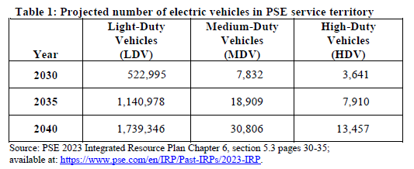
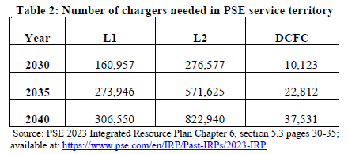
While important, PSE does not separately track the distribution, transformer, and resource acquisition needs to support load growth. Rather, these needs are modeled in combination with all other sources of electric demand in the service territory. PSE posits that insufficient charging infrastructure, high EV purchasing costs, and consumer education are the three most critical barriers to widespread EV adoption.
NWEC – No response.

- What data does your utility obtain from EV telematics software on private chargers in its service territory? How does your utility use this data?
Avista – In 2023, Avista began a Residential Smart Charging pilot using EV telematics and software. 111 customers are currently enrolled and the pilot has resulted in a 95% load-shift to off-peak hours resulting in a reduction of 0.5kW on-peak per EV. Avista is leveraging this data to gain a better understanding of various customer types and preferences to be used in future system planning and IRP planning processes. Avista notes that a total of 818 residential users and 652 commercial customers utilize some form of managed charging programs. Further, Avista cites the AFDC that shows 2,363 station locations with 6,352 charging ports within the state.
PacifiCorp – PacifiCorp does not have specific numbers for L2 and DCFC for its entire service area, but did provide a breakdown of highly impacted communities in its 2024 CEIP progress report. Although PacifiCorp does not offer any managed charging programs, it intends to introduce such programs in 2025.
Puget Sound Energy – PSE does not maintain this data in house and instead utilizes AFDC data that finds there are 2,514 public charging stations in Washington, of which 1,895 are within PSE’s service area. The following table denotes the number and type of chargers found in highly impacted communities and vulnerable populations.
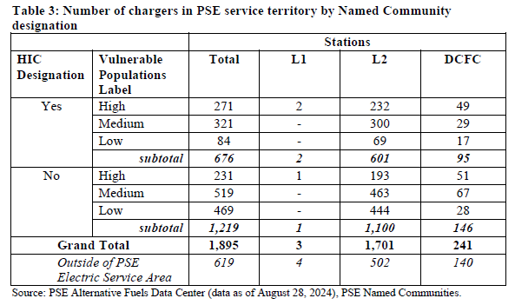
PSE notes that four EV fleet customers are enrolled in passive load management programs under Schedule 556 and 1,349 EVSE and 2,609 Telematics are enrolled in a Virtual Power Plant (VPP) program for DR dispatch events under Schedule 272.
NWEC – No response.

- Some estimates note that approximately 80 percent of light-duty vehicle (LDV)6 charging is completed at home. If this charging is unmanaged, the periodic demand increases can quickly eliminate any available capacity at the distribution level. Managed charging mechanisms can help spread this demand to off-peak hours and mitigate the load stress of the system. What managed charging programs does your utility offer?
Avista – Avista notes that most LDV residential charging will not necessitate the overall distribution system for some time (possibly around 2030), unless there is considerable clustering which may require some infrequent distribution upgrades as needed. Avista advocates for TOU rates as an effective method of shifting usage and the company employs seasonable TOU rate schedules for both residential and small commercial customers. The figure below outlines the rates for both of these TOU schedules.
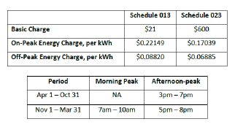

Avista estimates that an aggregated reduction of 0.5 kW on-peak per EV results in avoided costs for system generation resource capacity and distribution upgrades of $103 per year, per EV in 2025. When contrasted with the costs to administer the EV programs of $400 per EV, this results in a net negative benefits cost of -$258 per EV which is not sustainable.

Avista notes it maintains 818 L2 charging ports, 652 commercial L2 ports, and 37 DCFC ports.
PacifiCorp – PacifiCorp does not currently offer any managed charging programs but intends to offer such programs in 2025. Alternatively, PacifiCorp does offer a pilot TOU program for both residential and commercial customers but is not for specific EV users.
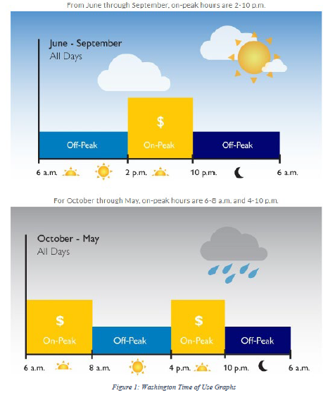
Puget Sound Energy – PSE currently offers TVR rates on Schedules 307, 317, 324, and 327. The peak and off-peak hours of these schedules is shown below.
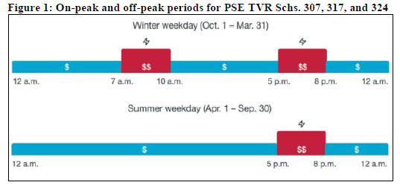
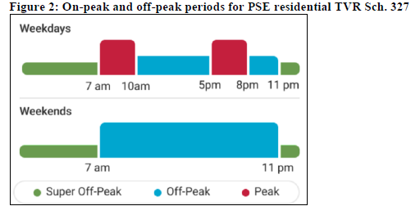
PSE estimates that 3.2% of LDV customers participate in a static load control program while 1.5% of LDV customers are enrolled in a dynamic load management program. PSE points to a reduction of 6.53 MWs of average load reduction during the Aug. 8, 2024, flex event that was the result of PSE’s EV and Telematics DR program.
NWEC – No response.

- EV infrastructure are common targets for theft and vandalism. What studies or programs are you aware of that address issues of vandalism and/or theft of EV supply equipment?
Avista – Avista notes that while theft and vandalism do occur, it is not a widespread issue in its territory. As such, the Company does not have any data or reporting on the extent of theft and vandalism. Avista highlights the use of pole-mounted L2 chargers as a possible consideration to mitigate theft and vandalism issues. Avista does coordinate with local and municipal authorities during the siting process to ascertain the threat of vandalism and theft in the area and Avista has deselected some areas and its site host partners due to high risk of theft/vandalism. Avista highlights that in 2024, one DCFC site and four L2 sites were vandalized amounting to $6,000 in expenses for repairs out of a total of $55,923 in EVSE related O&M expenses through August 2024.
PacifiCorp – PacifiCorp does not track these expenses in Washington state. In most instances, these costs are covered warranty with the EVSE manufacturer.
Puget Sound Energy – PSE participates in a consortium of EVSE providers that seek to address issues related to cable theft and vandalism in the Seattle metro area. PSE notes that in 2023, it spent $18,400 on repair and/or replacement of EV charging infrastructure.
NWEC – No response.

- What is your utility’s process to repair inoperable EVSE equipment? Please detail the process and timelines from the moment the utility is notified to re-energization of the EVSE.
Avista – Avista notes there are numerous variables that impact the repair timelines. These variables include: equipment type, location, notification source, networked or non-networked, and etc. Non-networked L2 EVSE are highly reliable and a simple power cycle of the breaker at the charger resolves most issues. If a power cycle does not resolve the issue, Avista typically contracts out the repair or replace the unit. For networked chargers, the additional layer between Avista and the manufacturer complicates the repair timeline especially if there is no warranty in place. If there is no warranty in place, Avista typically coordinates with the EVSE to determine which replacement parts are needed and then hires a third-party contractor to make the repairs. Avista notes that uptime and reliability for Avista owned EVSE is high as evidenced by the table below.
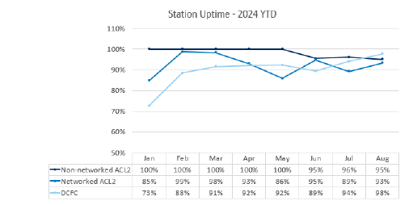
PacifiCorp – PacifiCorp monitors uptime and reliability on all utility owned stations and hires third-party contractors to repair contracted EVSPs. The timelines to repair specific charging stations is dependent on multiple variables.
Puget Sound Energy – If PSE learns of the outage before the network operator, PSE will shut off the charger if any safety issues are apparent before the EVSE provider arrives. If the issue can be resolved remotely, the operator typically resolves the issue remotely. If the issue can not be resolved remotely, the technician is typically dispatched within 48 hours to assess the issue. At that point, any required parts are ordered and may be subject to delays dependent on the supply chain. If the issue was safety related, PSE return to restore power within five days of the repairs being completed. PSE notes that corrective maintenance packages are purchased through Shell Recharge and Enel X Way with costs between $400-$700 for L2 chargers and $3,000-$10,000 for DCFC Chargers.
NWEC – No response.

See https://westernresourceadvocates.org/wp-content/uploads/2022/04/Overview-of-Utility-Transportation-Electrification-Plans_Final.pdf
Avista 2024 DER Potential Study
https://apiproxy.utc.wa.gov/cases/GetDocument?docID=867&year=2021&docketNumber=210829

