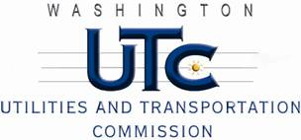

Memorandum
June 14, 2011

To: TR-110412 - File

From: Kathy Hunter, Deputy Assistant Director Transportation Safety

Subject: TR-110412 Tacoma Rail
Grade Crossing Protective Fund (GCPF) Project at the Intersection of
99th Street East and Tacoma Rail’s Tracks in the City of Tacoma, Washington

On March 9, 2011, the Washington Utilities and Transportation Commission (Commission) awarded a GCPF grant totaling $20,000 to replace the incandescent lights with LED type lights and replace the bungalow which is complete with motion sensing train detection. Tacoma Rail will also add a pedestrian bell and replace the cross-bucks. The upgrades will occur at the 99th Street East crossing in the City of Tacoma. The USDOT number assigned to this crossing is 396674N.

On June 13, 2011, the applicant, Tacoma Rail submitted a request for reimbursement pursuant to Commission order. On May19, 2011, Commission staff conducted a site visit and verified that the project is completed according to the specifications outlined in the order approving the grant.

Please close this docket.

