June 12, 2015

Steven V. King, Executive Director and Secretary

Utilities and Transportation Commission

1300 S. Evergreen Park Dr. SW

P.O. Box 47250

Olympia, WA 98504-7250

RE: *Washington Utilities and Transportation Commission v. Air Van Moving & Storage, Inc.*

Commission Staff’s Response to Request for Hearing TV-150872

Dear Mr. King:

On May 26, 2015, the Utilities and Transportation Commission issued a $1,000 Penalty Assessment in Docket TV-150872 against Air Van Moving & Storage, Inc. for 10 violations of Washington Administrative Code (WAC 480-15-480), which requires household goods carrier companies to furnish annual reports to the commission no later than May 1 each year.

On June 5, 2015, Air Van Moving & Storage, Inc. wrote the commission requesting a hearing disputing the violation occurred. In its hearing request, the company states, “The form was filled out and payment made. A late penalaty was assessed and payment made. Apparently an email was sent to me which I did not receive. It looks like a typo for the last letter of the email address and I did not receive any notice of incompleteness. The violation was for mileage and in the all the years we have filed we always responded to the mileage question in the same way, and have never had any questions raised or negative responses to it. If this is no longer an acceptable response, then we will make changes to accommodate the needed change”.

It is the company’s responsibility to ensure that the regulatory fee is paid and the annual report is filed by the May 1 deadline. On February 27, 2015, Annual Report packets were mailed to all regulated household goods companies. The instructions for annual report completion page of the annual report informed the regulated company that it must complete the annual report form, pay the regulatory fees, and return the materials by May 1, 2015, to avoid enforcement action.

1See Attachment A for a copy of the 2013 Annual Report submitted by Air Van Moving & Storage, Inc.

2See attachment B for a copy of email communications sent on May 5, 2014 and May 12, 2014

UTC Annual Reports

June 12, 2015

Page 2

On May 6, 2015, Air Van Moving & Storage, Inc. filed an incomplete 2014 annual report and paid the required regulatory fees and late payment fees. The mileage information omitted from Schedule 1 of the 2014 report, which resulted in the report being incomplete, was also omitted from the 2013 report1. However, commission staff contacted the company regarding the 2013 report requiring the information be submitted on May 5, 2014 via email. The company complied on May 12, 2014 via email2. During the 2013 reporting year, Air Van Moving & Storage, Inc. was assessed a penalty for failure to file the report by the May 1 deadline under TV-140937. However, the company was only penalized for the days delinquent after May 1 until the initial filing on May 5, 2014 as previous year annual reports were accepted by the commission without the mileage information.

Air Van Moving & Storage, Inc. previously missed the deadline for filing its annual report and paying its regulatory fees for the 2013, 2012 and 2009 annual report years. Due to the prior violations of WAC 480-15-480 and prior notification of required mileage data, staff does not support mitigation of the penalty. As of June 12, 2015, the company has also failed to respond to the now known deficiency contained within the 2014 annual report. However, as commission staff failed to notify the company of the discrepancy due to a typo of the email address, staff would be ameniable to reduce the penalty from $1,000 for 10 violations of WAC 480-15-480 to $300 for 3 violations to reflect the annual report being received by the commission on May 6, 2015 subject to the submission of the missing mileage information.

If you have any questions regarding this recommendation, please contact Amy Andrews, Regulatory Analyst, at (360) 664-1157, or [aandrews@utc.wa.gov](mailto:aandrews@utc.wa.gov).

Sincerely,

Sondra Walsh, Director

Administrative Services

ATTACHMENT A

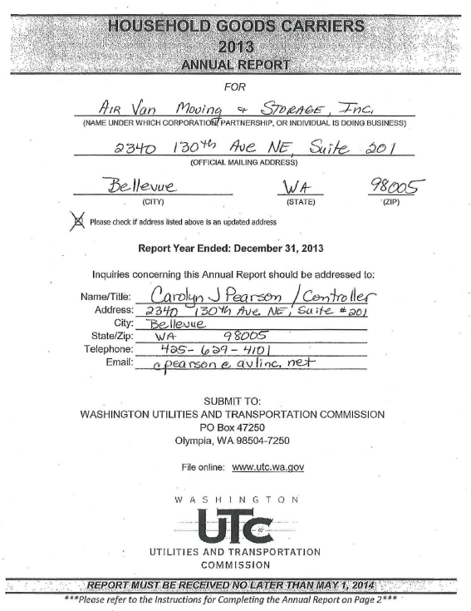

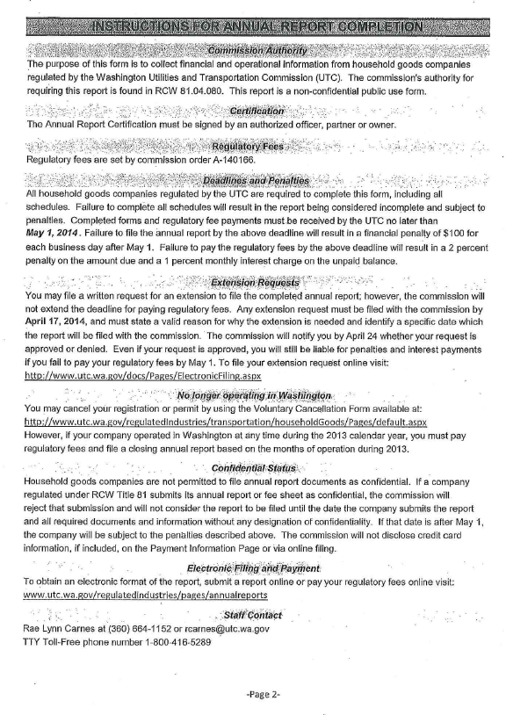

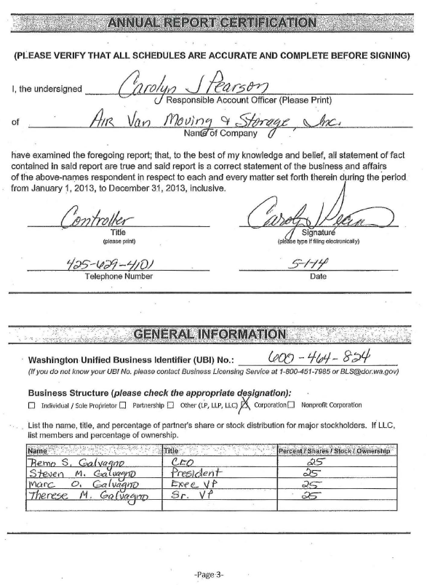

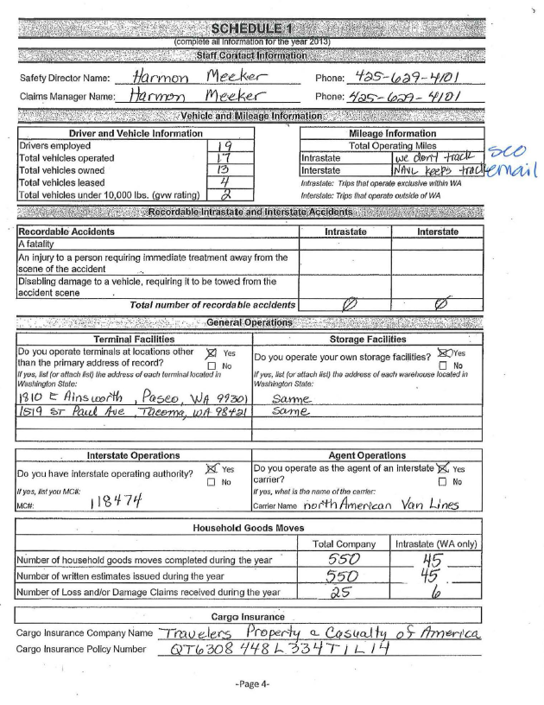

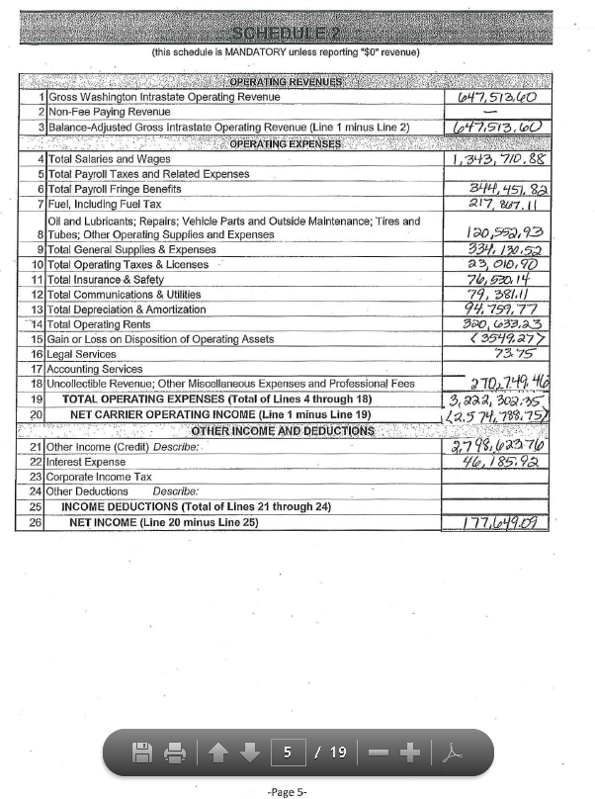

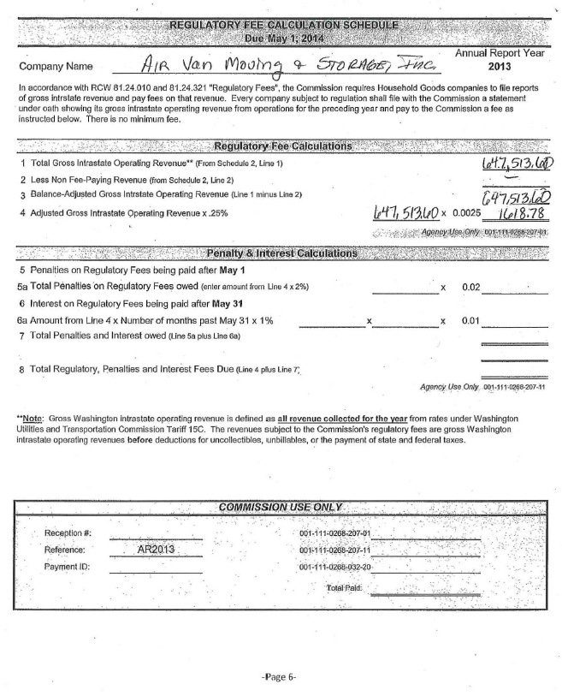

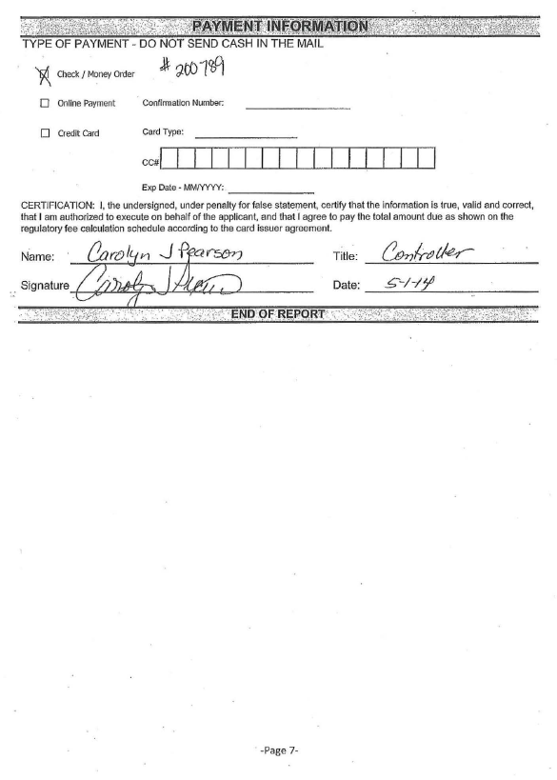

ATTACHMENT B

