August 10, 2012

David W. Danner, Executive Director and Secretary

Washington Utilities and Transportation Commission

1300 S. Evergreen Park Dr. SW

P. O. Box 47250

Olympia, Washington 98504-7250

RE: *Washington Utilities and Transportation Commission v. T & S Transportation & Installation, Inc.*

Commission Staff’s Response to Application for Mitigation of Penalties

Docket TV-120947

Dear Mr. Danner:

On July 24, 2012, the Washington Utilities and Transportation Commission issued a $2,100 Penalty Assessment in Docket TV-120947 against T & S Transportation Installation, Inc. for 21 violations of Washington Administrative Code (WAC) 480-15-480, which requires permitted household goods companies to furnish annual reports to the commission no later than May 1 each year.

On August 3, 2012[1], T & S Transportation Installation, Inc. wrote the commission requesting mitigation of penalties (Mitigation Request). In its Mitigation Request, T & S Transportation Installation, Inc. does not dispute that the violation occurred. The company states, “We were not aware of any potential $2,100.00 penalty for a late report as the annual report form details only the 2% fee and the 1% per month fee. We respectfully request any additional late fee be forgiven as not appropriate to apply to a $400 tax. We have had a very difficult year due partly to the economy as well as experiencing two heart attacks and quadruple bypass operation on myself with an additional operation of installing a defibulator unit in my chest at the beginning of the year. While I could have filed the report timelier, cash flow played a roll in accepting the 2% penalties that I was aware of. Again, I respectfully request the Penalty Assessment be forgiven as not appropriate to the tax or circumstances.”

It is the company’s responsibility to ensure that the regulatory fee and the annual report are filed by the May 1 deadline. On February 29, 2012[2], Annual Report forms and Regulatory Fee packets were mailed to all regulated permitted household goods companies. In addition to other information, the cover letter informed the regulated company it must complete the annual report form, pay any regulatory fees and return the material by May 1, 2012 to avoid enforcement action. On May 15, 2012[3], the commission mailed a letter to those companies that had not yet filed an annual report notifying them that, to date, they had incurred a penalty of $900. The letter went on to explain that companies who filed their annual reports no later than May 25, 2012, would receive mitigated penalties of $25 per day, with an additional $25 per day for each instance in the previous five years that the company received a penalty for filing a late report.

T & S Transportation Installation, Inc. filed its annual report on August 3, 2012. T & S Transportation Installation, Inc. did not file its annual report by May 31, 2012, which is 21 business days past the deadline of May 1. The penalty is $100 per day for a total of $2,100. T & S Transportation Installation, Inc. became regulated in February 2007 and has received three penalties for filing a delinquent annual report. T & S Transportation Installation, Inc. received a penalty of $100 in 2008, a penalty of $200 in 2009 and a penalty of $400 in 2010.

Based on the company’s delinquent annual report filling in the past, staff does not support mitigating the assessed penalty and recommends the request be denied.

If you have any questions, please contact Mathew Perkinson, Compliance Investigator, at (360) 664-1105, or at [Mperkinson@utc.wa.gov](mailto:Mperkinson@utc.wa.gov).

Sincerely,

Sharon Wallace, Assistant Director

Consumer Protection and Communications

**Attachment A**





**Attachment B**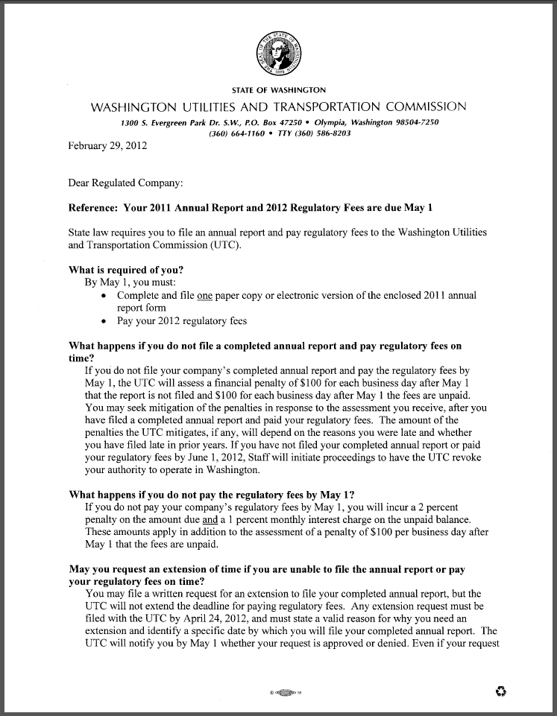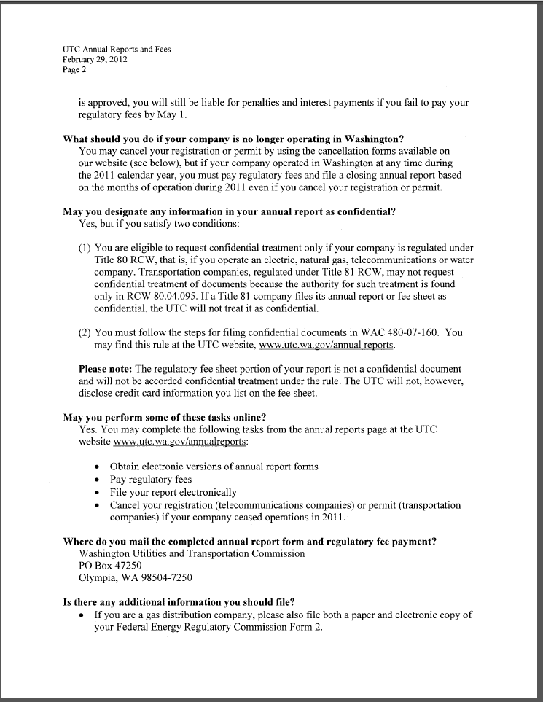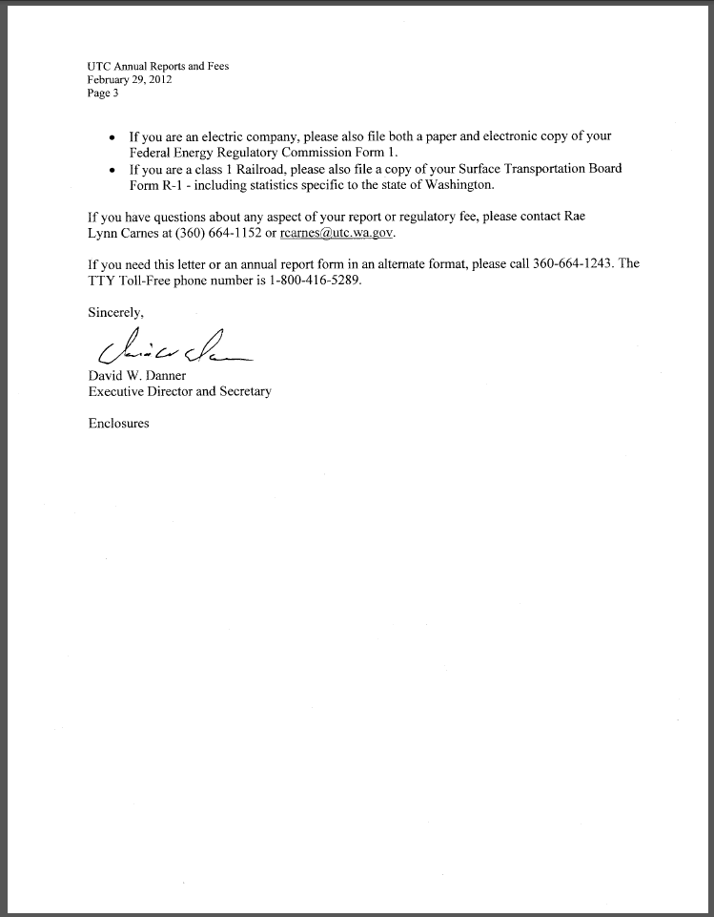

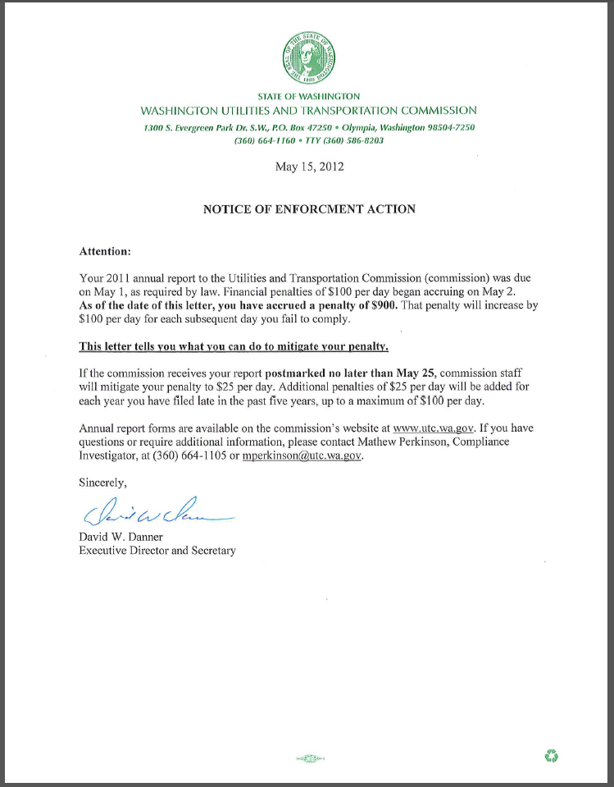**Attachment C**

1. See attachment A for a copy of T & S Transportation Installation, Inc.’s Mitigation Request.
2. See attachment B for a copy of the letter sent to all regulated companies on February 29, 2012.
3. See attachment C for a copy of the enforcement letter sent to the company on May 15, 2012.