1

2

3

4

### 5

6

7

8 UTILITIES AND TRANSPORTATION COMMISSION STATE OF WASHINGTON

### 9

THE CITY OF WOODINVILLE, a political )

1o subdivision of the State of Washington,

) DOCKETS: TR-143902 and TR-143903

)

### 11

1. v.

Petitioner,

) DECLARATION OF SERVICE

)

)

)

1. EASTSIDE COMMUNITY RAIL; and )

BALLARD TERMINAL RAIL, )

14 )

Respondents, )

15 )

16 Douglas Engle, declares as follows:

17 1. I am the owner of Eastside Community Rail, llc, am over the

age of 18, am a party to this action, and am competent to testify herein.

19

1. On the date below, caused to be delivered true copies of the following:

20

* 1. ECYR’s submittals in this matter including five attachments

21

22

1. These documents were sent by email to The Commission at [**records@utc.wa.gov,**](mailto:records@utc.wa.gov) and copies
2. were submitted to the following at the mailing addresses and email addresses listed below:

# 26

|  |  |
| --- | --- |
| Washington Utilities and Transportation Commission:  Judge Rayne Pearson Administrative Law Judge PO Box 47250  1300 S Evergreen Park DR SW Olympia, WA 98504-7250 rpearson(a),utc. wa.gov | City of Woodinville: Thomas E. Hansen, PE  Assistant Public Works director 17301 133rd AVE NE  Woodinville, WA 98072  thom asb(a),ci.woodinvillc. wa. us |
| Washington State Department of Transportation: Ahmer Nizam  310 Maple Park AVE SE PO Box 47329  Olympia, WA 98504-7250 nizama(a),wsdot.wa.gov | Ballard Terminal Railroad: Byron Cole  4725 Ballard AVE NW Seattle, WA 98107-4810 byroncole(a),comcast.net |
|  |
| Commission Staff: Julian Beattie  Assistant Attorney General 1400 S Evergreen Park DR SW PO Box 40128  Olympia, WA 98504-0128 jbeattie(a),utc. wa.gov | Eastside Community Rail: Doug Engle  Managing Director 1011 Maple AVE  Snohomish, WA 98290 doug.engle(a),escrail. org |
|  |
| Port of Seattle: Isabel Safora Sean Sullivan  Deputy General Counsel PO Box 1209  Seattle, WA 98111-1209 safora.i@portseattle. org sullivan.s(a),portseattle. org | King County: Kevin Workman Erica Jacobs  201 S Jackson ST #700  Seattle, WA 98104 kevin.workman(a),kingcountv .gov erica.jacobs(a),kingcountv .gov |
|  |
| King County: Andrew Marcus  Sr Deputy Prosecuting Atty, Civil Division 516 3rd AVE, Room E554  Seattle, WA 98104  andrew.marcuse(a),kingcountv .gov |  |

### 1

2

3

4

5

6

7

8

9

10

11

12

13

14

15

16

17

18

19

20

21

1 3. The original and three copies of these documents were mailed to:

2 Washington Utilities and Transportation Commission 3 PO Box 40128

4 Olympia, WA 98504-0128

1. I declare under penalty of perjury under the laws of the State of Washington that the
2. foregoing is true and correct. 7

DATED THIS 2nd day of October 2015, in Kirkland, Washington.

8

9

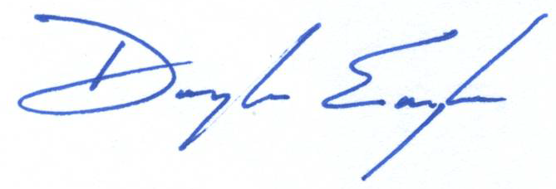

10 Douglas Engle, *Manager*

11

12

13

14

15

16

17

18

19

20

21