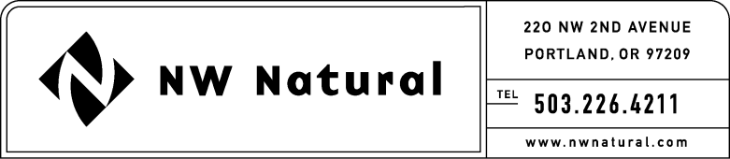

Rates and Regulatory Affairs

**Facsimile: 503.721.2516**

February 3, 2010

David Danner, Secretary and Executive Director

Washington Utilities & Transportation Commission

1300 Evergreen Park Drive, SW

Post Office Box 47250

Olympia, Washington 98504-7250

Re: **Results of Operations Report per WAC 480-90-275**: Extension Request

Northwest Natural Gas Company, dba NW Natural, respectfully requests an extension of time to February 26, 2010, in which to file its Results of Operations required per WAC 480-90-275 for the fourth quarter (October-December), 2009. Such an extension is necessary to avoid having our results of operations report posted on the WUTC website prior to our 4th quarter and full-year earnings release and conference call.

Thank you for your consideration of this matter. Please feel free to call me if you have any questions.

Sincerely,

/s/ Natasha Siores

Natasha Siores

Senior Rates Analyst

Extension 3588

cc: Joanna Huang, WUTC