DISTRIBUTED SOLAR

Contents
M-2. OVERVIEW
M-3. DISTRIBUTED SOLAR
PV IMPACT AT THE
CIRCUIT LEVEL
- Study Design and
Assumptions
- Findings
- Summary
M-23. Distributed
Photovoltaic
Technical and Market
Potential
- Cadmus Group Report

As part of PSE’s continuing exploration of emerging resources, the 2015 IRP looks at the impacts of high penetration of rooftop solar installations on both the distribution system and on resource builds. Distributed solar generation has never been selected in the portfolio analysis as a cost-effective resource for the PSE system, but federal tax credits and state production incentives have made it cost-effective for customers. Already, PSE has 2,800 net-metered customers who have installed rooftop solar panels totaling 17.4 megawatts of capacity and 17,360 megawatt hours of annual energy, and we expect many more customers will install solar panels in the future.

Overview

This appendix includes the details and results from two studies.

The Distributed Photovoltaic Technical and Market Potential study is a system-wide study prepared by the Cadmus group that explores the maximum potential for rooftop solar within the PSE system. It asks how much distributed solar might be added to the system in two scenarios:

a) if federal and state incentives are renewed, and
b) if incentives are allowed to sunset.

This information was used as an input in the IRP portfolio analysis. The results of the portfolio analysis are discussed in Chapter 6 and in Appendix N: Electric Analysis. The Cadmus report on the study appears at the end of this chapter.

The second study, Distributed Solar PV Impact at the Circuit Level, investigates the impact that significant amounts of photovoltaic (PV) generation will have at the circuit level of the electric distribution system, particularly with regard to voltage impacts, peak demand and line losses. This study description begins on the following page.

DISTRIBUTED SOLAR PV IMPACT
AT THE CIRCUIT LEVEL

Rooftop solar requires the existing energy system – which is built for one-way traffic (system to user) – to accommodate two-way traffic (system to user and user to system). This study looks at how this shift impacts the system.

Study Design and Assumptions

PSE analyzed three effects in particular:

Voltage Drop. Does the interconnection of distributed solar generation change PSE’s ability to deliver energy at a voltage that stays within the range of acceptability (114 to126 volts)?
Peak Demand. Can distributed solar generation contribute to meeting peak need by reducing system load at times of peak demand?
Line Losses. Does PV generation increase or decrease line losses beyond expected, base-level loss?

Circuits. Four circuits were chosen for the study. They represent different mixes of residential and commercial buildings, different feeder line lengths and different peak seasons. These are described in Figure M-1.
Figure M-1: Circuits Studied for PV Impact
Circuit ID | Location | Load Mix | Peak Season | Current # Net Meters | 2014 Penetration | Length | Current Conditions
Carolina-15 (CAR-15) | Bellingham | 76% Commercial  24% Residential | Winter | 13 | 1.7% | 1.5 mi | Downtown with most net meters of any commercial feeder.
Union Hill-21 (UHL-21) | Redmond | 29% Commercial  71% Residential | Winter | 77 | 4.3% | 5.3 mi | Fairly heavily loaded longer feeder. Mostly residential.
Winslow-16 (WIN-16) | Bainbridge Island | 51% Commercial  49% Residential | Winter | 20 | 39% | 1.0 mi | Lightly loaded short feeder with high solar penetration rate.
Evergreen-17 (EVE-17) | Redmond | 100% Commercial | Summer | 0 | 0% | 0.6 mi | One of few summer-peaking feeders.

Design Days. Each circuit was studied for a winter design day and a summer design day. For each of these, maximum and minimum sun radiation days and maximum and minimum loads were identified using 2013 data selected at three-minute intervals. Together these variables established eight studies for each circuit.

Loads

- Light Winter: winter day with lowest peak for 2013
- Heavy Winter: winter day with highest peak for 2013
- Light Summer: summer day with lowest peak for 2013
- Heavy Summer: summer day with highest peak for 2013

Solar Radiation

- Summer Low Sun: day with lowest amount of sun in summer
- Summer High Sun: day with most amount of sun in summer
- Winter Low Sun: day with lowest amount of sun in winter
- Winter High Sun: day with highest amount of sun in winter

Finally, the study created a base case that assumed no solar generation. This added another study for each circuit.

Solar PV Penetration Potential. High technical potentials are assumed, since the purpose of the study is to consider the impact of high levels of solar penetration at the circuit level.

- For residential customers, 40 percent of houses are assumed to have PV systems capable of generating 5 kilowatts per house.
- For existing commercial buildings, 70 percent of roof space is assumed to be available for PV, with equipment capable of generating 15 Watts per square foot, limited to 200 kW per building.

These assumptions are at the high end of the reasonable range, and in some circuits they produce penetration that is greater than 100 percent of peak. Current U.S. standards call for a system impact study when circuits reach 15 percent PV penetration, and they recommend penetration should not exceed 30 percent. The table below shows the peak capacity for each circuit, the penetration potential based on these assumptions, and the 30 percent and 15 percent penetration levels for comparison.

Figure M-2: Maximum Potential PV Penetration for Circuits Studied
Circuit  ID | Peak Load MW | Max Potential PV in MW Com+Res=Total |  |  | Max Potential  Penetration | 30% Penetration  MW | 15% Penetration  MW
CAR-15 | 4.2 | 4.6 | 1.1 | 5.7 | 135% | 1.26 | 0.63
UHL-21 | 7.6 | 1.1 | 5.1 | 6.2 | 82% | 2.28 | 1.14
WIN-16 | 0.6 | 0.3 | 0.1 | 0.4 | 67% | 0.18 | 0.09
EVE-17 | 6.5 | 0.6 | 0.0 | 0.6 | 9% | 1.95 | 0.975

Circuit Profiles. The following pairs of charts show how these assumptions translate into daily load curves and PV potential for each circuit. The daily load curve charts illustrate how demand on the circuit varies with seasonal conditions (heavy summer, light summer, heavy winter and light winter). The potential PV generation charts show how PV generation varies on the circuit under different solar radiation conditions (low sun summer, high sun summer, low sun winter and high sun winter). This is the basic information used to analyze each circuit.

TO READ THE CHARTS ON THE FOLLOWING PAGES: Note that the vertical axis scales differ from chart to chart. All charts use the same 24-hour timeline for the horizontal axis.

The CAR-15 circuit feeds downtown Bellingham. Its load mix is 76 percent commercial and 24 percent residential, and it experiences a winter peak.

Figure M-3: Car-15 Daily Load Curves
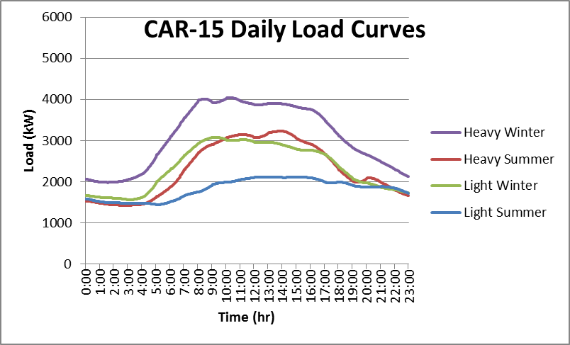
Figure M-4: Car-15 Potential PV Generation
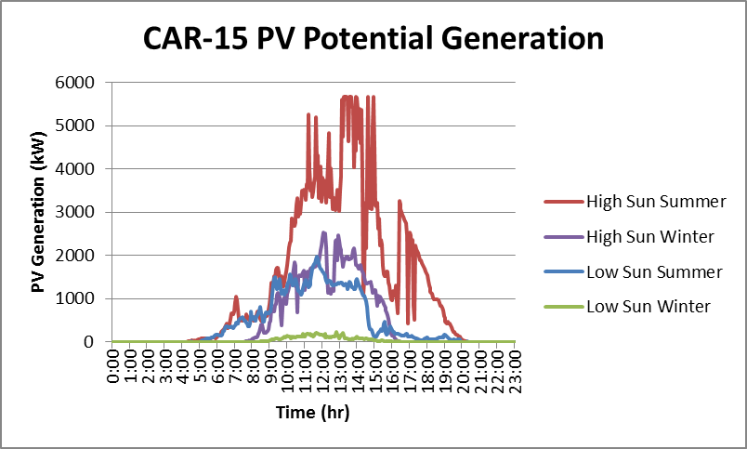

WIN-16 on Bainbridge Island is a small circuit with a 51 percent commercial / 49 percent residential mix. The island does not have natural gas heating, so it experiences a big morning peak in winter.
Figure M-5: WIN-16 Daily Load Curves
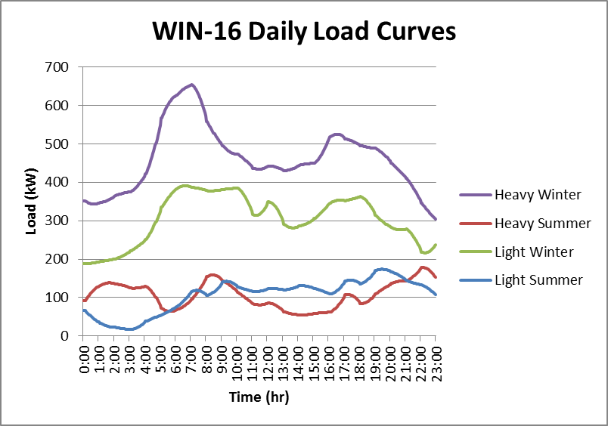
Figure M-6: WIN-16 Potential PV Generation
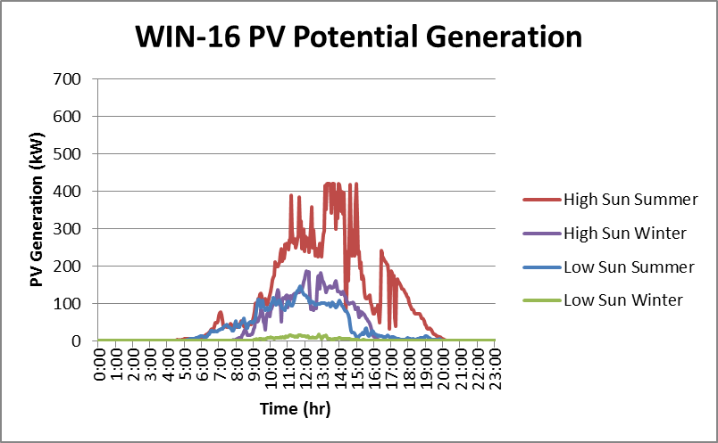

UHL-21 in Redmond is primarily residential (71 percent), and experiences a winter evening peak. Note that this circuit is 10 times larger than WIN-16.

Figure M-7: UHL-21 Daily Load Curves
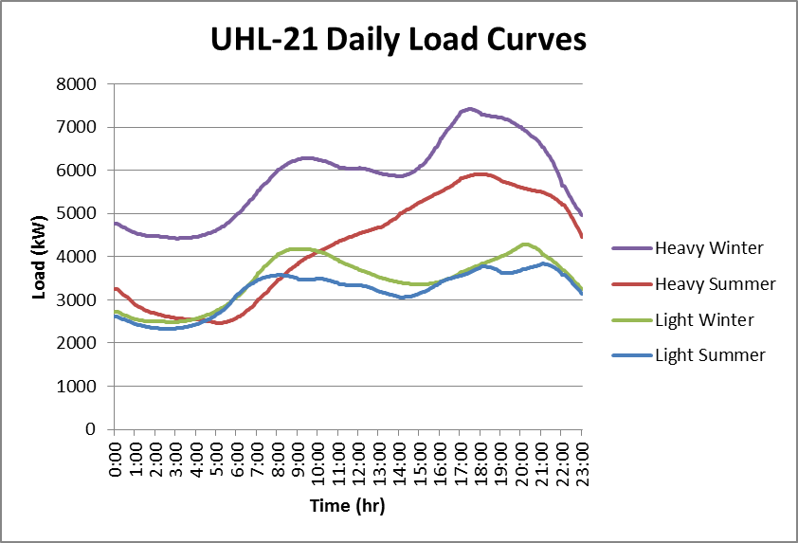
Figure M-8: UHL-21 Potential PV Generation
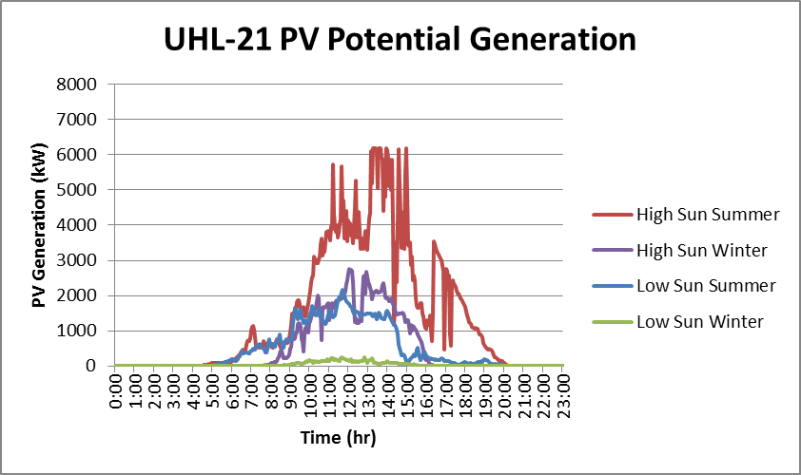

In Redmond, EVE-17 is an all-commercial circuit. Unlike the other three circuits, EVE-17 produces a summer afternoon peak because of the many offices it feeds. Since this circuit serves only three commercial buildings, and the maximum solar potential generation is 200 kW per building, the maximum solar potential for the entire circuit is only 600 kW.

Figure M-9: EVE-17 Daily Load Curves
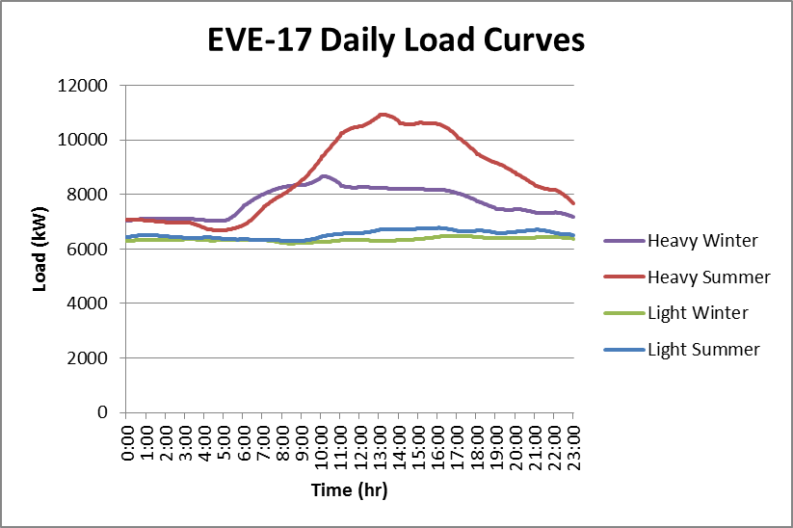
Figure M-10: EVE-17 Potential PV Generation
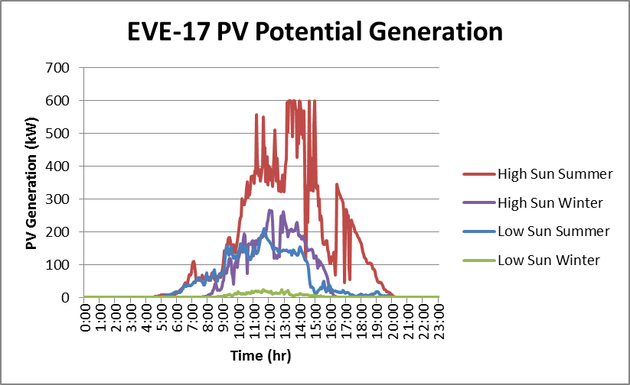

Impact on Demand. The solar PV generation that customers originate is accounted for in the system as a reduction in demand because it reduces the amount of energy that PSE must supply to that circuit from other sources. The more solar PV power that is generated, the more demand is driven down, as illustrated by the red line in the charts below. The less solar power generated, the greater the demand on other PSE resources to supply energy to the circuit, as illustrated by the blue lines. Demand that PSE must fill with system resources will swing between the values shown by the blue and red lines. On CAR-15, for example, on a cloudy day in the summer when customers are using more electricity, PSE will have to provide about 2,000 kW. But on a very sunny day if customers are not using much power, PSE will be purchasing over 2,000 kW from customers.

Figure M-11: CAR-15 Net Demand Range, Summer
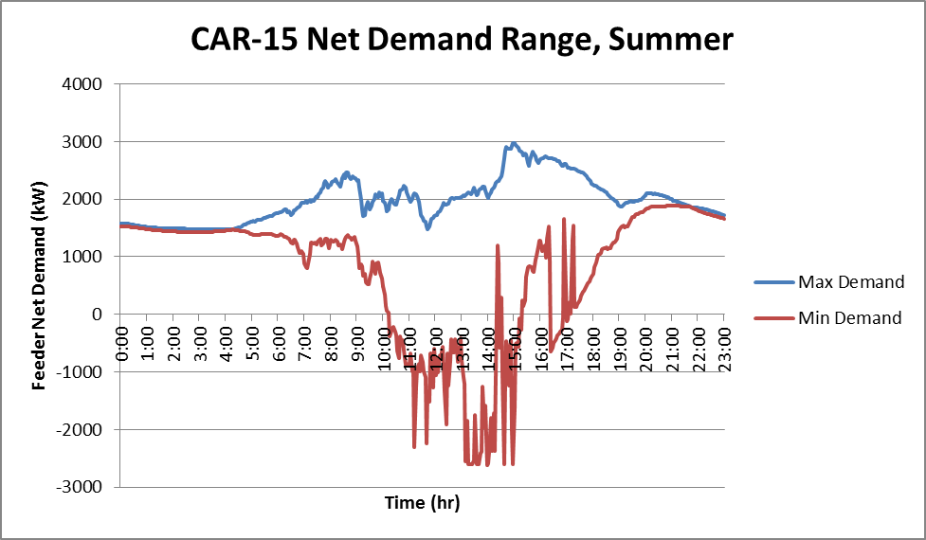

Figure M-12: WIN-16 Net Demand Range, Summer
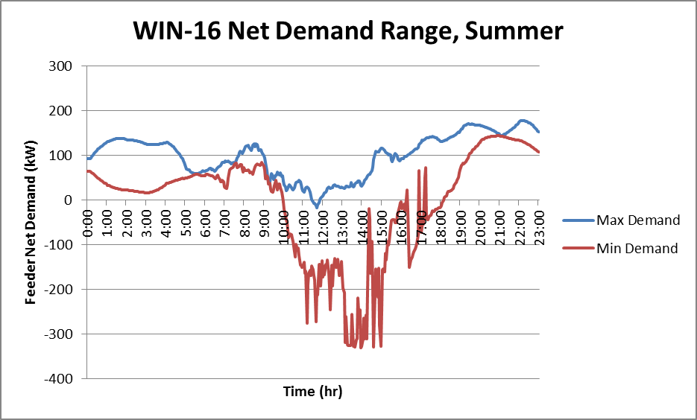

Figure M-13: UHL-21 Net Demand Range, Summer
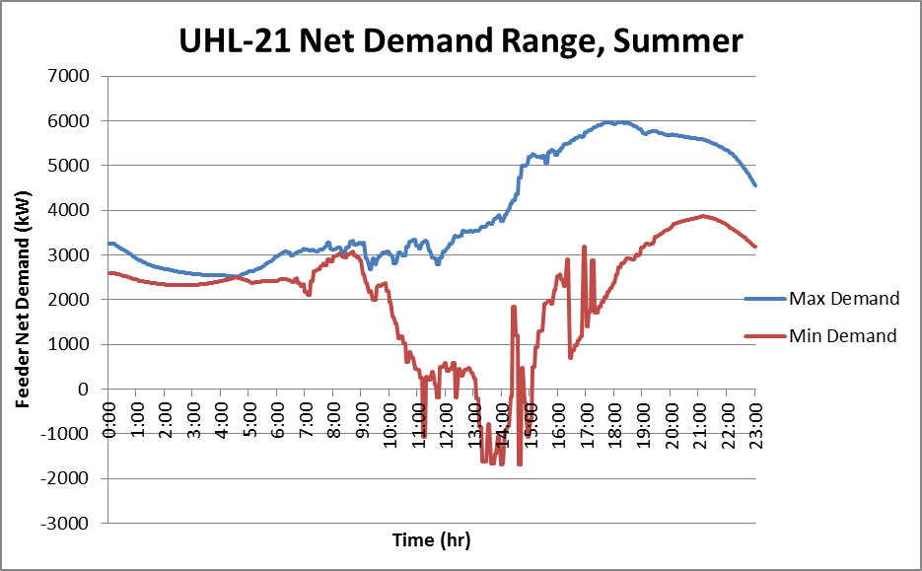

Figure M-14: EVE-17 Net Demand Range, Summer
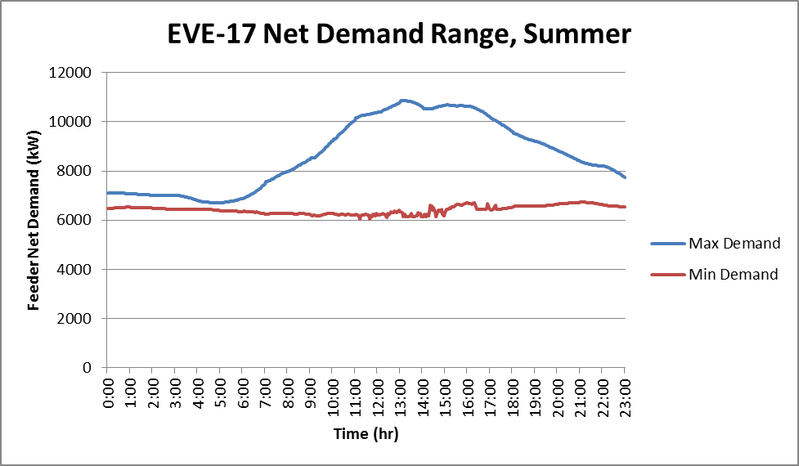

Findings

Voltage Impacts. Distributed solar PV increases the complexity of managing voltage regulation on circuit feeders due to its intermittent nature.

Power needs to flow to customers at a relatively constant voltage level of 114 to 126 volts per ANSI standard C84.1 (the national standard for utility voltage regulation). Voltage swings outside of this range can wear down utility equipment, degrade customer appliances and create operational issues with sensitive equipment. To keep levels within the acceptable range as customer loads increase and decrease, voltage regulators installed at the substation and/or on the feeder line respond by making adjustments in real time. To prevent unnecessary adjustments, they often operate on a 30 to 40 second delay.

Solar PV adds a layer of complexity by increasing the volatility of voltage changes. When customers’ solar panels export power onto the feeder, line voltage surges; when a cloud passes across the sun the PV stops producing and line voltage drops; when the sun comes back out, voltage often spikes again. This variation must now be compensated for in addition to variations in load.

The following charts show the PV generation impact on line voltage for each circuit studied. Note that while 114V is the minimum that can be served to customers, the following charts show the voltage without taking into account the voltage drop across the distribution transformer and customer connection (which can be anywhere from 2 to 6 volts depending on the customer). This means that any instances in the charts where the lowest feeder voltage dips below 120V, there is a possibility that a customer is receiving low voltage (typically verified by taking measurements at the meter following a complaint). Voltage on all circuits remains within the acceptable range, except on UHL-21 which experiences high voltages during periods of heavy solar generation. The voltage at the substation must be set to higher than 120V so that the customers at the end of the line remain within the limit despite the long length of this feeder and the high amount of load it serves.

For CAR-15, Figure M-16 shows that under light summer load conditions, significant levels of PV generation impact both the magnitude of voltage changes and the volatility of those changes on this line. Voltage increases up to 3.4 percent; voltage can also spike down briefly, as shown in Figure M-15.

Figure M-15: CAR-15 Heavy Summer Lowest Feeder Voltage Variation
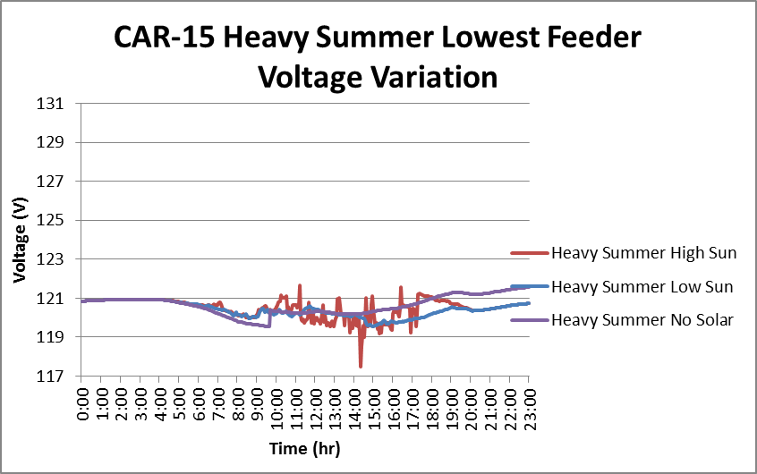

Figure M-16: CAR-15 Light Summer Highest Feeder Voltage Variation
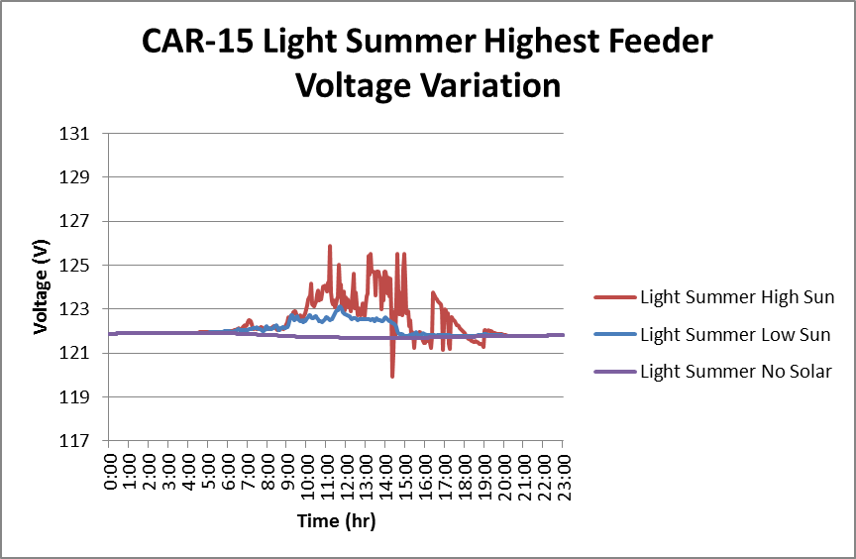

On UHL-21, Figure M-17 shows that distributed solar generation does not help increase the minimum voltage on the circuit during heavy summer loading. Figure M-18 shows that it can cause some customers to receive much higher voltages than allowed during periods of high solar generation.

Figure M-17: UHL-21 Heavy Summer Lowest Feeder Voltage Variation
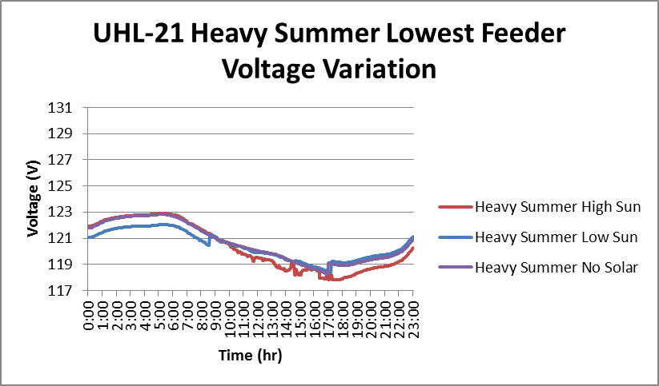

Figure M-18: UHL-21 Light Summer Highest Feeder Voltage Variation
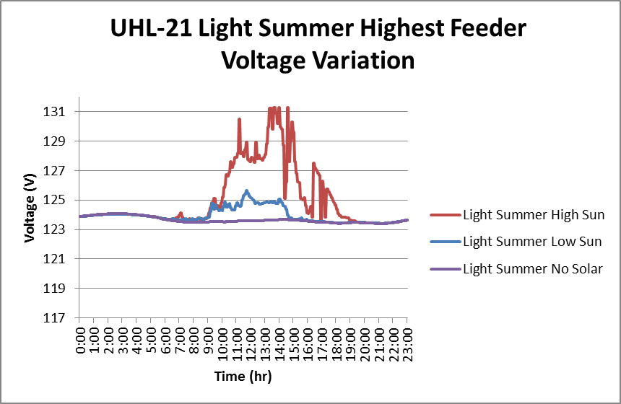

EVE-17 is the circuit that serves only three commercial buildings in Redmond, so it has only 9 percent PV potential penetration. Figure M-19 shows that EVE-17 experiences a voltage increase of only 0.057 percent (unnoticeable on the same scale as the other charts), compared to 3.4 percent in the CAR-15 circuit. The highest feeder voltage was constant because the potential solar penetration was not significant enough to raise the voltage above the substation voltage on any section of the circuit, therefore it is not shown. Similarly, WIN-16 did not have a high enough potential solar generation to noticeably impact circuit voltages; it is also not shown.

Figure M-19: EVE-17 Heavy Summer Lowest Feeder Voltage Variation
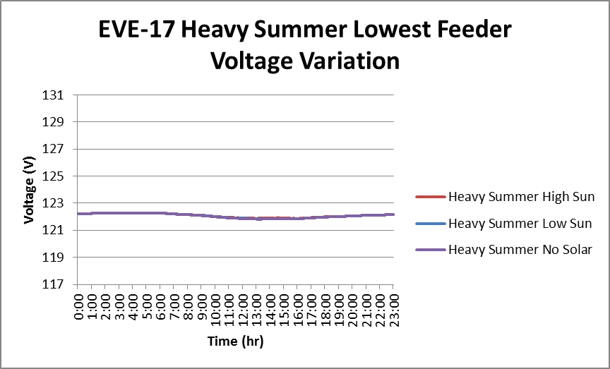

Peak Demand. Meeting peak demand is a particularly important responsibility, so we wanted to know if distributed solar PV generation can contribute to meeting that need. In the charts below, the purple line represents the daily demand curve for a circuit in its peak demand season. The space between the purple line and the red line represents the reduction in demand that is produced by solar PV generation on high sun days. Only on EVE-17 does solar PV contribute to meeting peak need.

CAR-15, with 76 percent commercial loads, has a generally flat load once everything is “turned on.” Solar generation contributes to meeting need during midday, but does not reduce the peak need in the morning.

Figure M-20: CAR-15 Winter Peak PV Effects
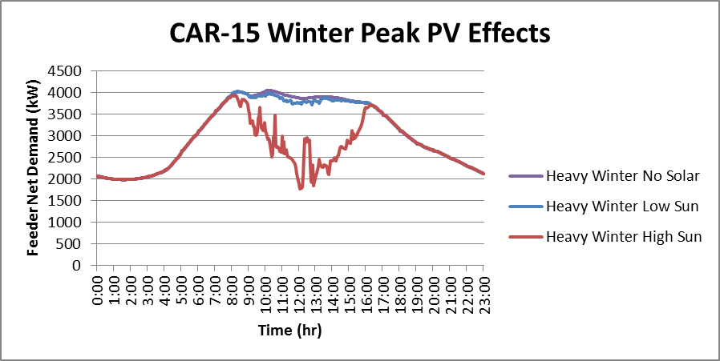

Figure M-21 shows that the winter morning peak on WIN-16 cannot be lowered by additional solar power, although it contributes to meeting need at midday.

Figure M-21: WIN-16 Winter Peak PV Effects
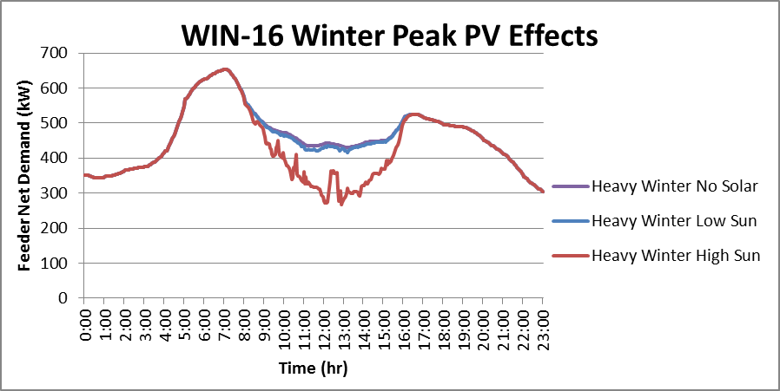

Figure M-22 shows that the evening winter peak on circuit UHL-21 is also not positively affected by solar power; however there are energy savings in mid-day on high sun days.

Figure M-22: UHL-21 Winter Peak PV Effects
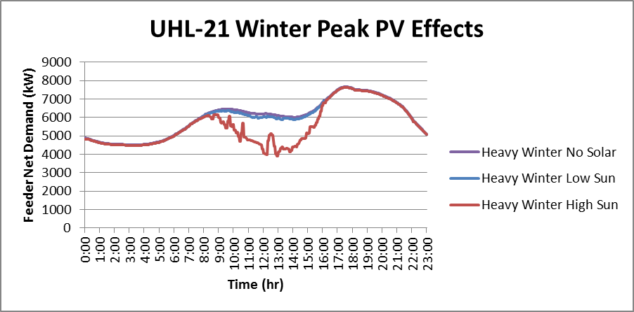

Figure M-23 shows EVE-17, the summer peaking circuit that serves business offices with lots of lighting, computers and air conditioning. On a high sun day, solar power can reduce peak load on this circuit.

Figure M-23: Eve-17 Summer Peak PV Effects
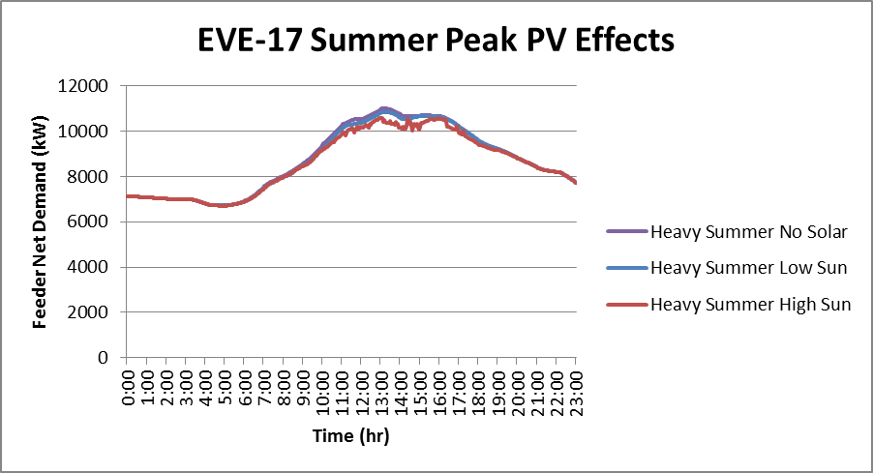

Line Losses. Line losses include all the electric power transmitted on a line but not delivered to the other side. They increase in proportion with the square of the current flowing through the line, so efficiency is higher when less electricity is flowing. When large amounts of solar PV flow back onto the grid, the amount of electricity can be much more than normal, leading to greater line losses.

CAR-15 and UHL-21, below, show significant losses due to the over-supply of PV generation. When compared to the potential PV production in Figures M-4, 6, 8 and 10, these losses range from 25 percent to 30 percent. WIN-16 has losses up to 10 percent. In comparison, the average line loss across PSE’s entire transportation and delivery system is approximately 8 percent.
While line losses do not cause problems for customers and their appliances, they are an unnecessary waste of energy. Measures to limit line losses include increasing the size of conductors or using smart inverters to limit the amount of energy that goes onto the grid.

Figure M-24: CAR-15 Heavy Summer Line Losses
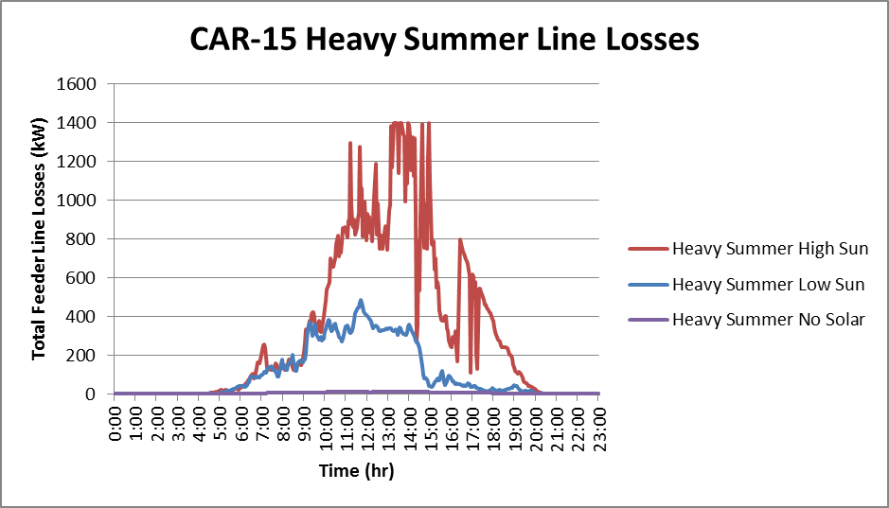

Figure M-25: UHL-21 Heavy Summer Line Losses
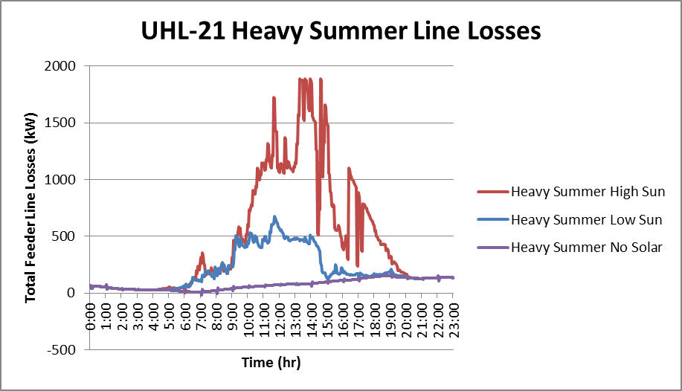
Figure M-26: WIN-16 Heavy Summer Line Losses
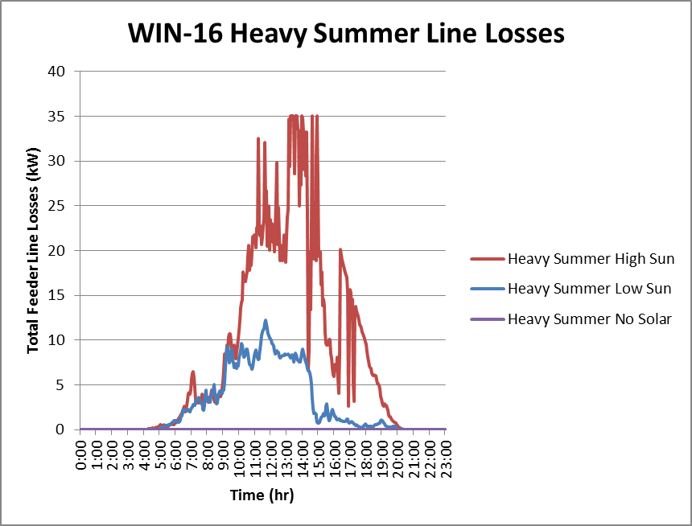

EVE-17 provides a very different result: Here, PV can reduce line losses. In this case for the heavy summer load with high sun the daily line loss is reduced by 3.5 percent. This occurred because the solar generation is less than the power consumed by the customer at all times.

Figure M-27: EVE-17 Heavy Summer Line Losses
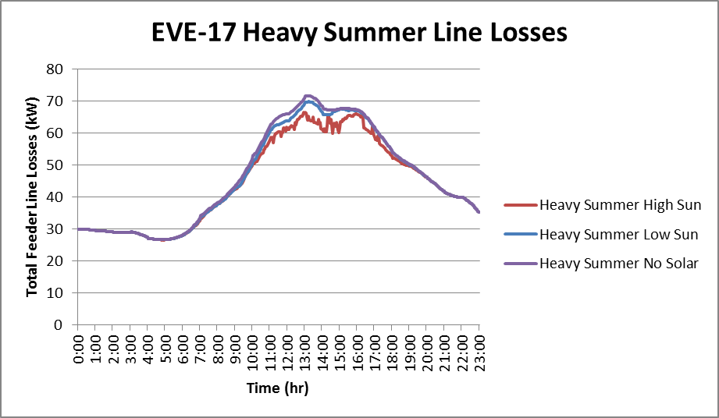

Summary

As a result of this analysis, the following conclusions were reached. For quick reference, the figures that support each conclusion are referenced in brackets following each bullet.

Customer Voltage

- Longer feeders are more difficult to keep within voltage limits when serving large numbers of distributed solar customers. [M-18]
- Shorter feeders have more rapidly changing voltages when serving high penetrations of distributed solar customers, but not by enough for customers to be served a voltage outside of allowable limits. [M-16]

Line Losses

- Feeders with load that is distributed across a large area are more likely to see significantly higher line losses with high amounts of distributed solar. [M-24, M-25]
- Solar customers that use more load than they can generate reduce line losses on a circuit. [M-27]

Feeder Demand

- Using realistic assumptions about maximum levels of solar penetration for western Washington, it is possible that some feeders could generate significantly more power than they consume. [M-11, M-12, M-13]
- Demand varies significantly from minute to minute when the volatility of customer load is combined with the volatility of distributed solar generation. [M-11, M-12, M-13]
- Even in the winter, or on cloudy summer days, a significant amount of solar power can be produced by solar customers in western Washington. [M-4, M-6, M-8, M-10]
- Peak demand in winter is generally not reduced by large penetrations of distributed solar generation, because nearly all PSE feeders peak in the winter in either the early morning or evening when there isn’t enough sunlight to produce a significant amount of solar power. [M-20, M-21, M-22]
- For feeders that peak in the summer, peak demand is reduced by distributed solar generation. [M-23]

DISTRIBUTED PHOTOVOLTAIC TECHNICAL AND MARKET POTENTIAL

The Cadmus report on this study appears on the following pages.

/ PV penetration as a percentage is determined by dividing the total capacity of PV systems on the circuit (in KW) by the peak load on that circuit (in KW).

