

**STATE OF WASHINGTON**

UTILITIES AND TRANSPORTATION COMMISSION

***1300 S. Evergreen Park Dr. S.W., P.O. Box 47250 ● Olympia, Washington 98504-7250***

***(360) 664-1160 ● www.utc.wa.gov***

June 2,2015

Steven V. King, Executive Director and Secretary

Utilities and Transportation Commission

1300 S. Evergreen Park Dr. SW

P.O. Box 47250

Olympia, WA 98504-7250

RE: *Washington Utilities and Transportation Commission v. Tri Valley Construction.*

Commission Staff’s Response to Application for Mitigation of Penalties

Docket DG-144100

Dear Mr. King:

On April 13, 2015, the Utilities and Transportation Commission (commission) issued a $4,000.00 Penalty Assessment in Docket DG-144100 against Greg Huylar, d/b/a Tri Valley Construction (Tri-Valley) for three violations of RCW 19.122.030(1)(a), for failing to request a dig ticket prior to performing an excavation on three separate occasions. RCW 19.122.055(1)(a) states, in part, that any excavator who fails to notify a one-number locator service and causes damage to a hazardous liquid or gas facility is subject to a civil penalty of not more than ten thousand dollars for each violation.

On April 28, 2015, Tri Valley Construction wrote the commission requesting mitigation of the penalties. In its mitigation request, Tri Valley Construction identified each violation and gave their reason why the violation should be mitigated. Commission staff has outlined the company’s mitigation request on each violation and has responded below:

**First Violation:** Tri-Valley states, in part, that they had a valid locate on file prior to the damage incident and referenced ticket #1319741[1], which was requested on July 30, 2013. Tri-Valley also stated that the digging took place on September 8, 2013, which according to the calendar was a Sunday.

**Staff Response:** RCW 19.122.030(6)(c) states, facility operator's markings of underground utilities expire forty-five calendar days from the date that the excavator provided notice to a one-number locator service. For excavation occurring after that date, an excavator must provide additional notice to a one-number locator service pursuant to subsection (1) of this section.

All records provided by Cascade Natural Gas (CNG) to commission staff indicate the damage to the company’s facilities occurred on Wednesday, September 18, 2013. Staff reviewed locate ticket #13197411, provided by Tri-Valley and confirmed it was requested on July 30, 2013, making the last day to legally dig on that ticket September 13, 2013. For this reason, staff does not support mitigation of this violation.

**Second Violation:** Tri-Valley states, in part, that they were working with the general contractor who requested they dig alongside of some existing power for them to install another conduit. Tri-Valley claims they were doing them a “favor” by renting them their excavator and operator so they could get the work done.

**Staff Response:** RCW 19.122.030(1)(a) states in part, before commencing ***any excavation***, an excavator must provide notice of the scheduled commencement of excavation to all facility operators through a one-number locator service. As Tri-Valley was the actual excavator, staff does not support mitigation of this violation.

**Third violation:** Tri-Valley states, in part, that the line was hit by their subcontractor, Russell Crane Service. Tri-Valley goes on to say that the violation should go to their subcontractor, especially in light of the second violation in the penalty assessment where they say they were working for a general contractor.

**Staff Response:** The damage incident on July 2, 2014, was reported to the commission by CNG, and through staff’s investigation was again verified by CNG that the company who damaged their facilities was Tri-Valley. CNG told commission staff that the vehicles on-site had Tri-Valley logos and the employee they spoke to regarding the damage identified himself as a Tri-Valley Construction employee.

Staff also found through a corporations search on the Secretary of State website at www.sos.wa.gov that Russell Crane Service, Inc. and Tri-Valley Construction, Inc. appear to be owned by, and list the same three governing persons as, Greg G. Huylar, Joy M. Delorme, and Jodee L. Huylar[2]. Because it appears that Tri-Valley is attempting to transfer the blame of the incident onto another company owned by the exact same people who own Tri-Valley, staff does not support mitigation of the third violation.

If you have any questions regarding this recommendation, please contact Lynda Holloway at (360) 664-1118, or lhollowa@utc.wa.gov.

Sincerely,

David D. Lykken

Pipeline Safety Director

Enclosures

**Attachment A**

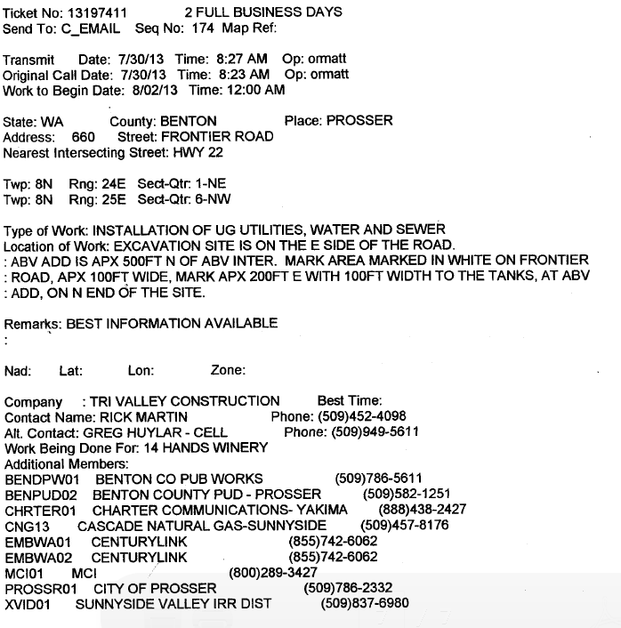

**Attachment B**

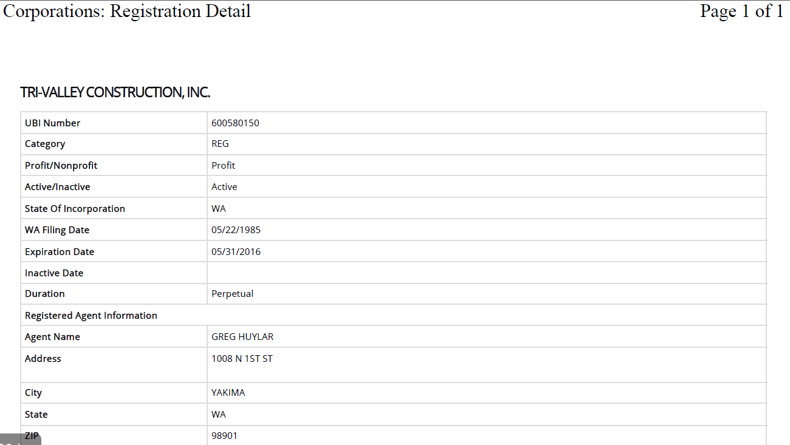

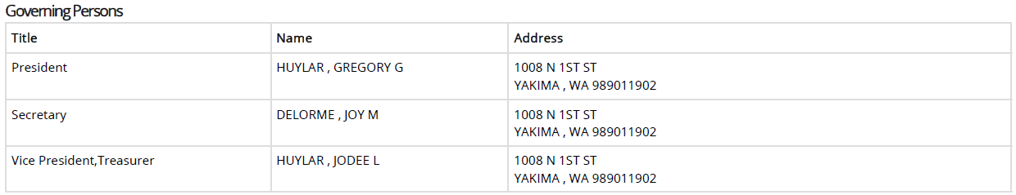

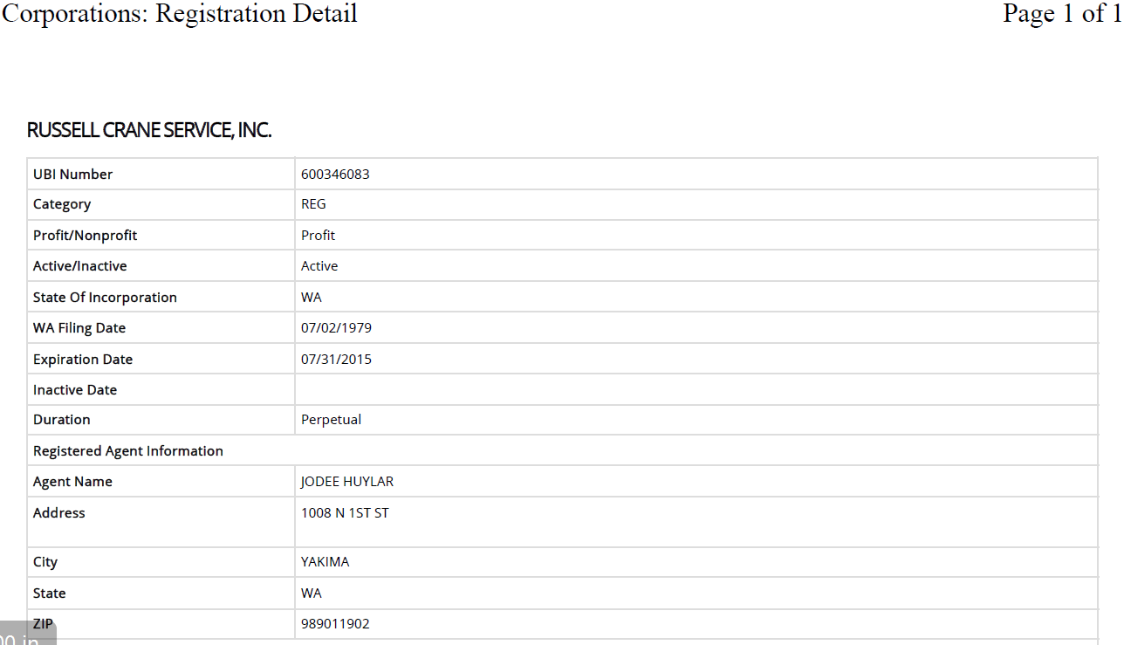

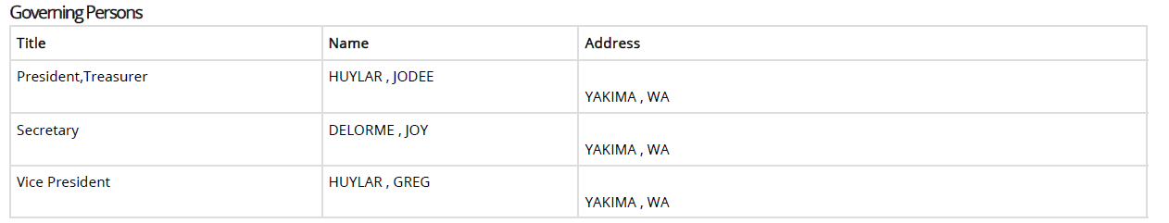

1. See Attachment A – Utility locate ticket #13197411.
2. See Attachment A – Corporate registrations for Tri-Valley Construction, Inc. and Russell Crane Service, Inc.