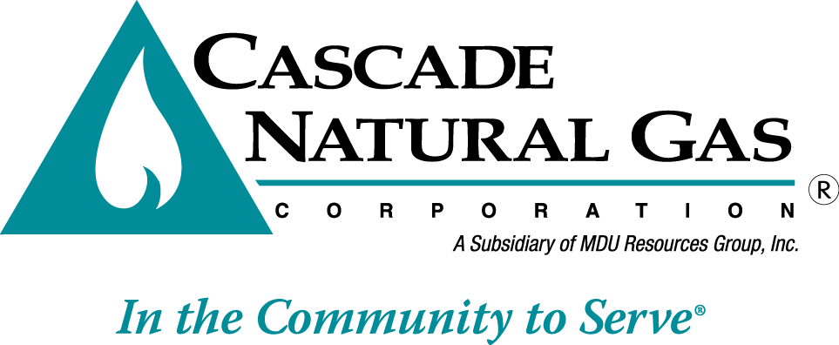 | 8113 W. GRANDRIDGE BLVD., KENNEWICK, WASHINGTON 99336-7166  TELEPHONE 509-734-4500 FACSIMILE 509-737-7166  www.cngc.com

VIA ELECTRONIC MAIL
records@utc.wa.gov

January 20, 2017

Records Center
Washington Utilities and Transportation Commission
1300 S. Evergreen Park Drive SW
Olympia, WA 98504

Re: UG-160967, Informational Filing
January 2017 Line Extension Data

On July 29, 2016, Cascade Natural Gas Corporation’s (Cascade or Company) submitted Advice No. W16-07-01, docketed as UG-160967, which the Commission approved with an effective date of September 1, 2016.

The filing revised the Company’s line extension policy to offer an upfront allowance based on the perpetual net present value (PNPV) of the revenues generated from that customer.

A PNPV allowance is the annual basic service charge and distribution revenue for the average residential or average commercial customers, as applicable, divided by 7.35%, which is the Company’s rate of return as approved in Commission Order No. 04 issued in UG-152286. This methodology provides an upfront allowance for residential customers not to exceed $3,255 and an allowance of no more than $12,350 for commercial customers.

When the Commission approved the Company’s filing, they expressed an interest in receiving line extension data in order to track the impact of the policy changes. The table below provides a history of the number of new services added per quarter, the total length of new service lines and mains installed, the overall cost, and the average cost per foot of pipe.

Year-Quarter | Number of Services | Total Service Footage | Total Main Footage | Total Footage | Cost | Cost Per Foot
2014 Q3 July thru September | 471 | 26,821 | 35,754 | 62,575 | $573,663.87 | $9.17
2014 Q4 October thru December | 552 | 34,805 | 40,937 | 75,742 | $946,773.45 | $12.50
2015 Q1 January thru March | 523 | 32,106 | 32,051 | 64,157 | $818,538.39 | $12.76
2015 Q2 April thru June | 561 | 30,706 | 56,432 | 87,138 | $1,594,264.57 | $18.30
2015 Q3 July thru September | 529 | 27,913 | 40,772 | 68,685 | $977,336.95 | $14.23
2015 Q4 October thru December | 751 | 43,354 | 45,809 | 89,163 | $1,441,120.47 | $16.16
2016 Q1 January thru March | 630 | 32,314 | 41,385 | 73,699 | $1,034,005.55 | $14.03
2016 Q2 April thru June | 735 | 36,056 | 26,084 | 62,140 | $913,930.95 | $14.71
2016 Q3 July thru September | 647 | 34,350 | 27,431 | 61,781 | $986,557.67 | $15.97
2016 Q4 October thru December | 745 | 41,415 | 18,508 | 59,923 | $843,103.54 | $14.07
Grand Total | 6,144 | 339,840 | 365,163 | 705,003 | $10,129,295.41 | $14.37

As stated in Cascade’s initial informational filing of October 13, 2016, the Company will submit semi-annual informational filings by the end of January and July of each year. Each filing will provide an additional two quarters of line extension information.

If you have any questions regarding this report, please contact Jennifer Gross at (509) 734-4635.

Sincerely,

/s/ Michael Parvinen

Michael Parvinen
Director, Regulatory Affairs

