**BEFORE THE WASHINGTON UTILITIES AND TRANSPORTATION COMMISSION**

|  |  |  |
| --- | --- | --- |
| In the Matter of the Joint Application of  QWEST COMMUNICATIONS INTERNATIONAL INC. AND CENTURYTEL, INC.  For Approval of Indirect Transfer of Control of Qwest Corporation, Qwest Communications Company LLC, and Qwest LD Corp. |  | DOCKET NO. UT-100820  QWEST’S AND CENTURYLINK’S MOTION TO EXCLUDE ACCESS TO HIGHLY CONFIDENTIAL INFORMATON UNDER THE PROTECTIVE ORDER |

1. On August 23, 2010, Joint Applicants Qwest Communications International, Inc. (“Qwest”) and CenturyTel, Inc. (“CenturyLink”) (collectively, “Joint Applicants”) received a submission by the Department of Defense/Federal Executive Agencies (“DOD”) including the signed Exhibit C to the protective order for several outside consultants and for DOD’s in-house attorney. Exhibit C is the agreement regarding access to Highly Confidential information.
2. Counsel for Qwest immediately contacted counsel for DOD, and asked that DOD withdraw the Exhibit C signed by counsel, as in-house personnel are not permitted under the terms of the protective order to request or access Highly Confidential Information. DOD refused to do so.
3. The Joint Applicants state that they object to any in-house counsel having access to Highly Confidential Information contrary to the terms of the protective order.
4. Joint Applicants therefore file this motion with the Commission, supported by affidavit, setting forth the basis for their objection to access to Highly Confidential Information under the protective order, and asking exclusion of the person from access to Highly Confidential Information.
5. Attached hereto is the Declaration of Lisa A. Anderl, in support of this motion.
6. The provisions of the protective order prohibit access to Highly Confidential Information by anyone other than outside counsel or outside experts. Those provisions are contained in paragraphs 14-21 of the protective order.

* Paragraph 14 provides that “[p]arties who seek access to or disclosure of Highly Confidential documents or information must designate one or more *outside* counsel and one or more *outside* consultant, legal or otherwise, to receive and review materials marked “Highly Confidential . . . (emphasis added).”
* Paragraph 15 provides the only exception to, stating that “[t]he restrictions in paragraph 14 do not apply to persons employed with the Attorney General's office for Public Counsel and Commission Staff.”
* Paragraph 17 provides that “[*o]utside* counsel designated in the manner described in Section 14, above, may provide one copy of Highly Confidential documents or information to their *outside* consultants or experts who have been designated to receive Highly Confidential Information in the manner described in paragraph 14, above. Designated *outside* counsel and consultants will each maintain the Highly Confidential documents and information and any notes reflecting their contents in a secure location to which only designated counsel and consultants have access…(emphasis added).”
* Paragraph 18 provides that “[s]taff of designated *outside* counsel and staff of designated *outside* consultants who are authorized to review Highly Confidential Information may have access to Highly Confidential documents or information for purposes of processing the case, including but not limited to receiving and organizing discovery, and preparing prefiled testimony, hearing exhibits, and briefs. *Outside* counsel and consultants are responsible for appropriate supervision of their staff to ensure the protection of all confidential information consistent with the terms of this Order…(emphasis added).”

1. Thus, there are no provisions in the order that allow an in-house attorney such as counsel for DOD to have access to Highly Confidential Information. In fact, the only exceptions to the “outside personnel only” are Staff and Public Counsel, and those exceptions are specifically called out in the protective order.
2. Counsel for DOD points to the Exhibit C itself, which has a space for an “X” that identifies the individual signing the Exhibit as an “In-house attorney”. DOD contends that Exhibit C therefore contemplates that an in-house attorney will be permitted access to the Highly Confidential Information.
3. Joint Applicants disagree. The text of the protective order is clear in limiting access to outside personnel. When the “In-house attorney” line is marked, as it is in the case of DOD’s counsel, it is simply a clear indication that the individual has identified himself as someone who is not entitled to see the information. A copy of DOD’s Exhibit C is attached hereto.
4. DOD’s interpretation is contrary to all rules of drafting and interpretation, as DOD would have three words in the Exhibit C render several paragraphs in the protective order itself void. Joint Applicants’ interpretation gives meaning to all the terms of the protective order and Exhibit C, and as such is a more reasonable interpretation.
5. Joint Applicants note that two other in-house attorneys have signed, and then withdrawn, an Exhibit C in this matter. Most recently, the signature page for Covad’s in-house attorney was withdrawn via cover letter noting it was inadvertently filed and that an Exhibit C signature page from an in-house attorney is not appropriate under the terms of the protective order in this proceeding. While no one party’s interpretation of the protective order is determinative of the meaning of the order, Joint Applicants believe it is important to note that other parties have interpreted the order in a way that is consistent with Joint Applicants’ interpretation.
6. Thus, Joint Applicants request that the Commission grant this motion to exclude access and further clarify the protective order, if necessary, to exclude in-house personnel from accessing or requesting Highly Confidential Information.

Respectfully submitted this 26th day of August, 2010.

CENTURYLINK QWEST

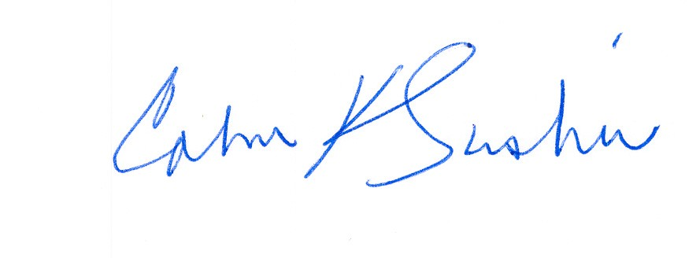

__________________________ ___________________________

Calvin K. Simshaw Lisa A. Anderl (WSBA # 13236)

CenturyLink Qwest Law Department

805 Broadway 1600 – 7th Ave., room 1506

Vancouver, WA 98660 Seattle, WA 98191

[calvin.simshaw@centurylink.com](mailto:calvin.simshaw@centurylink.com) [lisa.anderl@qwest.com](mailto:lisa.anderl@qwest.com)