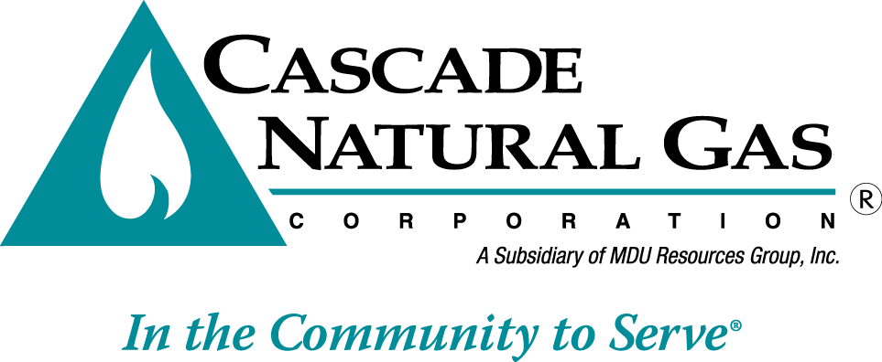 | 8113 W. GRANDRIDGE BLVD., KENNEWICK, WASHINGTON 99336-7166  TELEPHONE 509-734-4500 FACSIMILE 509-737-7166  www.cngc.com
VIA ELECTRONIC MAIL
records@utc.wa.gov

August 5, 2015

Records Center
Washington Utilities and Transportation Commission
1300 S. Evergreen Park Drive SW
Olympia, WA 98504

Re: UG-151595 Tariff Revisions
Advice No. CNGC/W15-07-02 – Replacement filing

Cascade Natural Gas Corporation (Cascade or the Company) submitted Advice No. CNG/W15-07-02 on July 31, 2015. The Company herewith replaces that filing in its entirety and files the following revisions to its Tariff WN U-3, stated to become effective with service August 30, 2015:

Fifty-Second Rev. Sheet No. 502
Fifty-Seventh Sheet No. 503
Forty-First Rev. Sheet No. 504
Fortieth Rev. Sheet No. 505
Fifty-Seventh Rev. Sheet No. 511
Thirty-Seventh Rev. Sheet No. 512
Fifty-Fourth Rev. Sheet No.541
Fifty-First Rev. Sheet No. 570
Forty-Eighth Rev. Sheet No. 577
Fourteenth Revision Sheet No. 663

Please find enclosed with tariff filing is an application for waiver requesting that the revised tariff sheets become effective with Less than Statutory Notice (LSN) on August 17, 2015. Also, the purposes of the filing is to reorganize the base tariffs such that the Company can make its annual Purchase Gas Adjustment (PGA) filings independently from margin or base rate changes that would occur in a rate case.

The reason for the LSN request is so that the tariff changes are is in place prior to September 1 so that the out of cycle PGA also filed concurrently with this docket and the rate increase filed on June 23, 2015, (Docket UG-151309) can be reviewed and acted on independently.
This filing has not rate or revenue impact.

If you have any questions regarding this report, please contact me at (509) 734-4593.

Sincerely,

Michael Parvinen
Director, Regulatory Affairs

