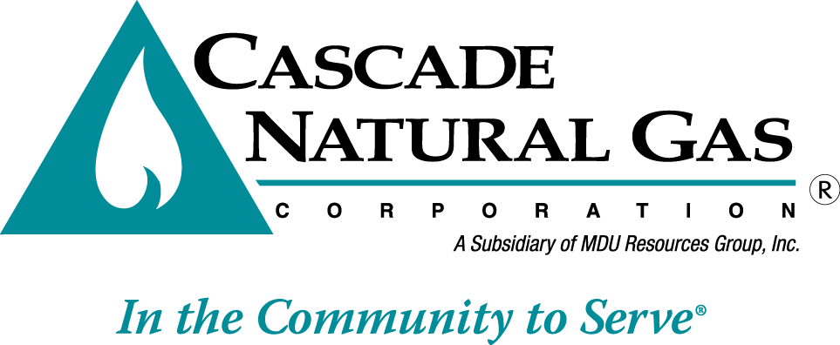 | 8113 W. GRANDRIDGE BLVD., KENNEWICK, WASHINGTON 99336-7166  TELEPHONE 509-734-4500 FACSIMILE 509-737-7166  www.cngc.com

VIA ELECTRONIC MAIL
records@utc.wa.gov

July 29, 2016

Records Center
Washington Utilities and Transportation Commission
1300 S. Evergreen Park Drive SW
Olympia, WA 98504

Re: Advice No. CNG/W16-07-01 Rule 8, Extension of Distribution Facilities

Cascade Natural Gas Corporation (Cascade or the Company) files the following revisions to its Tariff WN U-3, stated to become effective September 1, 2016:

Tenth Revision of Sheet No. 12
First Revision of Sheet No. 12-A
First Revision of Sheet No. 12-B

The Company also withdraws the following sheets in their entirety:

Original Sheet No. 12-C
First Revision Sheet No. 12-D
Original Sheet No. 12-E
Fourth Revision of Sheet No. 13

The purpose of this filing is to revise the Company’s line extension policy in an effort to better address the first-cost barrier that often prevents homeowners and businesses from converting to low-cost, clean-burning natural gas.

The Company’s current policy offers applicants an upfront credit of either 3.3 times their estimated annual margin to be applied towards the cost of installing a service line, or a credit of 6.6 times estimated annual margin for both a main extension and service line. Before service is initiated, a new customer must pay the Company all costs to install the necessary distribution facilities in excess of the allowance. This is often a hardship since a conversion customer is paying for the purchase and installation of new-gas fired appliances at the same time.

The Company has observed that once a customer is connected, that customer’s site will likely receive gas service for many years. In recognition that an investment in a gas service continues to yield returns, the Company proposes an upfront allowance based on the perpetual net present value (PNPV) of the revenues generated from that customer.

A PNPV allowance is the annual basic service charge and distribution revenue for the average residential or average commercial customers, as applicable, divided by 7.35%, which is the Company’s approved pre-tax rate of return as approved in Commission Order No. 04 issued in UG-152286. This methodology results in an upfront allowance for residential customers not to exceed $3255 and an allowance of no more than $12,350 for commercial customers. Attached is a work paper that shows how the line extension allowance was derived. The Company proposes using this same PNPV methodology for industrial, large volume, and interruptible customers, but on a case-by-case basis based on each individual customer’s unique load profile.

The PNPV methodology was discussed in a report by the National Regulatory Research Institute, and Avista uses PNPV to determine the residential credit offered per their service line extension policy, filed in UG-152394 and approved in Order No. 01.

Cascade’s proposal differs from Avista’s in a few ways: The Company is not seeking to offer appliance rebates with any excess allowance. As such, the Company is not requesting authorization to defer any costs.

Language is added clarifying that customer contracts signed prior to the adoption of this new policy will be honored in accordance with the terms and condition in place when the contract was executed. For instance, main refunding contracts that offer rebates for significant investments in main extensions when additional customers are served on the same main within five years will be honored.

The changes made herein greatly simplify the Company’s service line and main extensions policies. An easily understandable policy that removes the first cost barrier to natural gas conversion is the keystone in making low cost, clean gas service available to underserved communities looking for the improved air quality or economic boost that access to gas can offer.

Related housekeeping changes include the removal of Rule 9, Main Extensions, which established a policy that was “frozen” or no longer effective. The proposed main extension policy is included in Rule 8, Extensions of Distribution Facilities. Also, language regarding Excess Flow Valves is removed from Rule 8 as it is reiterated verbatim in Rate Schedule 200.

If you have any questions regarding this report, please contact Jennifer Gross at (509) 734-4635.

Sincerely,

/s/ Michael Parvinen

Michael Parvinen
Director, Regulatory Affairs

Attachments

“Line Extension for Natural Gas: Regulatory Considerations,” National Regulatory Research Institute, February 2013. https://www.michigan.gov/documents/energy/Ken_Costello-_NRRI.pdf_natural_gas_418345_7.pdf

