January 21, 2010

W.U.T.C.
Tariff Division
1300 S. Evergreen Park Drive SW
Olympia, WA 98504-8002
Re: Shuttle Express Inc. C-975, tariff #6
(Recently filed tariff changes)

In working with staff I have found several pages needing to be removed as they are no longer applicable. I would like to request under the same docket the following pages be removed:
- Fourth revised page three A
- Fourth revised page three D
- Third revised page three E
- Original page three E-a
- Original page three E-b
- Second revised page three E-c
- Appendix A
- Page 2 of Appendix A continuation
- First Revised page four
- Original page four A
- Original page five
- Original page six

Unfortunately I also found a misalignment on the second revised page one, and am also submitting a third revised page one with a minor change. Thank you for all of your help in cleaning up our tariff.

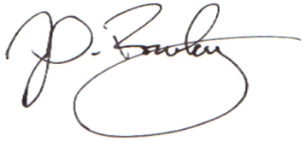
Respectfully,

John Rowley, General Manager

