BEFORE THE WASHINGTON UTILITIES AND TRANSPORTATION COMMISSION

DOCKET NO. UE-160228

DOCKET NO. UG-160229

REBUTTAL TESTIMONY OF

KAREN K. SCHUH

REPRESENTING AVISTA CORPORATION

# I. INTRODUCTION

**Q. Please state your name, employer and business address.**

A. My name is Karen K. Schuh. I am employed by Avista Corporation as a Senior Regulatory Analyst. My business address is 1411 East Mission, Spokane, Washington.

**Q. Have you previously provided direct testimony in this case?**

A. Yes. My direct testimony and exhibits in this proceeding covered the Company’s capital investments in utility plant through the 2017 rate year and the January – June 2018 rate period. As explained by Company witness Ms. Andrews, the Company based its electric and natural gas revenue increases requested in this case on its electric and natural gas Attrition Studies. However, as a companion to the attrition studies, Company witness Ms. Smith also prepared electric and natural gas Modified Test Year Studies[1] and Cross Check Studies, which incorporated Washington’s share of the 2017 rate year and the January – June 2018 rate period adjustments for expenses and capital additions.

**Q. What is the scope of your rebuttal testimony in this proceeding?**

A. In response to the testimony of Staff and other parties,[2] I will address the positions of other parties regarding pro forma capital adjustments and their inclusion in the Modified Test Year Studies. In addition, I explain the fact that the rate making studies prepared by Staff and other parties do not reflect the balance of plant-in-service that will benefit customers during the 2017 rate year and the January to June 2018 rate period. I follow this by a discussion of updates to the Company’s expected capital investments in utility plant through the 2017 rate year and the January to June 2018 rate period to reflect the most current information. These updates have been incorporated into the revised Modified Test Year and Cross Check Studies included in Ms. Smith’s rebuttal testimony. This is followed by specific discussions related to capital investment in AMI, the Spokane River Projects, and General Plant, as well as discussion of the purpose of the allowance for funds used during construction (AFUDC). My testimony concludes with corrections of errors in other parties’ testimonies.

**Q. Are you sponsoring any exhibits?**

A. No. I am not.

**TABLE OF CONTENTS**

Description Page

I. INTRODUCTION 1

II. OTHER PARTIES’ POSITIONS 2

III. UPDATES TO CAPITAL ADDITIONS SINCE ORIGINAL FILING 8

IV. AMI 10

V. SPOKANE RIVER PROJECTS 11

VI. GENERAL PLANT 17

VII. ALLOWANCE FOR FUNDS USED DURING CONSTRUCTION (AFUDC) 19

# II. OTHER PARTIES’ POSITIONS

Q. Is the way Staff calculated the threshold to define major plant additions appropriate?

A. No. Staff used the “one-half of one percent” threshold.[3] This was calculated using the Company’s December 31, 2015 electric and natural gas Commission Basis Reports by usingthe net plant before ADFIT balance. It is not appropriate to exclude the ADFIT balance in the calculation. The Company has included all other additions in this filing for the Modified Test Year Studies and Cross Check Studies on a “net of ADFIT” basis, in order to adhere to standard rate making policy. Therefore, the threshold used to calculate the pro forma capital additions should be consistent with this method. The Company used the net plant after ADFIT balance to calculate this threshold, and believes this is the correct application of the rule.

When the net plant balance after ADFIT threshold is updated with the information contained in the most recently filed Commission Basis Reports (at December 31, 2015), the threshold changes, from the originally filed threshold of $6.3 million for electric and $1.17 for natural gas, to $6.4 million and $1.22 million, respectively. Updating this threshold yields the same group of major pro forma projects as was proposed in the Company’s direct case for both electric and natural gas. In contrast, Staff’s threshold was $7.9 million for electric and $1.5 million for natural gas. The higher threshold used by Staff resulted in the exclusion of two electric projects and one natural gas project from their pro forma adjustment, compared with the Company’s.

Q. Irrespective of how the threshold was calculated, does the Company believe that the use of a limiting threshold is appropriate and reflective of the plant-in-service in the rate year?

A. No. For 2017, the plant adjustments that are included based upon the threshold limitation exclude roughly one-half of the overall plant that will be serving customers in the rate effective period (regardless of which application of the threshold is considered).[4]

Q. What did Staff, ICNU and NWIGU propose regarding certain cut-off dates for the inclusion of post-test year capital additions for major projects.

A. Staff includes transfers-to-plant on major pro forma projects only through July 2016. ICNU and NWIGU include the actual transfer-to-plant amounts from January to May 2016 for all projects except the Nine Mile Redevelopment Project, in which case Mr. Mullins includes the estimated July 2016 transfer-to-plant amount.

**Q. What are the impacts of each Parties’ adjustments on net plant?**

A. Staff’s proposed pro forma adjustments beyond the historical test period increase net plant from September 30, 2015 by $82.4 million and $17.1 million for electric and natural gas, respectively.[5] ICNU and NWIGU’s adjustment is an increase of $81.6 million and $12.2 million, respectively.[6] Public Counsel did not propose a pro forma adjustment to net plant.

Q. How do these adjustments compare with the plant-in-service during the rate year, as shown by the Company?

A. The following illustration provides a comparison for electric net plant additions through the 2017 rate period, as proposed by the Company and other parties:

Illustration No. 1:

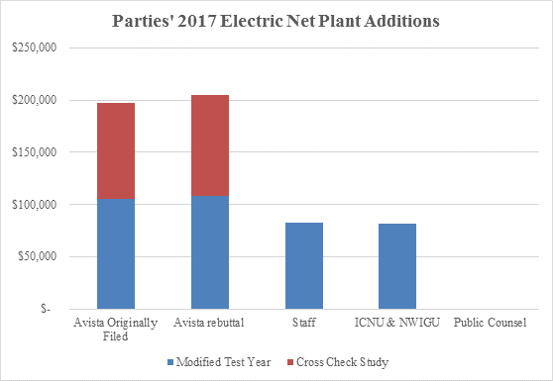

The following illustration shows this comparison for electric net plant adjustments for the January through June 2018 rate period:

Illustration No. 2:

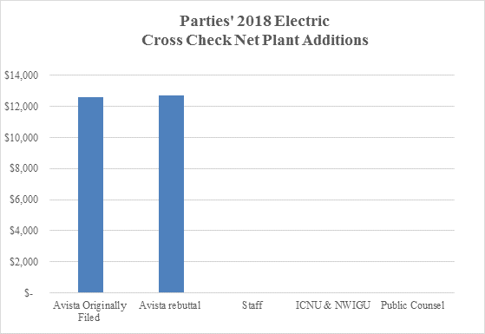

The following illustration shows a similar comparison for natural gas net plant adjustments through the 2017 rate period:

Illustration No. 3:

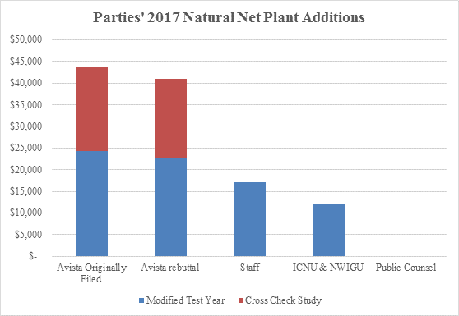

The following illustration shows a similar comparison for natural gas net plant adjustments for the January through June 2018 rate period:

Illustration No. 4:

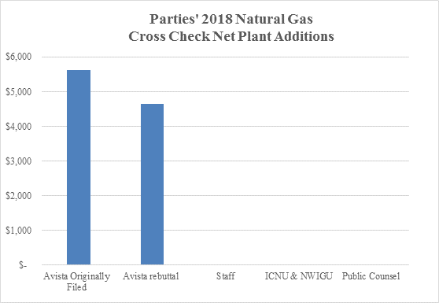

These illustrations show that the net plant adjustments, as pro formed by other parties, fall well below the plant-in-service that will be in place and serving customers during the 2017 rate year and the January through June 2018 rate period.

This also illustrates why the Company does not agree with the practice of excluding transfers-to-plant after a cut-off point for the limited, “major” pro forma projects included in the Modified Test Year. Limiting the capital adjustments contained in the Modified Test Year Study to major projects already severely understates the actual plant investment what will be providing service to customers in the rate year. Further reducing the capital adjustment through the application of a cut-off only exacerbates this deficiency.

This was recognized by Staff witness Mr. Hancock, as well as the Company, in proposing electric and natural gas revenue increases that reflect attrition adjustments.

# III. UPDATES TO CAPITAL ADDITIONS SINCE ORIGINAL FILING

**Q. Have there been any changes, since Avista’s original filing, to the expected capital additions for the 2017 rate year and the January to June 2018 rate period.**

A. Yes. There has been a net increase to the expected electric plant-in-service since the Company’s original filing, and a net decrease to the expected natural gas plant-in-service.

**Q. What are these changes in expected plant-in-service?**

A. For electric service, there are two main reasons for the net increase to the Washington net electric plant adjustment for the 2017 rate year from the initial presentation in my direct testimony. First, updating actual transfers for the January through May 2016 time period resulted in an increase in expected plant-in-service. These increases are primarily a result of larger generation/production-related projects transferring at a higher balance than had been included in my original testimony. Those increases were partially offset by decreases that resulted from revisions in the planned in-service dates for components of the AMI project. I will discuss these changes later in my testimony. This change impacted both the 2017 and June 2018 AMA balances. Overall, for the 2017 rate year, the net effect is an increase of approximately $6.9 million in net plant. The 2018 rate period experienced a minimal increase of $146,000 in net plant. [7]

Turning to natural gas service, the main reason for the net decrease to the Washington natural gas plant adjustments for the 2017 rate year was the aforementioned revision in the AMI Project timeline. The net impact of this and other minor changes on the 2017 rate year adjustment is a net decrease of $2.6 million in net plant. For the January to June 2018 rate period the net decrease to the net plant adjustment was $957,000. [8]

**Q. Are the revised total net plant adjustments for the electric and natural gas 2017 rate year reflected in Ms. Smith’s Modified Test Year and Cross Check Studies?**

A. Yes. Ms. Smith’s updated electric studies start with restated electric net plant after ADFIT, as of September 30, 2015, of $1.255 billion and adds $204.4 million in net plant additions to arrive at a total level of Washington electric plant for the 2017 rate year of $1.459 billion. After adjusting for other rate base items (e.g. working capital), total rate base equals $1.51 billion for 2017.

For natural gas, Ms. Smith’s updated study starts with the restated natural gas net plant after ADFIT, as of September 30, 2015, of $235 million and adds $41 million in net plant to arrive at a total level of Washington natural gas net plant for the 2017 rate year of $276 million.[9] After adjusting for other rate base items (e.g. working capital and inventory), total rate base equals $303.3 million for 2017.

**Q. How does the rate base for the Cross Check Studies for the 2017 rate year compare with the Attrition Studies’ total rate base for the 2017 rate year?**

A. Ms. Andrews’ revised electric and natural gas Attrition Studies show net rate base of $1.47 billion and $299 million, respectively.[10]/[11] The comparison between Ms. Andrews’ Attrition Studies and Ms. Smith’s Cross Check Studies is illustrated in the table below:

**Table No. 1:**



# IV. AMI

**Q. You mentioned above that one of the major changes to the Pro Forma adjustments for the 2017 rate year results from a shift in the AMI project schedule in 2017. Would you please elaborate on these changes?**

A. Yes. The shift in the AMI costs reflects the revised in-service date for the Meter Data Management (MDM) System,[12] which was originally expected to go into service in April 2017 and has now shifted to July of 2017. This shift in timing also shifts the timing of meter deployment, which would have started in July 2017, and is now expected to begin in September 2017. The updated in-service dates change the AMA balances previously reflected in the original filing. The changes in net plant and associated expense have been reflected in my electric and natural gas Cross Check Study adjustments.

**Q. What are the investment balances associated with the updated AMI adjustments included in the Cross Check Studies?**

A. The updated total investment is $96.7 million for 2017 through June 30, 2018. The $96.7 million relates to gross transfers to plant on an end of period basis from January 1, 2017 to June 30, 2018.[13] The Cross Check Studies in this case include total additions to net plant after accumulated deferred income taxes (on an AMA basis) of $24 million for electric ($8.8 million in 2017 and $15.2 million in 2018) and $9.1 million for natural gas ($3 million in 2018 and $6.1 million in 2018). Ms. Andrews includes these 2017 additions in her Studies as After Attrition Adjustments.

# V. SPOKANE RIVER PROJECTS

**Q. Do you agree with Staff’s method of calculating the after-attrition adjustment[14] for the Spokane River Projects?**

A. No. Staff only included $17 million as an after attrition adjustment rather than the $67.1 million proposed by the Company. As I will explain, Staff’s proposed after attrition adjustment is both insufficient to reflect the generation plant that will be serving customers in the rate year[15] and inconsistent with the concept of a pro-forma addition, as defined by Staff.

The Nine Mile Redevelopment project, Post Falls South Channel Gate Replacement project and Little Falls Powerhouse Redevelopment project have collectively been referred to in Ms. Andrews’ testimony as the Spokane River Projects. These three projects, together, have been treated as an after attrition adjustment, as they are large in investment scale and their associated transfers to plant are well above the historical level of capital transfers for the production plant functional group. Each of the projects are already in service.[16] The total additions to plant-in-service in 2016 related to these three projects is $67.1 million.

**Q. Earlier you mentioned that the additions associated with the three Spokane River Projects included in Ms. Andrews’ Attrition study were well above the historical average of production plant additions. Would you please discuss this further?**

A. The historical levels of production plant rate base additions have ranged from $7 to $33 million per year over the last nine years. The table below shows the historical gross plant additions per year in the production plant functional group for 2007 through 2015.

**Table No. 2:**



*Average production plant 2007 to 2015 is $15.9 million annually.

The Company recognized, as a part of the Modified Test Year and Cross Check Studies for Production Plant Additions in the 2017 rate year and January to June 2018 rate period, approximately $156 million of plant to be in placed in service between January 2016 and June 30, 2018. The Chart below shows what amount is expected in each year.

**Table No. 3:**



The additions to production plant (on an AMA basis) are well above the historical levels presented in Table No. 2.

**Q. Both Staff and the Company realized the need for an after attrition adjustment with regards to the Spokane River Projects. Why is Staff’s proposed adjustment insufficient?**

A. The effect of Staff’s adjustment includes only $17 million in additional production plant, versus the $67.1 million proposed by Avista. The primary difference between Staff’s position and Avista’s position is that Avista included the full investment cost of the plant additions related to these three projects, while Staff limited its pro forma after attrition adjustment to a level which does not reflect the full investment cost for these three projects.

The illustration below shows a comparison of the Company’s proposed level of production plant additions (both from the Modified Test Year and Cross Check Study and from the Attrition Study, including the after attrition adjustment) and the comparative level of Staff’s proposed level of production plant additions.

**Illustration No. 5:**

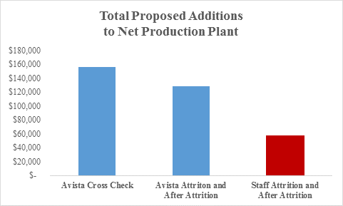

This illustration demonstrates that even the total proposed net production plant additions in Avista’s Attrition analysis, including the After Attrition Adjustment, does not fully reflect the level of production plant that will be serving customers in the rate year (as illustrated by the Avista Cross Check bar above). In fact, Staff effectively excludes approximately $99 million (or 64%) of expected additions to net production plant, which will be serving customers during the 2017 rate year. This exclusion appears inconsistent with Mr. Hancock’s discussion of pro forma adjustments to the attrition models, in which he states:

Pro forma adjustments are made in the traditional modified historical test year approach as a way to adjust base figures to more accurately represent figures as they are anticipated to be in the rate year. That is precisely the function served by the “after-attrition adjustments.”[17]

If the intent is to more accurately reflect anticipated production plant balances in the rate year, a nearly $100 million reduction to the expected production plant investment does not appear to accomplish this intent.

**Q. Above, you discuss that Avista recognized the after attrition adjustment for the Spokane River Projects on the basis of full investment cost. Please explain why this is appropriate.**

A. The Company included the full investment cost for the Spokane River projects because the amounts included already are serving customers. Additionally, the Nine Mile Redevelopment project, which was moved into service in July of 2016, will add additional generation accounted for in the Company’s power cost model (Aurora). Past precedent from this Commission has allowed additions of this nature to be accepted on an annualized basis, even when the additions occur into the rate period.[18]

Additionally, Staff’s own witness, Ms. Huang, recognized pro forma capital investments in the Modified Test Year Study at their full investment costs through July.[19] While this does not include the full amount of additions expected in 2016, Ms. Huang did recognize that these additions should be included at full cost. Given Mr. Hancock’s position that Avista’s proposed after attrition adjustment is “analogous to a pro forma adjustment in the familiar modified historical test year ratemaking framework,”[20] the investment amounts considered through an after attrition adjustment should receive similar treatment of full recognition of the investment, consistent with Staff’s pro forma adjustment in its Modified Test Year Study.

Finally, simply considering this matter from an accounting point of view, any capital additions that occur in the interim period between the end of the test year and the rate effective date will be included in plant at their full cost in each month of the rate year. This means that the AMA plant balance in the rate year for these projects will be equal to their full cost. Please see Ms. Andrews’ testimony for further details regarding the after attrition adjustments.

# VI. GENERAL PLANT

**Q. Do you agree with Mr. Mullins that the investment in general plant is “generally less time-sensitive” and that “it is probably unnecessary for a Company experiencing low load growth to invest in a new office building?” [21]**

A. No. First, Mr. Mullins makes the assumption that the only asset types included in the general plant category are those of an office building or those of a facilities-related nature. However, the FERC uniform system of accounts includes a number of other categories in the “General Plant” category. The following table includes each FERC accounts within General Plant, along with the AMA balance included in each account, as of December 31, 2015, for both Washington electric and natural gas services:

**Table No. 4:**



As shown above, the General Plant category also includes assets such as Transportation Equipment, Tools, and Communication Equipment, which are all tied to the everyday operations of the Company. These are items that are no less “time-sensitive” than other asset categories. This table also shows the relative size of each account as a percentage of the total general plant balance. Communication Equipment and Transportation Equipment represent significant portions of the overall general plant category balance.

One example of Communication equipment that has been a driver in this category is the Company’s Next Generation Radio System program, which is refreshing the Company’s 20-year-old Land Mobile Radio System. The Company maintains this private system because no public provider is capable of supporting communications throughout our rural service territory. Because the Company’s systems represent a portion of the nation’s critical infrastructure, the Company is required to have a communication system that will operate in the event of a disaster. This project is mandated by the Federal Communications Commission, which requires that all licensees in the Industrial/Business Radio Pool migrate to spectrum efficient narrowband technology. Projects such as these cannot simply be deferred.

In addition, Structures and Improvements are indeed a large part of the balance (25% for electric) of this category. However, the Company has been investing in its current office facilities, as many of our facilities have been in service for over 50 years. In particular, the HVAC Renovation project for the Company’s main office building, which has been ongoing for the last several years, replaced a ventilation and Air Conditioning system that had been operating 24/7 since the original construction in 1956. This renovation included a massive asbestos abatement component, and the removal of original fire proofing on the basic steel structure of the building. Avista is investing in its existing main office building and campus to “make do” with the existing facilities, to avoid the need to build a new building and new campus in another location.

**Q. You mention above that the Company’s Next Generation Radio System is mostly included in General plant under the Communication FERC account. However, I see that on your Exhibit No. KKS-4 Next Generation Radio is listed as an Information Technology Asset. Please explain why this asset is functionalized differently in this Exhibit?**

A. Technology assets are categorized at a high level, for planning purposes, to the group that will work most closely on that particular project, which is how the Company has categorized them for presentation purposes in Exhibit No. KKS-4. However, from an accounting standpoint, when these assets are transferred to plant, a more granular examination occurs with respect to the asset category, as classified by FERC account, and with respect to which depreciation rate is used. As a part of the adjustment prepared by the Company in this case, the Company allocated information technology projects between software and hardware components to reflect the portions of the Next Generation Radio System project and other information technology projects which fall in the general plant category. This is done in order to calculate the appropriate depreciation expense and accumulated depreciation for these investments.

# VII. ALLOWANCE FOR FUNDS USED DURING CONSTRUCTION (AFUDC)

**Q. Do you have concerns with Public Counsel witness Mr. Watkins’ conclusions regarding AFUDC?**

A. Yes. The role of AFUDC is not to address regulatory lag. Rather, AFUDC represents compensation to the Company to cover the carrying cost of assets during construction, i.e., the costs associated with debt and equity financing that funds the construction.[22] The recognition of AFUDC stops once an asset is placed into service. Therefore, the time between when an asset is placed in service and when that same asset is included in rates for cost recovery certainly results in lag. Therefore, the argument that AFUDC addresses regulatory lag (the period between the time plant is placed in service and the point recovery of the costs associated with said plant is granted) is not only incorrect, but it also reflects a fundamental misunderstanding of both AFUDC and regulatory lag.

**Q. Does this conclude your rebuttal testimony?**

A. Yes, it does.

1. In the Company’s rebuttal testimony the use of “Modified Test Year Study” is synonymous with the Company’s previous use of “Pro Forma Study”. The Company continues to describe specific adjustments within its Modified Test Year Study as Pro Forma Adjustments for consistency purposes within direct testimony and workpapers.
2. I will refer to the other parties in the case as follows: Staff (The Washington Utilities and Transportation Commission Staff), ICNU (Industrial Customers of Northwest Utilities), NWIGU (Northwest Industrial Gas Users) and Public Counsel (Washington Office of Attorney General).
3. Exhibit No.__JH-1T, page 15, line 19.
4. The Company understands that the Commmission’s last order in Dockets Nos. UE-150204 and 150205 used the “one-half of one percent” of net utility plant as a threshold for defining major plant additions, deriving it from the Commission’s rule on budgets (see WAC 480-140-040). Nevertheless, the Company believes that such a threshold arbitrarily removes from consideration a substantial level of new plant investment (nearly half) that is used to provide service to customers—e.g., smaller discrete levels of investment not otherwise meeting the threshold.
5. This number represents Staff’s Pro Forma Adjustments and does not reflect Staff’s overall position, which recognizes that the Modified Test Year Study is insufficient, and therefore includes an attrition adjustment.
6. These numbers represent ICNU and NWIGU’s Pro Forma Adjustments and do not reflect ICNU and NWIGU’s overall position.
7. For purposes of the rebuttal Modified Test Year and Cross Check Studies, the Company has included updated information as of July 2016 that was provided to Staff in response to Staff Data Request 12. The Company has also updated the AMI project. On rebuttal, Avista used the same approach as in the Company’s direct filing. Avista started with AMA rate base for the twelve months ended September 30, 2015 adjusting through AMA June 30, 2018, updated with current information.
8. Id.
9. Ms. Smith’s updated electric Cross Check Study for the 2018 rate period starts with restated electric net plant after ADFIT of $1.459 billion and then adds $12.7 million in net plant additions to arrive at a total level of Washington electric plant for the January to June 2018 rate period of $1.472 billion. For natural gas, Ms. Smith’s updated Cross Check Study starts with the restated natural gas net plant after ADFIT of $276 million and then adds $4.7 million of net plant to arrive at a total level of Washington natural gas net plant for the 2018 rate period of $280.6 million.
10. The Attrition Study amounts represented above are from Exhibit No.__(EMA-7) page 5, line 46, column M, for electric, and Exhibit No.__(EMA-8) page 5, line 42, column M for natural gas, grossed down by the revenue growth factor of 1.013115 and 1.011566, respectively.
11. Id.
12. The MDM system consists of computer hardware and software applications that store, validate, edit, and analyze the interval consumption data for use with Avista’s billing system, as well as coordinate specified metering commands.
13. The $96.7 million total investment for 2017 through June 30, 2018 comprises the following components: Meter Data Management system ($28.3 million), Electric Meter Deployment ($21.3 million), Gas Meter Deployment ($13.4 million), Head End System ($16.4 million), Collector Infrastructure ($9.9 million), and Data Analytics ($7.4 million).
14. Mr. Hancock makes a point of using the phrase “pro forma adjustment to the attrition study models.” Avista has continued to use the phrase “after attrition adjustment.” Please see Ms. Andrews’ rebuttal testimony at Exhibit No.__(EMA-6T) for further discussion of the similarity between these terms.
15. The additional generation from the upgrade of the Nine Mile Redevelopment Project has already been reflected in the Company’s 2017 Power Supply model (Aurora).
16. Minor amounts of trailing investment costs may occur through the end of the year for these projects as invoices arrive and close-out work is completed.
17. Exhibit No.__(CSH-1T), page 53, lines 16-19.
18. Dockets UE-090134, UG-090135& UG-060518, Order 10, page 36, paragraphs 80 and 81, where Staff, Parties and the Commission accepted the Noxon No. 3 upgrade as a pro forma adjustment even though was to go into service 3 months after the start of the rate period in March of 2010. This project was included on a pro rata basis (9/12 of the annualized value) versus AMA.
19. Exhibit No.__(JH-1T), page 18, lines 10-12 (emphasis added): “The figures Staff supports as 2016 transfers to plant represent capital [sic] costs that the Company actually incurred for plant placed into service by July 31, 2016.”
20. Exhibit No.__(CSH-1T), page 53, lines 3-4.
21. Exhibit No.__(BGM-1CT), page 20, lines 1-4.
22. As explained by PricewaterhouseCoopers (PwC) in its 2013 publication, “Guide to Accounting for Utilities and Power Companies” (page 18-3), “Constructing utility plant takes time, potentially resulting in the incurrence of significant carrying costs in advance of when the facilities are ready for use and included in allowable costs for ratemaking purposes. … Therefore, regulators typically allow utilities to capitalize an allowance for funds used during construction for future recovery.