**AVISTA CORP.**

### RESPONSE TO REQUEST FOR INFORMATION

# JURISDICTION: WASHINGTON DATE PREPARED: 06/03/2016

# CASE NO.: UE-160228 & UG-160229 WITNESS: Heather L. Rosentrater

# REQUESTER: Public Counsel/Energy Project RESPONDER: Rodney Pickett / L. La Bolle

# TYPE: Data Request DEPT: State & Federal Regulation

# REQUEST NO.: PC/EP – 078 TELEPHONE: (509) 495-4710

EMAIL: larry.labolle@avistacorp.com

**REQUEST:**

With regard to the response to Public Counsel and The Energy Project Joint Data Request No. 10:

1. Based on the document entitled, “Outage Management-Reduced Customer Losses” provided as part of the workpapers for Ms. Heather L. Rosentrater, it appears that Avista inputted certain data into the DOE ICE Calculator accessed on the DOE website. Is this correct?
2. Please provide the basis for or derivation of Avista’s inputs to this model with respect to the distribution of outages by time of day, by time of year, by time of week, and those with advanced warning. In the response, identify the types of outages and the time period during which these outages occurred for this input data.
3. Does Avista have access to the model and its assumptions? If so, please provide that information.
4. Does Avista have access to or has Avista reviewed the 34 different value of service studies that it states are included in this model? If so, please provide those studies.
5. How does Avista know that these value of service studies reflect customer data from the Pacific Northwest as stated in response to Public Counsel and The Energy Project Joint Data Request No. 10?
6. If Avista does not have or cannot obtain the 34 value of service studies, please identify and provide the secondary source or sources that Avista relies upon for its statements in this Response.
7. If not otherwise provided in response to (a), provide the work papers that show how the annual values in Line 12 in the Tab labeled, “Outage Management-Avoided Customer Outage Losses” in the Benefits Workbook were derived (relating to the annual avoided customer outage losses).
8. Please provide the complete presentation on “risk-based asset management” reference in footnote 3 of the response to Public Counsel and The Energy Project Joint Data Request No. 10.

**RESPONSE:**

Please see Avista’s **CONFIDENTIAL** response to data request no. ICNU – 078C. Please note that Avista’s response to ICNU – 078C is **Confidential per Protective Order in UTC Dockets** **160228 & UG-160229.**

1. Avista used the online interruption cost estimator model, found on the U.S. Department of Energy’s website, to calculate the value to customers associated with a five percent reduction in outage duration enabled by the early outage notification capability provided by advanced metering.
2. The inputs Avista used to segregate customer outages by time of day, time of the year, time of the week, and those with advanced warning, were developed by sorting the 34,342 individual outage events on Avista’s system for the five-year period 2010 – 2014[1] into the subject categories. This outage data is provided electronically only as PC/EP_DR_078 Attachment A. Each of the outage events is listed under the tab labeled “Outage Events.” These outage events, sorted by the month of the year in which they occurred, are provided under the tab labeled “Time of Year.” The outages, as sorted by the hour of the day in which they occurred, are provided under the tab labeled “Hour of Day.” These outages, as sorted by the time of the week in which they occurred, are provided under the tab labeled “Time of Week.” These outages, as sorted by the hour of the day, are assigned to the respective time periods of the day, under the tab labeled “Hours to Periods.” All outages, as summarized for the time of day, are shown in the table under the tab labeled “Time of Day.” The number of outages that were preceded by Avista’s prior notification of the customers (advance warning) are shown on line 11 of the tab labeled “Prior Notice.”

The results of the analysis of the Company’s outage events, described above, are summarized in the table below.



1. Avista’s understanding of the detailed assumptions, capabilities, and limitations of the interruption cost estimator model is contained in the documents listed below:
   1. “Estimated Value of Service Reliability for Electric Utility Customers in the United States,” a report prepared by the principal authors of the interruption cost estimator, and published by the U.S. Department of Energy in 2009, attached as PC/EP_DR_078 Attachment B.
   2. “Updated Value of Service Reliability Estimates for Electric Utility Customers in the United States,” an update report prepared by the principal authors of the interruption cost estimator, and published by the U.S. Department of Energy in 2015, attached as PC/EP_DR_078 Attachment C, and
   3. “How to Estimate the Value of Service Reliability Improvements,” a technical paper prepared by the principal authors of the interruption cost estimator, attached as PC/EP_DR_078 Attachment D.
2. Based on its experience using the interruption cost estimator to help value the customer benefit associated with reliability improvement projects, it has not identified any issues, questions, or other needs that could not be resolved by referencing the information contained in the subject reports (provided in part c), or through its own personnel communication with the authors. The Company has reviewed a study conducted by the principal authors for the Pacific Gas & Electric Company.[2] The principal authors of the interruption cost estimator have very briefly summarized the criteria they used for including the results of certain studies in the meta-database they developed, as cited in PC/EP_DR_078 Attachment B, page xvii, and as noted below:

“The (28)[3] studies comprising the current meta-database were selected for study because they employed a common estimation methodology including: sample designs, measurement protocols, survey instruments, and operating procedures. This common survey methodology is described in detail in the Electric Power Research Institute *Outage Cost Estimation Guidebook* (Sullivan and Keane, 1995).”

The authors discussed other aspects of the individual studies they included in the database, in various places in the documents they authored (provided in part c), including the reconciliation of differences where they existed, such as noted in PC/EP_DR_078 Attachment C, page 16, Table 1-1.

1. The subject reports provided in part (c), above, list the regions of the Country represented by the utility studies included in the meta-database, which include the “Northwest,” as found in PC/EP_DR_078 Attachment B, page 17. Avista confirmed this regional designation as referring to the “Pacific Northwest” through personal communication with the authors.
2. Please refer to the Company’s response to parts (c) and (d), above.
3. The subject benefit was determined in the steps explained below:
   1. The first input values entered into the interruption cost estimator are shown in the screenshot below. The screenshots that were included on pages 13-16 of Exhibit No. HLR-3 Attachment B, were provided as “examples” of the input pages for the calculator, but were inadvertently referred to as showing the actual input values Avista used in the model. The values shown in the screenshots contained in this data response are the values that were used to calculate the customer benefit presented by Avista in line 12 under the tab labeled “Outage Management-Avoided Customer Outage Losses.”

Avista’s electric system reliability values for the year 2014 for system outage frequency (SAIFI), system average outage duration (SAIDI), and customer average outage duration (CAIDI), are shown in the web page screenshot below. The number of the Company’s electric customers, listed by residential and non-residential class, are also shown, along with the states where our service is provided (Idaho – selection made but not shown here) and Washington.

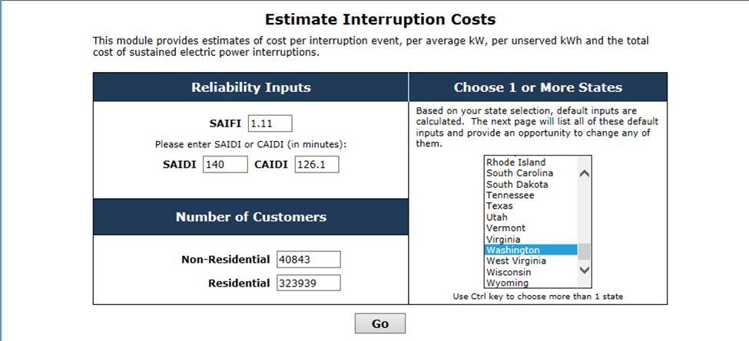

* 1. The screenshot below shows the input number of customers and average annual use for the three customer categories listed in the interruption cost estimator. The input values for the average annual use are the weighted average of the actual energy used by every Avista electric customer for the year. The file containing this information is not included in this response because it contains individual customer account numbers, and because it requires a computer with a 64 bit version of Excel to open the file. Avista will, however, provide this file upon request.

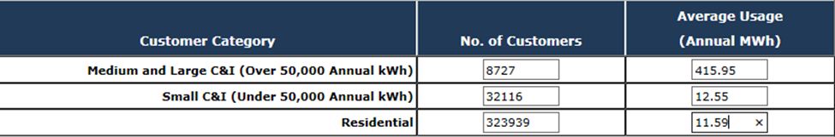

* 1. The screenshot below shows the values input by Avista for its commercial and industrial customers, listed by “Construction,” “Manufacturing,” and “All Other Industries”

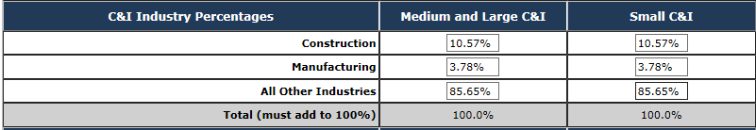

The information used by the Company to derive these percentages was accessed from the U.S. Census Bureau’s American FactFinder website,[4] and is provided in the file attached as PC/EP_DR_078 Attachment E. The information contained under the tab labeled “CB1300A13” includes the counties where Avista provides electric service, the customer count for each qualifying category for each county, and descriptive and interpretive information provided by the Census Bureau. The data is for the year 2013, which was the most recent information available to Avista preceding our filing. The tab labeled “2013 Business Patterns” contains the same customer count information provided under the first tab, but with additional detail on the qualifying employment numbers for each type of business. The tab labeled “C&I Industry Percentages” provides the summary tables for the commercial and industrial customer percentages input to the interruption cost estimator.

* 1. The percentages of Avista’s customers having emergency backup generation and/or power conditioning are shown as inputs in the screenshot below. The data used to determine these percentages is from Avista’s customer data, which is provided as PC/EP_DR_078C Confidential Attachment A. Each tab is labeled using a three letter code that designates one of the Company’s geographic operating divisions (e.g. “KEC”). The data in each tab lists the individual customers having these capabilities.

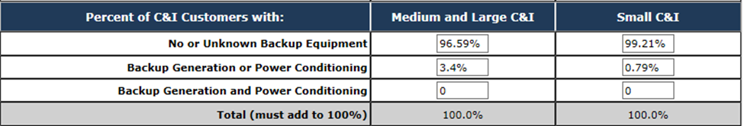

* 1. The residential customer characteristics, represented by the median household income, is shown as an input in the screenshot below. This information is provided for each county served by Avista on the U.S. Census Bureau’s QuickFacts website.[5] To calculate the average value for the interruption cost estimator, Avista averaged the values for each county (counties are listed in PC/EP_DR_078 Attachment E) as accessed from the website.

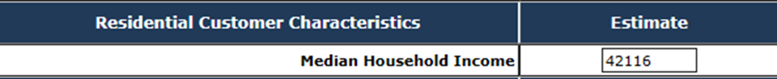

* 1. Avista analyzed its outage event data, as explained in part (b), above, and as provided in the table in that section, which was used to provide the inputs to the calculator as shown in the screenshot below.

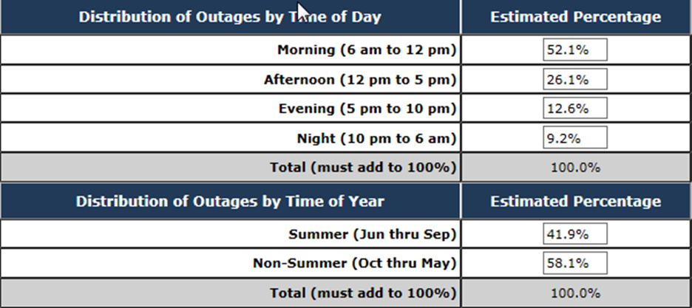

* 1. With the relevant information input as described above, in this section of the response, Avista completed the calculation of customer outage costs, the results of which are shown in the screenshot below.

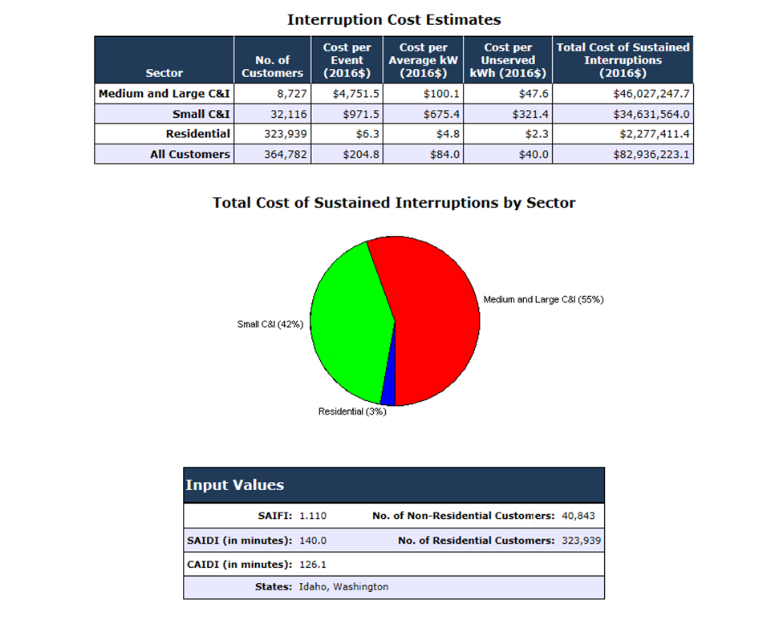

* 1. The next step taken by Avista in the process of calculating the customer value associated with a 5% reduction in outage duration, was to apply the values produced by the interruption cost calculator for the “average cost per unserved kWh” for each customer class to the Company’s actual outage data for each of its electric customers. In the file provided as PC/EP_DR_078 Attachment F, the tab labeled “Average Customer Cost per Hour,” shows the outage cost for each of Avista’s electric customers for one hour of outage time. The values used in the calculation of these per-customer hourly costs, include:
     1. Average hourly use in kWh per hour for each Avista customer
     2. Average cost per unserved kWh for each customer by customer class
     3. Actual outage duration that was experienced by each customer

The average of the hourly per-customer outage costs is derived by summing all of the individual customer costs in column A and dividing by the number of customers (364,783). The average per customer cost for one hour of outage time is shown in column B, line 2, at $91.24.

* 1. In the next step, Avista’s average customer cost for one hour is applied to the average annual frequency of outages, categorized by the cause or type identified for Washington in our Outage Management system, and which occurred for the years 2010-2014. The results are categorized in column A under the tab labeled “Per Event Calculations.” As an example, for the outage cause “Arrester,” in column A, line 5:
     + Column B “Average of ri” is the average duration of the outages of this cause expressed in “days,” for outages occurring in Washington only.
     + Column C “Average of Ni” is the average number of customers affected by the average outage of this type (cause), for Washington only
     + Column E “Average Duration” is the Average Outage Duration for that Outage Type converted from “days” in column B to “hours,” for Washington only.
     + Column G “Average Customer Impact” is the cost to all of Avista’s customers on average for each outage event of that cause or type (Average customer cost per hour ($91.24) x average duration (hours) x average number of customers impacted). All data for Washington outages only.
     + Column H “Average Annual Customer Impact” is the total cost to all Washington customers for all (Washington only) outages of this cause or type for the year. This value is for Avista’s “Current Case” (i.e. today’s costs before the benefit enabled by advanced metering).
     + Column I “Average Annual Customer Impact” is the total cost to all Washington customers for all (Washington only) outages of this cause or type for the year, based on a 5% reduction in duration of these outages (with AMI case).
     + Column J “Savings per Year” is the reduction in customer costs for that outage type, which is the difference between the current (without AMI) case, shown in column H, and the “with AMI case” as shown in column I.
     + Column K, line 4 shows the annual customer savings, which is the sum of the savings for each outage type for the year.
  2. The annual savings in column K, line 4, above, or $2,622,923, is the benefit value shown on line 8 in column B under the tab labeled “OutageMgmt_Customer AvoidedCosts,” in Appendix B of Exhibit No. HLR-3.
  3. The customer benefit of $32,817,495, as shown line 12 of column B under the tab labeled “OutageMgmt_CustomerAvoidedCosts,” in Appendix B of Exhibit No. HLR-3, is the total lifecycle cost for this benefit, derived as explained in the Exhibit and as shown by the results in line 12, columns C-W.

1. The subject presentation, which is confidential and proprietary, is provided as PC/EP_DR_078C Confidential Attachment B.

1. Though the file also contains outage data for year 2009, only the outage data for the five year period 2010-2014 were used to derive inputs for the interruption cost calculation.
2. Pacific Gas & Electric Company’s 2012 Value of Service Study. Freeman, Sullivan and Company. May 2012. http://www.caiso.com/Documents/AttachmentB_ISOResponsesCommentsDraft2012-2013TransmissionPlan.pdf
3. Number of studies included in the 2009 report, which has since been updated to 34 studies.
4. http://factfinder.census.gov/faces/nav/jsf/pages/index.xhtml
5. <http://quickfacts.census.gov/qfd/index.html>