**Q. Please state your name, business address, and present position with PacifiCorp d/b/a Pacific Power & Light Company (PacifiCorp or Company).**

A. My name is Kelcey A. Brown. My business address is 825 NE Multnomah Street, Suite 600, Portland, Oregon 97232. My present position is Manager, Load Forecasting.

**Qualifications**

**Q. Briefly describe your education and professional experience.**

A. I have been employed by PacifiCorp since May 2011. I have been the Manager, Load Forecasting, since June 2012. Before that time, I worked as a Senior Consultant in the Regulatory Net Power Costs Department. Before joining PacifiCorp, I worked at the Public Utility Commission of Oregon from 2007 through May 2011, where I sponsored testimony in several dockets involving net power costs, integrated resource planning, and various revenue and policy issues. From 2003 through 2007, I was the Economic Analyst with Blackfoot Telecommunications Group, where I was responsible for revenue forecasts, resource acquisition analysis, pricing, and regulatory support. I have a Bachelor of Science degree in Business Economics from the University of Wyoming, and I have completed all course work towards a Master of Science degree in Economics from the University of Wyoming.

## Purpose of Testimony

**Q. What is the purpose of your testimony?**

A. The purpose of my testimony is to provide information on PacifiCorp’s historical sales (at the customer meter) for the 12 months ended June 2012 and forecast load (at system input) for the 12 months ending December 2014. In addition, I will discuss the Company’s inclusion of temperature normalization of the commercial class for the July 2011 through June 2012 test period.

**Summary of Changes in Sales and Load**

**Q. Please summarize the changes in Washington sales in the current filing as compared to the Washington sales included in the Company’s 2011 general rate case, docket UE-111190 (2011 Rate Case).**

A. As shown in Table 1 below, the Company’s Washington sales in the test period were 25,118 megawatt-hours (MWh), or 0.6 percent lower than the sales included in the 2011 Rate Case on a weather normalized basis.[1] The decrease in sales is largely driven by lower sales to the residential class and is offset in part by increases in sales to the commercial and industrial classes.

**Table 1**



**Q. How are the temperature normalized sales and load for the test period used in the preparation of this case?**

A. The temperature normalized retail sales for the test period are used by Ms. Joelle R. Steward to develop present revenues and proposed rates, and Mr. Steven R. McDougal uses the test period temperature normalized loads to calculate West Control Area inter-jurisdictional allocation factors.

**Q. Please summarize the changes in forecasted load compared to the 2011 Rate Case.**

A. As shown in Table 2 below, the temperature normalized forecasted load for the 12 months ending December 2014 are lower than forecasted loads for both the state of Washington and the west control area from the 2011 Rate Case, which were based on the 12 months ending May 2013.

**Table 2**



The decrease in the load forecast in this case is driven by prolonged recessionary impacts in all states and growth in energy efficiency and conservation programs.

**Q. How are the forecasted loads for the west control area used in preparing this case?**

A. The forecasted loads for the west control area are used by Mr. Gregory N. Duvall to calculate net power costs.

**Temperature Normalization of Historical Sales**

**Q. Please explain temperature normalization and how it is used in ratemaking.**

A. Temperature normalization is the process of removing variances in sales due to temperature variances and restating the sales that would have occurred under “normal” temperatures. The Company uses a 20-year rolling average to establish normal temperatures. Using normal temperatures to determine sales and loads avoids setting rates on sales and loads that occur under extreme weather conditions.

**Q. What is the Company’s framework for temperature normalization of historical sales in Washington?**

A. In the 2005 Rate Case, the Commission approved a stipulation that set forth an interim approach to temperature normalization (used in the 2006 Rate Case), and an agreement to develop a long-term approach. This long-term approach was established in “The Company’s Plan for a Long-Term Temperature Normalization Solution in Washington,” dated January 22, 2007 (the Plan).

**Q. Has the Company changed or refined its temperature normalization methodology since the Plan was agreed to in 2007?**

A. Yes. Since the Plan was adopted by the Commission, the Company modified the methodology to use daily temperature records over a 20-year period rather than a 30-year period, and modified its calculation of peak load to include temperature data two days ahead, for a total of three days of data, rather than only using the temperature data on the day of the peak load. These changes were agreed to by Commission Staff and adopted by the Commission in the Company’s 2009 general rate case, docket UE-090205. In the Company’s 2010 general rate case, docket UE-100749 (2010 Rate Case), and the 2011 Rate Case, the Company updated temperature data as it became available and has done the same in this case.

**Q. Has the Company made any adjustments to its temperature normalization methodology in this case?**

A. No.

**Q. Which class of customers includes a temperature normalizing adjustment in the current filing?**

A. The residential, commercial, and irrigation customers include a temperature normalization adjustment in this filing.

**Q. What is the magnitude of the temperature normalizing adjustment for the commercial class in the test period?**

A. The temperature normalizing adjustment for the commercial class in the test period is a reduction in sales of 4,579 MWh or 0.1 percent of total Washington sales.

**Q. Why is it important for the Company to include temperature normalization of the commercial class in this case?**

A. It is important because the Company seeks to avoid fluctuations in commercial rates due to temperature variations. The Company’s goal is consistent with the Commission’s statement regarding residential temperature normalization in the order in the 2010 Rate Case: “Simply put, the Joint Parties’ proposed adjustment creates exactly the situation we seek to avoid: significant fluctuations in rates due to temperature differences.”[2]

**Q. Is the commercial class electricity usage sensitive to temperature?**

A. Yes. The commercial class is sensitive to temperature, and it is appropriate to include a temperature normalizing adjustment in the current rate case and in future rate cases. While the current test period requires a small temperature normalizing adjustment to reflect normal weather, a future rate case period that includes more extreme weather can introduce volatility in rates that is not in the best interest of customers.

**Q. Please summarize the Commission’s findings regarding temperature normalization for the commercial class in the 2010 Rate Case.**

A. In the 2010 Rate Case, the Commission found “that the Company did not demonstrate a ‘proximate relationship between temperature and electricity consumption’”[3] for the commercial class in Washington. The Commission suggested, however, that other analyses of the commercial data could be performed to examine causes of the variability in results and the Company could pursue that as an option in a future rate case.[4]

**Q. What was the basis of Staff’s and the Commission’s determination that the commercial class did not show a “proximate relationship”[5] between temperature and electricity?**

A. Staff asserted that the commercial class model statistics, specifically the   
R-squared, was too low at 0.64 and therefore the model did not explain 36 percent of the variation between temperature and load.[6]

**Q. Have the statistics of the commercial class model changed in this case?**

A. Yes. While the Company continues to believe that use of the R-squared value is a limited analysis, the model statistics of the commercial class have improved by 0.19 points from an R-squared value in the 2010 Rate Case of 0.64 to an   
R-squared value of 0.83 in this case.

**Q. Did Staff consider an R-squared statistic of greater than 0.80 to be a good measure of the model’s ability to explain the relationship of temperature and load?**

A. Yes. In testimony, Staff stated that the “R-squared value for the commercial class from the study conducted by Avista was over 0.8.”[7] However, as stated previously, the statistical analytics of a model, such as an R-squared analysis, can provide important information, but it is not appropriate to use it as the single measure of the model. Proper model selection should be based on several criteria, and focusing on R-squaredalone can give an incomplete picture.

**Q. Has the Company performed additional analyses of the commercial class that explains the variability in the relationship of temperature and load as suggested by Staff and the Commission in the 2010 Rate Case?**

A. Yes. As stated by the Company in the 2010 Rate Case, the commercial class is made up of a heterogeneous mix of customers. The types of customers in the commercial class include refrigerated warehousing, food manufacturing or processing, department stores, grocery stores, schools, a state prison, and restaurants. The majority of these customers exhibit a strong relationship to temperature; however, refrigerated warehousing does not and makes up approximately 15 percent of the class.[8]

**Q. Did the Company analyze the temperature sensitivity of the commercial class excluding the refrigerated warehousing load?**

A. Yes. The Company analyzed historical commercial load and historical temperatures. Graphs 1 and 2 below show the commercial class electricity usage and its relationship to hot and cold temperatures on a monthly basis using Heating Degree Day (HDD) 50 and Cooling Degree Day (CDD) 60 (the temperature variables that are used in the commercial model) to show historical temperatures.

**Graph 1**

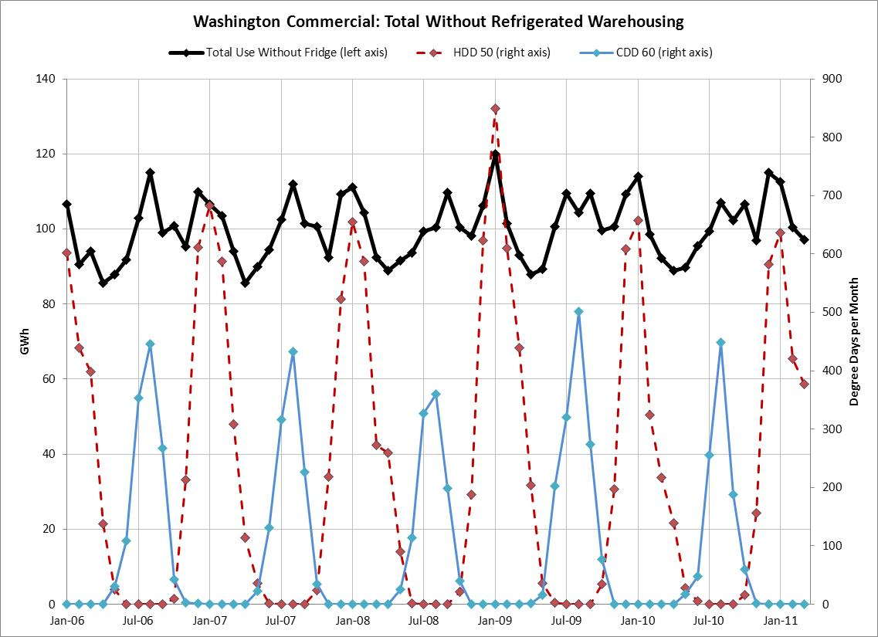

**Graph 2**

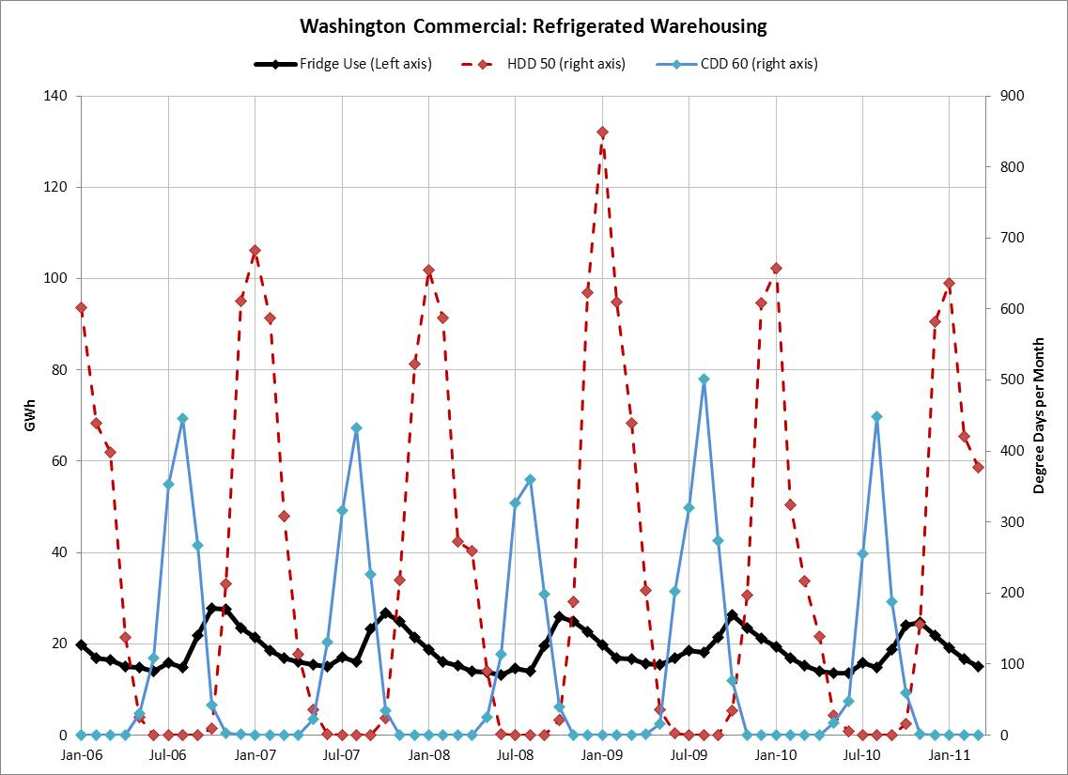

**Q. Please explain what Graphs 1 and 2 are illustrating.**

A. The dark solid line in Graph 1 (read from the left axis) shows electricity usage of the commercial class without refrigerated warehousing load from January 2006 through June 2012 by month. The dashed line, which reaches its peak of approximately 850 in January 2009 (read from the right axis), is the degree days per month for HDD 50, and the grey solid line, which reaches a peak of approximately 500 in August 2009 (read from the right axis), is the degree days per month for CDD 60. As temperatures in the winter and summer are at their peaks, such as in January 2009 and August 2009, the commercial electricity usage increases in a corresponding manner.

The dark solid line in Graph 2 is the electricity usage of refrigerated warehousing from January 2006 through June 2012 by month (read from the left axis) and the HDD 50 and CDD 60 are the same as in Graph 1.

**Q. What are HDD 50 and CDD 60, and how are they used to temperature normalize the commercial class?**

A. HDD 50 reflects the number of degrees that a day’s average temperature is below 50 degrees Fahrenheit and is highest in December, January, and February. For example, if the average temperature in a day is 30 degrees, the HDD 50 value for that day is 20. The Company then sums each day’s HDD 50 value for a monthly HDD 50 that is used in the model to reflect the daily average temperature for the month. CDD 60 is calculated similarly, but reflects daily average temperatures that are greater than 60 degrees Fahrenheit. Both the HDD 50 and CDD 60 variables are used to capture the weather sensitive component of load and are used to adjust historical electricity usage to reflect normal weather.

**Q. What does Graph 1 show regarding temperature sensitivity of the commercial class?**

A. Graph 1 shows that the majority of the commercial class is weather sensitive. When it is cold (high HDDs) and when it is hot (high CDDs), loads are at their highest. When it is mild (low HDDs and CDDs), loads are at their lowest.

**Q. What does Graph 2 show regarding temperature sensitivity of refrigerated warehousing usage?**

A. Graph 2 shows that refrigerated warehousing electricity usage is not temperature sensitive to colder temperatures and has its highest usage in the fall as various crops are harvested and put into cold storage. However, the commercial class model includes variables other than weather, such as employment, and inclusion of the refrigerated warehousing load is important to the model’s ability to forecast and adequately capture the characteristics of the commercial class that are sensitive to variables other than temperature.

**Q. Does the Company’s current commercial temperature normalization model capture the weather sensitive portion of the commercial load, regardless of the refrigerated warehousing load that is not weather sensitive?**

A. Yes. The model differentiates the relationship of electricity usage to temperature for the appropriate portion of the commercial load. It does not diminish the model’s ability to capture the weather sensitive load of the remaining commercial class by including the refrigerated warehousing load. Including temperature variables in the commercial model provides an accurate temperature normalizing adjustment to historical sales while also providing an accurate forecast model for the total commercial class.

**Q. Do the residential and irrigation class of customers reflect a consistent relationship between temperature and load?**

A. Yes. Residential and irrigation electricity use is strongly correlated to daily average temperatures.

**Q. Did the Company include a temperature normalization adjustment for the irrigation customer class in the 2011 Rate Case?**

A. No. The Company investigated including a temperature normalization adjustment in the 2011 Rate Case, but because it was a “make-whole” case, the Company did not include it.

**Updates to the 2014 Load Forecast**

**Q. Please list the assumptions and updates to the current load forecast.**

A. The Company updated the following information in the current load forecast:

* Actual sales January 1997 through March 2012.
* Load research data through December 2011 updated in the temperature normalization model.
* Actual weather was rolled forward one year to the 1992—2011 time period (measured at Yakima).
* February 2012 release from IHS Global Insight of economic data, such as households, population, and employment figures.

**Q. Does this conclude your direct testimony?**

A. Yes.

1. In this case, the Company calculated temperature normalization for the residential, commercial, and irrigation customers consistently with the methodology approved by the Washington Utilities and Transportation Commission (Commission) in the Company’s 2005 general rate case, docket   
   UE-050684 (2005 Rate Case), and 2006 general rate case, docket UE-090205 (2006 Rate Case).
2. Docket UE-100749, Commission Order 06, ¶ 219.
3. *Id*., ¶ 225.
4. *Id.*
5. *Id.*
6. *Id.*, ¶ 223.
7. Docket UE-100749, Redacted Exhibit No.__CT(VN-1CT) at 9, lines 5-6.
8. The Company classifies its customers within the commercial class by a Standard Industrial Code (SIC). There are approximately 700 SIC codes in the commercial class. Refrigerated warehousing constitutes approximately 15 percent of the commercial class’s annual sales.