October 23, 2012

David W. Danner, Executive Director and Secretary

Washington Utilities and Transportation Commission

1300 S. Evergreen Park Dr. SW

P. O. Box 47250

Olympia, Washington 98504-7250

RE: *Washington Utilities and Transportation Commission v. Quality Telephone, Inc.*

Commission Staff’s Response to Application for Mitigation of Penalties

Docket UT-121003

Dear Mr. Danner:

On August 1, 2012, the Washington Utilities and Transportation Commission issued a $1,050 Mitigated Penalty Assessment in Docket UT-121003 against Quality Telephone, Inc., for 14 violations of Washington Administrative Code (WAC) 480-120-382, which requires permitted telecommunication companies to furnish annual reports to the commission no later than May 1 each year.

On August 10, 2012[1], Quality Telephone, Inc., wrote the commission requesting mitigation of penalties (Mitigation Request). In its Mitigation Request, Quality Telephone, Inc., does not dispute that the violation occurred. The company states, “Quality Telephone, Inc. received a notice on August 6th, 2012 from the Washington Utilities and Transportation Commission assessing a penalty in the amount of $1,050 for untimely filings of annual reports dated August 1st, 2102. We were given 15 days to respond to the notice. We would like to request that the penalty be mitigated. Currently Quality Telephone, Inc. has no customers in the State of Washington and is planning on having our license surrendered prior to the end of this year. Our last customer line was disconnected in October of 2011. Over the past four years Quality Telephone, Inc. has had no obligation to pay after completing the Regulatory Fee Calculation Schedule due to a very small customer base in the Washington market. This being said a $1,050 fine on a zero dollar obligation seems a bit unjust.”

In accordance with chapter 80.24.010 RCW "Regulatory Fees," the commission requires Telecommunication companies to file reports of gross intrastate operating revenue and pay fees on that revenue. Every company subject to regulation shall file with the commission a statement under oath showing its gross intrastate operating revenue for the preceding year and pay to the commission a fee as instructed. If the telecommunications company’s intrastate revenue is below $20,000, the company will not be required to pay a regulatory fee.

Quality Telephone, Inc.’s Intrastate Revenue:

|  |  |
| --- | --- |
| Report Year | Intrastate Revenue |
| 2011 | $3,627.26 |
| 2010 | $9,632 |
| 2009 | $12,941 |
| 2008 | $1,973 |

Based on this Intrastate Revenue information for Quality Telephone, Inc., the company is correct that it was not required to pay regulatory fees in the past four years. Quality Telephone, Inc., is however, required to file an annual report.

It is the company’s responsibility to ensure that the regulatory fee and the annual report are filed by the May 1 deadline. On February 29, 2012[2], Annual Report forms and Regulatory Fee packets were mailed to all regulated telecommunications companies. In addition to other information, the cover letter informed the regulated company it must complete the annual report form, pay any regulatory fees and return the material by May 1, 2012, to avoid enforcement action. On May 14, 2012[3], the commission mailed a letter to those companies that had not yet filed an annual report notifying them that, to date, they had incurred a penalty of $800. The letter went on to explain that companies who filed their annual reports no later than May 25, 2012, would receive mitigated penalties of $25 per day, with an additional $25 per day for each instance in the previous five years that the company received a penalty for filing a late report.

Quality Telephone, Inc., filed its annual report on May 21, 2012, which is 14 business days past the deadline of May 1, 2012. The penalty was mitigated from $100 per day to $25 per day for a total of $350. Quality Telephone, Inc., has been regulated since January 2003 and received a penalty for filing a delinquent annual report in 2006, 2008 and 2009. The 2008 and 2009 penalties increased the current penalty by an additional $50 per day, for an additional amount of $700.

Based on the company’s delinquent annual report filing in the past, staff does not support mitigating the assessed penalty further and recommends the request be denied.

If you have questions regarding this recommendation, please contact Mathew Perkinson, Compliance Investigator, at (360) 664-1105 or at mperkinson@utc.wa.gov.

Sincerely,

Sharon Wallace, Assistant Director

Consumer Protection and Communications

**Attachment A**

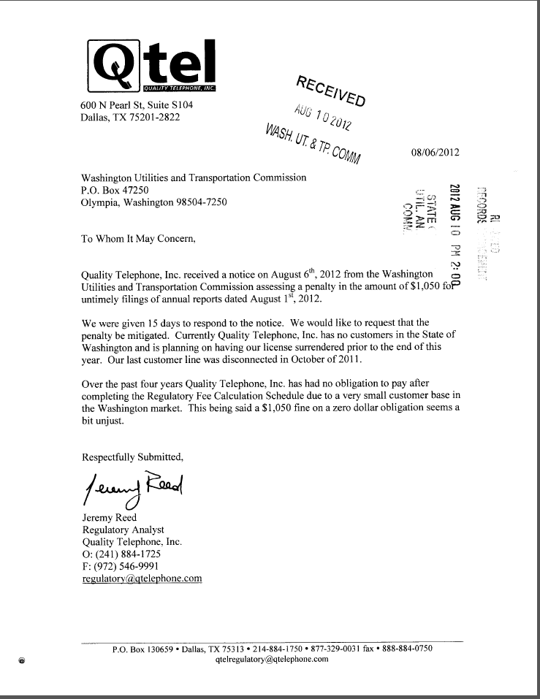

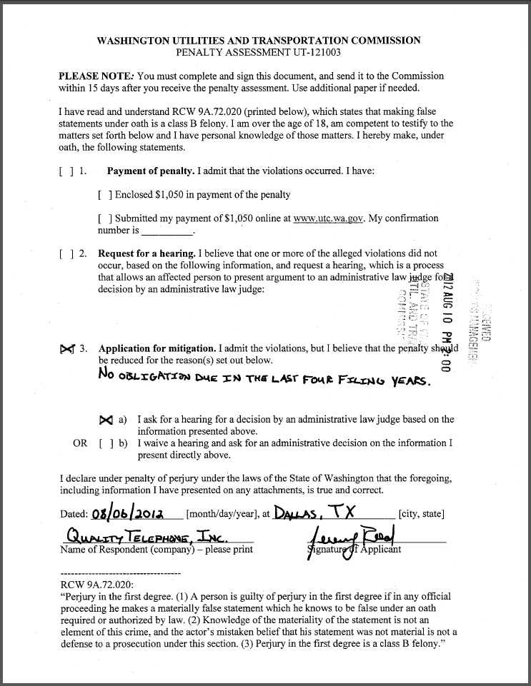

**Attachment B**

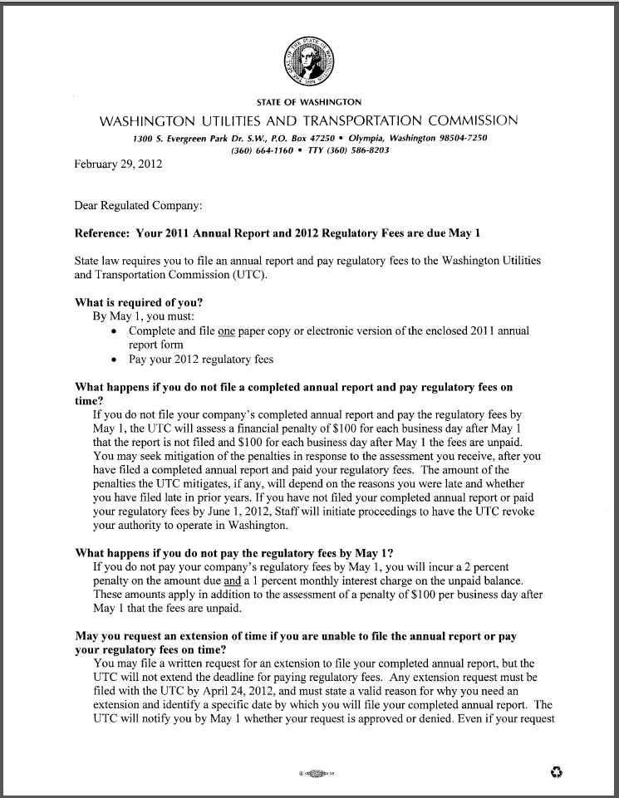

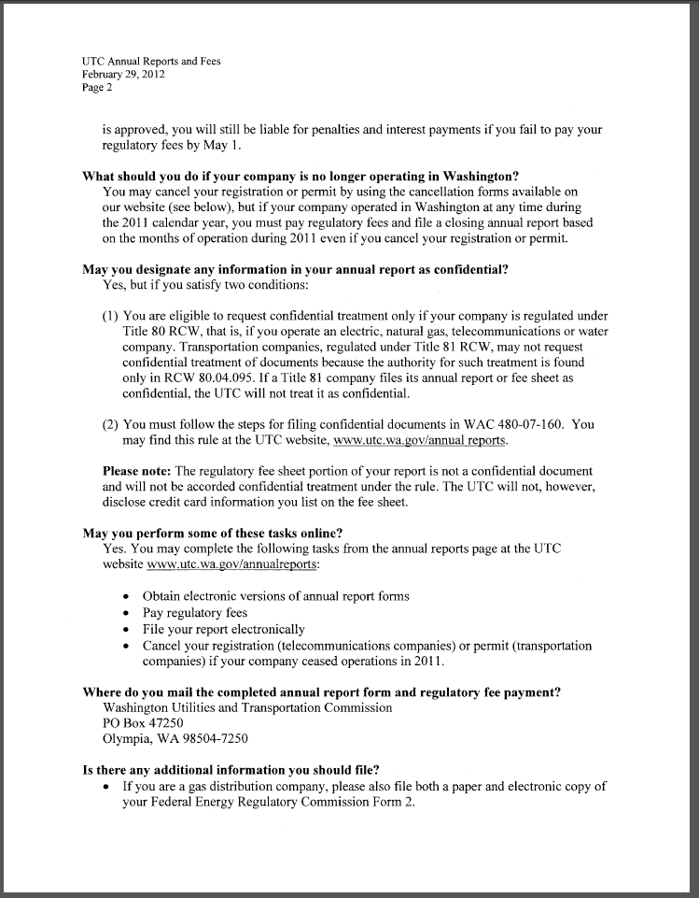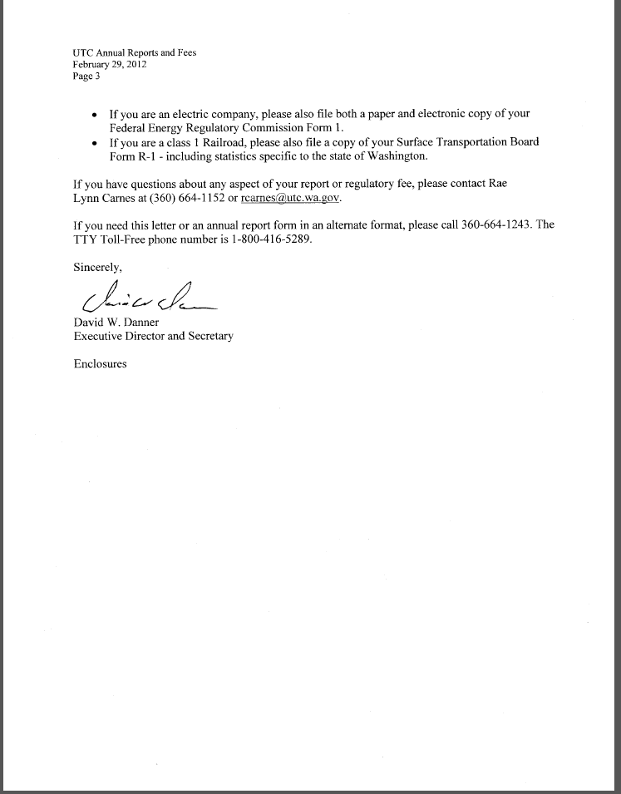

**Attachment C**

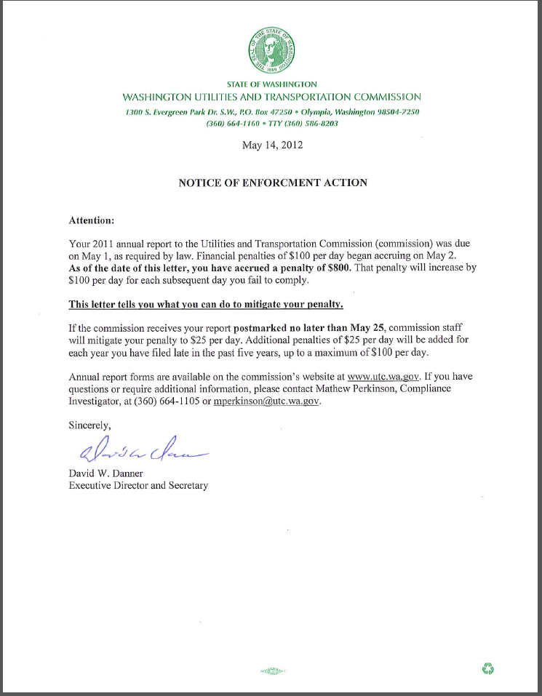

1. See attachment A for a copy of Quality Telephone, Inc.’s Mitigation Request.
2. See attachment B for a copy of the letter sent to all regulated companies on February 29, 2012.
3. See attachment C for a copy of the enforcement letter sent to the company on May 14, 2012.