|  |  |
| --- | --- |
|  | Puget Sound Energy 2014-15 Biennial Electric Conservation Achievement Review (BECAR)  Final Report |
|  |  |
| Submitted to | Puget Sound Energy  Washington Utilities and Transportation Commission |
| Submitted by | SBW Consulting, Inc.  2820 Northup Way, Suite 230  Bellevue, WA 98004 |
| In association with | Evergreen Economics, Inc.  **Portland, OR** |
|  | May 18, 2016 |





Table of Contents

Executive Summary ES-1

Introduction ES-1

Objectives ES-1

Methodology ES-1

Findings ES-2

Conclusions and Recommendations ES-5

1. Introduction 1

1.1. Background 1

1.2. Objectives 1

1.3. 2014-2015 Electric Portfolio 2

1.4. Data Sources 5

2. Methodology, Findings, and Recommendations 7

2.1. Overview 7

2.2. Portfolio Savings Audit 7

2.2.1. Methodology 7

2.2.2. Findings 9

2.2.2.1. Residential Energy Management 10

2.2.2.2. Business Energy Management 13

2.2.3. Recommendations 20

2.3. PSE, RTF UES Reviews 20

2.3.1. Methodology 20

2.3.1.1. REM UES Reviews 21

2.3.1.2. BEM UES Reviews 23

2.3.2. Findings 24

2.3.3. Recommendations 24

2.4. 2012-2013 BECAR Recommendation Response Review 26

2.4.1. Methodology 26

2.4.2. Findings 27

2.4.2.1. Future Improvements in BECAR Process 27

2.4.2.2. PSE Deemed Savings 28

2.4.2.3. Impact Evaluations 28

2.4.2.4. Cost-Effectiveness Calculations 36

2.4.3. Recommendations 37

2.5. Evaluation Response Report Review 37

2.5.1. Methodology 37

2.5.2. Findings 38

2.5.3. Recommendations 40

3. Conclusions and Recommendations 41

APPENDIX 43

A. Glossary 44

B. Review of E-251 C/I New Construction LED Grow Lighting Projects 46

C. PSE Deemed Review Memo 53

D. Lighting Calculator review 81

E. ERR Reviews 83

Executive Summary

## Introduction

The Washington Utilities and Transportation Commission (the “Commission” or “UTC”) established the requirement for an independent third-party review of Puget Sound Energy’s (PSE’s) 2014-2015 reported electric savings in Order 01, Appendix A of Docket UE-132043, condition (6)(g). Additionally, WAC 480-109-110(1)(d) requires PSE to involve its Conservation Resource Advisory Group (CRAG) on its independent third-party evaluation of portfolio-level biennial achievement. The intent of the review is to confirm electric savings reported in compliance with RCW 19.285.040(1). PSE retained a Biennial Electric Conservation Achievement Review (BECAR) consultant team, consisting of SBW Consulting, in conjunction with Evergreen Economics, to carry out the 2014-2015 BECAR under the direction of PSE and WUTC staff, with further input and oversight provided by the CRAG.

This 2015 final report encompasses the overall 2014-2015 BECAR effort. It documents the BECAR team methodology, findings, conclusions, and recommendations based on an examination of reported achievements for the 2014 and 2015 program years.

## Objectives

The objectives of the 2014-2015 BECAR are threefold:

1. Assess the extent to which PSE’s reported electric energy savings were achieved**.** It is limited to those existing electric conservation programs that PSE operated in 2014 and 2015 and which are the basis for the electric energy savings that PSE reports for that two-year period.
2. Offer recommendations concerning PSE’s adaptive management performance in regards to implementing Evaluation Report Responses (ERRs) and go-forward adjustments from the previous BECAR.
3. Offer recommendations for how to continually improve the BECAR process and reporting for future biennia.

## Methodology

The 2014-2015 BECAR builds on the experience and results of previous biennial reviews. Hence this BECAR features a narrower, more targeted approach than past BECARs. Key tasks include the following:

* **Portfolio Savings Audit:** Determine whether reported savings match tracking system data and further investigate irregularities or discrepancies to determine causes and, if necessary, recommend adjustments to reported savings.
* **PSE and RTF UES Reviews:** Review deemed Unit Energy Savings (UES) values used by PSE, for consistency with the requirements of the *Proposed Conditions for 2014-2015 PSE Electric Conservation* in Docket UE-132043 and the policy on selection and application of RTF values in PSE’s *2014-15 BCP Overview* *101513*.
* **Recommendation Response Review:** Review PSE actions taken in response to recommendations from 2012-2013 BECAR. Determine reasonableness of action/response relative to the magnitude of the issue and standard industry practice, paying particular attention to findings and recommendations regarding PSE program/measure verification practices.
* **Evaluation Response Report Review:** Assess whether PSE has undertaken follow-up actions on program evaluation studies completed after the 2012-13 BECAR, based on the Evaluation Response Reports included with each completed program evaluation
* **Detailed Review (if needed):** Review in more detail the energy savings of some programs or measures selected in consultation with PSE, Commission Staff, and the CRAG. This review may include sampling of project files, surveys, on-site inspections, modeling or engineering analysis.

The review was implemented in two phases. This 2014 interim report was the first phase. The second phase culminated in this final two-year report, which aggregates and synthesizes from all review activities over the entire 2014-2015 biennium, including those documented in the 2014 report. Not all the deliverables were completed in distinct 2014 and 2015 phases, but instead were developed across the two-year span. The work is highly dependent on the savings results presented in PSE’s Annual Reports of Energy Conservation Accomplishments, filed on February 27, 2015, and February 26, 2016, for program years 2014 and 2015 respectively.

The review is limited to the claimed electric savings which are included in the Total Biennial Energy Independence Act (EIA) Target as defined in PSE’s 2014-2015 Biennial Conservation Plan. The “Total Biennial EIA Target” is the sum of the “Total Biennial Potential” plus the “legacy HER” minus the “NEEA” savings.[1] BECAR does not cover the Individual Energy Reports (Residential and Business Pilot programs, E240 and E249, respectively); nor does this review cover Northwest Energy Efficiency Alliance efforts (E254).

## Findings

The review team’s findings, after carrying out the methodologies described above for each of the five areas of investigation, are briefly summarized below.

Portfolio Savings Audit

The BECAR review team has verified that the electric savings shown in the 2014 Annual Report of Energy Conservation Accomplishments (ACR) and 2015 ACR accurately reflect the savings listed in the PSE tracking databases.

The BECAR review team found only one small issue involving the selection of the correct UES values for residential insulation and windows, which resulted in PSE updating their 2015 claimed savings by +89,989 kWh for E214 – SF Existing Weatherization. Along with the weatherization claim update, PSE informed of us a change that came about at a March 16, 2016, meeting with the CRAG, which resulted in a -29,900 kWh correction to the 2015 savings claim under E258-Resource Conservation Manager. Both of these updates are included in the claimed savings listed throughout this report.

Residential Sector

* **E214-SF Residential Lighting** accounts for 153,542 MWh (53%) of the total 2014-2015 REM portfolio. Although still well above (8,319 MWh) the savings goal in 2015, this program saw a 5% (3,689 MWh) decrease in savings compared to 2014.
* The trend toward LEDs continued as there was a large increase in **A-Lamp LED and** **Reflector LED** savings in 2015 compared to 2014, and a comparable decrease in savings for Standard CFLs. Increased quantities of installed LEDs, combined with reduced quantities of CFLs, are the main driver; however UES values also played a role as UES values for A-Lamp and Reflector LEDs saw a slight increase in 2015 while the UES values for CFLs decreased.
* **E214-Home Appliances**, **E214-Residential Showerheads**, and **E216-Fuel Conversion** each had claimed savings less than their goal in both 2014 and 2015. Combined, these programs fell 8,509 MWh (3% of total 2014-2014 REM portfolio) short of their goals.
* **E217-MF Existing** accounts for 50,202 MWh (17%) of the total 2014-2015 REM portfolio. Savings for this program exceeded the goal in 2014 and fell just short of the goal (1% under) in 2015.

Business Sector

* **Business Enhanced Lighting** and **Business Standard Lighting** (part of **E250-Commercial / Industrial Retrofit**) realized a combined savings increase of 18,817 MWh in 2015 compared to 2014, primarily due to the increased number of projects (nearly double) for three measures.
* **C&I Retro** (part of **E250-Commercial / Industrial Retrofit**) saw an 18,855 MWh decline in savings 2015 compared to 2014; primarily due to lighting measures (-12,871 MWh), many of which were moved to Business Lighting in mid-2014, and HVAC controls (-5,425 MWh).
* **E-251-C/I New Construction** saw a savings increase of 9,974 MWh (4% of the total 2014-2015 BEM portfolio) in 2015 compared to 2014. This increase is primarily due to 13 cannabis grow farms installing LED lighting.
* **E262-Commercial Rebates** savings in 2014 surpassed the goal by 10,988 MWh, whereas savings in 2015 fell short of the goal by 6,693 MWh.Overall, E262-Commercial Rebates saw a savings decrease of 22,591 MWh (9% of the total 2014-2015 BEM portfolio) in 2015 compared to 2014. The majority of this savings decrease (15,406 MWh) occurred in the Lighting To Go program.
* Overall, **prescriptive LED lighting** (from seven different BEM programs) accounts for 16% of the total 2014-2015 BEM savings. In 2014 prescriptive LED lighting measures accounted for 30,218 MWh of savings (20% of the 2014 BEM total savings). In 2015 the savings for prescriptive LED lighting measures dropped to 11,071 MWh. The reduction is savings went hand-in-hand with reduced measure quantities: 211,794 total lamps, fixtures or signs in 2014, compared to 107,204 total lamps, fixtures or signs in 2015.

RTF and PSE Deemed UES Reviews

With the exception of several (29 total) residential insulation and windows UES values, for which PSE subsequently corrected their 2015 saving claim, PSE selected the correct RTF deemed value and entered it properly into the tracking database. In addition, we found that PSE followed its published protocol for the timing of deemed savings revisions.

PSE also selected the correct PSE deemed value for each measure, and entered it properly into the tracking database. The review team did, however, alert PSE to several UES values (e.g. Residential and Business LEDs) for which baseline conditions are out of date, leading us to recommend future adjustments to the UES values.

Recommendation Response Review

PSE addressed and/or took action in response to all recommendations (listed below) in the 2012-2013 BECAR. For all of these recommendations the review team found PSE’s responses to be appropriate.

* Future BECARs: Clarify scope and objectives for subsequent BECAR studies
* PSE Deemed Savings: Account for non-residential lighting mark-down installations.
* PSE Deemed Savings: Revise UES values highlighted in BECAR.
* Impact Evaluations: Reach agreement on study methodologies
* Impact Evaluations: Require consistent, high-quality evaluation reports.
* Cost Effectiveness: Improve measure life consistency.
* Cost Effectivesness: Improve load shape assignment.
* Cost Effectiveness: Improve incremental measure cost assignment.

Evaluation Report Response Review

PSE clearly understood evaluation findings and recommendations and they have appropriately integrated them into ongoing program process improvement. For one ERR review, there was some initial miscommunication between PSE staff and the review team, resulting in a recommendation regarding the interview process.

## Conclusions and Recommendations

The BECAR effort has yielded a comprehensive assessment, as required by the Order, of PSE’s electric efficiency portfolio claim for the 2014-15 biennium. Conclusions and recommendations for each of the objective areas—portfolio savings, PSE adaptive management, and future improvements in the BECAR process—are provided below.

Portfolio Savings

The BECAR review team verified that the electric savings shown in the 2014 ACR and 2015 ACR, combined with the small corrections applied to the 2015 saving claim after publication of the 2015 ACR, accurately reflect the savings listed in the PSE tracking databases. Table E-1 summarizes the verified savings for the biennium, by program.

Future Improvements in Savings Estimation

Below are suggestions, based on BECAR findings, for PSE to consider when making future program and portfolio improvements.

* **Revise UES values highlighted in BECAR**.The review team found several instances where PSE should examine and make appropriate adjustments to their bases for savings for the 2017 program year and beyond; most notably all UES values for residential and commercial LEDs should be based on federal minimum efficacy standards for the incandescent portion of the baseline wattage.
* **Revise Lighting Calculator values and assumptions.** The review team recommends that PSE update their lighting calculator to include the federal minimum efficacy standards for the incandescent portion of the baseline wattage. Also, savings should incorporate HVAC interactive factors.
* **Make improvements to assumptions for LED grow light savings.** For cannabis grow farm lighting projects, PSE should consider adopting a uniform method for calculating operating hours, which would ideally be built into the PSE calculator. Also, for farms with mechanical cooling**,** PSE should implement an HVAC interaction factor into their savings calculation.
* **Work with WUTC and CRAG to develop an appropriate review timeline** so that adjusted UES values can be incorporated into future program plans in a timelier manner.

Future Improvements in PSE Adaptive Management and BECARs

* Continue the BECAR recommendations and ERR reviews, which provide ongoing assurance that continuous improvement in critical areas occurs. PSE is doing a good job implementing recommendation and keeping track of responses.
* Provide more details in the text of the ACRs. Future BECAR efforts would benefit from ACRs that included more detailed explanations and insights on accomplishments vis a vis the savings targets. This would aid the BECAR review team in more readily identifying programs and/or measures of interest and therefore allow more time for focused verification.
* Document interview findings. To avoid misunderstandings, following a BECAR interview with PSE staff, the interviewer should provide a transcribed copy of their interview notes to the interviewee for review, correction if necessary, and eventual mutual concurrence.

Table E-1: 2014-2015 Verified Savings

|  | | 2014 | | | 2015 | | | |
| --- | --- | --- | --- | --- | --- | --- | --- | --- |
| Program | | Savings Claim  (kWh) | Goal (kWh) | | Savings Claim  (kWh) | | Goal (kWh) | |
| Residential Energy Management | | | | | | | | |
| E201- Low Income Weatherization | | 1,766,554 | 1,571,000 | | 1,739,101 | | 1,571,000 | |
| E214 - Single Family Existing | | 122,126,107 | 108,552,000 | | 105,746,552 | | 101,369,000 | |
| Residential Lighting | | 78,615,443 | 66,120,000 | | 74,926,842 | | 66,609,000 | |
| Space Heat | | 8,811,172 | 10,132,000 | | 8,008,681 | | 7,842,000 | |
| Water Heat | | 567,908 | 545,000 | | 910,507 | | 635,000 | |
| HomePrint | | 2,675,890 | 3,400,000 | | 3,784,133 | | 3,009,000 | |
| Home Appliances | | 8,985,753 | 10,011,000 | | 7,529,689 | | 11,386,000 | |
| Mobile Home Duct Sealing | | 6,540,835 | 3,592,000 | | 4,479,886 | | 4,666,000 | |
| Residential Showerheads | | 4,301,679 | 5,255,000 | | 2,507,406 | | 4,139,000 | |
| Weatherization + ARRA | | 5,735,907 | 3,607,000 | | 3,599,408 | | 2,610,000 | |
| Home Energy Reports | | 5,891,520 | 5,890,000 | | - | | 473,000 | |
| E216 - Fuel Conversion | | 1,741,000 | 1,893,000 | | 1,173,000 | | 2,063,000 | |
| E217 - Multi Family Existing | | 24,523,673 | 20,446,000 | | 25,678,247 | | 25,862,000 | |
| E218 - Residential New Construction | | 1,102,052 | 926,000 | | 1,517,734 | | 1,057,000 | |
| Total | | 151,259,386 | 133,388,000 | | 135,854,635 | | 131,922,000 | |
| Business Energy Management | | | | | | | | |
| E250 - Commercial / Industrial Retrofit | | 65,986,172 | | 71,560,000 | | 69,245,483 | | 62,259,600 |
| E251 - Commercial / Industrial New Construction | | 4,287,412 | | 2,525,000 | | 14,261,642 | | 9,350,000 |
| E253 - Resource Conservation Management | | 14,081,463 | | 12,150,000 | | 12,793,140 | | 16,350,000 |
| E255 - Small Business Lighting Rebate | | 3,945,077 | | 2,000,000 | |  | |  |
| E258 - Large Power User Self Directed | | 22,664,740 | | 15,350,000 | | 4,635,950 | | 1,700,000 |
| E261 - Energy Efficient Technology Evaluation | |  | | 500,000 | | - | | 500,000 |
| E262 - Commercial Rebates | | 37,864,636 | | 26,877,000 | | 15,273,888 | | 21,966,715 |
| Lighting To Go | | 19,914,345 | | 9,500,000 | | 4,508,420 | | 6,166,728 |
| Commercial Kitchen & Laundry | | 356,920 | | 779,000 | | 317,989 | | 598,313 |
| Commercial Direct Install (NON-SBDI) | | 453,720 | | 762,000 | | 200,717 | | 702,730 |
| Commercial HVAC | | 2,030,995 | | 3,250,000 | | 1,139,747 | | 3,332,530 |
| Business Lighting Express | | 5,529,105 | | 5,950,000 | | 1,914,015 | | 5,116,000 |
| Small Business Direct Install | | 8,759,196 | | 6,636,000 | | 7,193,001 | | 6,050,414 |
| Legacy (Jan - May) | | 820,355 | | - | |  | |  |
| Total | | 148,829,501 | | 130,962,000 | | 116,210,103 | | 112,126,315 |
|  | - Indicates program did not exist during that year | | |  | |  | |  |

# Introduction

## Background

On December 19 2013, the Washington Utilities and Transportation Commission (the “Commission” or “UTC”) established the requirement for an independent third-party review of Puget Sound Energy’s (PSE’s) 2014-2015 reported electric savings, in Order 01, Appendix A of Docket UE-132043, condition (6)(g). Additionally, WAC 480-109-110(1)(d) requires PSE to involve its Conservation Resource Advisory Group (CRAG) on its independent third-party evaluation of portfolio-level biennial achievement. The intent of the review is to confirm electric savings reported in compliance with RCW 19.285.040(1). The Order and WAC rule continue a review cycle established for PSE in 2010.

Condition (6)(g) in the Order is the following requirement to conduct an independent third-party review of the electric energy savings reported by PSE for the 2014-2015 biennium.

*“An independent third-party review of portfolio-level electric energy savings reported by Puget Sound Energy for the 2014-2015 biennial period, from existing conservation programs operated during that period, shall be conducted. The independent third-party reviewer shall be selected through an RFP process, unless unanimously agreed by the CRAG [Conservation Resources Advisory Group]. The review will be funded by the Puget Sound Energy Electric Conservation Service Rider. The review will be managed by UTC and Puget Sound Energy staff with input on the scope, cost, RFP development, reviewer selection and ongoing oversight by the CRAG.*

*A final report for the entire 2014-2015 biennium shall be submitted as part of Puget Sound Energy 's two-year report on conservation program achievement, required by Paragraph (8)(e) below. The report shall be finalized and made available no later than June 2016 and may be implemented in phases and delivered as a final product at an earlier date, as needed by Puget Sound Energy.“*

The previous BECAR reviews were very extensive in scope, including detailed audits of program tracking data and savings calculations, on-site inspections of measure installation, review of program evaluation studies, and checks of cost-effectiveness and avoided cost calculations. This 2014-2015 BECAR builds on the experience and results of these previous biennial reviews. PSE has retained a BECAR consultant team, consisting of SBW Consulting, in conjunction with Evergreen Economics, to carry out the 2014-2015 BECAR under the direction of PSE and WUTC staff, with further input and oversight provided by the CRAG.

This 2015 final report encompasses the overall 2014-2015 BECAR effort. It documents the BECAR team methodology, findings, conclusions, and recommendations based on an examination of reported achievements for the 2014 and 2015 program years.

## Objectives

The objectives of the 2014-2015 BECAR are threefold:

1. Assess the extent to which PSE’s reported electric energy savings were achieved**.** It is limited to those existing electric conservation programs that PSE operated in 2014 and 2015 and which are the basis for the electric energy savings that PSE reports for that two-year period.
2. Offer recommendations concerning PSE’s adaptive management performance in regards to implementing ERRs and go-forward adjustments from the previous BECAR.
3. Offer recommendations for how to continually improve the BECAR process and reporting for future biennia.

## 2014-2015 Electric Portfolio

PSE offers its customers a broad range of programs and measures, across all of its customer classes. Each of PSE’s programs has its own tariff schedule approved by the WUTC. PSE reports its progress toward achieving its savings target on a semi-annual basis. All energy savings are reported and evaluated on a gross basis. PSE must derive electric energy savings from either the deemed savings estimates developed by the RTF, or from other methods based on impact evaluation data or other relevant data that has verified savings levels.

The PSE 2014 Annual Report of Energy Conservation Accomplishments (ACR) claims annual electric savings of 378,539 MWh, exceeding the 2014 electric savings goal of 344,405 by 10%. The PSE 2015ACR claims annual electric savings of 282,623 MWh, exceeding the 2015 electric savings goal of 277,656 by 2%. Table 2 shows the 2014 and 2105 electric portfolio savings claims and goals.

Table 2: PSE 2014-2015 Electric Portfolio, Claimed and Targeted Savings

|  |  |  |  |  |  |  |
| --- | --- | --- | --- | --- | --- | --- |
|  | 2014 | | | 2015 | | |
|  | Savings  (MWh) | Goal  (MWh) | Savings  (% of Goal) | Savings  (MWh) | Goal  (MWh) | Savings  (% of Goal) |
| Residential | 151,259 | 133,388 | 113% | 135,855 | 131,922 | 103% |
| Business | 148,830 | 130,962 | 114% | 116,210 | 112,127 | 104% |
| Pilots | 26,759 | 26,760 | 100% | 8,220 | 8,219 | 100% |
| Regional | 51,691 | 53,295 | 97% | 22,338 | 25,388 | 88% |
| Total | 378,539 | 344,405 | 110% | 282,623 | 277,656 | 102% |

The 2014-2015 BECAR covers the Residential Energy Management (REM) and Business Energy Management (BEM) electric savings; BECAR does not cover Pilots programs or Regional programs.

Table 3 and Table 4 provide the details of the REM and BEM claimed and targeted savings for 2014 and 2015, respectively.

Table 3: 2014 Electric Portfolio, Claimed and Targeted Savings

|  | | 2014 | | | |
| --- | --- | --- | --- | --- | --- |
| Program | | Savings Claim  (kWh) | Goal (kWh) | Savings  (% of Goal) | Delta (Claim - Goal) |
| Residential Energy Management | | | | | |
| E201 - Low Income Weatherization | | 1,766,554 | 1,571,000 | 112% | 195,554 |
| E214 - Single Family Existing | | 122,126,107 | 108,552,000 | 113% | 13,574,107 |
|  | Residential Lighting | 78,615,443 | 66,120,000 | 119% | 12,495,443 |
|  | Space Heat | 8,811,172 | 10,132,000 | 87% | (1,320,828) |
|  | Water Heat | 567,908 | 545,000 | 104% | 22,908 |
|  | HomePrint | 2,675,890 | 3,400,000 | 79% | (724,110) |
|  | Home Appliances | 8,985,753 | 10,011,000 | 90% | (1,025,247) |
|  | Mobile Home Duct Sealing | 6,540,835 | 3,592,000 | 182% | 2,948,835 |
|  | Residential Showerheads | 4,301,679 | 5,255,000 | 82% | (953,321) |
|  | Weatherization + ARRA | 5,735,907 | 3,607,000 | 159% | 2,128,907 |
|  | Home Energy Reports | 5,891,520 | 5,890,000 | 100% | 1,520 |
| E216 - Fuel Conversion | | 1,741,000 | 1,893,000 | 92% | (152,000) |
| E217 - Multi Family Existing | | 24,523,673 | 20,446,000 | 120% | 4,077,673 |
| E218 - Residential New Construction | | 1,102,052 | 926,000 | 119% | 176,052 |
| Total |  | 151,259,386 | 133,388,000 | 113% | 17,871,386 |
| Business Energy Management | | | | | |
| E250 - Commercial / Industrial Retrofit | | 65,986,172 | 71,560,000 | 92% | (5,573,828) |
| E251 - Commercial / Industrial New Construction | | 4,287,412 | 2,525,000 | 170% | 1,762,412 |
| E253 - Resource Conservation Management | | 14,081,463 | 12,150,000 | 116% | 1,931,463 |
| E255 - Small Business Lighting Rebate | | 3,945,077 | 2,000,000 | 197% | 1,945,077 |
| E258 - Large Power User Self Directed | | 22,664,740 | 15,350,000 | 148% | 7,314,740 |
| E261 - Energy Efficient Technology Evaluation | |  | 500,000 | 0% | (500,000) |
| E262 - Commercial Rebates | | 37,864,636 | 26,877,000 | 141% | 10,987,636 |
|  | Lighting To Go | 19,914,345 | 9,500,000 | 210% | 10,414,345 |
|  | Commercial Kitchen & Laundry | 356,920 | 779,000 | 46% | (422,080) |
|  | Commercial Direct Install (NON-SBDI) | 453,720 | 762,000 | 60% | (308,280) |
|  | Commercial HVAC | 2,030,995 | 3,250,000 | 62% | (1,219,005) |
|  | Business Lighting Express | 5,529,105 | 5,950,000 | 93% | (420,895) |
|  | Small Business Direct Install | 8,759,196 | 6,636,000 | 132% | 2,123,196 |
|  | Legacy (Jan - May) | 820,355 | - | - | 820,355 |
| Total |  | 148,829,501 | 130,962,000 | 114% | 17,867,501 |

Table 4: 2015 Electric Portfolio, Claimed and Targeted Savings

|  | | 2015 | | | |
| --- | --- | --- | --- | --- | --- |
| Program | | Savings Claim  (kWh) | Goal (kWh) | Savings  (% of Goal) | Delta (Claim - Goal) |
| Residential Energy Management | | | | | |
| E201 - Low Income Weatherization | | 1,739,101 | 1,571,000 | 111% | 168,101 |
| E214 - Single Family Existing | | 105,746,552 | 101,369,000 | 104% | 4,377,552 |
|  | Residential Lighting | 74,926,842 | 66,609,000 | 112% | 8,317,842 |
|  | Space Heat | 8,008,681 | 7,842,000 | 102% | 166,681 |
|  | Water Heat | 910,507 | 635,000 | 143% | 275,507 |
|  | HomePrint | 3,784,133 | 3,009,000 | 126% | 775,133 |
|  | Home Appliances | 7,529,689 | 11,386,000 | 66% | (3,856,311) |
|  | Mobile Home Duct Sealing | 4,479,886 | 4,666,000 | 96% | (186,114) |
|  | Residential Showerheads | 2,507,406 | 4,139,000 | 61% | (1,631,594) |
|  | Weatherization + ARRA | 3,599,408 | 2,610,000 | 138% | 989,408 |
|  | Home Energy Reports | - | 473,000 | 0% | (473,000) |
| E216 - Fuel Conversion | | 1,173,000 | 2,063,000 | 57% | (890,000) |
| E217 - Multi Family Existing | | 25,678,247 | 25,862,000 | 99% | (183,753) |
| E218 - Residential New Construction | | 1,517,734 | 1,057,000 | 144% | 460,734 |
| Total |  | 135,854,635 | 131,922,000 | 103% | 3,932,635 |
| Business Energy Management | | | | | |
| E250 - Commercial / Industrial Retrofit | | 69,245,483 | 62,259,600 | 111% | 6,985,883 |
| E251 - Commercial / Industrial New Construction | | 14,261,642 | 9,350,000 | 153% | 4,911,642 |
| E253 - Resource Conservation Management | | 12,793,140 | 16,350,000 | 78% | (3,556,860) |
| E258 - Large Power User Self Directed | | 4,635,950 | 1,700,000 | 273% | 2,935,950 |
| E261 - Energy Efficient Technology Evaluation | | - | 500,000 | 0% | (500,000) |
| E262 - Commercial Rebates | | 15,273,888 | 21,966,715 | 70% | (6,692,827) |
|  | Lighting To Go | 4,508,420 | 6,166,728 | 73% | (1,658,308) |
|  | Commercial Kitchen & Laundry | 317,989 | 598,313 | 53% | (280,324) |
|  | Commercial Direct Install (NON-SBDI) | 200,717 | 702,730 | 29% | (502,013) |
|  | Commercial HVAC | 1,139,747 | 3,332,530 | 34% | (2,192,783) |
|  | Business Lighting Express | 1,914,015 | 5,116,000 | 37% | (3,201,985) |
|  | Small Business Direct Install | 7,193,001 | 6,050,414 | 119% | 1,142,587 |
| Total |  | 116,210,103 | 112,126,315 | 104% | 4,083,788 |

## Data Sources

The list below describes the various categories of data the team relied upon to perform their review. In all cases the data was promptly and thoroughly provided by PSE in an organized and efficient manner.

* **2014-2015 Biennial Plan (BCP)**: Titled *2014-2015 Biennial Conservation Plan*, this PSE report, filed in Docket No. 132043 on November 1, 2013, outlines the new and revised programs, functions, and activities PSE is putting in place to meet energy conservation targets for 2014-2015 electric and gas programs.
* 2014 Annual Conservation Report (ACR): Titled *2014 Annual Report of Energy Conservation Accomplishments*, this PSE report, filed in Docket Nos. UE-970686 and UE-132043 on February 27, 2015, is the primary documentation of the claimed savings from 2014 conservation activities. It presents overall and program-level expenditures and savings and cost-effectiveness ratios, as well as information about evaluation, measurement, and verification activities, programmatic activities in the residential and business sectors, regional programs and relationships, support activities, and stakeholder relationships.
* 2015 Annual Conservation Report (ACR): Titled *2015 Annual Report of Energy Conservation Accomplishments*, this PSE report, filed in Docket No. UE-132043 on February 27, 2016, is the primary documentation of the claimed savings from 2015 conservation activities. It presents overall and program-level expenditures and savings and cost-effectiveness ratios, as well as information about evaluation, measurement, and verification activities, programmatic activities in the residential and business sectors, regional programs and relationships, support activities, and stakeholder relationships.
* Interviews: During the course of the review, the review team has been in contact with PSE Energy Efficiency Services (EES) managers and staff to obtain information and clarification about programs, data, and evaluation activities. These contacts occurred in person, over the phone, and via e-mail, in both formal and informal contexts.
* 2014 Tracking database extracts: PSE provided the review team with extracts from the 2014 Residential Energy Management (REM) and Business Energy Management (BEM) savings tracking databases. The tracking database extracts underpin the results shown in the 2014 Annual Conservation Report.
* 2015 Tracking database extracts: PSE provided the review team with extracts from the 2015 Residential Energy Management (REM) and Business Energy Management (BEM) savings tracking databases. The tracking database extracts underpin the results shown in the 2015 Annual Conservation Report.
* **2015 Claimed savings corrections:** PSE provided the review team with documentation regarding corrections to the 2015 savings claim for the E214-SF Existing Weatherization (SAVINGS CORRECTION WRITE_18230627_2015_BECAR.docx, SFWxFullData_LHG_18230627_03282016.xlsx) and E253-Resource Conservation Manager (Saving-financial adjustment form_ver2.75.docx) programs.
* Source of Savings database extract: Source of Savings (SoS) is a PSE database that tracks every current and retired measure in each program, and the corresponding energy savings, incentive, and measure cost information. SoS serves as a reference for energy analysts when assigning deemed energy savings and incentives for a measure. PSE provided the review team with a current extract of this database.
* 2012-2013 BECAR Final Report: Submitted to PSE in May of 2014, this report includes eight recommendations covering the BECAR process, PSE deemed savings, impact evaluations, and cost-effectiveness calculations.
* **Evaluation Response Reports (ERRs):** Filed in Docket Nos. UE-970686 and UE-132043 for Commercial Rebates and Small Business Lighting, Home Energy Reports, Home Print, MF Air Sealing and Insulation, Residential Retail Lighting, Fuel Conversion, and Web Enabled Thermostat Pilot.

# Methodology, Findings, and Recommendations

## Overview

This section of the report is divided into subsections that cover the review methodology, findings, and recommendations for each of the review tasks, namely:

* Portfolio Savings Audit
* PSE, RTF UES Reviews
* 2012-2013 BECAR Recommendation Response Review
* Evaluation Response Report Review

## Portfolio Savings Audit

### Methodology

The Portfolio Savings Audit is a key component of the BECAR’s primary purpose “to assess the extent to which PSE’s reported electric energy savings were achieved.” Under this task there are two sub-tasks:

1. Compare the claimed savings shown in the 2014 and 2015 Annual Conservation Reports (i.e. claimed savings) to the savings listed in the PSE tracking databases.
2. Determine if there are any significant changes between the claimed savings and the planned (PSE 2014-2015 Biennial Conservation Plan) savings. This comparison may indicate programs or sub-programs that warrant further investigation under one of the other BECAR tasks.

The second sub-task grew to include comparison of the 2014 claimed savings to the 2015 claimed savings. This year-to-year comparison was used to help identify programs, sub-programs or measures that warranted further investigation.

In order to accomplish the first sub-task, in March of 2015 the review team downloaded the 2014 ACR from the WUTC website. PSE then provided the BECAR review team with extracts from the 2014 savings tracking databases. The extracts contain all the individual savings records that comprise the 2014 Residential Energy Management (REM) and Business Energy Management (BEM) claimed savings. The extracts were provided in three separate MS Excel files:

* **BEM2014_BECAR**: Business Energy Management programs. The BEM file contains 8,708 individual records spread across six BEM tariffs (E250, E251, E253, E255, E258, and E262), along with two individual records for tariff E292. There are no records for E261-Energy Efficient Technology Evaluation because there were no claimed savings for this program during 2014.
* **2014ResBecar**: Residential Energy Management programs (with the exception of E201 Low Income Weatherization, which was provided separately, and Home Energy Reports, a subprogram of E214, for which individual database entries are not recorded). The REM file contains 267,007 individual records spread across five tariffs (E214, E215, E216, E217, E218)
* **LIW_2014_BECAR:** E201 Low Income Weatherization including Multifamily, Single Family, and Manufactured Homes. The LIW file contains an additional 1,370 individual records comprising the entirety of E201.

In early March, 2016, PSE provided the BECAR review team with a copy of the 2015 ACR along with extracts from the 2015 savings tracking databases. The extracts were provided in three separate MS Excel files:

* **2015BEM_BECAR**: Business Energy Management programs. The BEM files contain 7,481 individual records spread across five BEM tariffs (E250, E251, E253, E258, and E262. There are no records for E261-Energy Efficient Technology Evaluation because there were no claimed savings for this program during 2015.
* **2015ResBecar**: Residential Energy Management programs (with the exception of E201 Low Income Weatherization, which was provided separately, and Home Energy Reports, a subprogram of E214, for which individual database entries are not recorded). The REM file contains 301,846 individual records spread across four tariffs (E214, E216, E217, E218).
* **LIW_2015_BECAR:** E201 Low Income Weatherization including Multifamily, Single Family, and Manufactured Homes.

The PSE tracking databases contain multiple fields for each record. The BECAR review team requested an abbreviated set of fields in the extracts provided to them by PSE (i.e. gas savings are not required for this review, nor is incentive amount or other cost data). The principal fields requested by the review team and subsequently provided in the savings tracking extracts include the following:

* Tariff ID
* Program
* Project No
* Project Name
* Measure ID
* Measure Name
* Measure QTY
* Savings
* Saving UOM
* MMID
* Claimed Date
* Estimated Date Paid
* Estimated Installed Date

Along with the savings tracking extracts, PSE also provided the BECAR review team with an extract from the PSE Source of Savings (SoS) database. The SoS database lists, among other things, the savings calculation type and UES value (when applicable) for every PSE energy savings measure. The link between the SoS database and the savings tracking databases is the MMID number. The BECAR team used the MMID number listed in the savings tracking extracts to cross-reference the SoS database and thereby determine the savings calculation type (RTF deemed, PSE deemed, calculated, custom) and the corresponding UES value (when applicable) for each record. PSE staff provided timely and conscientious assistance throughout the process of cross-referencing between the SoS database extract and the savings tracking extracts.

Then, within the savings tracking extracts, using the Measure QTY and Savings for each record, the review team calculated the UES values for the RTF and PSE deemed measures (UES = Savings/Measure QTY). This calculated UES was then compared against the UES listed in the SoS.

Next, the review team sorted the tracking data for each year according to PSE program and sub-program and compared the savings values to those shown in the respective ACR. The review team also reviewed the “Accomplishments and Activities” sections of the ACRs; we checked for factual consistency with the claimed savings values, cohesive explanations of the savings achievements compared to the goals, and any insights regarding savings trends. The verification process included not only checking the tracking databases and ACR savings tables for math errors and entry errors; the verification process included reviewing the claimed savings in the context of the program and measure environments described in the respective ACRs.

We completed our review by comparing the 2015 savings claim by program and measure type to the comparable 2014 savings claim. This year-to-year comparison was used to help identify programs, sub-programs or measures that warranted further investigation or comment in this report.

### Findings

Using the methodology described above, the BECAR review team identified a minor discrepancy in single-family weatherization UES values. This, as well as a PSE-identified correction to two RCM projects, led to a small upward change to the overall biennial savings claim. In addition, we made a number of observations that may affect future claims, such as adjustments for indoor grow operations, which comprised a large and presumably expanding segment of BEM savings, as well as large year-to-year swings in CFL/LED lighting quantities.

As mentioned above, the BECAR review team identified an inconsistency in the selection of UES values for attic insulation measures under E214-SF Existing Weatherization. We alerted PSE staff and collaborated with them to understand and resolve the issue. This collaboration resulted in an update to the 2015 claimed savings: +89,989 kWh to E214-SF Existing Weatherization spread across 29 different measures. The update is included in the claimed savings listed throughout this report. Subsequently PSE informed us of another change to the 2015 savings claim (-29,900 kWh); this one involving two projects under E258-Resouce Conservation Manager program. In both of these instances, PSE provided concise explanatory documentation regarding the corrections; the reconciliation process was therefore clear and efficient.

After making the above described changes to the 2015 savings claim, we found no other issues that require changes to the savings claim. However we did find identify several trends – some of which are already pointed out in the ACRs -- that we feel are worthy of comment. Our comments regarding the 2014 and 2015 claimed savings are provided in the following REM and BEM sections.

#### Residential Energy Management

Table 5 shows the 2014 and 2015 REM electric savings claimed by PSE. Also shown are the goals for 2014 and 2015, and the difference between 2014 and 2015. As stated previously in this report, the BECAR review team verified that the savings shown in Table 5 accurately reflect the savings listed in the PSE tracking data.

Table 5: 2014-2015 Residential (REM) Electric Savings by Program

| Program | | | Savings Claim  (kWh) | Goal (kWh) | Savings Claim  (kWh) | Goal (kWh) | Delta Savings (2015 - 2014) |
| --- | --- | --- | --- | --- | --- | --- | --- |
| E201 - Low Income Weatherization | | | 1,766,554 | 1,571,000 | 1,739,101 | 1,571,000 | (27,453) |
| E214 - Single Family Existing | | | 122,126,107 | 108,552,000 | 105,746,552 | 101,369,000 | (16,379,554) |
|  | Residential Lighting | | 78,615,443 | 66,120,000 | 74,926,842 | 66,609,000 | (3,688,601) |
|  | Space Heat | | 8,811,172 | 10,132,000 | 8,008,681 | 7,842,000 | (802,491) |
|  | Water Heat | | 567,908 | 545,000 | 910,507 | 635,000 | 342,599 |
|  | HomePrint | | 2,675,890 | 3,400,000 | 3,784,133 | 3,009,000 | 1,108,243 |
|  | Home Appliances | | 8,985,753 | 10,011,000 | 7,529,689 | 11,386,000 | (1,456,064) |
|  | Mobile Home Duct Sealing | | 6,540,835 | 3,592,000 | 4,479,886 | 4,666,000 | (2,060,949) |
|  | Residential Showerheads | | 4,301,679 | 5,255,000 | 2,507,406 | 4,139,000 | (1,794,273) |
|  | Weatherization + ARRA | | 5,735,907 | 3,607,000 | 3,599,408 | 2,610,000 | (2,136,499) |
|  | Home Energy Reports | | 5,891,520 | 5,890,000 | - | 473,000 | (5,891,520) |
| E216 - Fuel Conversion | | | 1,741,000 | 1,893,000 | 1,173,000 | 2,063,000 | (568,000) |
| E217 - Multi Family Existing | | | 24,523,673 | 20,446,000 | 25,678,247 | 25,862,000 | 1,154,574 |
| E218 - Residential New Construction | | | 1,102,052 | 926,000 | 1,517,734 | 1,057,000 | 415,682 |
| Total | |  | 151,259,386 | 133,388,000 | 135,854,635 | 131,922,000 | (15,404,751) |

In-depth review of the PSE tracking data led the BECAR review team to some general observations regarding particular programs and/or measures. We compared our observations to text from the 2014 ACR and 2015 ACR, being careful to not take information out of context. Table 6 shows the BECAR review team observations, which are based on the PSE tracking data, along with what we found to be relevant text in the respective 2014 and 2015 ACR. Note: gray shaded text indicates a statement from an ACR that we believe to be in error because they contradict the numeric results presented in the ACR tables.

Table 6: REM Savings Observations

| BECAR Observations based on PSE Tracking Data | From 2014 ACR | From 2015 ACR |
| --- | --- | --- |
| **E214-SF Residential Lighting** accounts for 153,542 MWh (53%) of the total 2014-2015 REM portfolio. See Table 7 below for a breakdown of Residential Lighting savings by measure.  Although still well above the savings goal in 2015**, E214-Residential Lighting** saw a 3,689 MWh decrease in savings compared to 2014. | In 2013, LEDs only accounted for 20 percent of the residential lighting savings for the year, but in 2014 LEDs accounted for almost 50 percent of the savings. The increased adoption of LED technology is in large part due to better technology and lower prices as manufacturing processes gain efficiency. | In 2015 the Residential Retail Lighting program exceeded its savings goal while meeting the program’s budget. This accomplishment was aided by changing market conditions in which the overall cost of LED technology declined and the customer adoption rate of residential LEDs increased.   The decrease in cost for LED technology coupled with the overall growth in customer adoption rate of LEDs caused a decline in sales for CFLs. |
| **E214-Home Appliances** under-performed (i.e. claimed savings less than goal) in both 2014 and 2015. | ...the overall appliance savings result was 10 percent shy of meeting the forecast and spending was a little over the forecast for the year. The reasons for this are due to the reduced participation in the clothes washer program and adjustment from all Energy Star® refrigerators to only CEE Tier 3 Energy Star refrigerators. | Starting in 2015, Energy Star specifications changed for both refrigerators and clothes washers; making Energy Star appliances much more efficient. As a result, many appliances were removed from the Energy Star qualified list, and this significantly limited the quantity of Energy Star products available for customer purchase.   ...the overall appliance savings and budget result was below its forecast and spending goals for the year. Two key drivers are:  The reduced participation in the clothes washer and refrigerator rebate programs due to lack of qualifying products available and also stocked on the retail sales floor.  Lower adoption of refrigerator & clothes washer replacements and refrigerator & freezer decommissioning. Customers with qualifying units are becoming scarcer. |
| **E214-Residential Showerheads** under-performed (i.e. claimed savings less than goal) in both 2014 and 2015. |  | Although significant progress was made in 2015 for expanding the reach and recognition of PSE’s retail showerhead program, PSE’s electric and natural gas savings goals were high. The program fell short of achieving its forecasted savings goal. This was due to lower than anticipated customer interest in showerheads. |
| **E216-Fuel Conversion** under-performed (i.e. claimed savings less than goal) in both 2014 and 2015. |  | Overall, the Fuel Conversion program missed its expected savings and budget target for 2015. This was a direct result of the program’s minimum annual electric consumption of 19,000 kWh. That high of an annual usage level posed a challenge for customers to qualify. |
| **E217-MF Existing** accounts for 50,202 MWh (17%) of the total 2014-2015 REM portfolio.   **E217-MF Existing** savings exceeded its goal in 2014 and fell just short of its goal (1% under) in 2015. | Overall, the program served over 520 multifamily properties, 2,925 buildings, and 31,000 units in 2014, exceeding its electric savings targets by 20 percent. | Overall, the program served more than 520 multifamily properties, almost 3,000 buildings, and 31,000 units in 2015, exceeding its electric savings target, with natural gas savings coming in short of goal by 11 percent. The Multifamily Existing program had an impressive 2015 with achieved savings of over 25 million kWh and more than 70,000 therms. |

As shown below in Table 7 there is a large increase in A-Lamp LED and Reflector LED savings in 2015 compared to 2014, and a comparable decrease in savings for Standard CFLs. Increased quantities of installed LEDs, combined with reduced quantities of CFLs, are the main driver; however UES values also played a role as UES values for A-Lamp and Reflector LEDs saw a slight increase in 2015 while the UES values for CFLs decreased.

Table 7: E214 – Residential Lighting Savings by Measure

|  |  | | | | 2014 | 2015 | 2014-2015 | |
| --- | --- | --- | --- | --- | --- | --- | --- | --- |
|  |  | | | | Savings (kWh) | Savings (kWh) | Combined Savings (kWh) | Combined  Savings  (% of REM Total) |
| E214 - Residential Lighting | | | | | 78,615,443 | 74,926,842 | 153,542,285 | 53% |
| A-Lamp LED | | | | | 18,399,654 | 24,887,028 | 43,286,681 | 15% |
| Candelabra LED | | | | | 3,012,090 | 2,657,264 | 5,669,355 | 2% |
| Engagement Bulb LED | | | | | 3,127 | 458 | 3,586 | 0% |
| Globe LED | | | | | 1,508,682 | 1,471,799 | 2,980,481 | 1% |
| Indoor LED Fixture | | | | | 1,739,814 | 1,671,455 | 3,411,269 | 1% |
| MR-16 LED | | | | | 167,782 | 280,578 | 448,360 | 0% |
| Outdoor LED Fixture | | | | | 1,723,813 | 2,844,624 | 4,568,437 | 2% |
| Reflector LED | | | | | 10,896,180 | 19,114,065 | 30,010,244 | 10% |
| Retrofit Kit LED | | | | | 1,727,296 | 3,835,612 | 5,562,908 | 2% |
| Specialty CFL | | | | | 11,033,211 | 4,096,776 | 15,129,987 | 5% |
| Standard CFL | | | | | 27,830,626 | 14,067,183 | 41,897,809 | 15% |
| Engagement Bulb | | | | | 1,700 |  | 1,700 | 0% |
| Indoor CFL Fixture | | | | | 175,725 |  | 175,725 | 0% |
| Outdoor CFL Fixture | | | | | 188,520 |  | 188,520 | 0% |
| CFL: Direct Mail & Door-to-Door | | | | | 206,760 |  | 206,760 | 0% |
| Standard CFL - Door-to-Door/Direct-Mail | | | | | 465 |  | 465 | 0% |
|  | |  |  |  |  |  |  |  |
|  | | - Indicates measure was not incentivized during that year | | | | |  |  |

#### Business Energy Management

Table 8 shows the 2014 and 2015 BEM electric savings claimed by PSE. Also shown are the goals for 2014 and 2015, and the difference between 2014 and 2015. As stated previously in this report, the BECAR review team verified that the savings shown in Table 8 accurately reflect the savings listed in the PSE tracking data.

Table 8: 2014-2015 Business (BEM) Electric Savings by Program

|  | | 2014 | | 2015 | |  |
| --- | --- | --- | --- | --- | --- | --- |
| Program | | Savings Claim  (kWh) | Goal (kWh) | Savings Claim  (kWh) | Goal (kWh) | Delta Savings (2015 - 2014) |
| E250 - Commercial / Industrial Retrofit | | 65,986,172 | 71,560,000 | 69,245,483 | 62,259,600 | 3,259,310 |
| Business Enhanced Lighting | | 5,389,286 |  | 14,544,307 |  | 9,155,021 |
| Business Standard Lighting | | 13,047,235 |  | 22,708,752 |  | 9,661,517 |
| Simplified Building Tune-Up | |  |  | 623,590 |  | 94,772 |
| C&I Retro | | 29,123,854 |  | 10,269,223 |  | (18,854,631) |
| Controls | |  |  | 142,117 |  | 142,117 |
| Industrial | | 3,002,875 |  | 1,694,229 |  | (1,308,646) |
| Data Center Energy Efficiency | | 611,902 |  | 297,201 |  | (314,701) |
| Energy S. Grocer REBATE | | 5,689,495 |  | 9,035,417 |  | 3,345,922 |
| Ind. System Optimization | | 8,507,535 |  | 6,326,443 |  | (2,181,092) |
| Street Lighting Express | | 85,173 |  | 71,198 |  | (13,975) |
| Street Lighting Standard | |  |  | 3,533,006 |  | 3,533,006 |
| E251 - Commercial / Industrial New Construction | | 4,287,412 | 2,525,000 | 14,261,642 | 9,350,000 | 9,974,230 |
| E253 - Resource Conservation Management | | 14,081,463 | 12,150,000 | 12,793,140 | 16,350,000 | (1,288,323) |
| E255 - Small Business Lighting Rebate | | 3,945,077 | 2,000,000 |  |  | (3,945,077) |
| E258 - Large Power User Self Directed | | 22,664,740 | 15,350,000 | 4,635,950 | 1,700,000 | (18,028,790) |
| E261 - Energy Efficient Technology Evaluation | |  | 500,000 | - | 500,000 | 0 |
| E262 - Commercial Rebates | | 37,864,636 | 26,877,000 | 15,273,888 | 21,966,715 | (22,590,748) |
| Lighting To Go | | 19,914,345 | 9,500,000 | 4,508,420 | 6,166,728 | (15,405,925) |
| Commercial Kitchen & Laundry | | 356,920 | 779,000 | 317,989 | 598,313 | (38,931) |
| Commercial Direct Install (NON-SBDI) | | 453,720 | 762,000 | 200,717 | 702,730 | (253,003) |
| Commercial HVAC | | 2,030,995 | 3,250,000 | 1,139,747 | 3,332,530 | (891,248) |
| Business Lighting Express | | 5,529,105 | 5,950,000 | 1,914,015 | 5,116,000 | (3,615,090) |
| Small Business Direct Install | | 8,759,196 | 6,636,000 | 7,193,001 | 6,050,414 | (1,566,196) |
| Legacy (Jan - May) | | 820,355 | - |  |  | (820,355) |
| Total | | 148,829,501 | 130,962,000 | 116,210,103 | 112,126,315 | (32,619,398) |
|  | -Indicates the program did not exist during that year | | |  |  |  |

Detailed review of the PSE tracking data led the BECAR review team to some general observations regarding particular programs and/or measures. We compared our observations to text from the 2014 ACR and 2015 ACR, being careful to not take information out of context. Table 9 shows the BECAR review team observations, which are based on the PSE tracking data, along with what we found to be relevant text in the respective 2014 and 2015 ACR. Note: gray shaded text indicates a statement from an ACR that we believe to be in error because they contradict the numeric results presented in the ACR tables.

Table 9: BEM Savings Observations

| BECAR Observations based on PSE Tracking Data | From 2014 ACR | From 2015 ACR |
| --- | --- | --- |
| The sub-programs **Business Enhanced Lighting** and **Business Standard Lighting** (part of **E250-Commercial / Industrial Retrofit**) realized large increases in savings in 2015 compared to 2014. As shown in Table 10 the savings increase for these programs is primarily due to the increased number of projects (nearly double) for three measures. |  |  |
| The sub-program **C&I Retro** (part of **E250-Commercial / Industrial Retrofit**) saw an 18,855 MWh decline in savings 2015 compared to 2014; primarily due to five measures shown as shown in Table 11 |  | Lighting efficiency projects continue to remain the major contributor to program savings with HVAC and Controls measures making up the second largest category of savings.  LED Street Lighting delivered approximately 10 percent of the lighting program achieved savings. The Enhanced Lighting Program continued to perform well, delivering 32 percent of the lighting program achieved savings. |
| **E-251-C/I New Construction** saw a 9,974 MWh increase in savings in 2015 compared to 2014. This increase is primarily due to 13 cannabis grow farms installing LED lighting. |  | The electric program ended 2015 above target, and below anticipated spending. The savings were driven by the boom in the current construction market and the new horticulture lighting market segment, where PSE has incentivized the switch from high pressure sodium or metal halide technology to LED. |
| As expected, **E258-Large Power User** saw a large decrease in savings in 2015 compared to 2014. | The Large Power User, Self-Directed program entered the final year of the 2010-2014 program cycle in 2014. Thus, the focus of the participating customers and PSE staff in 2014 was to wrap up and close out all projects that had received Large Power User grants, in order to ensure the customers did not miss out on using their remaining allocations, and/or the available competitive phase money. | Projects totaling 4.6 million kWh/year in energy savings were closed in 2015, representing a total of $1.7 million in incentives. As 2015 was the first year of a new cycle, the number of projects and quantity of savings was lower than typically seen in a mid-cycle year. The length of time to plan and implement efficiency projects makes completing projects difficult in the first, shortened year of a RFP cycle. |
| **E262-Commercial Rebates** savings in 2014 surpassed the goal by 10,988 MWh.  **E262-Commercial Rebates** savings in 2015 fell short of the goal by 6,693 MWh.  **E262-Commercial Rebates** saw a savings decrease of 22,591 MWh in 2015 compared to 2014. The majority of this savings decrease (15,406 MWh) occurred in the Lighting To Go program. | The Business Rebate portfolio for both gas and electric exceeded projected savings targets for the year. The electric savings accomplishments were mainly due to the success of its lighting programs and Small Business Direct Install Program.  In an effort to actively manage costs and changing market conditions, PSE’s Lighting To Go program adjusted the omnidirectional lamp incentive from $10 to $5. This measure is the largest cost and savings driver of the program. | The Business Rebates portfolio for both gas and electric exceeded projected savings targets for the year.   The electric savings accomplishments were mainly due to the success of the Small Business Direct Install Program. For this reason, additional funds were also utilized by the program, which increased savings accomplishments and ensured that the Business Rebate portfolio exceeded electric targets.  Commercial HVAC programs, including Premium HVAC Commercial Retrofit and Hospitality, did not meet goal this year due to several reasons. The program transitioned program mangers going a couple months without a program manager.   Due to fluctuating market conditions and the high cost of new equipment, electric savings for the Commercial Kitchen & Laundry sector came in under target.   The (Lighting To Go) program did not meet its savings goal or budget target for 2015 due to slower than expected adoption of commercial LED measures. |

In 2014, PSE created the Business Lighting program, and in mid-2014, the C&I Retro lighting projects were moved from C&I Retro to Business Lighting, accounting for the increase in Business Lighting (see Table 10 below) and the corresponding large drop in C&I Retro savings (Table 11 below).

Table 10: Business Enhanced Lighting and Business Standard Lighting Biggest Savers

|  | 2014 | | 2015 | |
| --- | --- | --- | --- | --- |
|  | No of Projects | Savings (kWh) | No of Projects | Savings (kWh) |
| E250 - Business Enhanced Lighting |  |  |  |  |
| Lighting Enhanced with Controls | 56 | 4,274,401 | 170 | 13,258,755 |
| E250 - Business Standard Lighting |  |  |  |  |
| Lighting Standard | 229 | 10,303,618 | 473 | 14,708,911 |
| Lighting Standard w/ Controls | 50 | 2,366,327 | 85 | 6,280,686 |

Table 11: C&I Retro Savings by Measure

|  | 2014 | 2015 | Delta Savings  (2015-2014)  kWh |
| --- | --- | --- | --- |
|  | Savings  (kWh) | Savings  (kWh) |
| HVAC controls only | 7,635,048 | 2,210,095 | (5,424,953) |
| LED Street Lighting | 4,945,477 | 192,692 | (4,752,785) |
| Lighting | 3,758,745 | 117,808 | (3,640,937) |
| Lighting fixtures plus controls | 2,535,951 | 164,865 | (2,371,086) |
| Ltg Enhanced Ltg | 2,526,219 | 419,808 | (2,106,411) |
| Other* | 7,722,414 | 7,163,955 | (558,459) |
| Total | 29,123,854 | 10,269,223 | (18,854,631) |

*37 measures including VFD’s, HVAC Equipment, Commissioning, Process Modification, LED Lighting

Due to the large decrease in savings (-22,591 MWh) from 2014 to 2015 in E262-Commercial Rebates, the BECAR review team requested clarification and/or additional insights from PSE regarding the large reduction in savings in 2015 in the Lighting To Go sub-program. PSE responded in part by explaining that in June 2014 PSE split commercial lighting into multiple programs; therefore PSE suggested that we examine all commercial LED lighting programs as a whole. Based on our examination of all the commercial lighting programs in the 2014 and 2015 tracking data we can make the following observations.

* Overall, prescriptive LED lighting (from seven different BEM programs) accounts for 16% of the total 2014-2015 BEM savings.
* In 2014 prescriptive LED lighting measures accounted for 30,218 MWh of savings. In 2015 the savings for prescriptive LED lighting measures dropped to 11,071 MWh. The reduction in savings went hand-in-hand with reduced measure quantities: 211,794 total lamps, fixtures or signs in 2014, compared to 107,204 total lamps, fixtures or signs in 2015.
* Table 12 shows that two commercial lighting programs saw an increase in prescriptive LED quantities and savings in 2015 compared to 2014: E250 Business Enhanced Lighting and E250 Business Standard Lighting. The other five commercial lighting programs that include prescriptive LED measures saw substantial decreases in prescriptive LED quantities and savings in 2015. The decrease in savings for these programs is partially due to decreased UES values for some measures; however the decrease in savings is primarily due to the decrease in quantities.

Table 12: BEM Prescriptive LED Savings, 2014 and 2015

|  | |  | 2014 | | 2015 | |  |  |
| --- | --- | --- | --- | --- | --- | --- | --- | --- |
| Program | | LED Type | Measure  QTY | Savings  (kWh) | Measure  QTY | Savings  (kWh) | Delta  (2015-2014) Measure QTY | Delta  (2015-2014) Savings (kWh) |
| E250 Business Enhanced Lighting | | | 1,748 | 236,633 | 9,692 | 1,055,925 | 7,944 | 819,292 |
|  | | Decorative | 22 | 2,870 | 524 | 53,575 | 502 | 50,705 |
|  | | Exit Sign | 115 | 17,630 | 376 | 59,565 | 261 | 41,935 |
|  | | MR16 | 210 | 38,744 | 505 | 59,884 | 295 | 21,140 |
|  | | Omnidirectional | 938 | 115,356 | 4,953 | 581,393 | 4,015 | 466,037 |
|  | | PAR20 | 45 | 6,075 | 322 | 60,181 | 277 | 54,106 |
|  | | PAR30 | 378 | 50,349 | 1,008 | 123,313 | 630 | 72,964 |
|  | | PAR38 & 40 | 40 | 5,609 | 594 | 77,947 | 554 | 72,338 |
|  | | Tubular | - | - | 1,410 | 40,067 | 1,410 | 40,067 |
| E250 Business Standard Lighting | | | 1,968 | 270,688 | 9,354 | 1,058,629 | 7,386 | 787,941 |
|  | | Decorative | 48 | 5,856 | 76 | 5,178 | 28 | (678) |
|  | | Exit Sign | 146 | 22,382 | 363 | 52,530 | 217 | 30,148 |
|  | | MR16 | 132 | 32,457 | 906 | 136,787 | 774 | 104,330 |
|  | | Omnidirectional | 484 | 59,001 | 2,647 | 348,578 | 2,163 | 289,577 |
|  | | PAR20 | 168 | 21,358 | 234 | 29,885 | 66 | 8,527 |
|  | | PAR30 | 540 | 69,755 | 1,549 | 156,156 | 1,009 | 86,401 |
|  | | PAR38 & 40 | 450 | 59,879 | 2,434 | 297,833 | 1,984 | 237,954 |
|  | | Tubular | - | - | 1,145 | 31,682 | 1,145 | 31,682 |
| E255 Small Bus Calculated Rebates | | | 1,557 | 249,690 |  |  | (1,557) | (249,690) |
|  | | Decorative | 11 | 1,128 |  |  | (11) | (1,128) |
|  | | Exit Sign | 111 | 26,608 |  |  | (111) | (26,608) |
|  | | Fixtures | 32 | 7,240 |  |  | (32) | (7,240) |
|  | | Hardwired | 59 | 6,537 |  |  | (59) | (6,537) |
|  | | MR16 | 93 | 14,315 |  |  | (93) | (14,315) |
|  | | Omnidirectional | 624 | 98,417 |  |  | (624) | (98,417) |
|  | | PAR20 | 38 | 4,188 |  |  | (38) | (4,188) |
|  | | PAR30 | 467 | 74,921 |  |  | (467) | (74,921) |
|  | | PAR38 & 40 | 122 | 16,336 |  |  | (122) | (16,336) |
| E262 Lighting To Go | | | 137,482 | 19,902,808 | 41,923 | 4,508,420 | (95,559) | (15,394,388) |
|  | | Decorative | 1,258 | 176,718 | 3,097 | 343,095 | 1,839 | 166,377 |
|  | | Hardwired | 3,820 | 577,900 | 2,112 | 344,054 | (1,708) | (233,846) |
|  | | MR16 | 6,424 | 1,057,431 | 1,647 | 264,279 | (4,777) | (793,152) |
|  | | Omnidirectional | 94,553 | 13,925,135 | 11,361 | 1,579,406 | (83,192) | (12,345,729) |
|  | | PAR20 | 3,038 | 471,921 | 1,376 | 215,717 | (1,662) | (256,204) |
|  | | PAR30 | 21,079 | 2,891,113 | 6,865 | 892,915 | (14,214) | (1,998,198) |
|  | | PAR38 & 40 | 5,121 | 745,533 | 3,532 | 506,128 | (1,589) | (239,405) |
|  | | Tubular | 2,189 | 57,057 | 11,933 | 362,826 | 9,744 | 305,769 |
| E262 Commercial Lighting Rebate | | | 20,823 | 2,305,447 |  |  | (20,823) | (2,305,447) |
|  | | Decorative | 58 | 5,974 |  |  | (58) | (5,974) |
|  | | Exit Sign | 192 | 44,852 |  |  | (192) | (44,852) |
|  | | Hardwired | 150 | 20,620 |  |  | (150) | (20,620) |
|  | | MR16 | 1,060 | 174,675 |  |  | (1,060) | (174,675) |
|  | | Omnidirectional | 15,234 | 1,621,727 |  |  | (15,234) | (1,621,727) |
|  | | PAR20 | 43 | 5,200 |  |  | (43) | (5,200) |
|  | | PAR30 | 3,644 | 381,297 |  |  | (3,644) | (381,297) |
|  | | PAR38 & 40 | 442 | 51,102 |  |  | (442) | (51,102) |
|  | | Tubular |  |  |  |  | 0 | 0 |
| E262 Business Express Lighting | | | 17,586 | 2,615,669 | 16,139 | 1,553,787 | (1,447) | (1,061,882) |
|  | | Decorative | 1,591 | 192,964 | 327 | 32,058 | (1,264) | (160,906) |
|  | | Exit Sign | 110 | 16,863 | 77 | 11,794 | (33) | (5,069) |
|  | | Hardwired | 216 | 28,997 | 42 | 4,536 | (174) | (24,461) |
|  | | MR16 | 1,458 | 253,727 | 695 | 88,672 | (763) | (165,055) |
|  | | Omnidirectional | 3,732 | 712,932 | 1,839 | 253,811 | (1,893) | (459,121) |
|  | | PAR20 | 1,006 | 158,591 | 3,296 | 481,474 | 2,290 | 322,883 |
|  | | PAR30 | 7,423 | 980,186 | 3,496 | 405,817 | (3,927) | (574,369) |
|  | | PAR38 & 40 | 2,050 | 271,409 | 1,009 | 126,882 | (1,041) | (144,527) |
|  | | Tubular | - | - | 5,358 | 148,743 | 5,358 | 148,743 |
| E262 Small Business Direct Install | | | 30,630 | 4,636,971 | 30,096 | 2,893,899 | (534) | (1,743,073) |
|  | | Decorative | 2,293 | 233,471 | 2,126 | 140,959 | (167) | (92,512) |
|  | | Exit Sign | 166 | 26,061 | 165 | 25,295 | (1) | (767) |
|  | | Fixture or Wall Pack with Photocell | 128 | 101,620 | 199 | 159,070 | 71 | 57,450 |
|  | | MR16 | 3,090 | 532,396 | 3,274 | 330,505 | 184 | (201,891) |
|  | | Omnidirectional | 10,044 | 1,663,089 | 12,578 | 961,509 | 2,534 | (701,580) |
|  | | Open Sign | 137 | 21,481 | 168 | 26,544 | 31 | 5,063 |
|  | | PAR20 | 1,884 | 264,193 | 1,807 | 225,342 | (77) | (38,851) |
|  | | PAR30 | 10,828 | 1,426,547 | 9,360 | 969,733 | (1,468) | (456,814) |
|  | | PAR38 & 40 | 2,060 | 368,113 | 419 | 54,942 |  |  |
| Total | | | 211,794 | 30,217,906 | 107,204 | 11,070,659 | (104,590) | (19,147,247) |
|  | -Indicates program did not exist during that year | | | |  |  |  |  |

E-251 LED Grow Lights Projects

Due to the relatively large amount (8% of the total 2015 BEM claimed savings) of E251-C/I New Construction savings in 2015 attributed to LED grow lights (and the sharp increase in savings compared to 2014), the BECAR team requested and received project files from PSE for the 13 cannabis grow farms with a combined total savings of 9,709,449 kWh.

The project files included cut sheets, invoices, light logging data, and photographs, along with populated lighting calculators used to calculate electric savings. The BECAR team reviewed the files and, given the information available in the project files, we verified the claimed savings. Our recommendations for improving the accuracy of the savings calculations are included in the following section. The details of our review are presented in Appendix B.

### Recommendations

Based on our verification of the PSE tracking data, review of the 2014 and 2015 ACRs, and PSE’s March updates to the savings claim, we recommend adoption of the 2014-2015 portfolio savings claim presented in this report.

We recommend that PSE make improvements to the savings estimates for cannabis horticulture LED lamps under E251-C/I New Construction, including:

* Develop a uniform method for calculating operating hours. Ideally it should be built into the calculator template. Reasoning for downtime hours would also be helpful. It should be made clear in each case which zones were excluded from the improvement so that a future evaluation has unambiguous information about affected zones and schedules.
* Develop an HVAC interaction correction factor for grow farms that have appropriately sized mechanical cooling system in use. Our estimate for the HVAC interaction factor (based on a very simple eQuest model) is approximately 1.1 for cooling (i.e. 10% higher electric savings), with no impact on heating.

We believe future BECAR efforts would benefit from ACRs that included more detailed explanations and insights on accomplishments vis a vis the savings targets. This would aid the BECAR review team in more readily identifying programs and/or measures of interest and therefore allow more time for focused verification. We are aware the level of detail that PSE provides in the text of the ACRs has been previously vetted with the CRAG, and detailed explanations and insights occur at CRAG meetings prior to the ACR. Perhaps more of this information could be incorporated into the text of the ACRs.

## PSE, RTF UES Reviews

### Methodology

The purpose of this task as stated in the work plan is to:

*Review deemed Unit Energy Savings (UES) values used by PSE, for consistency with the requirements of the Proposed Conditions for 2014-2015 PSE Electric Conservation in Docket UE-132043 and the policy on selection and application of RTF values in PSE’s 2014-15 BCP Overview 101513****.***

For all UES savings values we reviewed the PSE savings databases to ensure the values were properly selected and applied. We compared the values listed in Exhibit 5 of the 2014 and 2015 ACRs (and 2013 ACR for some early 2014 claims) to the values used in the PSE tracking data.

We then selected the UES values that contribute the largest portion of biennium savings for further review. For REM measures, we checked the RTF website to verify the UES values published in Exhibit 5. (RTF deemed measures comprise only 2% of the total BEM 2014-2015 portfolio; consequently we did not investigate any of them in detail).

For PSE deemed UES values we checked to see that the values listed in Exhibit 5 of the respective ACR were applied. We then reviewed several UES values for compliance with paragraph 6(c)[2] of the Order. During the course of this BECAR, members of the CRAG along with WUTC staff provided clarification regarding paragraph 6(c) and how it pertains to the BECAR scope. The CRAG effectively determined that PSE’s protocol for measure revisions[3] is consistent with paragraph 6(c) and provides guidance for compliance with 6(c). There was agreement that PSE had reasonably attempted to use the best information available at the time that programs were planned and approved, and if that information became outdated, it should be adjusted going forward according to PSE’s published protocol.

#### REM UES Reviews

Across the 2014-2015 biennium, measures with RTF UES values account for 53,861 MWh of savings (19% of total REM savings). In the 2014 savings claim there are over 85 measures with RTF UES values, accounting for approximately 26,000 MWh in savings. In 2015 there are over 70 of these measures, accounting for approximately 27,000 MWh of savings.

Each of the seven measures listed in Table 13 contributed more than 500,000 kWh of savings in both 2014 and 2015. Altogether these seven measures total more than 28,978,000 kWh of savings across the biennium. Because these RTF UES measures were consistently the largest savers during the biennium, we selected them for more detailed investigation. Note: Ductless Heat Pump and Refrigerator Decomm have more than one UES value listed in the same year, indicating the UES value was updated within that year of the claim.

Table 13: REM RTF UES Biggest Savers

|  |  | 2014 | | 2015 | |
| --- | --- | --- | --- | --- | --- |
|  |  | UES | Savings (kWh) | UES | Savings (kWh) |
| E214 | Ductless Heat Pump | 3500 | 3,909,500 | 3500 | 311,500 |
|  |  |  |  | 2700 | 3,574,800 |
| E214 | Refrigerator Decomm | 482 | 32,294 | 424 | 70,384 |
|  |  | 424 | 835,774 | 356 | 750,448 |
| E214 | Elec - MHDS Showerhead - Direct Install | 307 | 998,671 | 307 | 703,644 |
| E214 | Mobile Home Floor Insulation R-0 to R-30 | 1.47 | 956,472 | 1.47 | 645,151 |
| E217 | Advanced Power Strip (IR) - Direct Install | 300 | 3,908,400 | 300 | 3,874,500 |
| E217 | Attic Insulation R0 to R38 | 2.18 | 706,680 | 2.18 | 690,487 |
| E217 | Attic Insulation R11 to R38 | 1.39 | 2,237,562 | 1.39 | 4,771,799 |

Measures with PSE deemed UES values accounted for 222,394,621 kWh of savings during the 2014-2015 biennium, which is 77% of the total REM portfolio savings. The 13 measures listed in Table 14 account for 161,635,863 kWh (56% of the 2014-2015 REM claimed savings). We selected these measures for detailed review because they account for the bulk of the REM PSE deemed savings. The memorandum covering our detailed review of these measures is provided in Appendix C.

Measures that are listed more than once (e.g. A-Lamp LED) in Table 14 have a UES values that changed during the biennium (e.g. A-Lamp LED changed from 33 in 2013 to 13.48 in 2014 to 16.02 in 2015).

Table 14: REM PSE Deemed UES Reviewed in Detail

|  |  | UES | 2014 Savings  (kWh) | 2015 Savings  (kWh) | Combined 2014-2015 Savings (kWh) |
| --- | --- | --- | --- | --- | --- |
| E214 - Residential Lighting | |  |  |  |  |
|  | A-Lamp LED | 33 | 1,348,865 |  | 1,348,865 |
|  | A-Lamp LED | 13.48 | 17,050,789 | 4,724,806 | 21,775,595 |
|  | A-Lamp LED | 16.02 |  | 20,162,221 | 20,162,221 |
|  | Candelabra LED | 17.76 | 3,012,090 | 2,657,264 | 5,669,354 |
|  | Reflector LED | 34 | 388,856 |  | 388,856 |
|  | Reflector LED | 24.45 | 10,507,324 | 4,464,008 | 14,971,332 |
|  | Reflector LED | 28.23 |  | 14,650,057 | 14,650,057 |
|  | Specialty CFL - 1047 | 19 | 579,775 |  | 579,775 |
|  | Specialty CFL | 17 | 10,453,436 | 1,608,963 | 12,062,399 |
|  | Specialty CFL | 15.09 |  | 2,487,813 | 2,487,813 |
|  | Standard CFL - 1046 | 16 | 617,997 |  | 617,997 |
|  | Standard CFL | 16 | 27,212,629 | 5,044,686 | 32,257,315 |
|  | Standard CFL | 9.09 |  | 9,022,498 | 9,022,498 |
| E214 - Home Appliances | |  |  |  |  |
|  | Clothes Washer Replacement Electric WH / Electric Dryer | 524 | 234,228 |  | 234,228 |
|  | Clothes Washer Replacement Electric WH / Electric Dryer | 764 | 1,107,036 | 1,418,748 | 2,525,784 |
| E214 - Mobile Home Duct Sealing | |  |  |  |  |
|  | Elec - Manufactured Home Duct Sealing- Level 3 (Out of Park) | 1000 | 71,000 |  | 71,000 |
|  | Elec - Manufactured Home Duct Sealing- Level 3 (Out of Park) | 2500 | 2,830,000 | 1,935,000 | 4,765,000 |
| E214 - Residential Showerheads | |  |  |  |  |
|  | Showerhead - Retail_C - Any WH - 1.50 gpm and less (E) | 122 | 1,779,726 | 906,312 | 2,686,038 |
| E214 - Space Heat | |  |  |  |  |
|  | Forced-air-furnace to Heat Pump Conversion (greater than or equal to 8.5 HSPF, 14 SEER) | 5176 | 2,308,496 | 196,688 | 2,505,184 |
|  | Forced-air-furnace to Heat Pump Conversion (greater than or equal to 8.5 HSPF, 14 SEER) | 3192 |  | 1,658,688 | 1,658,688 |
| E217 - Multi Family Existing | |  |  |  |  |
|  | Clothes Washer Replacement Electric WH / Electric Dryer | 630 | 618,030 |  | 618,030 |
|  | Clothes Washer Replacement Electric WH / Electric Dryer | 764 | 1,722,820 | 859,500 | 2,582,320 |
|  | Refrigerator Replacement | 755 | 104,190 |  | 104,190 |
|  | Refrigerator Replacement | 679 | 1,305,717 | - | 1,305,717 |
|  | Refrigerator Replacement | 580 |  | 606,680 | 606,680 |
|  | Thermostatic Restrictor Showerhead | 502 | 1,360,420 | 1,530,096 | 2,890,516 |
|  | Thermostatic Restrictor Showerhead Adaptor | 195 | 1,767,480 | 1,320,930 | 3,088,410 |

#### BEM UES Reviews

As mentioned in Section 2.2.2.2, prescriptive LEDs comprise 16% of the total 2014-2015 BEM savings. Because LEDs are the majority (82%) of the PSE deemed savings we focused on them in our detailed review of PSE deemed UES values. The memorandum covering our detailed review of these measures is provided in Appendix C.

A large percentage of the Business sector lighting savings are determined for each project through the use of a lighting calculator. The review team requested and received an unlocked lighting calculator[4] from PSE to review the built-in assumptions and calculations. Our review focused on determining whether the calculator had any mathematical errors, and whether it was consistent with paragraph 6(c) of the Order. The detailed results of our review are provided in Appendix D.

### Findings

Based on the methodology discussed in the prior section and the Appendix C memorandum, here are our findings:

RTF UES Values

* RTF Deemed UES values are correctly applied. We found no discrepancies.

PSE Deemed UES Values

* None of the issues raised in SBW’s October 20, 2015 memorandum (Appendix C) result in retroactive changes to PSE’s 2014 or 2015 reported savings.
* PSE followed its published protocol for the timing of deemed savings revisions.

### Recommendations

The review team recommends working with WUTC and CRAG to develop an appropriate review timeline so that adjusted UES values can be incorporated into future program plans in a timelier manner. We also recommend that PSE incorporates review feedback on RTF and PSE UES values enumerated below into future plans.

RTF UES Values

In many cases the RTF measures vary according to climate zone and/or HVAC system type. In other instances, for RTF measures which have been recently updated we were not always able to definitively locate the previous RTF workbook that was used as the source of the PSE measure. Taking these two factors into account, we recommend PSE review their archived RTF detail pages in the Source of Savings system and review the UES values for the following measures:

Ductless Heat Pump (E214-SF Existing): The review team was unable to locate the value of 2700 kWh/year on the RTF website. The RTF updated measures savings in 2013, 2014, and 2015.[5] The measure has been split into measures for a home with forced air furnace (FAF),[6] and another for a home with zonal baseboard heating.[7] For a home with FAF, the current savings value in heating zone 1, where the majority of PSE’s customers reside, is 3800 kWh. For a home with baseboard heating, the current savings value in heating zone 1 is 1996 kWh. In response to our draft report, PSE sent materials that identified the source of savings as the RTF workbook dated December, 2014. The review team recommends that PSE update this measure to the latest workbook in accordance with the timing specified in the PSE Measure Revision Guidelines.

**Refrigerator Decomm (E214-SF Existing):** We were unable to locate any of the UES values in use by PSE during 2014 and 2015 on the RTF website. In response to our draft report, PSE sent materials that identified the source of savings as the RTF 3.1 Residential Refrigerator and Freezer decommissioning measure. The RTF UES value for refrigerator decommissioning, 356 kWh per year, matches the 2015 updated value used by PSE. The current RTF workbook version, adopted in September, 2015, is 4.2. The review team recommends that PSE update to the latest workbook in accordance with the timing specified in the PSE Measure Revision Guidelines.

**Mobile Home Floor Insulation R0-R30 (E214-SF Existing):** We could not find a corresponding RTF measure. The RTF workbook that we identified as the one which would apply[8] included measures for increasing floor insulation from R0->R22. This workbook took effect in February, 2012. It may be that we were not able to locate the workbook used by PSE to establish their UES for this measure.The RTF updated this measure in June, 2015.[9] In response to our draft report, PSE provided updated materials showing the source of savings as the workbook, “ResWXMF_FY10v2_1_PSE_ExtraMeasures.xls.” The workbook shows RTF staff did custom home energy simulation modeling with SEEM for PSE to produce a measure for R0->R30 floor insulation. The review team recommends this measure be categorized as PSE Deemed rather than RTF Deemed, and that PSE update to the latest version of SEEM.

**Attic Insulation R11-R38 (E217-MF Existing):** The RTF does not have a measure for R11->R38; the RTF covers R0->R38 and R19->R38. The PSE UES value for R11->R38 (1.39 kWh/sq-ft) is approximately the average of the two RTF measure UES values. The simple average of the two RTF measures overstates savings. It is the nature of insulation that the first application yields the greatest benefits. PSE provided updated materials showing the source of savings as the workbook, “ResWXMF_FY10v2_1_PSE_ExtraMeasures.xls.” The documentation explains that PSE wanted a measure for cases where the pre-existing attic was insulated to approximately R-11. The workbook shows that RTF staff did custom home energy simulation modeling with SEEM for PSE to derive the UES of 1.39 kWh/sq.-ft. The review team recommends this measure be categorized as PSE Deemed rather than RTF Deemed, and that PSE update to the latest version of SEEM.

PSE Deemed UES Values

**Residential LED lighting**: The review team recommends the following go-forward adjustments in the savings estimate with respect to the HVAC Interactive Factor.

* Use the newer RTF source file[10]
* Currently, PSE derives the HVAC interactive factor as the sum of the electric and gas factors[11]. These two factors have different units, and should not be summed.

**Thermostatic Restrictor Showerheads:** We recommend PSE review the savings estimate in light of the new RTF measure and other newly available information (showers per home per day, behavioral waste time, etc.).

Business LEDs:Post-EISA wattages should be used–or at least factored in–when establishing baseline incandescent wattages.

Business LEDs: Currently, PSE does not include an HVAC Interactive Factor in their derivation. The RTF HVAC factors vary widely according to building type and HVAC system type. Where the building type and HVAC type is known, such as may be the case with direct install measures, the specific HVAC factor from the RTF can be used. Where these parameters are not known, average values can be used. HVAC factors specific to PSE territory would have to be developed, based on the mix of gas and electric heating, as well as the mix of building types.

**Lighting Calculator:** The incandescent portion of the baseline wattage should be based on federal minimum efficacy standards rather than the pre-existing wattage. Also, savings should incorporate HVAC interactive factors.

## 2012-2013 BECAR Recommendation Response Review

### Methodology

The BECAR team reviewed each action taken by PSE in response to recommendations from the 2012-2013 BECAR and assessed the reasonableness of the response relative to the magnitude of the issue. Our team’s process included the following steps:

1. Compile a list of 2012-2013 BECAR recommendations and PSE responses.
2. Interview PSE staff and contractors as needed to verify activities.
3. Compare PSE response to industry best practices.
4. Provide additional recommendations for areas not adequately addressed.

To determine the status of PSE’s response to these recommendations, the BECAR team reviewed numerous evaluation reports and conducted interviews with PSE staff to find out what steps have been taken to address the recommendations. For each recommendation we assessed how well PSE actions addressed the particular issue, using industry best practices (i.e., comparison with similar programs in the Pacific Northwest) as the benchmark when needed.

### Findings

The four sections below correspond to the overarching categories for the BECAR recommendations, namely:

* Future Improvements in BECAR Process
* PSE Deemed Savings
* Impact Evaluations
* Cost-Effectiveness Calculations

Within each category, each specific 2012-2013 recommendation is listed (in italics), followed by the findings of our review regarding PSE‘s actions in response to the recommendation.

#### Future Improvements in BECAR Process

1. ***Clarify scope and objectives for subsequent BECAR studies.*** The approach and emphasis of this BECAR differed substantially from the previous 2010-11 effort, and it is fair to expect that the scope and objectives for future BECARs will also evolve. That said, it is particularly important that the “rules of engagement” —most notably, the nature by which savings numbers are adjusted, and whether those adjustments apply retroactively or to future years—be established by all stakeholders clearly at the outset. With PSE and WUTC impetus, this BECAR underwent a shift in approach, well after the work plan had been approved and the effort begun, from a focus on validating actual portfolio savings to an investigation of what information was available to PSE at what time (going back to 2010 when the business cases for some measure savings were written) in order to determine if corrections to the savings claim were warranted based on PSE internal guidelines and guidelines developed specifically for this BECAR by PSE and the WUTC. This unexpected change complicated the 2012-13 BECAR process. At the conclusion of the review, all parties needed to negotiate what kinds of UES adjustments were appropriate to make retroactively. Adding clarity early on about these types of issues would certainly improve the BECAR process.

**Findings:** The issues of BECAR scope and process were discussed during the project kickoff meeting and the BECAR process has been consistent with what was approved in the work plan. Through our interview with PSE staff on December 2, 2015, we learned that changes have been made to the BECAR process to address the above recommendation. External verifiers found the PSE savings verification processes to be sound and therefore, PSE was able to reduce the scope of the BECAR studies going forward. The scope of the 2014-2015 BECAR was simplified to look at those areas where very large savings exist or where evaluators discovered issues that warranted a more detailed look. Additionally, the timing of the BECAR reports changed so that they are now completed a few months earlier than in previous years so as to not coincide so closely with commission-mandated filing dates.

#### PSE Deemed Savings

1. ***Account for non-residential lighting mark-down installations.*** Develop defensible estimates of savings for CFL and LED lighting mark-downs installed in non-residential applications. Given that it appears a significant fraction (up to 20%) fall in the latter category, this may serve to increase program savings significantly.

**Findings:** The BECAR review team reviewed the 2014-2015 Residential Retail Lighting Impact Evaluation by Itron to assess the status of this recommendation. In this report, Itron describes research conducted on behalf of PSE to determine the percent of program lighting installed in non-residential settings. In order to estimate the breakout between program LEDs being installed in residential versus non-residential settings, Itron conducted a series of in-store intercept surveys on behalf of PSE. They approached customers near program lighting displays that had selected LED bulbs to purchase, and then asked them a series of questions to determine where they intended to install the bulbs (in their home, business, or some in each). In total, they surveyed 225 customers from three large retailers in 28 individual store locations.

Planned residential installations ranged from 85-91% by retailer. After weighting by each retailer’s total program LED sales, they estimated 90% of program bulbs are residential. Only one retailer type was represented in the survey sample, with 47% of actual program LED sales. They looked at the results of prior store intercept surveys to estimate the relative proportion of residential LED sales for the remaining retailer types. After applying these ratios to their current findings, they estimated the proportion of residential LEDs is 92% across all retailer types (a weighted program-level estimate). Since PSE’s estimated hours of use for LEDs in residential settings are lower than in non-residential, the program savings will be higher if fewer program LEDs are installed in residential buildings.

1. ***Revise UES values highlighted in BECAR.*** The review team found several instances where PSE should examine and make appropriate adjustments to their bases for savings for the 2015 program year and beyond. These instances are summarized in Table 8 of the final Work Plan and described in further detail in the program-specific findings in Section 3.3 of the previous BECAR report.

**Findings:** PSE made adjustments to the key UES values listed in Section 3.3 of the previous BECAR report. These adjustments became effective in the 2015 savings claim.

#### Impact Evaluations

1. ***Reach agreement on study methodologies.*** The review team found several instances where the PSE evaluation report responses (ERR) rejected the evaluation consultant’s findings. To prevent program rejection of evaluation findings on methodological grounds, in the program planning phase of an evaluation there should be agreement on PSE impact evaluation methodology and techniques to be applied. Further, any methodology that is applied should be consistent with accepted evaluation practices. The final evaluation report should include a description and justification for the chosen methodology, including a discussion of the implications of using one methodology over another.

**Findings:** The BECAR review team reviewed 2014 and 2015 evaluation reports and ERRs and discussed this recommendation with PSE staff. In our review, we found that PSE has taken a more inclusive approach to evaluation planning and now involves staff from many areas in conversations regarding evaluation methodologies and techniques. This early agreement on evaluation approach has resulted in far less rejection of evaluation findings in the ERRs based on methodological grounds. This early agreement on evaluation approach has resulted in no rejection of evaluation findings in the ERRs based on methodological grounds.

1. ***Require consistent, high-quality evaluation reports.*** The review team observed the quality of evaluation reporting to be inconsistent, even when performed by the same evaluator. This included poor documentation of secondary information sources as well as evaluation activities. PSE can continue improving evaluation practices by requiring consistent, high quality documentation of evaluation activities to ensure confidence in evaluation results.

**Findings:** In response to this recommendation, our team reviewed evaluation reports for program years 2014 and 2015. The evaluations we reviewed include:

1. 2014 Web-Enabled Thermostat Impact Evaluation
2. 2014-2015 Residential Retail Lighting Impact Evaluation
3. Impact Evaluation of Air Sealing and Insulation in Multifamily Buildings Pilot Program
4. Home Energy Report Program 2013 Impact Evaluation
5. 2014 Home Energy Reports Impact Evaluation
6. Fuel Conversion Impact & Process Evaluation
7. Commercial Rebates Programs Evaluation: Pre-Rinse Spray Valve Program Faucet Aerator Study
8. Roadmap for Customer-Level Analytics

Each of these evaluation reports was reviewed with respect to five criteria:

* Research objectives are identified
* Analysis methods and data collection activities are clearly described
* Secondary sources documented with complete citations
* Conclusions follow logically from the analysis results
* Report overall is clear and well-written

The findings from our review of each evaluation are included below, organized by the five criteria listed above. In reviewing the eight reports, the BECAR review team found them to be generally of high quality, continuing an arc of improvement that we have seen over several review rounds. For this, PSE is to be commended. While a minor point, it should be noted though that several of the reports lacked complete citations, or had sections that were difficult to follow or contained numerical inconsistencies.

2014 Web-Enabled Thermostat Impact Evaluation

* + **Research Objectives:** The research objective of this evaluation is clearly stated as “estimating energy savings due to the PSE WET program in 2014.”
  + **Analysis Methods and Data Collection:** The analysis method and data collection activities are explicitly outlined in Sections 3 and 4 of this report. A randomized control trial experimental design using equally-sized control and treatment groups (n=1,000) was used to evaluate the energy savings resulting from participation in the WET program. Data and data modifications used to complete the analysis are described thoroughly in Section 3. Section 4 outlines the study methodology.
  + **References:** While secondary sources are noted in the evaluation, complete citations are not present. Future evaluation should include complete in-text or footnote citations.
  + **Conclusions:** Using the results of the consumption and joint savings analysis, the evaluator concludes that the WET program generated 12,822 therms of gas savings in 2014. The conclusion follows logically from the analysis results and is a reasonable level of savings, given the fairly small change in participant gas usage. However, increases in electric usage are indicated in Table 5-5, and it is not completely clear why this is the case. The evaluator only notes that these electric savings are not statistically significant at the 90% confidence level.
  + **Report Quality:** The report is clear, logically consistent, and well written.

2014-2015 Residential Retail Lighting Share Study Memorandum

* + **Research Objectives:** The research objective of this study was to “estimate the percentage of LED bulbs sold through PSE’s residential lighting discount program that are being installed in non-residential locations, and to assess the impact these non-residential installations have on the resulting program impact estimates.” This is clearly indicated in the second sentence of the memorandum. This research addressed a recommendation made in the 2012-13 BECAR to investigate the possibility of additional, unclaimed savings from rebated LED sales to the commercial sector.
  + **Analysis Methods and Data Collection:** The analysis method and data collection activities are explicitly outlined in the memo. In-store data were collected from 28 stores and 225 in-store intercept surveys. These data were then analyzed by Itron staff, who computed residential and nonresidential HOU estimates, as well as bulb locations, replacement type trends, and awareness of the LED discount and PSE signage.
  + **References:** While secondary sources are noted in the study, complete citations are not present. Future evaluation should include complete in-text or footnote citations.
  + **Conclusions:** Using the results of the surveys, the evaluator makes a number of conclusions, which are summarized in the beginning of the document, rather than in a conclusion section. In future reports, we suggest that the evaluator include a conclusion section that briefly recaps the study methods and results.
  + **Report Quality:** The memo is clear and logically consistent; however, this document could be expanded into a more formal report with distinct introduction, and analysis, and conclusion sections to increase document quality and ensure more confidence in the study results.

Impact Evaluation of Air Sealing and Insulation in Multifamily Buildings Pilot Program

* + **Research Objectives:** The research objective for this evaluation is to “assess savings of pilot projects” and describe “the process and any limitations associated with creating deemed values and/or a calculator to estimate savings”. This is clearly stated in section 2.2.
  + **Analysis Methods and Data Collection:** The analysis methods and data collection activities are not always described in detail. The two main evaluation activities identified in the report are collecting survey data and billing analysis, then using the results of these to “true-up” the savings estimates for each site. However, there is no summary of which model inputs they chose to verify or supplement with the survey responses and billing data. In Section 3.1 of the report, they explain that that units without completed tenant surveys were analyzed using billing data alone, but they do not report on the proportion of units where this was the case.
  + **References:** No secondary data sources are noted in the report. All data utilized are from primary sources, so therefore, citations are unnecessary.
  + **Conclusions:** The realization rate for program savings was 100% for building with 2-8 units (n=17) and 77% for buildings with 9-20 units (n=19). The researchers concluded that a deemed savings approach be used for two of the multifamily unit size categories, provided that pre and post measurements from blower door tests be collected for a sample. They recommend using a prototype model for larger buildings, but only if additional sampling and site-specific modeling is conducted to refine the model inputs. This is consistent with their analysis, which demonstrated some weaknesses in prototyping models when they are not based on site-specific data. The report could be improved if the evaluator were to include specific analysis results in order to corroborate each of the recommendations included in the report conclusion.
  + **Report Quality:** Most individual sections of the report are sufficiently clear. However, the report would benefit from some additional text outlining the evaluation approach to make the report more navigable and explain how each task supports the overall objectives. We recommend that the conclusion include references to specific evaluation activities or sections of the report (and/or appendices) that support each of the recommendations.

Home Energy Report Program 2013 Impact Evaluation

* + **Research Objectives:** Three research objectives for this evaluation are clearly outlined in Section 2.2 of the report, all supporting the overall intention of determining “energy savings due to the PSE HER program for calendar year 2013.”
  + **Analysis Methods and Data Collection:** Section 3 and 4 of the report provide the research design, data collection activities, and methodology in detail. They used a randomized control trial experimental design with around 39,757 participant households – where 75% received monthly reports and the rest received quarterly – and around 44,000 households in the control group. After two years, 9,674 participants were randomly selected to stop receiving reports and act as a control group to test persistence of savings. They used PSE program tracking data and 1,616 phone surveys to estimate joint-savings and isolate the savings attributable to the 2013 Home Energy Reports.
  + **References:** No secondary data sources are noted in the report. All data utilized are from primary sources, so citations are unnecessary.
  + **Conclusions:** The evaluator concluded that the program can be credited with 325.3 kWh per household for current participants (3.0%) and 165.7 kWh for suspended participants (1.5%). This conclusion was supported by the results of the difference-of-differences model results – comparing the treatment groups and control groups – in terms of their home energy usage, activity in PSE rebate programs, and use of upstream lighting programs. The differences in savings between monthly and quarterly reports were not statistically significant. This conclusion follows logically from the analysis results and is a reasonable level of savings.
  + **Report Quality:** The report is clear, logically consistent, sufficiently detailed, and well- written.

2014 Home Energy Reports Impact Evaluation

* + **Research Objectives:** Three research objectives for this evaluation are clearly outlined in Section 2.1, all supporting the overall goal, to “estimate HER Legacy and Expansion Program savings for year 2014.”
  + **Analysis Methods and Data Collection:** Section 3 and 4 of the report provide the research design, data collection activities, and methodology in detail. They used a randomized control trial experimental design with households randomly assigned to participant and control groups in the Legacy program (a continuation of the 2013 program) and the Expansion program, which started in 2014. The expansion includes three types of households: high users, non-urban homes, and electric only service homes. They used PSE program tracking data and web surveys (n=1,741 for Legacy and 3,256 for Expansion) to estimate joint savings with PSE rebate programs and/or upstream lighting products, isolating the savings attributable to the 2014 Home Energy Reports.
  + **References:** No secondary data sources are noted in the report. All data utilized are from primary sources, so therefore, citations are unnecessary.
  + **Conclusions:** The conclusions in this evaluation follow logically from the analysis results and appear to be reasonable levels of savings. For example, the evaluators concluded that the Legacy HER program has continued to motivate participation in PSE’s gas rebate programs, as shown by the statistically significant increase in cumulative gas rebate program joint savings for each year evaluated. Similarly, the lack of statistically significant difference-of-differences between the treatment and control groups led them to conclude that the HER did not lead to increased participation in electric energy efficiency programs or increase purchase of upstream lighting products. The evaluators point out one strange finding, in that the suspended Legacy group’s upstream joint savings have increased beyond that of the households continuing to receive the HERs.
  + **Report Quality:** The report is clear, logically consistent, sufficiently detailed, and well- written.

Fuel Conversion Impact & Process Evaluation

* + **Research Objectives:** The research objective for the impact evaluation is clearly stated as “the estimation of the effect of fuel conversion on electric and gas consumption… [and an] updated cost effectiveness calculation.” Similarly, the objective for the process evaluation is “to assist PSE program staff in developing a logic model” and “assess participant satisfaction with various program components.”
  + **Analysis Methods and Data Collection:** Section 3 and 4 of the report provide the research design, data collection activities, and methodology in detail. The impact evaluation consisted of difference-in-differences regression models comparing current year participants (n=552 electric, n=285 gas) to a control group made up of future participants in the electric models (n=1,341) and past participants in the gas models (n=778). They constructed separate pre- and post-conversion models for each site and fuel using the basic PRISM approach (variable base degree-day) of calculating household normalized annual consumption estimates with 10-year average temperatures. They constructed benefit cost ratios using inputs provided by PSE (avoided cost schedule, a measure life of 30 years, and a discount rate of 7.77%) and PSE’s deemed savings or modeled impacts. They created additional regression models to explore possible relationships between site-level benefit cost ratios, their conversion type (water heat, space heat, or both), and normalized annual consumption before participation. The process evaluation consisted of in-depth interviews with program staff and 144 CATI phone surveys.
  + **References:** No secondary data sources are noted in the report. All data utilized are from primary sources, therefore, citations are unnecessary.
  + **Conclusions:** Most of the conclusions and recommendations follow logically from the analysis results, but there are a few exceptions to this in the impact evaluation. For example, their analysis includes a regression of the household level benefit cost ratio as a function of pre-period normalized electric consumption. They reasonably conclude from the coefficients and error bounds for each conversion type that there “are clear differences in both the level and in the rate of increase in cost effectiveness as a function of pre period total”. However, they also conclude that there “is evidence that targeting households with a certain heating load can lead to improved benefit/cost ratio,” but they do not provide any charts or regression output to support this conclusion in the body of the report.
  + **Report Quality:** Overall, the report is clear and well-written. Each section includes a description of its relevance to the research objectives, making the report easy to navigate. The researchers also consistently include error bounds or statistical significance in the discussion of their findings. For example, one of the recommendations from the process evaluation is that PSE streamline communication between Energy Advisors, the Construction Services Department, and contractors. The researchers make it very clear in the report that this recommendation is based on findings from the CATI survey, but that the number of respondents providing this suggestion was quite small.

Commercial Rebates Programs Evaluation: Pre-Rinse Spray Valve Program Faucet Aerator Study” (pg. 28)

* + **Research Objectives:** The research objectives are identified in Section 1.1 of the report as being to “guide the development of the impact evaluation framework” and to “estimate program-level, measure-level, and subprogram-level realization rates” for PSE’s 2011-2012 Pre-Rinse Spray Valve Program.
  + **Analysis Methods and Data Collection:** The data collection activities and analysis methods are provided in section 2.2, but they are not all clearly described. The main measurement and verification activity was on-site data collection including the building type, fuel source(s), measure quantity, installed flow rate, water heater efficiency, and other details.

The researchers used a stratified ratio estimation approach for the sample design, stratifying by building type. The confidence and precision levels used in the sampling design are not consistently reported. There is mention of 90%/10% in Section 1.1, 90%/10% and 80%/20% in Section 2.2.3, and then 80%/10% in Section 2.3. Similarly, Section 2.4 refers to the sampling plan’s precision level as 20% and 10%.

The sample size for the onsite verification activities is not clearly or consistently reported. In Section 2.2.1, the table indicates they selected a sample of 49 projects for the installation and operation verification and 49 for onsite verification, all from program year 2012. Section 2.2.3 includes a table showing an initial sample of 41 “projects in this evaluation” and another sample of 31 “additional projects required for this study.” These sample sizes are different from the preceding table, and the reasoning for these separate samples is unclear, stating that “the Commercial Rebates evaluation included ten eligible projects, thus 31 additional projects were required to achieve the confidence and precision levels.”

Furthermore, the report provides no clear information about the population from which the sample was pulled. Table 3 states that the onsite sample is made up of “projects in the 2012 program,” yet all of the tables describing the population for the sampling design (Tables 4-6) are for projects “during the 2011-2012 program years,” not 2012.

**References:** All of the data were provided by PSE, from their CSY database. There are no clear mentions of secondary data sources in the report warranting citations.

**Conclusions:** The researchers’ conclusions appear to follow logically from the analysis results. For example, after adjusting the estimated savings to account for misreported fuel types and missing measures (e.g. broken, uninstalled), the researchers estimated that the program-level savings realization rate was 76% for electric and 66% for gas. Schools had the lowest realization rates of all the building types, with only 27% for electric and 60 for% gas. Though fuel type was misreported for 10% of electric and 6% of gas, the verified savings for these aerators was 90-130% of the *ex ante* value. The researchers concluded that the low in-service rates, 79% across all building types, are driving the low savings realization rates and they recommend PSE apply a conservative in-service rate assumption to their savings estimates.

* + **Report Quality:** The report has many well-written sections, but there are a number of specific issues that make it difficult to understand the methodology and findings. Some of the issues we identified are the inconsistent reporting of the confidence and precision levels used in the sampling design and the sample size for the onsite verification, a lack of clarity regarding whether the installation and operation verification data collection is a separate activity or part of the onsite verification, tables with typographical errors in the totals or other statistics (e.g. Table 12).

Roadmap for Customer-Level Analytics

* + **Research Objectives:** The document is clearly described in the introduction as a “roadmap for PSE to develop customer analytics capabilities with a focus on energy efficiency programs”. The goal of the document is to ultimately “use customer-level analytics to translate customer experiences into more effective engagement strategies.”
  + **Analysis Methods and Data Collection:** Potential data collection activities and analysis methods are provided in section 1. These data collection activities include recording data related to energy consumption, service experience, program delivery, customer finances, premise characteristics, and customer characteristics. Analysis methods include spatial data analysis, clustering techniques, and discrete choice models.
  + **References:** Both primary data and potential secondary data sources are discussed in the roadmap.
  + **Conclusions:** No conclusions are included or necessary as this document is an analysis plan and not an evaluation report. However, the roadmap does include a number of recommendations related to implementation of customer analytics capabilities.
  + **Report Quality:** The document is clear, logically consistent, sufficiently detailed, and well written.

#### Cost-Effectiveness Calculations

1. ***Improve measure life consistency.*** Measure Metrics has a few inconsistencies in the value of measure life across similar measures in it and the program teams’ tracking systems. Ensure measure lives in Measure Metrics and program tracking databases are consistent and up to date, since this value is critical in total resource cost (TRC) calculations. Consider using Measure Metrics like a resource manual for all measure parameters, including savings, measure life, measure cost, and load shape. Measure tracking systems should then refer to the central warehouse. Program measure variables can then be clearly tracked, updated, and source documented at least on an annual basis.

**Findings:** The BECAR review team interviewed PSE staff on December 2, 2015 to discuss the status of this recommendation. During this interview, PSE staff indicated that they have made changes to the tracking database to resolve the issue of measure life consistency. PSE staff also provided a spreadsheet of prescriptive measure life data for 2014 and 2015.

Measure Metrics consists of three databases, and the “Source of Savings” database no longer tracks measure lives and savings. These values are now more appropriately recorded in the “EES Tracking and Forecasting System” database. Since measure life is now tracked in only one database, it is no longer possible for inconsistencies in measure life between databases to occur, and this issue is henceforth resolved.

1. ***Improve load shape assignment.*** While the overall effect is small, the load shapes for certain measures: Refrigeration and Cooking; Commissioning, Controls, Energy Management Systems (CI), and Single-family vs. Multi-family, as well as, SF Space Heat vs. SF Heat Pump for heat pump measures appear to have been mis-assigned. Develop a protocol, such as a Measure Metrics look up table, so that load shapes are assigned correctly.

**Findings:** The BECAR review team interviewed PSE staff on December 2, 2015 to discuss the status of this recommendation. PSE staff indicated that they have created a more consistent process to capture load shape assignment by standardizing the process. Load shapes are now preloaded for each measure, and this has reduced room for error, both in the planning stage and in the program tracking data. Additionally, PSE staff have worked to educate program managers and developed load shape documentation. Any load shape mis-assignments have been corrected in all relevant tracking systems by an experienced staff member.

1. ***Improve incremental measure cost assignment.*** The process by which program teams assign incremental measure costs--a critical piece in the TRC calculation--is not clear. Document the process by which incremental measure costs are applied in program tracking databases and cost-effectiveness calculations.

**Findings:** The BECAR review team interviewed PSE staff on December 2, 2015 to discuss the status of this recommendation. PSE staff also provided a spreadsheet of prescriptive measure cost data for 2014 and 2015. As a result of this recommendation, PSE reports that additional care has been taken by the company to document incremental measure cost assignments. In particular, PSE staff is now working more closely with program managers to ensure that RTF measure costs are captured accurately. All incremental measure costs for UES measures are reviewed for accuracy during the program planning stage to ensure the correct values are in place before the program begins a new cycle.

### Recommendations

The BECAR recommendations review provides ongoing assurance that continuous improvement in critical areas occurs. Therefore, we suggest that PSE incorporate a similar review to this one, tailored to the recommendations in this report, in the next BECAR Additionally, subsequent BECARs should include this review.

## Evaluation Response Report Review

### Methodology

This task will assess whether PSE has undertaken follow-up actions on program evaluation studies completed after the 2012-13 BECAR, based on the Evaluation Response Reports (ERRs) included with each completed program evaluation.

For this task we studied a particular evaluation report and then interviewed relevant PSE program and evaluation staff to ensure that we have a full understanding of evaluation results and any changes that occurred to the programs after the evaluation was completed. The key question was: Were the programmatic action items described in the PSE internal ERR implemented, particularly those that could have potentially affected future savings values?

The ERRs we reviewed are as follows:

* Fuel Conversion with ERR
* Home Energy Reports with ERR
* HomePrint Final Report and ERR1
* Residential Retail Lighting with ERR
* Web Enabled Thermostat Pilot with ERR
* UE-970686 UE-132043 Aerators evaluation_2014[12]
* MF Air Sealing Insulation Pilot Program Final ERR
* MHDS 2012-2013 Evaluation_and_ERR_Final 121815
* MF Eval_Final Report_151202_v3

The details of our reviews were previously submitted to PSE and WUTC staff as memorandums, first in November, 2015, and then in March, 2016. These two memorandums are included in their entirety in Appendix E. The findings are summarized in the section below.

### Findings

Fuel Conversion

Based on the conversation with the PSE program manager it is clear that the potential impact described above had not been considered. While the DNV GL analysis developed the data in the tables above, it appears that an additional feedback cycle was needed between the DNV GL evaluators and the program manager in order to assist the manager in interpreting the evaluation results. While at first glance the action plan laid out in the ERR appears reasonable, it does not factor in the potential impacts of such a change on the overall program cost effectiveness.

After reviewing the above paragraph in the November 2015 memorandum, PSE responded with the following clarification regarding our Fuel Conversion finding:

*PSE has reviewed SBW’s Task 5 memo and it generally looks good.  PSE offers one comment related to conclusions made regarding possible removal of Fuel Conversion eligibility requirement, and the potential effect of the removal on program cost effectiveness.*

*At this time there is no plan to remove the eligibility requirement.  As stated in the current WUTC filing, PSE’s Fuel Conversion program has committed to keep the eligibility requirements for 2016 and 2017, and meet a Total Resource Cost of 2.02 and a Utility Cost of 3.97.  If removal of the eligibility requirement is considered in the future, this removal would need to be reviewed and approved by the WUTC, and meet TRC and UC cost effectiveness requirements.*

*We respectfully request that SBW revise its report to reflect this commitment to keep the eligibility requirement.*

The review team revisited our Fuel Conversion interview notes, discussed the matter, and decided to leave our Fuel Conversion finding unchanged. We do not dispute the PSE clarification above, but we felt it important to capture our original finding because the discrepancy between our original finding and the clarification from PSE resulted in a recommendation for future BECARs.

The 2014-2015 BECAR Work Plan states in part [***emphasis added***]:

*For this task we will study a particular evaluation report and* ***then interview relevant PSE program and evaluation staff*** *to ensure that we have a full understanding of evaluation results and any changes that occurred to the programs after the evaluation was completed. The key question is: Were the programmatic action items described in the PSE internal evaluation report response (ERR) implemented, particularly those that could have potentially affected future savings values.*

We raised the issue with PSE, and they assured us that we had interviewed relevant PSE program staff. PSE believes that we misunderstood the answers given during the interview. We agreed that for future interviews with PSE staff (for the next BECAR or other evaluations), the interviewer should write-up their notes directly after completion of the interview and send them to the interviewee to make sure nothing was misunderstood.

Home Energy Reports

PSE has taken the appropriate steps to adopt new savings values into their current program while also considering the implications of the DNV GL findings on various forms of program participation. PSE has continued this study as it further expands the program in order to enable further program reassessment.

Residential Lighting

PSE appropriately adopted the new HOUs and incorporated them into future program energy savings calculations based on the RTF standard.

Web Enabled Thermostats

PSE appropriately adopted the new savings values from the impact evaluation and also used them to inform the process of creating a cost effective rebate to encourage further program participation.

Pre-Rinse Spray Valves and Faucet Aerators

The Navigant evaluation examined multiple facets of PSE commercial programs, including the pre-rinse spray valve and commercial aerator offerings. PSE’s response to the evaluation findings for these shows that they are actively working to incorporate the corresponding recommendations into the program reorganization that is currently underway.

Multifamily Air Sealing and Insulation Pilot

The DNV GL evaluation made clear recommendations regarding target sample sizes needed to develop reasonable deemed savings values based on the variability of the data examined by this evaluation. The action plan and program manager interview demonstrate that PSE clearly understood the evaluation recommendations and are pursuing an action plan that accounts for them.

HomePrint

The program manager interview and action plan developed for this evaluation show that PSE clearly understood the evaluation findings and recommendations and that they have appropriately integrated them into ongoing program process improvement.

Multifamily Retrofit

The action plan and discussions with PSE staff members show that they clearly understood the evaluation findings and appropriately took action to address them. Process improvement initiatives have been underway since 2014 that have integrated key recommendations made in the evaluation, while also seeking new program improvement opportunities.

Manufactured Home Duct Sealing

The PSE evaluation response and an interview with the program manager demonstrate a solid grasp of the evaluation results embodied by an action plan that address key issues indicated in the evaluation. Rather than further adjusting its savings values down to the average savings estimates found in the impact evaluation, PSE chose to adopt both the RTF measure savings values and measure implementation guidelines. This offers a more conservative savings estimate, while also serving to improve implementation standards.

### Recommendations

For future interviews with PSE staff (for the next BECAR or other evaluations), the interviewer should transcribe their notes directly after completion of the interview and send them to the interviewee to make sure nothing was misunderstood.

# Conclusions and Recommendations

The BECAR effort has yielded a comprehensive assessment, as required by the Order, of PSE’s electric efficiency portfolio claim for the 2014-15 biennium. Conclusions and recommendations for each of the objective areas—portfolio savings, PSE adaptive management, and future improvements in the BECAR process—are provided below.

Portfolio Savings

The BECAR review team verified that the electric savings shown in the 2014 ACR and 2015 ACR, combined with the small corrections applied to the 2015 saving claim after publication of the 2015 ACR, accurately reflect the savings listed in the PSE tracking databases.

Future Improvements in Savings Estimation

Below are suggestions, based on BECAR findings, for PSE to consider when making future program and portfolio improvements.

* **Revise UES values highlighted in BECAR**.The review team found several instances where PSE should examine and make appropriate adjustments to their bases for savings for the 2017 program year and beyond; most notably all UES values for residential and commercial LEDs should be based on federal minimum efficacy standards for the incandescent portion of the baseline wattage.
* **Revise Lighting Calculator values and assumptions.** The review team recommends PSE update their lighting calculator to include the federal minimum efficacy standards for the incandescent portion of the baseline wattage. Also, savings should incorporate HVAC interactive factors.
* **Make improvements to assumptions for LED grow light savings.** For cannabis grow farm lighting projects, PSE should consider adopting a uniform method for calculating operating hours, which would ideally be built into the PSE calculator. Also, for farms with mechanical cooling**,** PSE should implement an HVAC interaction factor into their savings calculation.
* **Work with WUTC and CRAG to develop an appropriate review timeline** so that adjusted UES values can be incorporated into future program plans in a timelier manner.

Future Improvements in PSE Adaptive Management and BECARs

* Continue the BECAR recommendations and ERR reviews, which provide ongoing assurance that continuous improvement in critical areas occurs. PSE is doing a good job implementing recommendation and keeping track of responses.
* Provide more details in the text of the ACRs. Future BECAR efforts would benefit from ACRs that included more detailed explanations and insights on accomplishments vis a vis the savings targets. This would aid the BECAR review team in more readily identify programs and/or measures of interest and therefore allow more time and resources for focused verification.
* Document interview findings. To avoid misunderstandings, following a BECAR interview with PSE staff, the interviewer should provide a transcribed copy of their interview notes to the interviewee for review, correction if necessary, and eventual mutual concurrence.

APPENDIX

1. Glossary

The alphabetical listing of acronyms and terms below appear in the report or are otherwise relevant to the review.

* Adjustment – Update to a savings value on a go-forward basis, usually implemented in January of the following calendar year.
* BECAR – Biennial Electric Conservation Achievement Review.
* Business Case – The PSE documentation called out in Source of Savings that provides the basis for a PSE deemed savings value; also called the Source of Savings.
* Commission – Washington Utilities and Transportation Commission (WUTC) or (UTC).
* Conditions – Requirements established by the Commission through orders in various dockets. The 2014-15 Biennium is governed by the conditions established in Docket No. UE-132403, Order 01, Appendix A, Proposed Conditions for 2014-2015 PSE Electric Conservation.
* Correction – Change to the PSE savings claim made at the time of error discovery and retroactively to the month in which the error first occurred—up to January of the year in which the discovery was made. A correction is required for mathematical errors, selection of the incorrect measure type, or measure savings claims made without complete validation in Source of Savings.
* CRAG – Conservation Resource Advisory Group.
* Council – Northwest Power and Conservation Council.
* Custom Savings – This savings type applies to conservation projects where a PSE EME performs specific evaluation and review of a unique customer site to determine savings values—therms or kWh—that apply only for that site.
* EIA –The Washington Energy Independence Act (EIA), is a Washington state law established by Ballot Initiative No. 937, passed by Washington voters in 2006 and codified as RCW 19.285. It is a clean energy initiative that requires large utilities to pursue all available cost-effective electricity conservation and obtain 15% of their electricity from new renewable resources by 2020.
* ERR – Evaluation Report Response. A form used by PSE to document an evaluation study’s resultant actions.
* LED – Light Emitting Diode (lamp type).
* Source of Savings – PSE’s database for tracking current and retired deemed measures in each program, and corresponding energy savings, incentive, and measure cost information.
* NEEA – Northwest Energy Efficiency Alliance.
* PSE Deemed – Relative to measure savings types (Custom, Calculated, PSE Deemed or RTF Deemed), these measures are supported by PSE engineering calculations or evaluation studies, in compliance with Settlement Agreement condition K(6)(c). This term is used in the Savings Type field in Appendix B, List of Measures.
* RTF – Regional Technical Forum, an advisory committee and a part of the Northwest Power and Conservation Council. The RTF develops standardized protocols for verifying and evaluating conservation.
* RTF Deemed – Former reference to the RTF’s UES (Unit Energy Savings). Relative to PSE savings types (Custom, Calculated, PSE Deemed or RTF Deemed), supported by RTF analyses, in compliance with Settlement Agreement condition (6)(b).
* Source of Savings – The PSE documentation called out in *Source of Savings* that provides the basis for a PSE deemed savings value; also called the Business Case.
* Settlement – Refers to a 2010 Washington Utilities and Transportation Commission order that adopted a settlement agreement between Puget Sound Energy and various stakeholder parties. The settlement included conditions for approving PSE’s ten-year electric conservation potential and biennial electric energy savings target, in compliance with the electric energy conservation portfolio standard required by I-937.
* WUTC (or UTC) – Washington Utilities and Transportation Commission; also called the Commission.

1. Review of E-251 C/I New Construction LED Grow Lighting Projects

The review team created an eQuest model of Project 093-2634 using the following inputs:

* eQuest defaults for a low bay warehouse
* Inputs for area and lighting density similar to the calculation sheet (floor area of 32,500 sq.ft., baseline LPD of 23.61 W/sq.ft., proposed LPD of 11.09 W/sq.ft).
* Setpoints ideal for a grow room (66⁰ F to 76⁰ F).

The resulting HVAC interaction factor for cooling is approximately 1.1, with no impact on heating.

|  | Project 100-9726 | Project 093-2634 | Project 096-7674 | Project 097-8174 |
| --- | --- | --- | --- | --- |
| Hours of Operation | Documentation indicates that all lights on 24/7, there was light logging to verify. At the time site was visited the first batch of plant clones were in the growth phase. As such only 50% of the lights were in use. Typically clones would be kept separate from flowering plants, and there were not yet any flowering plants. Best practices for flowering require lights to be off for some portion of the day to force large quantity of product growth. A typical fully operational facility would have half of the plants under a light 18-24 hours per day, and half the plants under lights for 8-12 hours per day. This means that the documented hours of use are probably 25% higher than they should be on average. Furthermore the number of hours in a full year are written as 8600, while 8760 is the actual number of hours in a year. This adjustment would slightly increase the savings. | Lights in the growing area are on 24/7, this is verified by light logging. Lights in the flowering area are on for 12 hours per day, also verified by light logging. This is a typicall best practice set up for lighting in an indoor growing operation. The number of hours in a full year are written as 8600, while 8760 is the actual number of hours in a year. This adjustment would slightly increase the savings. | Lights in the growing area are on 24/7 (8760 annual), this is verified by light logging. Lights in the flowering area are on for 12 hours per day, also verified by light logging. This is a typicall best practice set up for lighting in an indoor growing operation. | Clone area is lit 20 hours per day (7300 annual). Flowering area lit 12 hours per day (4380 annual) |
| Installed Fixtures | 390 Watt LED grow Lights. Cutsheets were provided. | 390 Watt LED grow Lights for the flowering area. Cutsheets were provided. 6 Lamp 54 Watt high output T5s for the clone area. Cutsheets provided for the fixture but not the bulbs. | 16-520 Watt LED fixtures in the flowering area. 30-237 Watt LED Fixtures in the clone area. | Clone Area uses 60-236 Watt LED fixtures. One flowering Area uses 60-520 Watt LED Fixtures. Second flowering area uses 72-330 watt Ceramic Metal Halide fixtures. |
| Baseline Fixtures | The Baseline lamp is a 1090 Watt HPS bulb. This is in the correct range for an off the shelf HPS grow light. | The Baseline lamp is a 1090 Watt HPS bulb. This is in the correct range for an off the shelf HPS grow light. | 16-1100 Watt HPS lamps in the flowering area. 30-1080 Watt metal halide lamps in the clone area | 60-1090 Watt HPS lights, 132-1090 Metal Halide Lights. |
| HVAC | There was no HVAC adjustment. In this type of facility there is an ideal climate condition for maximum growth. 72-76 degrees F with lights on, 66-70degrees F with lights off for plant comfort. Humidity should be around 52-66% to have the best plant health and least risk of mold and mildew. With moisture as a constant presence and the high lighting desnity of this facility type, climate control is not a factor that can be ignored completely in this type of evaluation. It is not clear what type of HVAC was available at these facilities. | Photos show a minisplit heat pump which indicates there is cooling. | Building uses gas heat. No mention of mechanical cooling. | Gas Heated. Report mentions that spaces will be continously cooled while lights are on. |
| Algorithm | Correct savings calculation used | Correct Savings Calculation used | Correct Savings Calculation used | Correct Savings Calculation used |
| Reported Savings (KWH) | 2,815,407 | 3,028,232 | 262,187 | 763,522 |
| BECAR Calculated Savings (kWH) | 2,127,629 | 3,124,501 | 262,187 | 763,522 |
| Difference (not including HVAC factor) | -24.4% | 3.2% | 0.0% | 0.0% |
| Documentation |  |  |  |  |
| Cutsheets | Yes | Yes | Yes | Yes |
| Lighting equipment and install invoices/quotes | No | No | Yes | Yes |
| Payment invoice | Yes | No | Yes | Yes |
| Potential for cooling savings? | Unknown | Yes | Unknown | Yes |

|  | Project 098-1794 | Project 099-2757 | Project 099-8621 | Project 100-1749 |
| --- | --- | --- | --- | --- |
| Hours of Operation | One clone area is lit 20 hours per day (6570 annual hours), the other is lit 24 hours per day (8760 annual hours). The flowering area is lit 12 hours per day (4380 annual hours). | One clone area is lit 20 hours per day (6570 annual hours), the other is lit 24 hours per day (8760 annual hours). The flowering area is lit 12 hours per day (4380 annual hours). | Clone area lit 24/7 minus 60 hours per year maintenance (8700). Flowering area lit 12 hours per day minus 60 hours for maintenance. The flowering area hours should come out to 4320 hours per year but they are documented as 4300 hours per year. Maintenance hours were an EME choice. | Clone are lit 18 hours per day (6570 annual hours. Flowering Area Lit 12 hours per day (4380 Annual Hours) |
| Installed Fixtures | Clone areas have a total of 80-237 Watt LED fixtures. The flowering area use 80 -520 Watt LED fixtures. | 46-520 Watt LED Fixtures | In the flowering area 20 -1100 Watt HPS fixtures, 41-340 Watt Ceramic Metal Halide fixtures, 35-520 Watt LED Fixtures. In The Clone area 35-237 Watt LED Fixtures | 142-538 Watt LED fixtures |
| Baseline Fixtures | The clone areas had 80-1080 Watt Metal Halide lights. The flowering area had 80-1100 Watt HPS lights. | 44-1090 Watt HPS bulbs, 2-180 Watt MH bulbs | 96-1100 Watt HPS bulbs in the flowering area. 35 Metal Halide Bulbs in the clone area | 108-1100 Watt HPS Fixtures in the flowering room. 36-1080 Watt MH fixtures in the cloning room. |
| HVAC | Heat Pump HVAC | Heat pump heating. Cooling is not mentioned | Natural gas heat. Mention of future install of cooling equipment. | No mention of heating or cooling. |
| Algorithm | Correct Savings Calculation used | Correct Savings Calculation used | Correct Savings Calculation used | Correct Savings Calculation used |
| Reported Savings (KWH) | 775,545 | 141,993 | 477,972 | 393,758 |
| BECAR Calculated Savings (kWH) | 775,545 | 141,993 | 479,001 | 393,758 |
| Difference (not including HVAC factor) | 0.0% | 0.0% | 0.2% | 0.0% |
| Documentation |  |  |  |  |
| Cutsheets | Yes | Yes | HPS cutsheet missing | Yes |
| Lighting equipment and install invoices/quotes | Yes | Yes | Yes | Yes |
| Payment invoice | Yes | Yes | Yes | Yes |
| Potential for cooling savings? | Yes | Unknown | Yes | Unknown |

|  | Project 100-4061 | Project 100-4707 | Project 100-6876 | Project 100-9033 | Project 101-2182 |
| --- | --- | --- | --- | --- | --- |
| Hours of Operation | Only the Clone/Vegetation area had a lighting upgrade done. This area is lit 24/7 (8760 annual hours) | Clone/Vegetation area is lit 18 hours per day minus 48 hours for maintenance (6522 hours/year). Maintenance hours were an EME choice. | Clone/Vegetation area lit 19 hours per day all year minus two days for maintenance (should be 6897 hr/year, documented as 6878 hr/year). Maintenance hours were an EME choice | Clone/Vegetation area lit 18 hours per day 365 Days per year minus 48 hours for maintenance (6522 hr/year). Flowering area lit 12 hours per day 365 days per year minus 48 hours for maintenance. Maintenance hours were an EME choice | Flowering area lit 12 hours per day. Total hours per year in Flowering area amount to 4300 hr/yr when maintenance and downtime are accounted for. Vegetation/Clone area lit 24 hours per day amounting to 7600 hours per year when accounting for down time. It is not clear how the down time was estimated. |
| Installed Fixtures | 42-390 Watt LED Fixtures | 21-340 Watt Ceramic Metal Halide fixtures | 15-520 Watt LED Fixtures, 20-236 Watt LED Fixtures | In the flowering area: 18-520 Watt LED Fixtures, 36-300 Watt LED fixtures. In the Vegetation area 50-237 Watt LED fixtures. | In the flowering area: 10-520 Watt LED Fixtures, 18-340 Watt CMH fixtures. In the Vegetation area 10-237 Watt LED fixtures. |
| Baseline Fixtures | 42-1100 Watt HPS fixtures | 21-1000 Watt MH Fixtures | 35-1080 Watt MH Fixtures | In the flowering area: 18-1100 Watt HPS Fixtures, 36-665 Watt MH fixtures. In the Vegetation area 50-1080 Watt HPS fixtures. | In the flowering area: 10-1100 Watt HPS Fixtures, 18-1080 Watt MH fixtures. In the Vegetation area 10-1080 Watt MH fixtures. |
| HVAC | No Mention of Heating Or Cooling | No mention of HVAC | No mention of HVAC | No HVAC | No Mention of HVAC |
| Algorithm | Correct Savings Calculation used | Correct Savings Calculation used | Correct Savings Calculation used | Correct Savings Calculation used | Correct Savings Calculation used |
| Reported Savings (KWH) | 261,223 | 101,352 | 173,876 | 377,051 | 143,755 |
| BECAR Calculated Savings (kWH) | 261,223 | 101,352 | 174,356 | 377,051 | 143,755 |
| Difference (not including HVAC factor) | 0.0% | 0.0% | 0.3% | 0.0% | 0.0% |
| Documentation |  |  |  |  |  |
| Cutsheets | Yes | Yes | Yes | Yes | Yes |
| Lighting equipment and install invoices/quotes | No | No | Yes | Yes | No (Does not match) |
| Payment invoice | Yes | Yes | Yes | Yes | Yes |
| Potential for cooling savings? | Unknown | Unknown | Unknown | No | Unknown |

1. PSE Deemed Review Memo

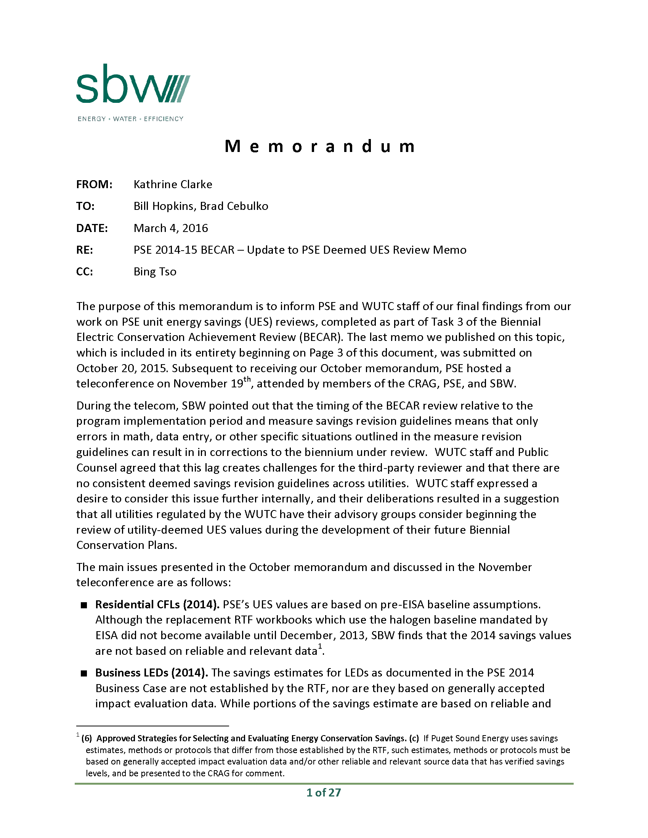

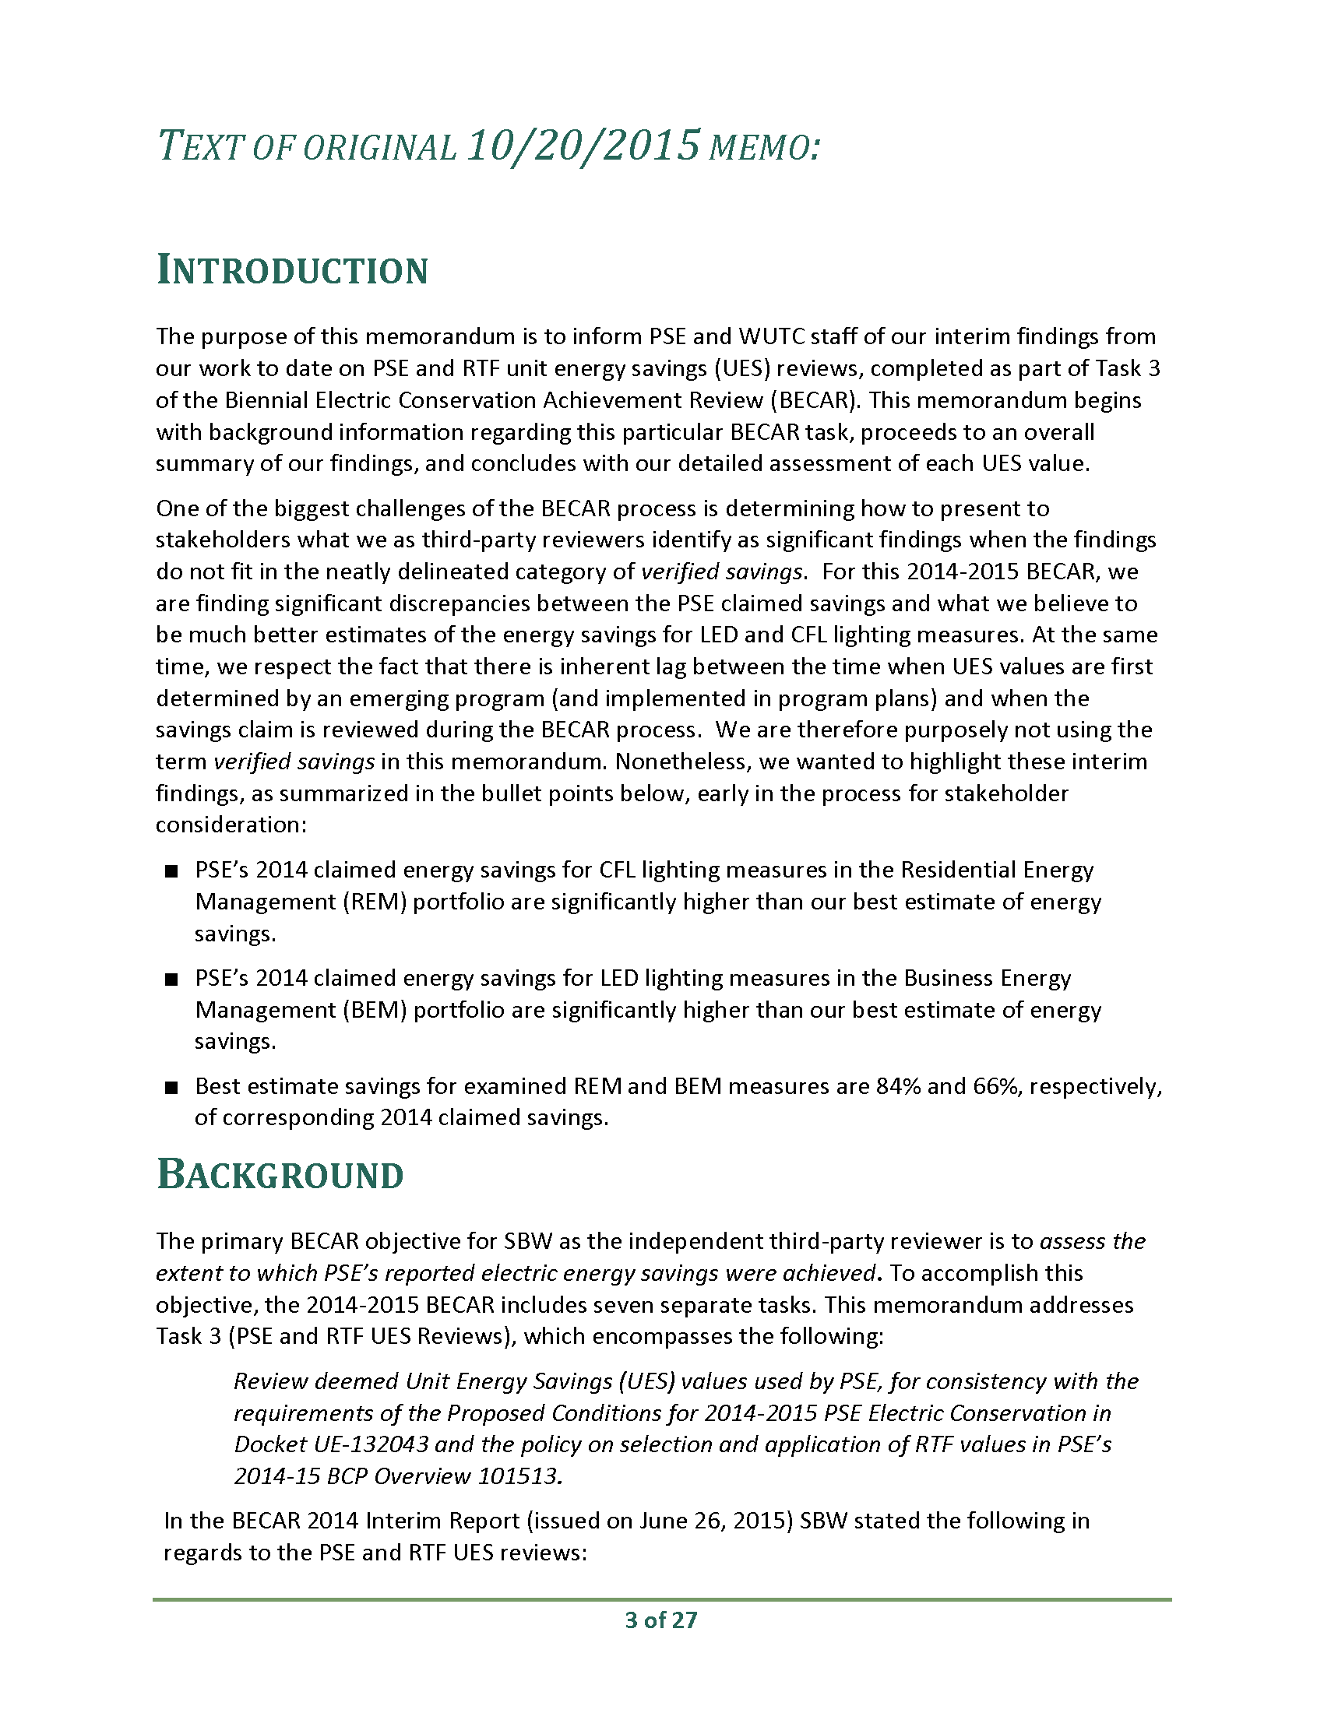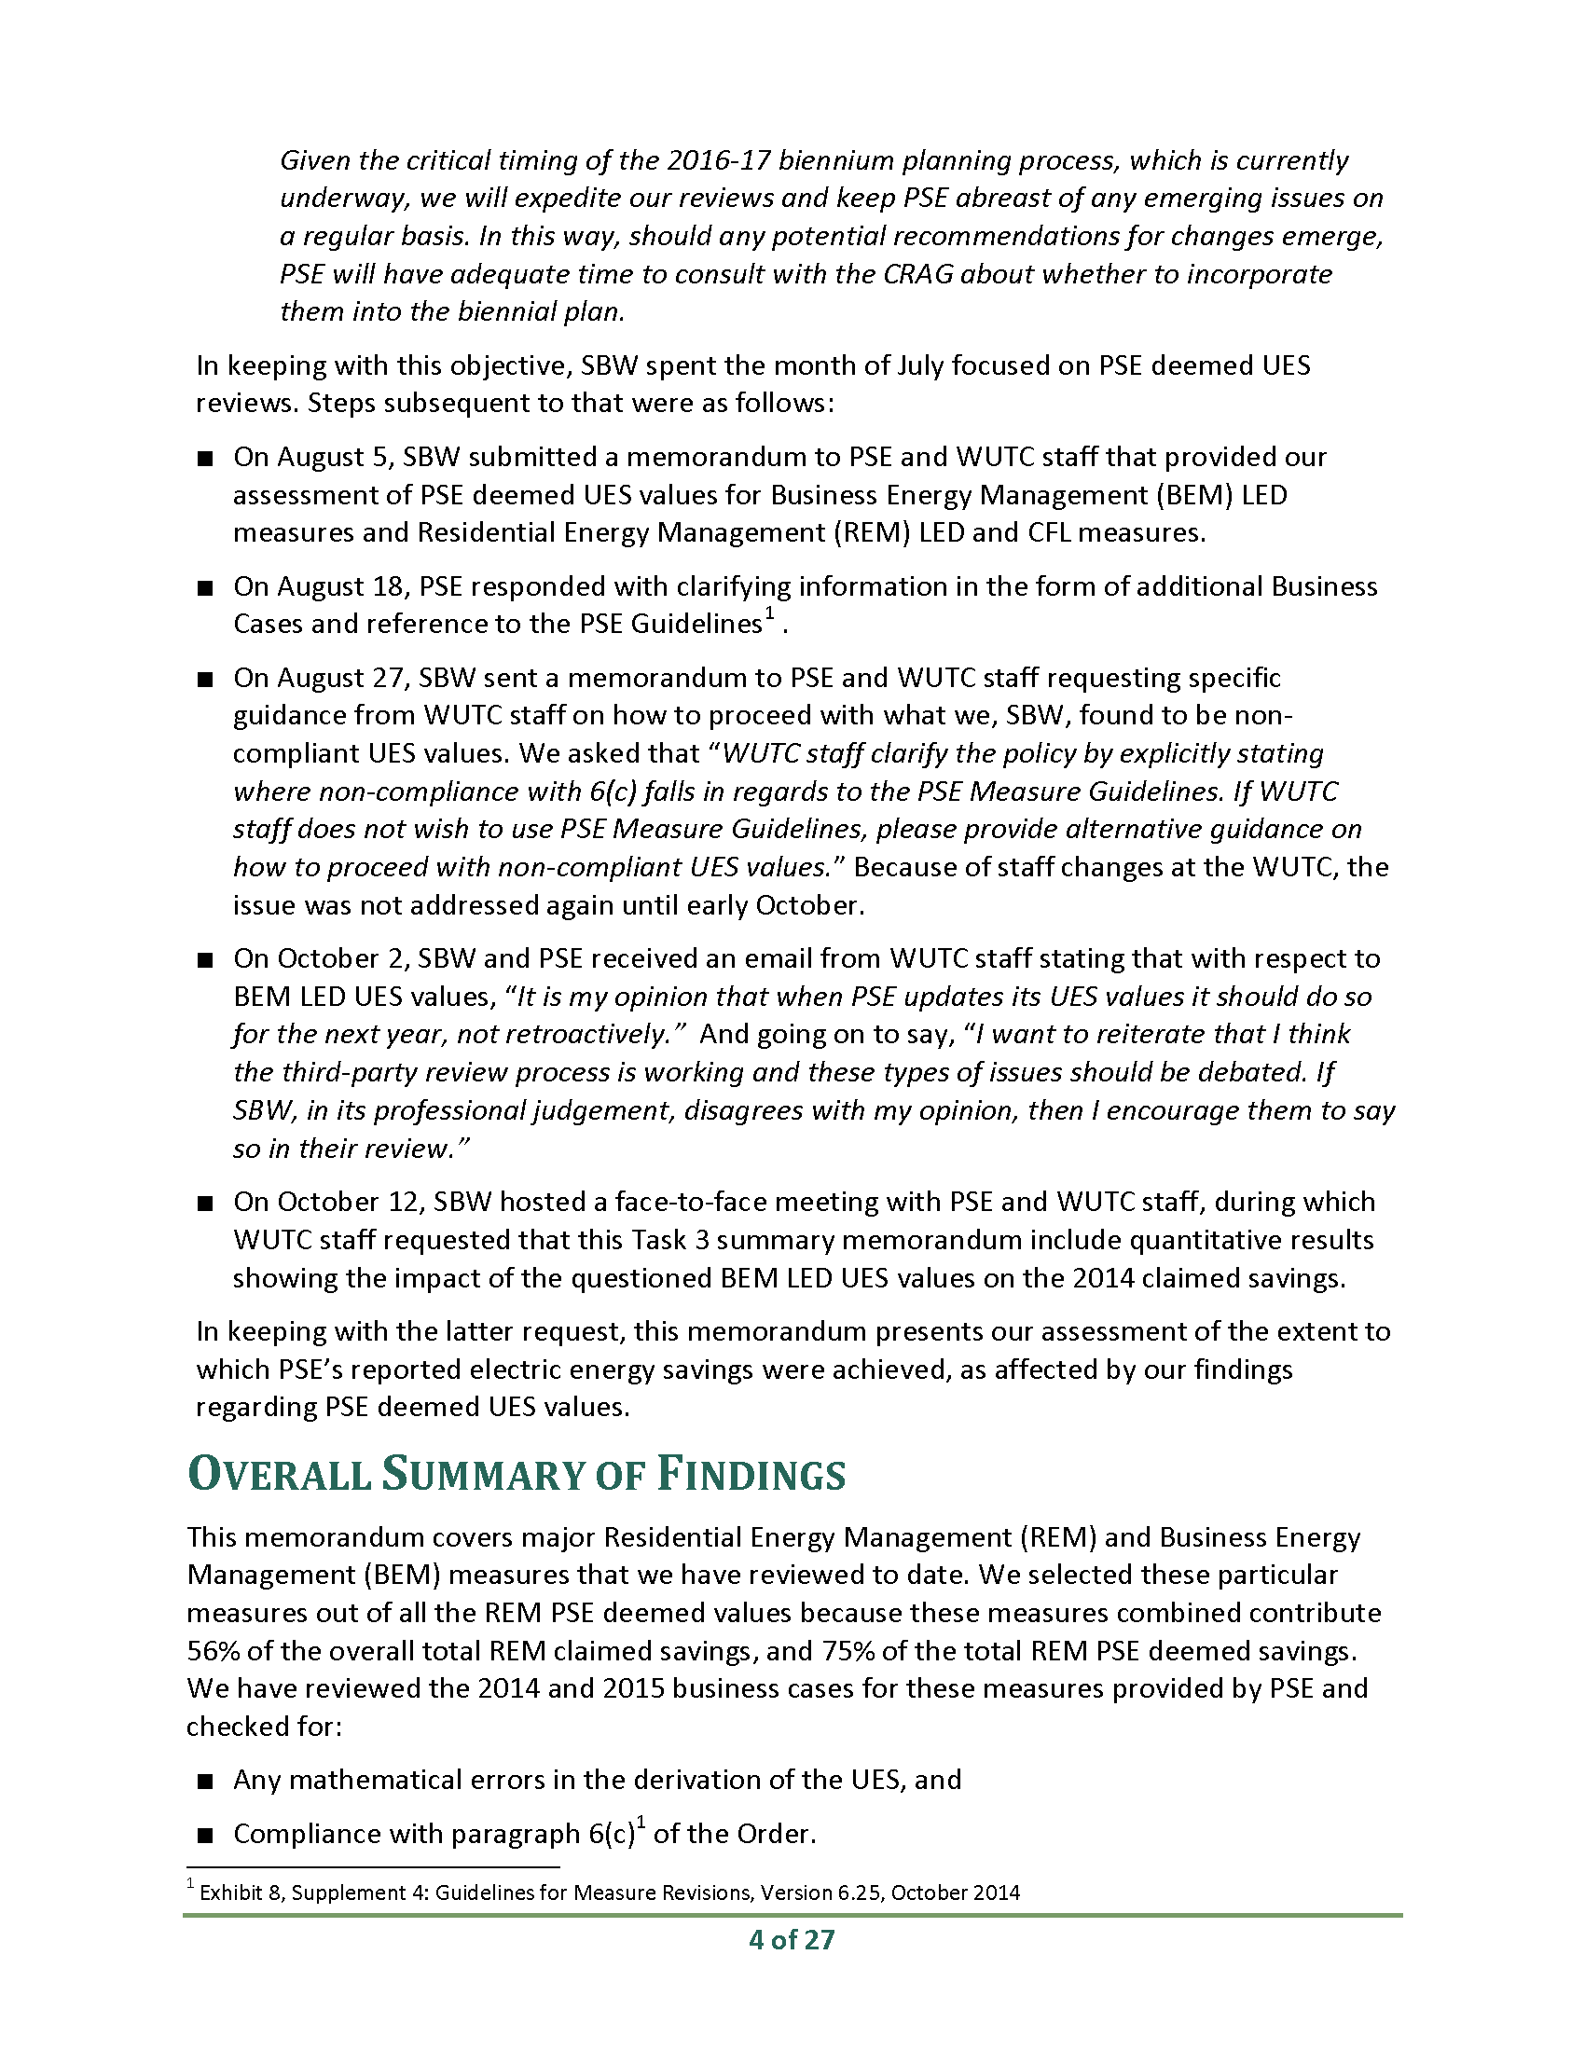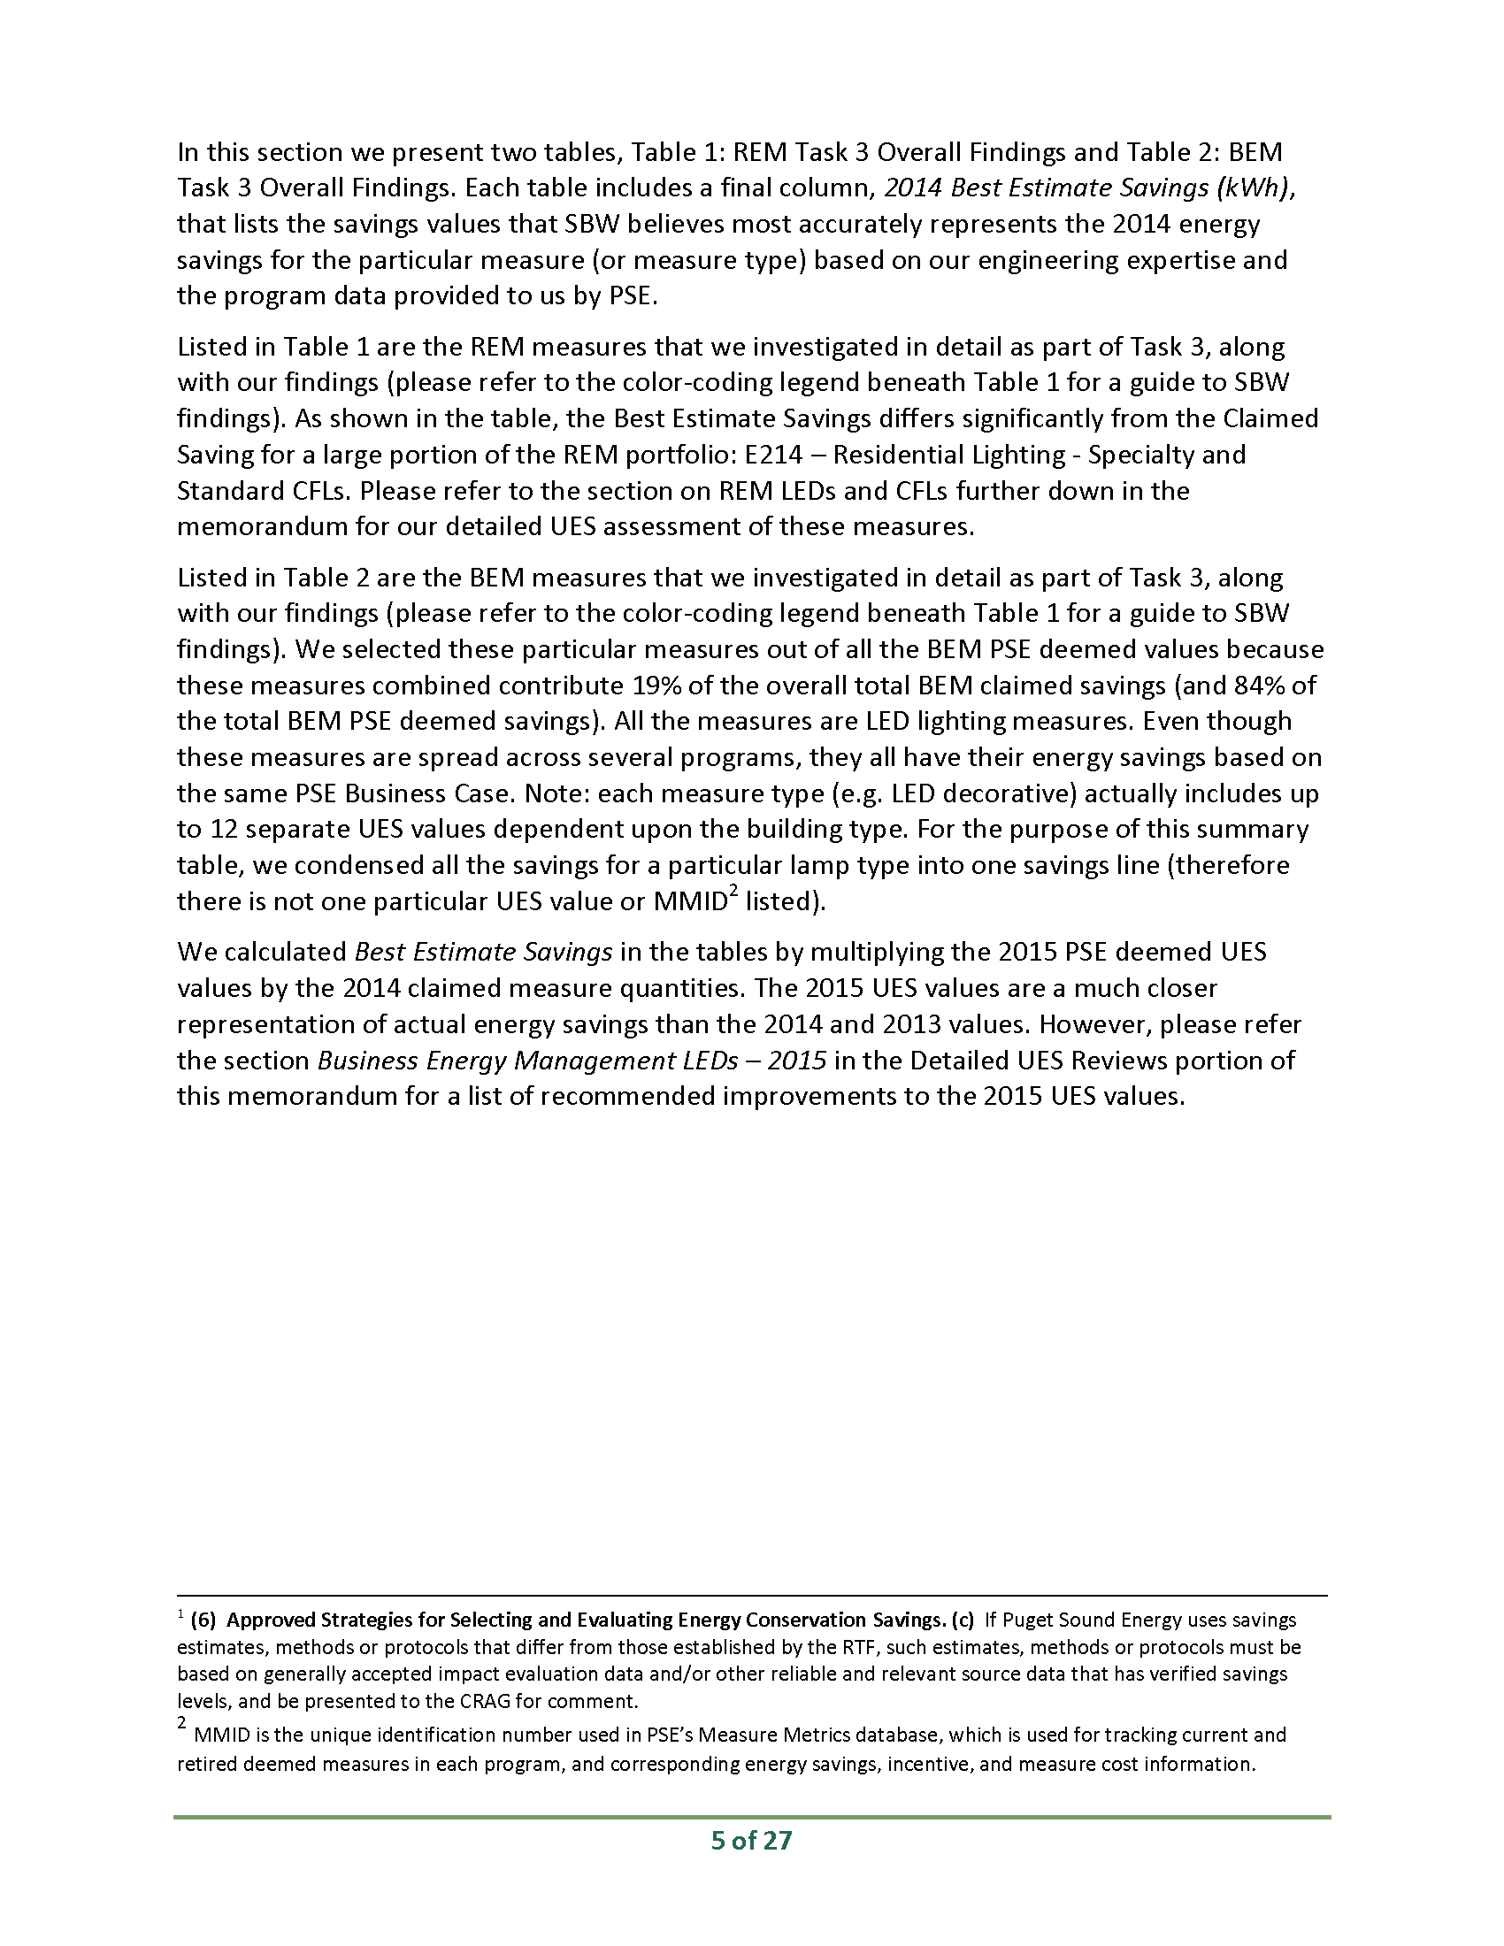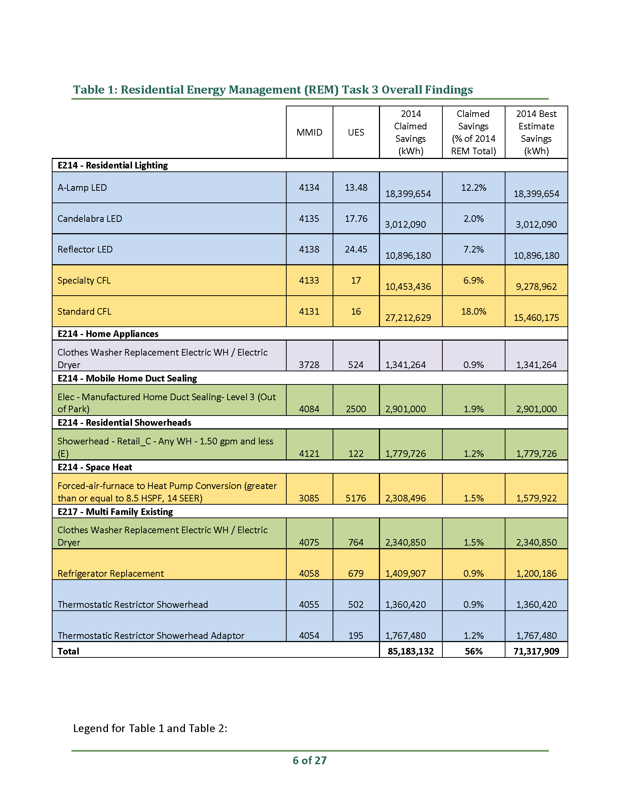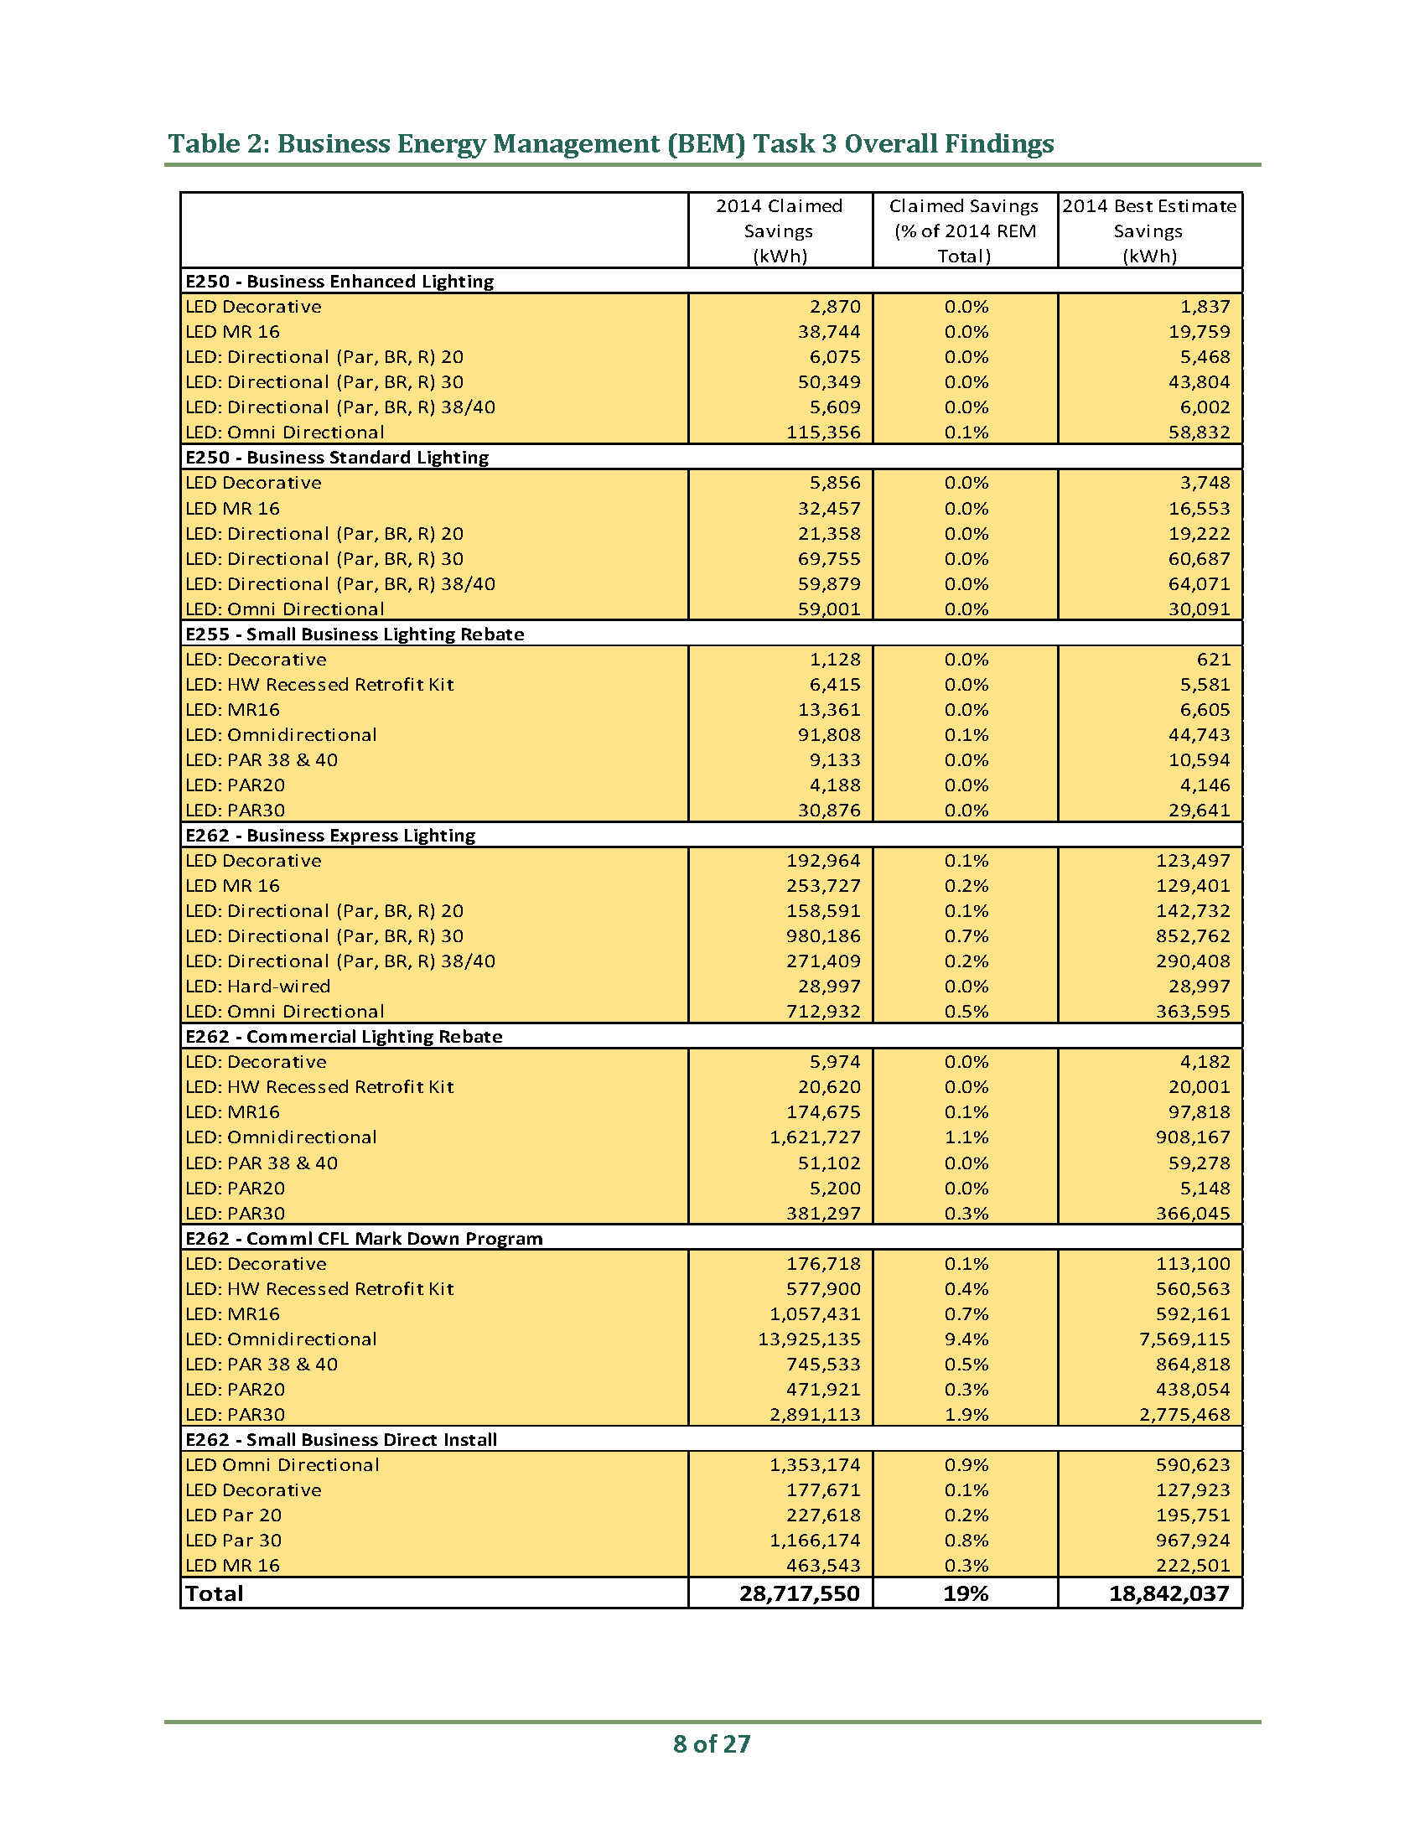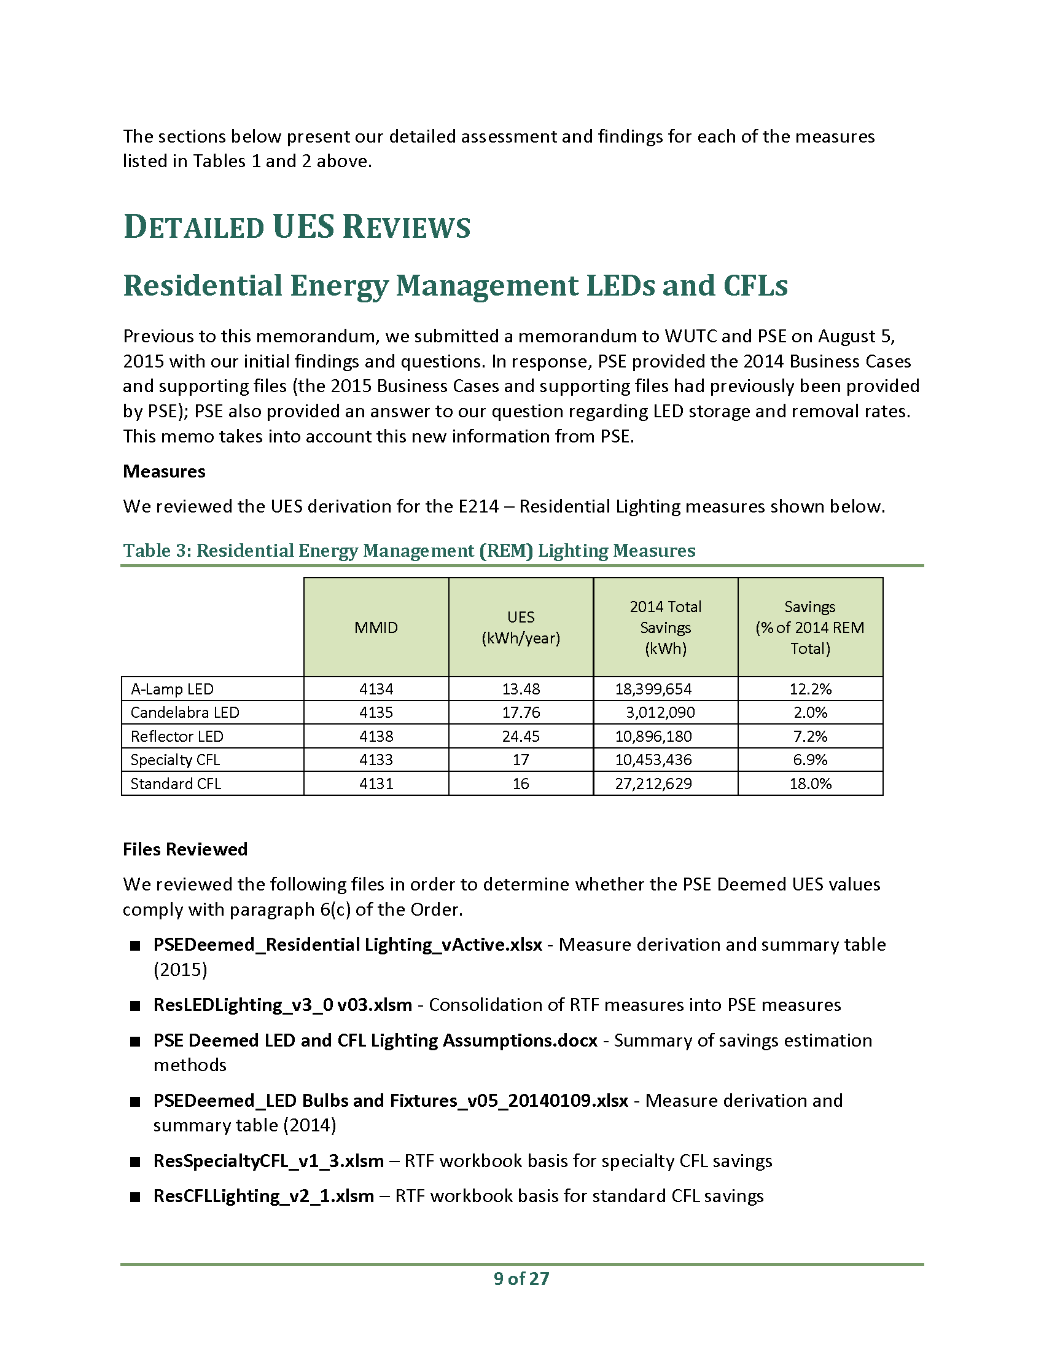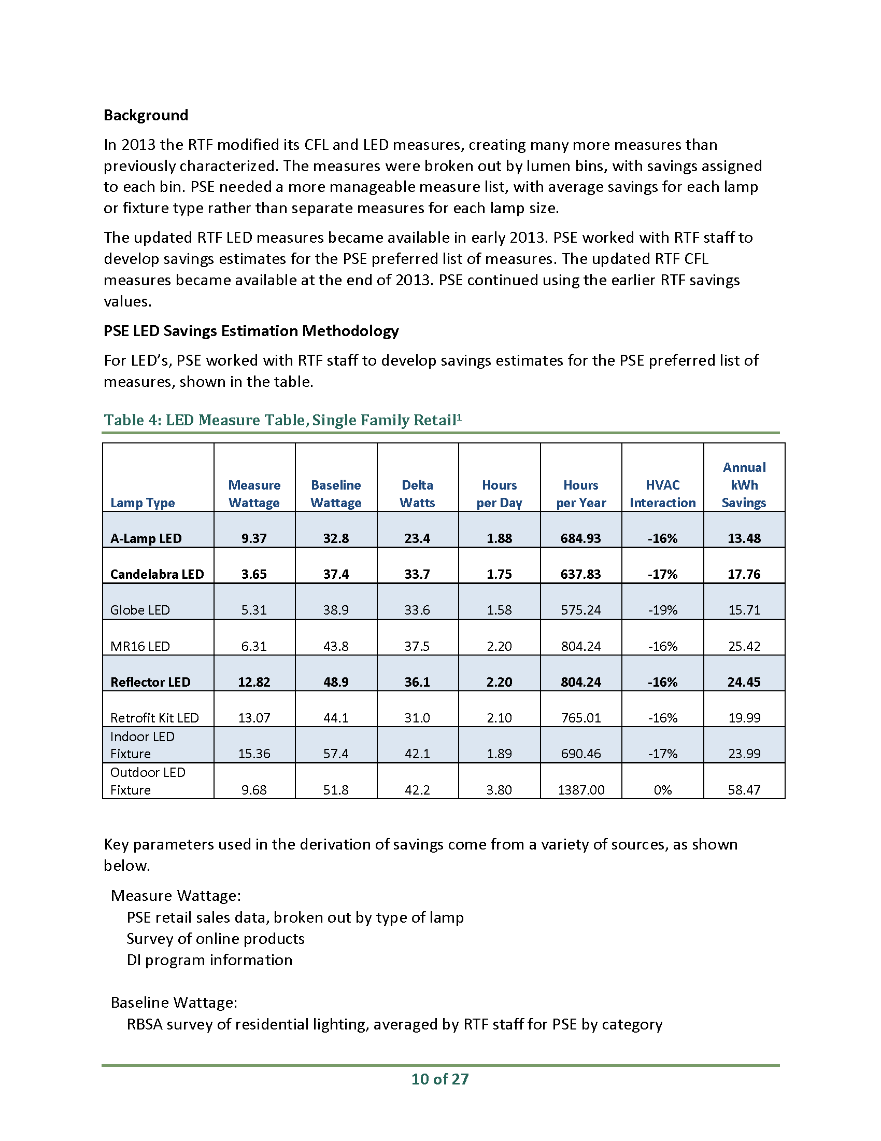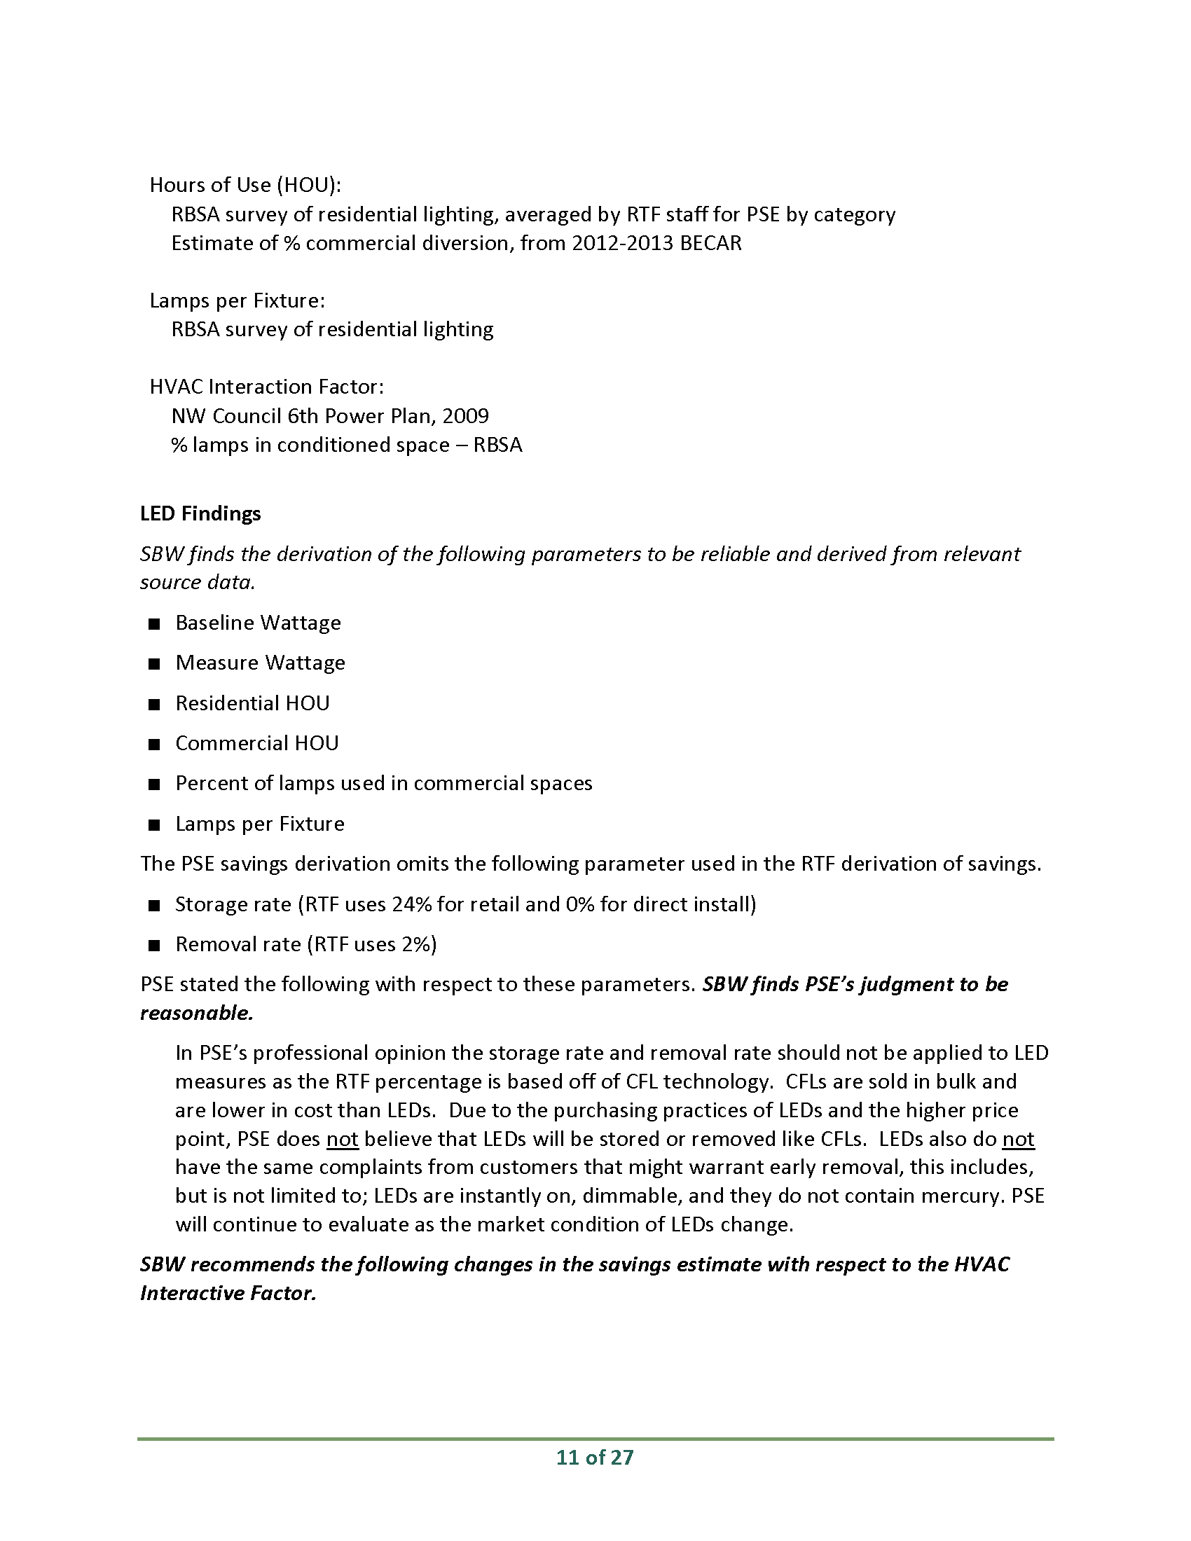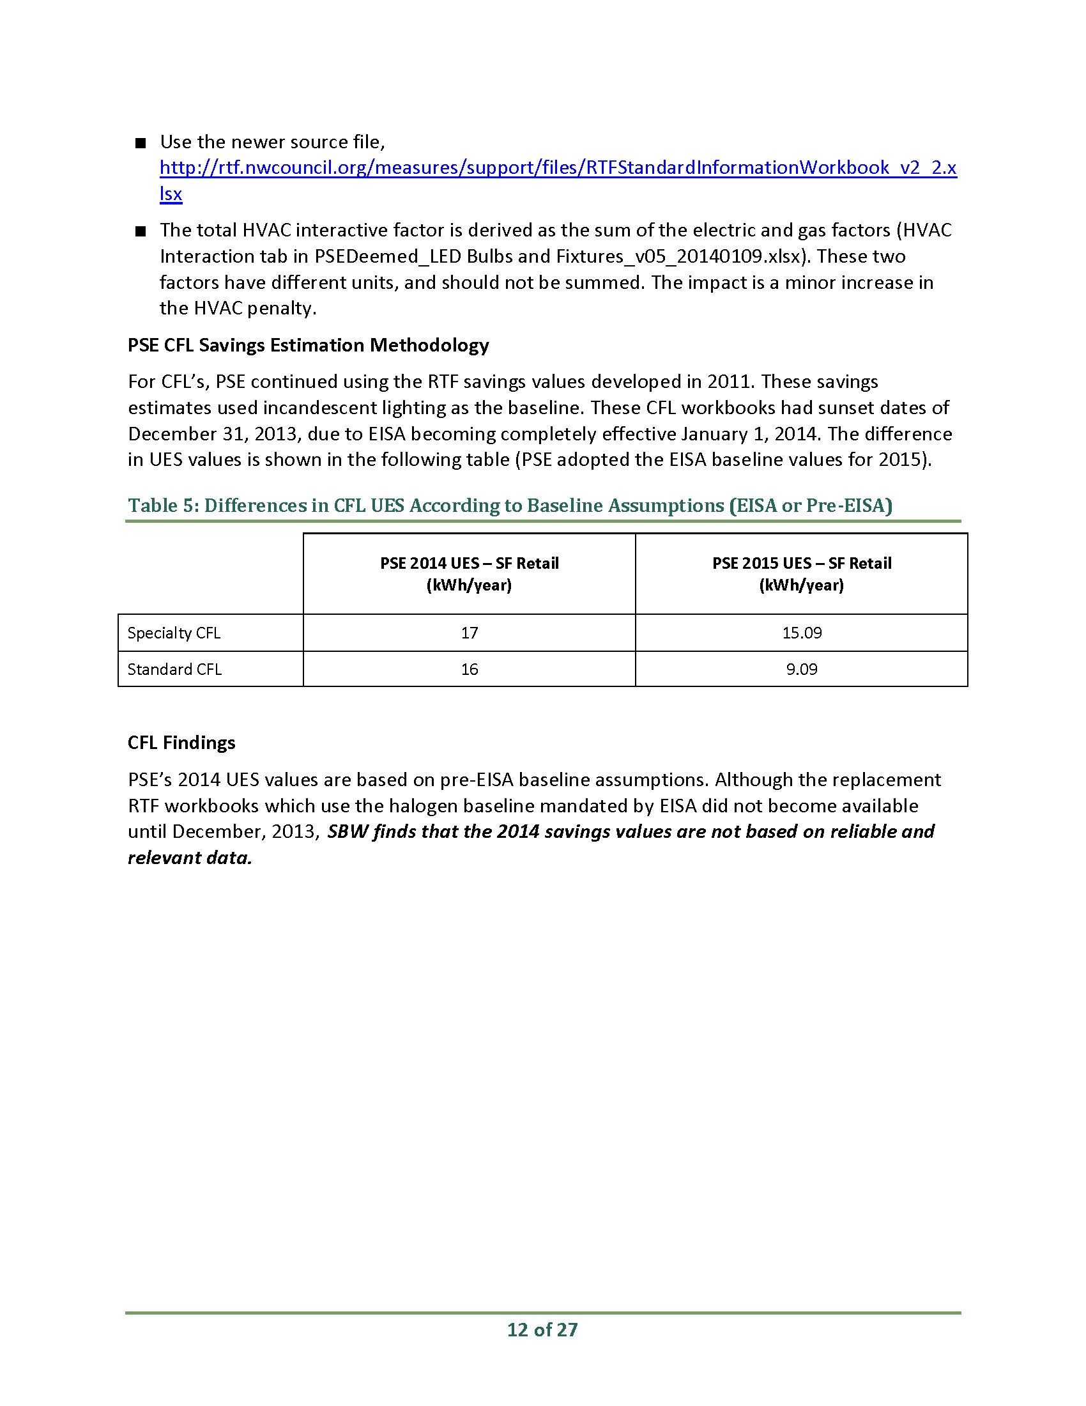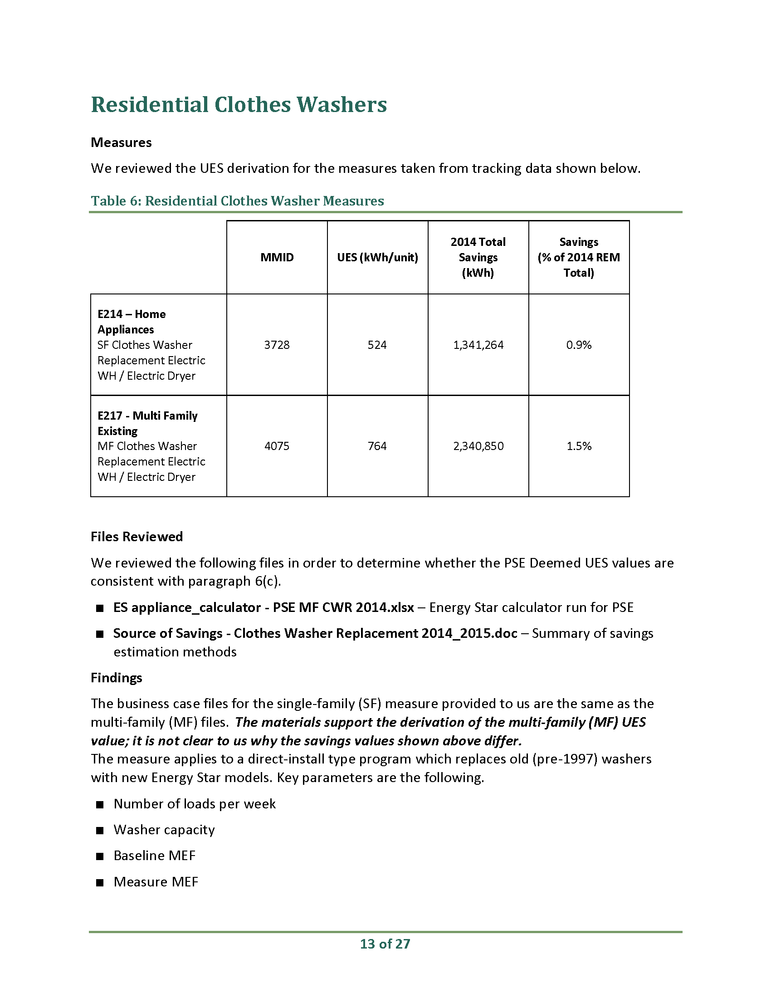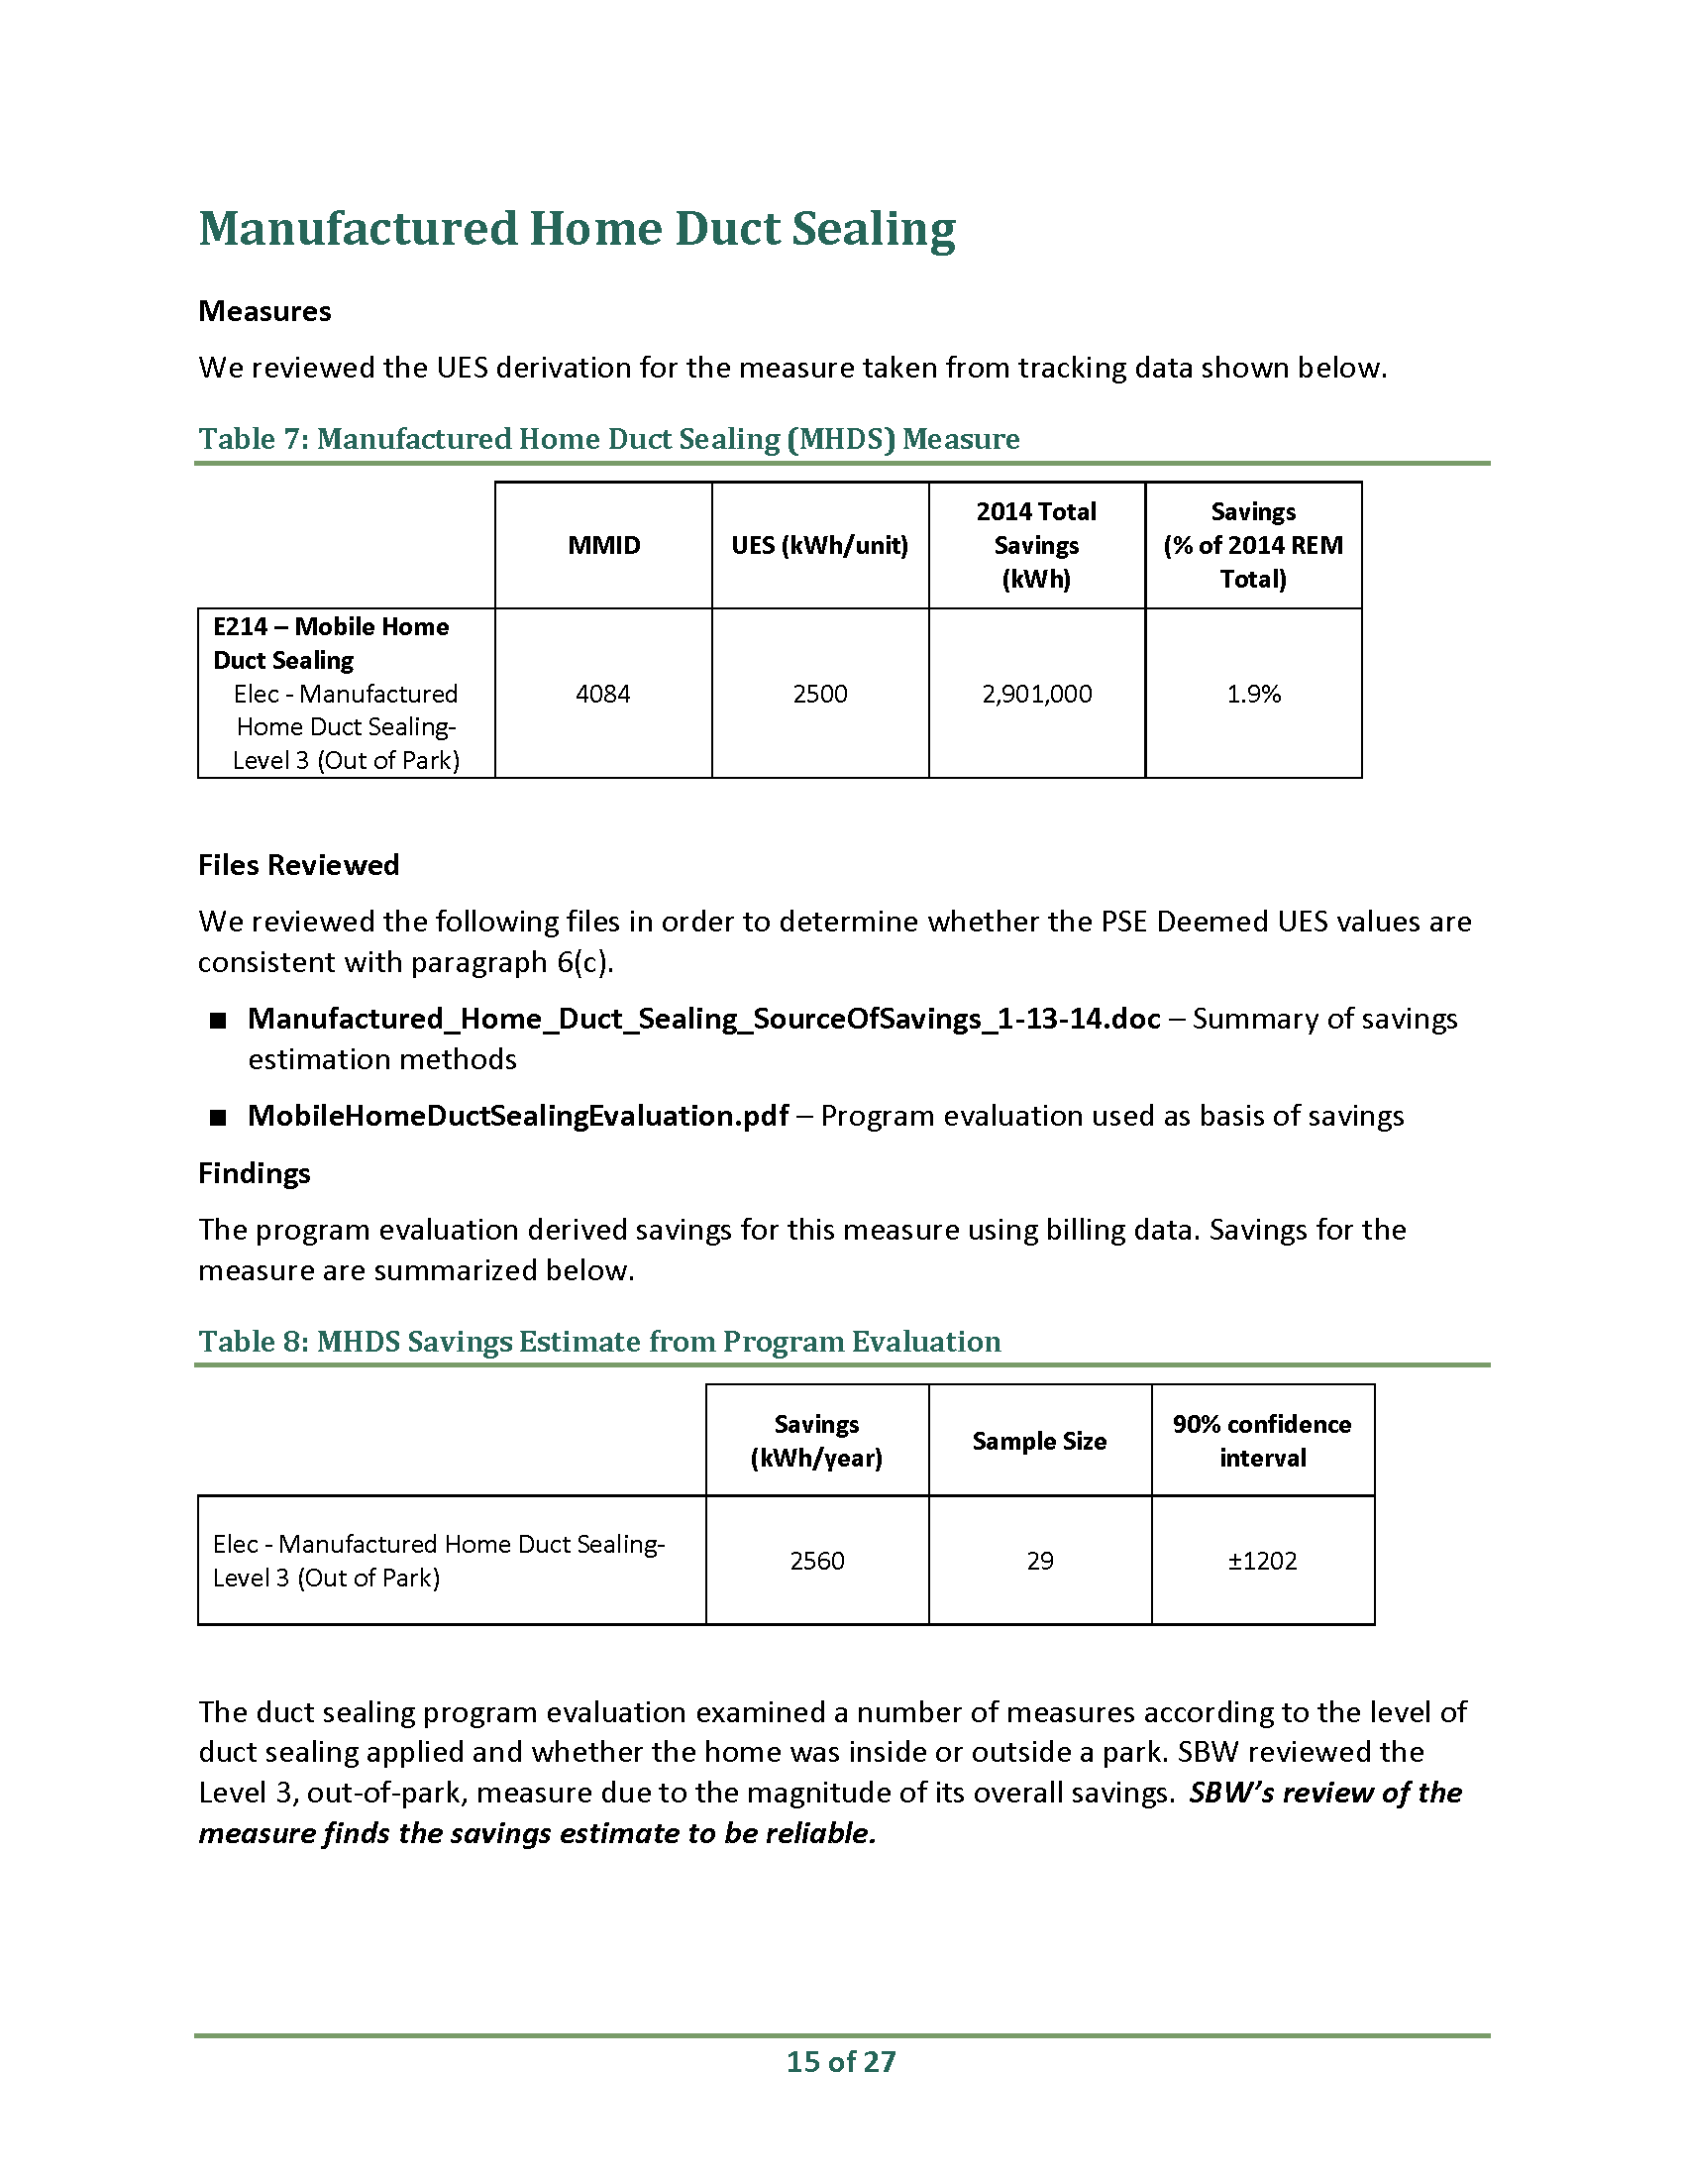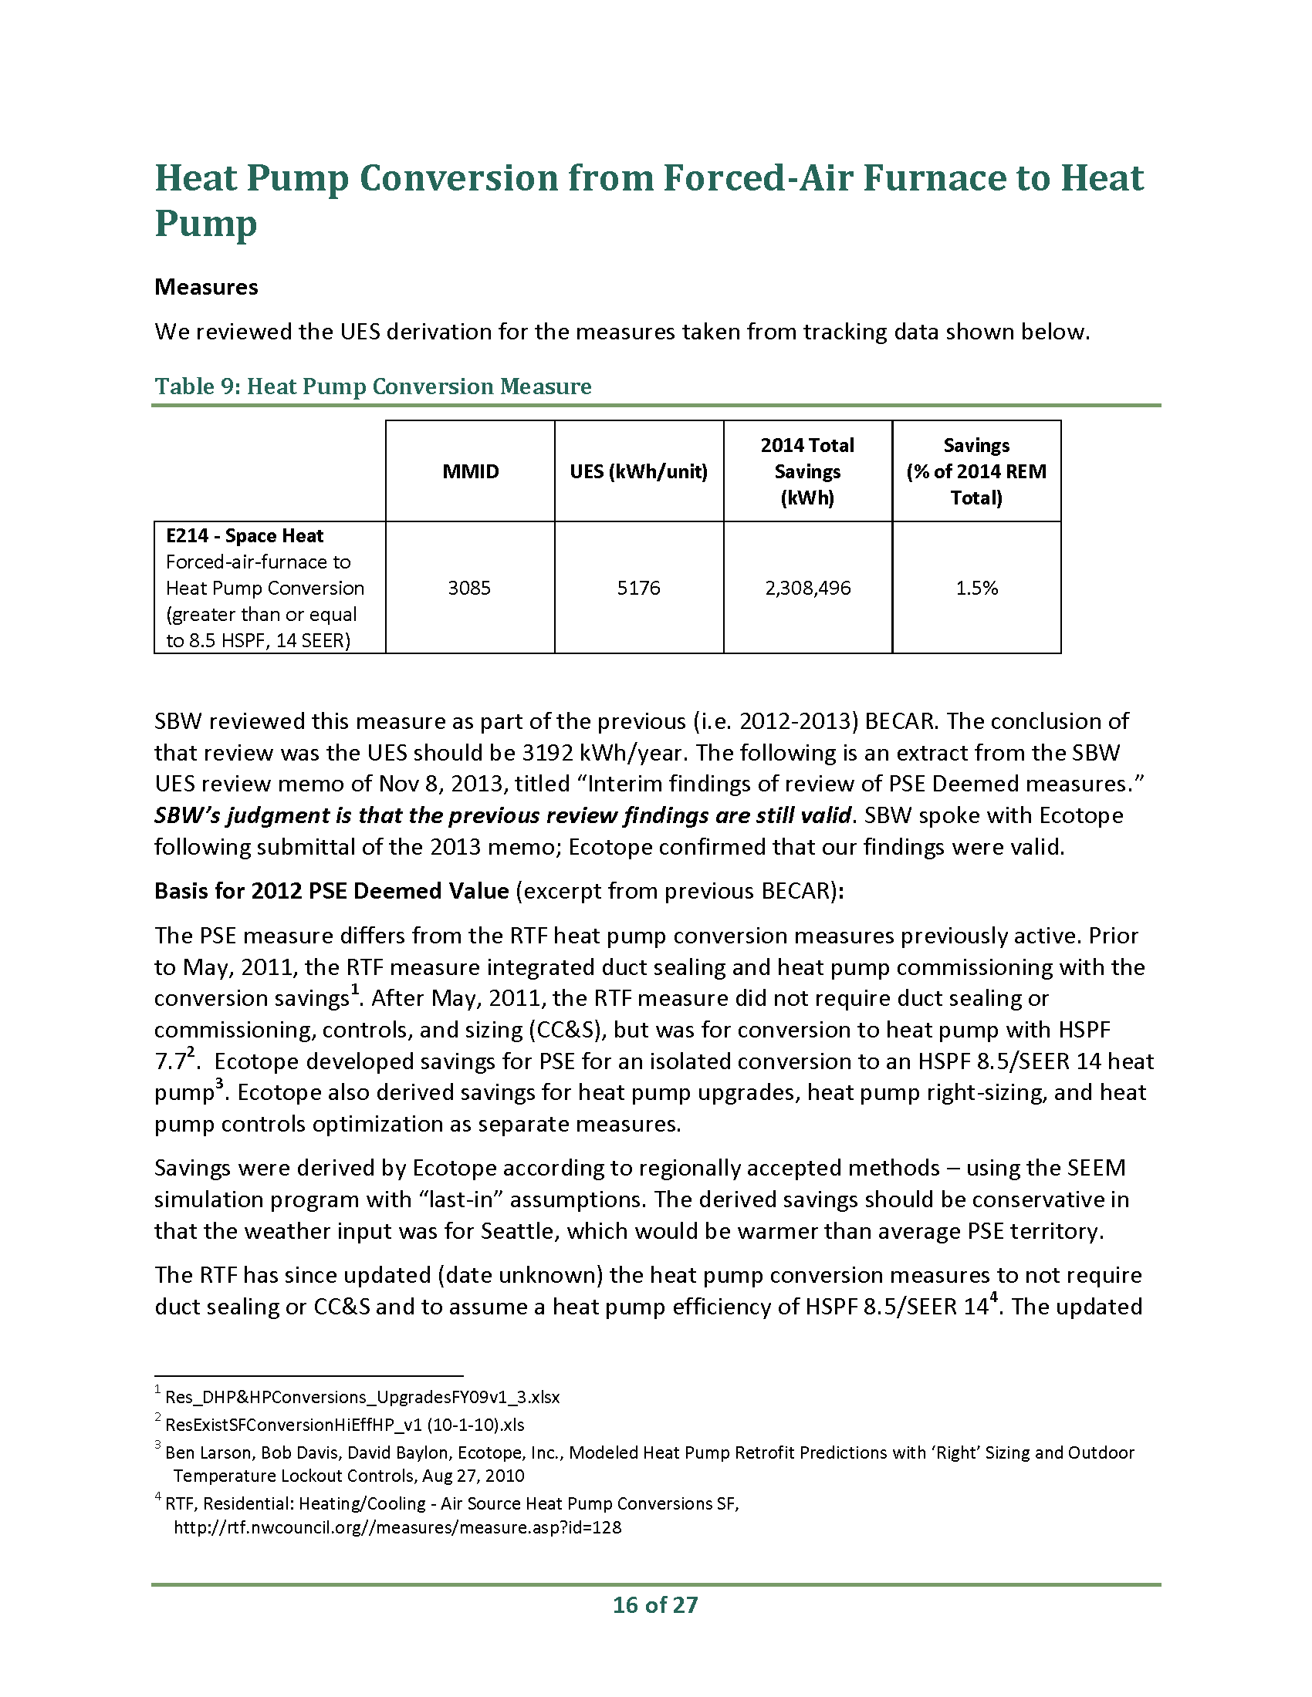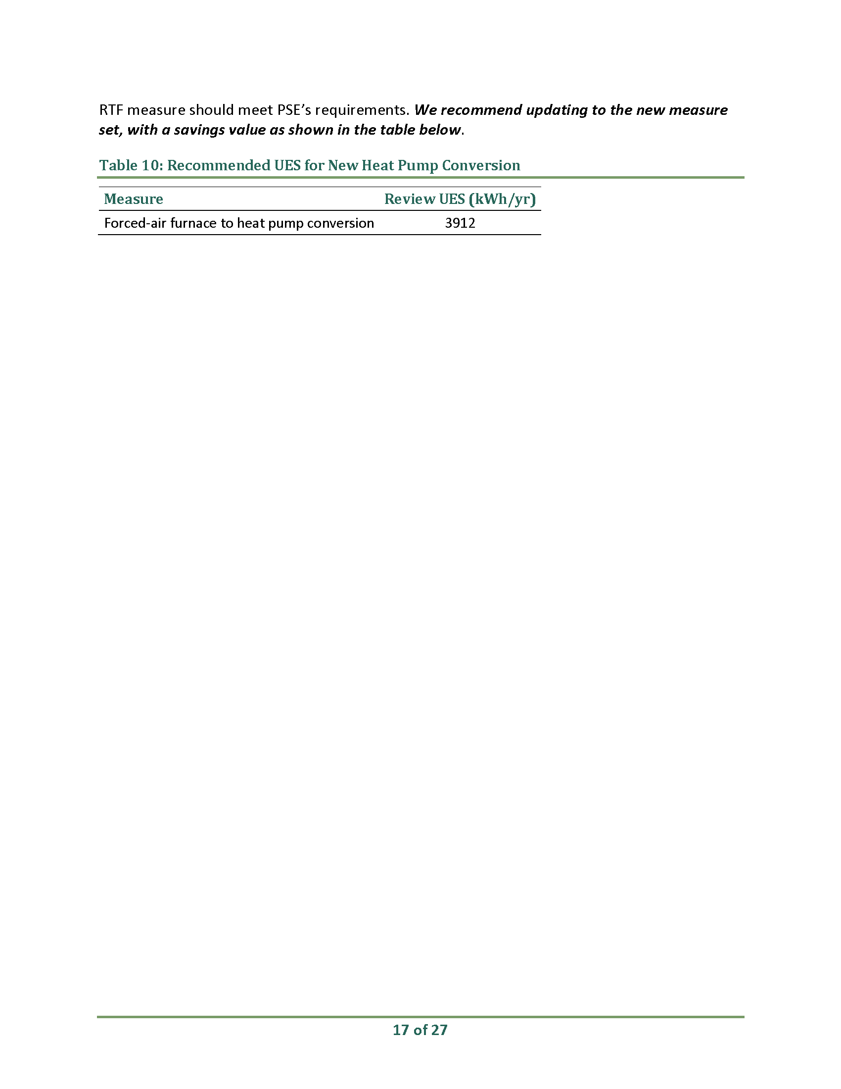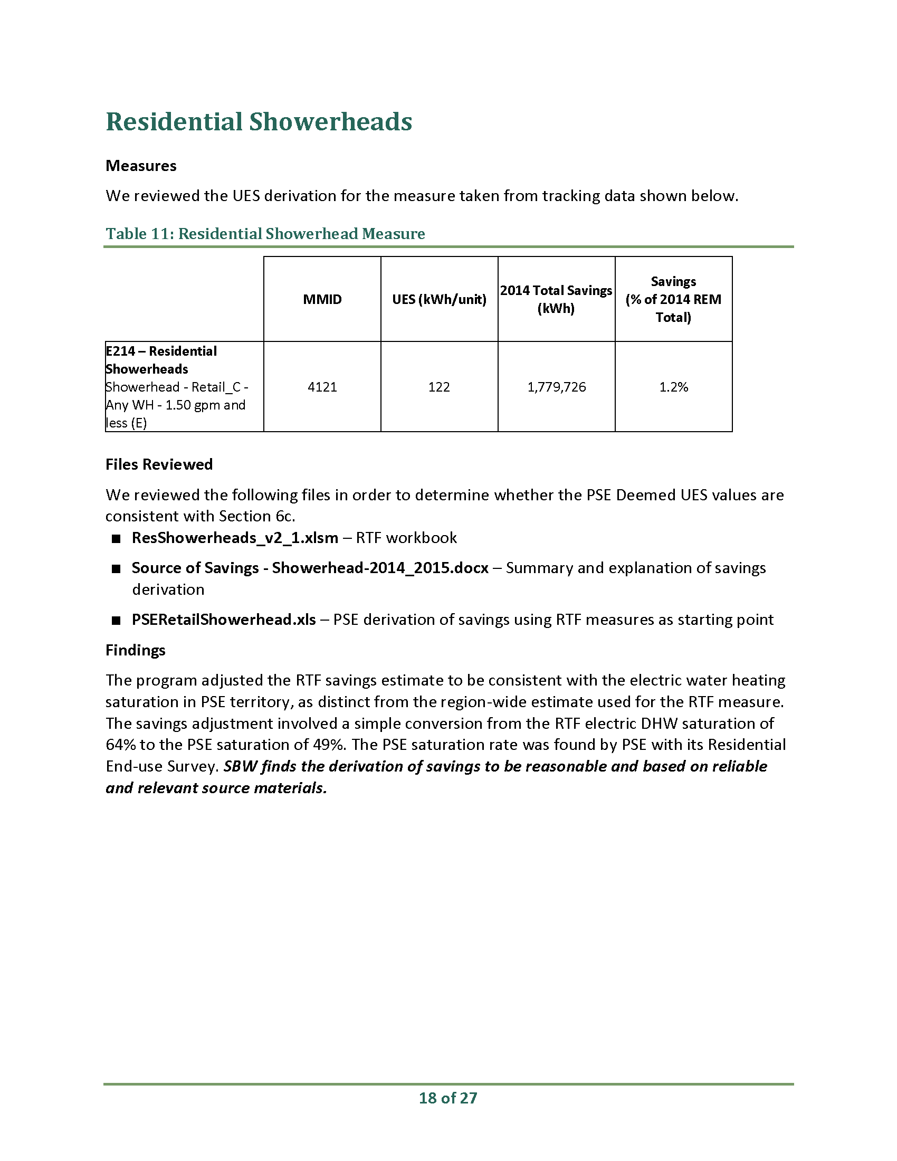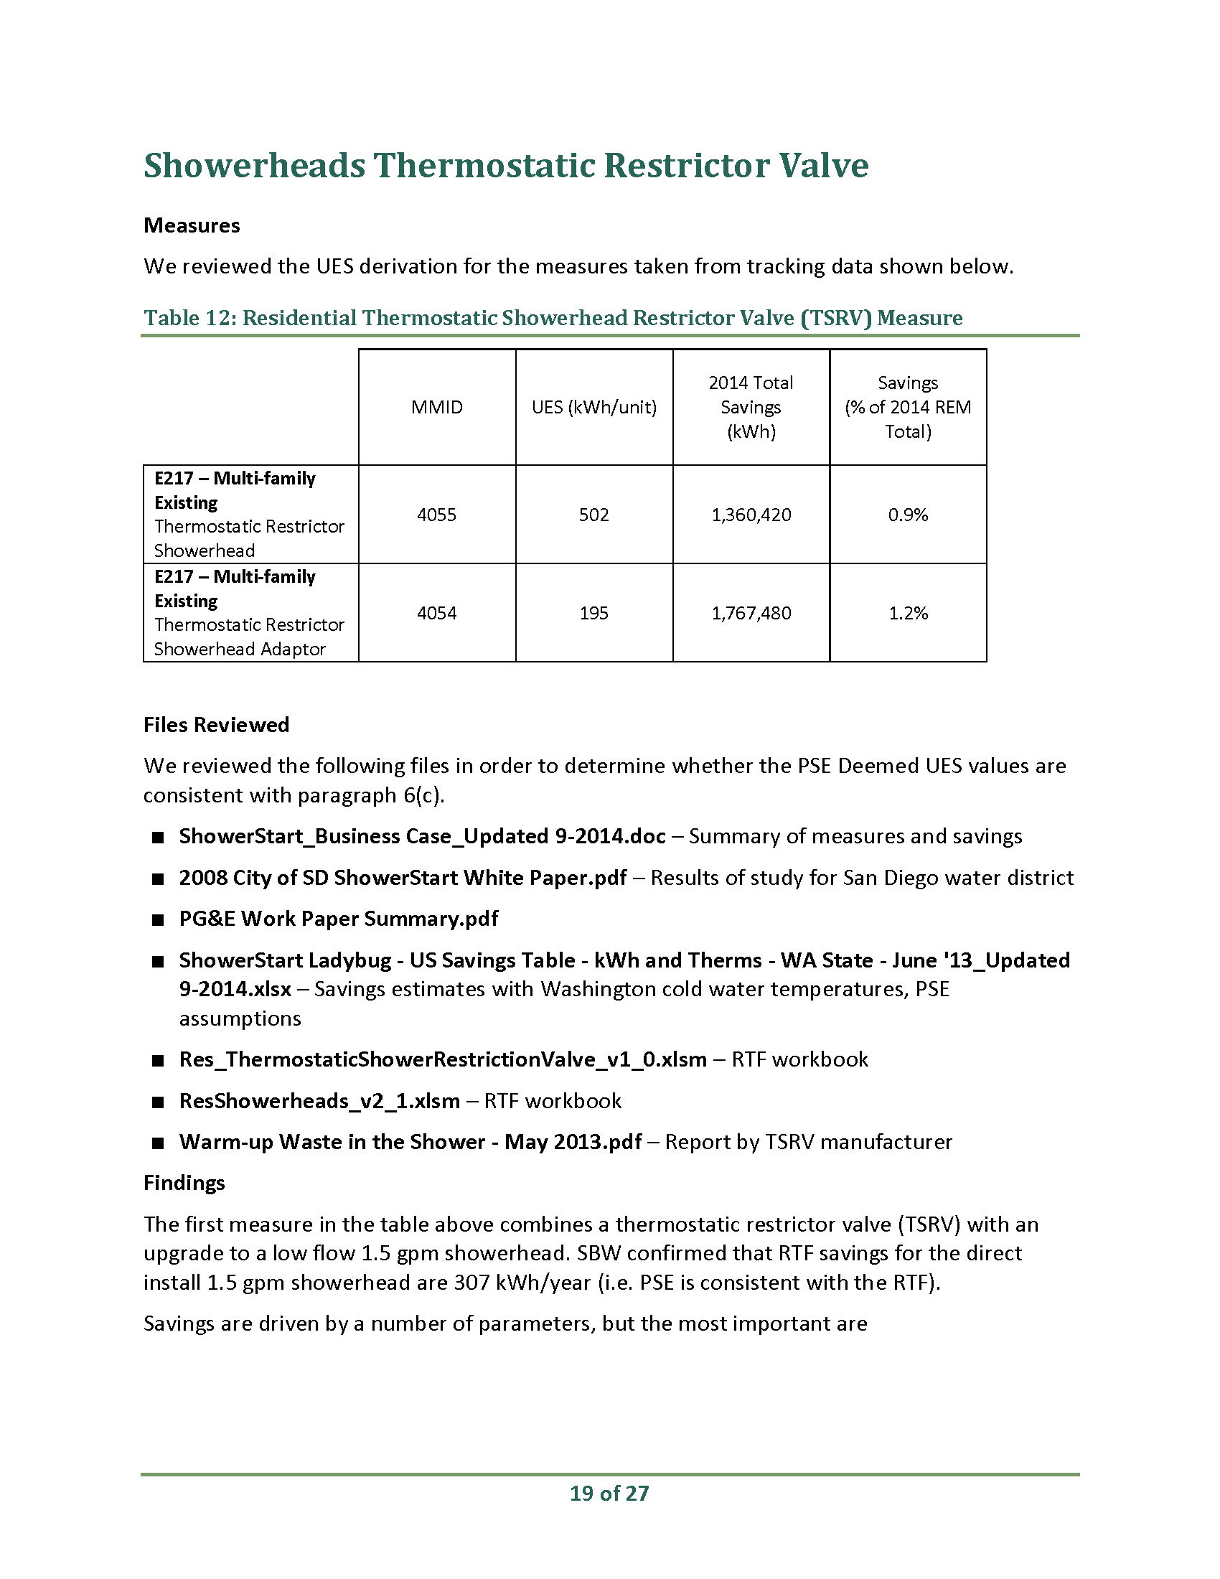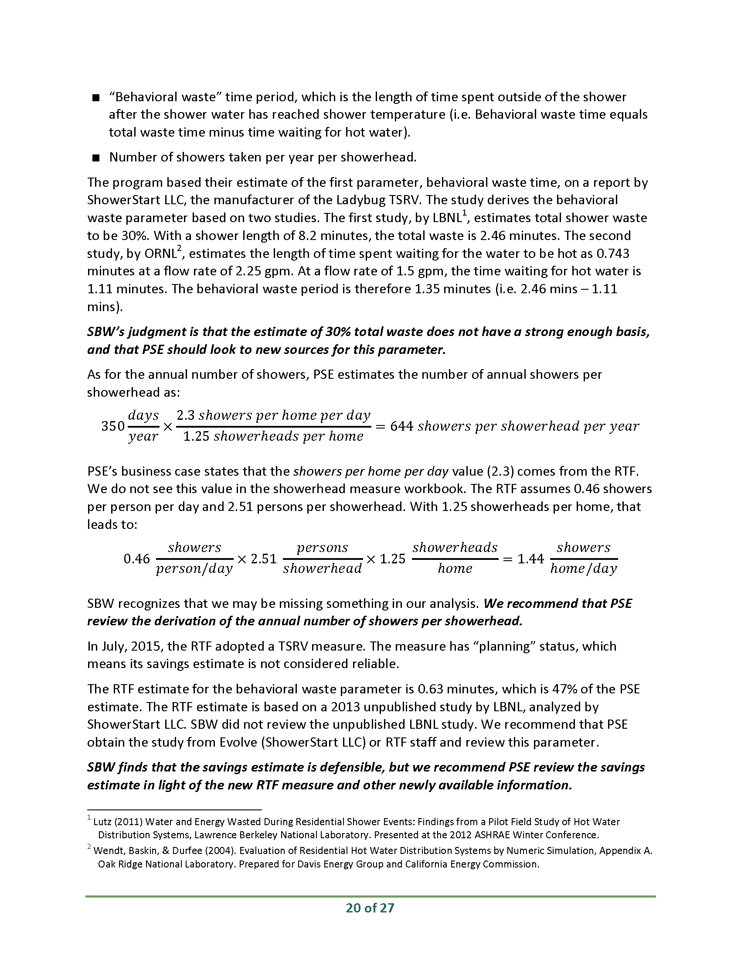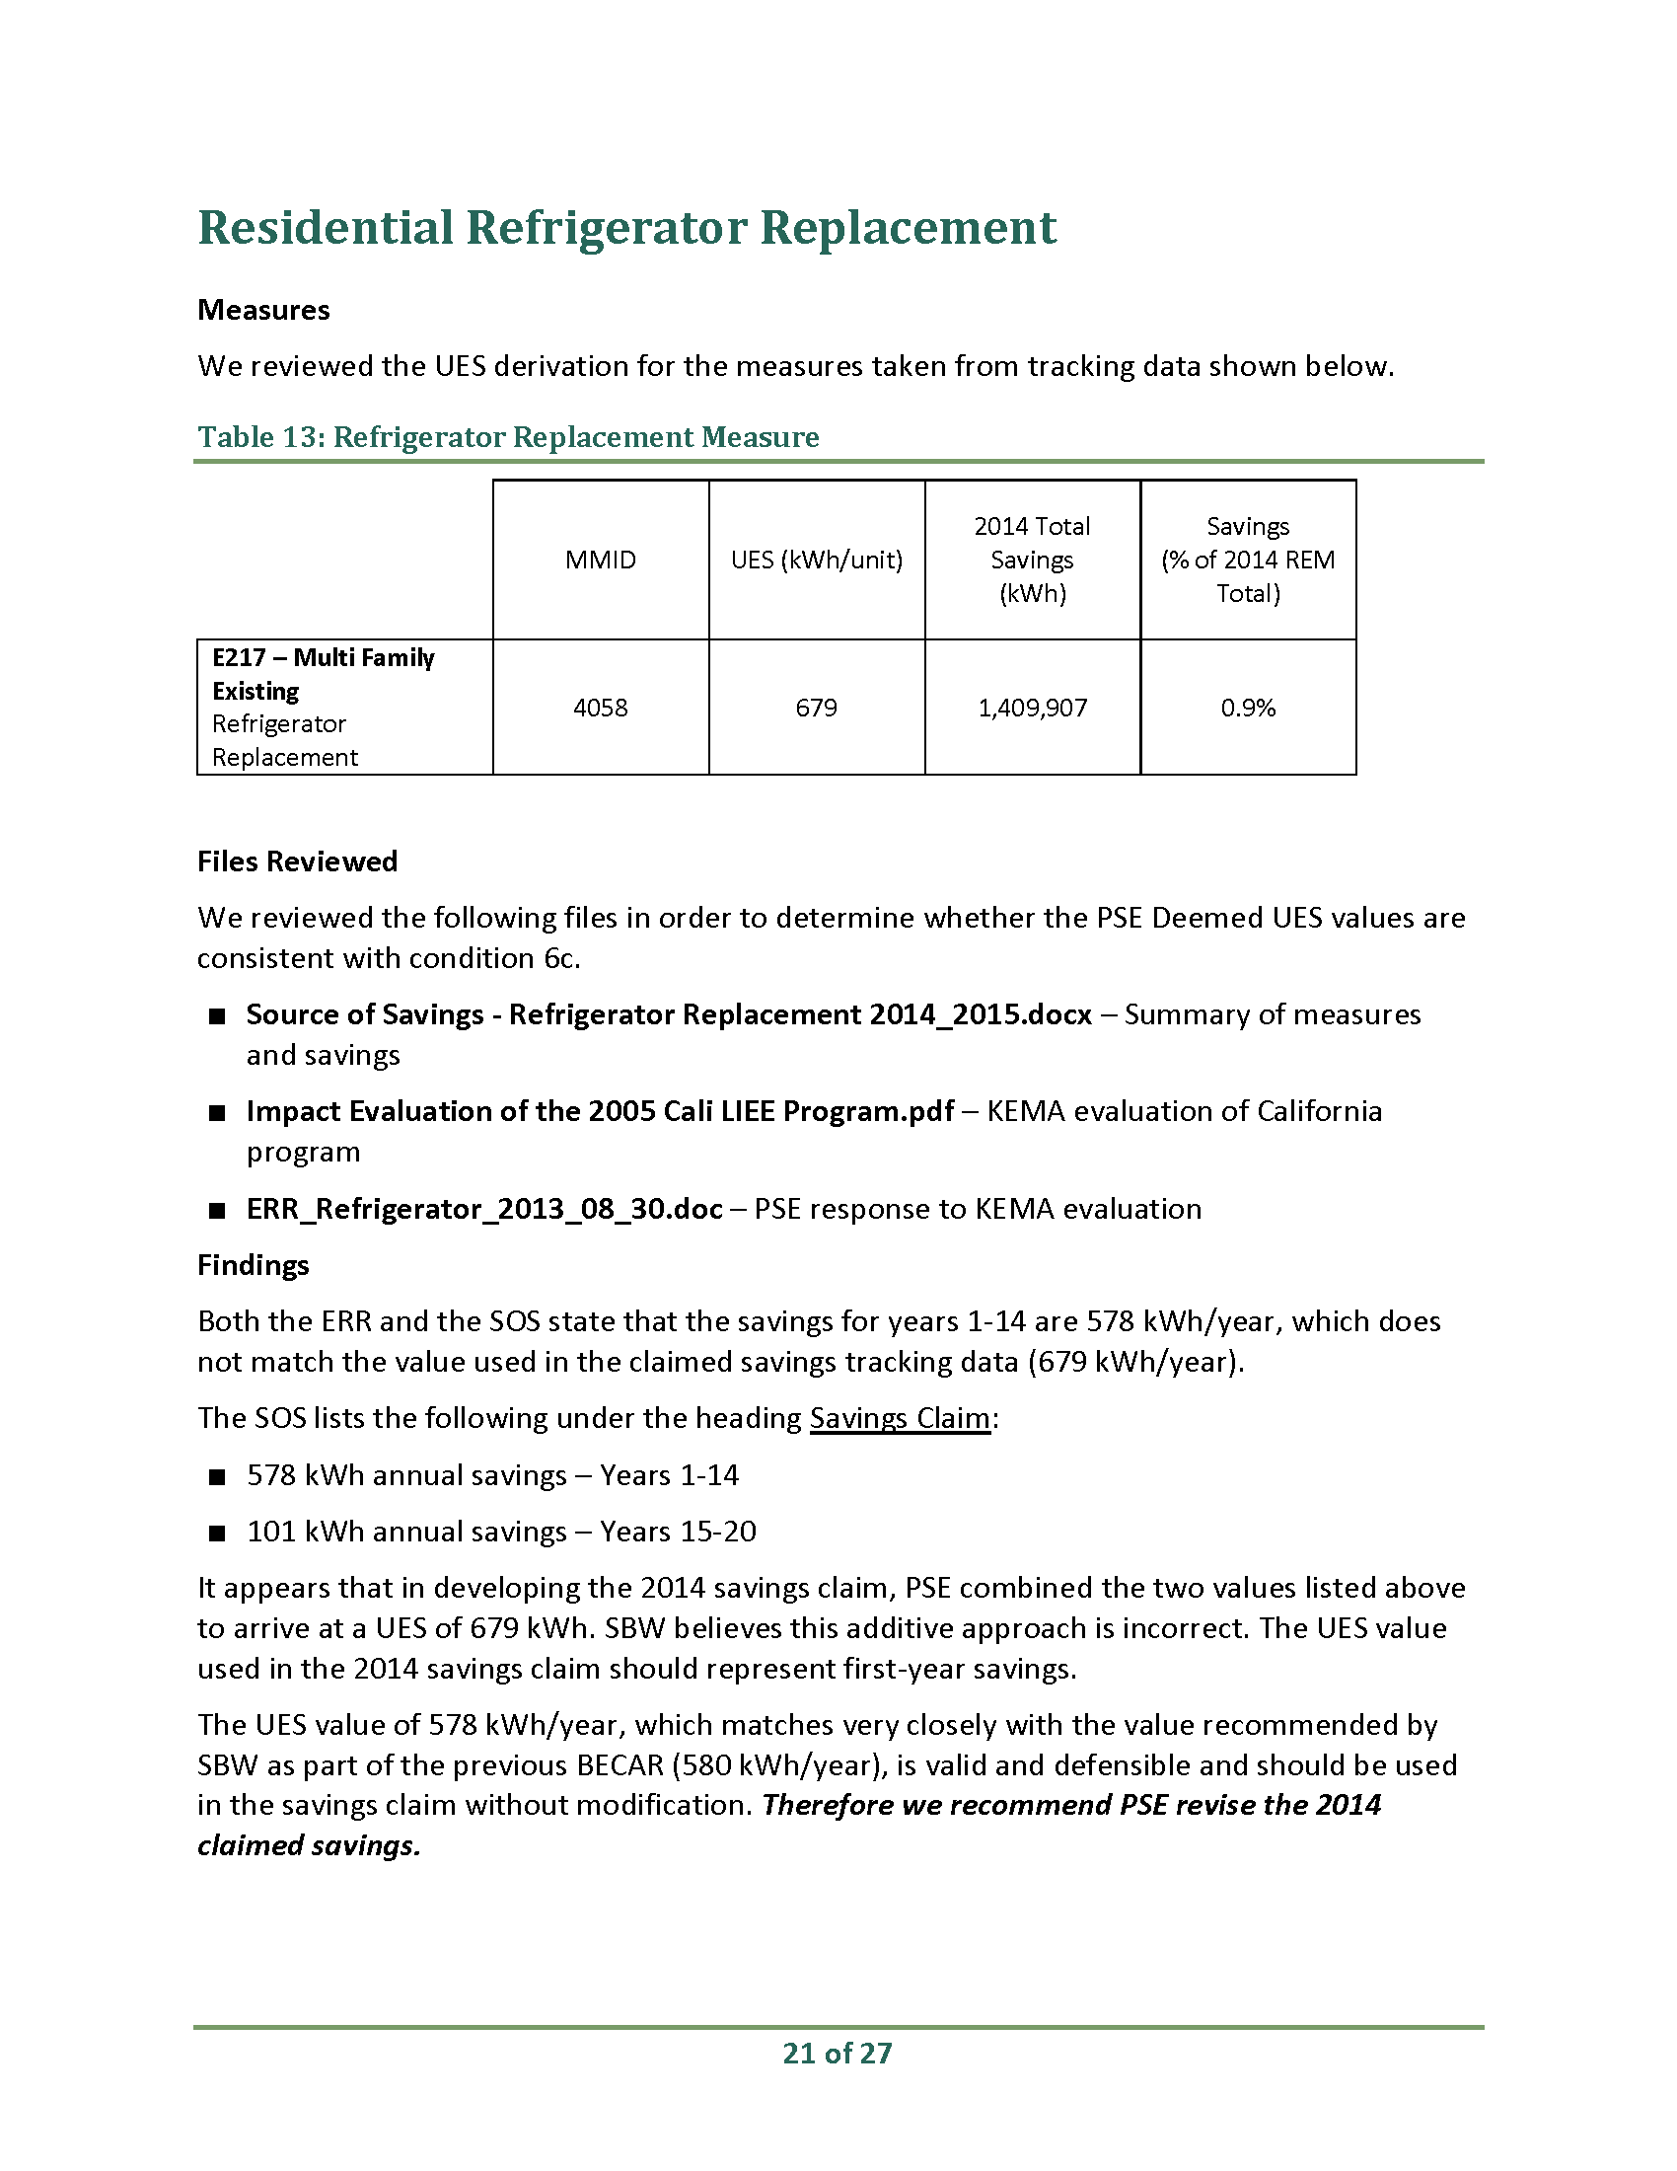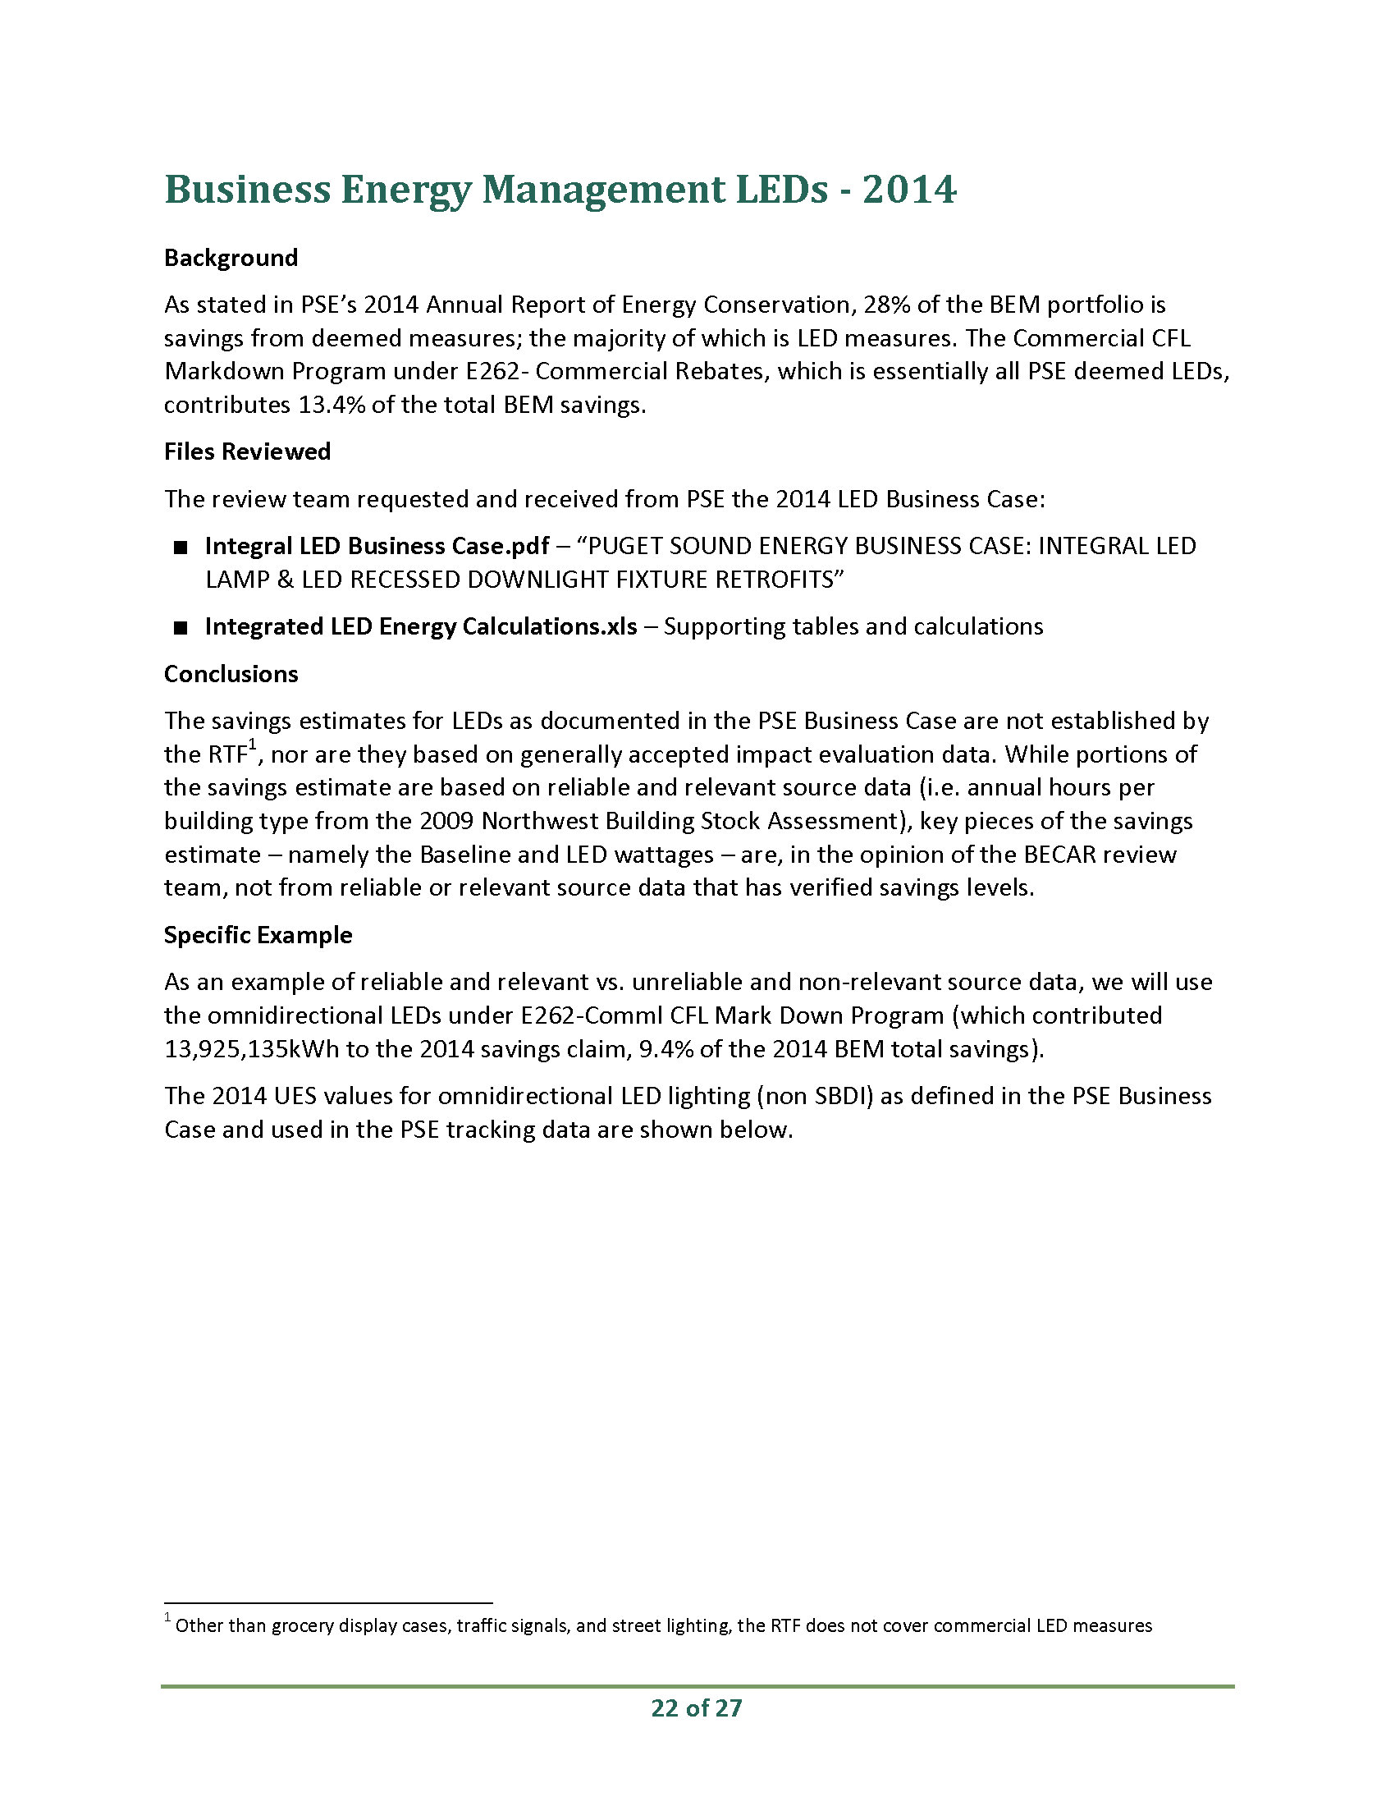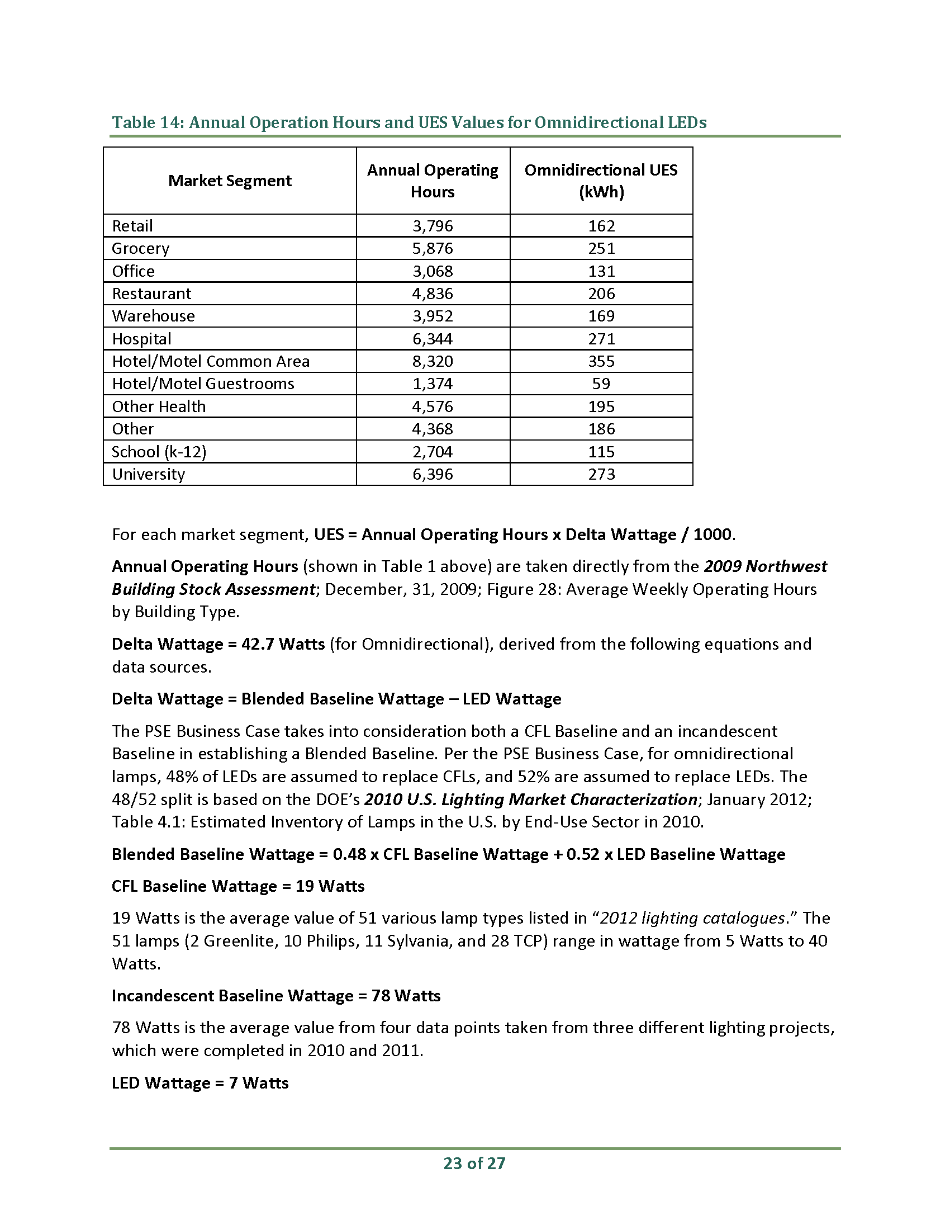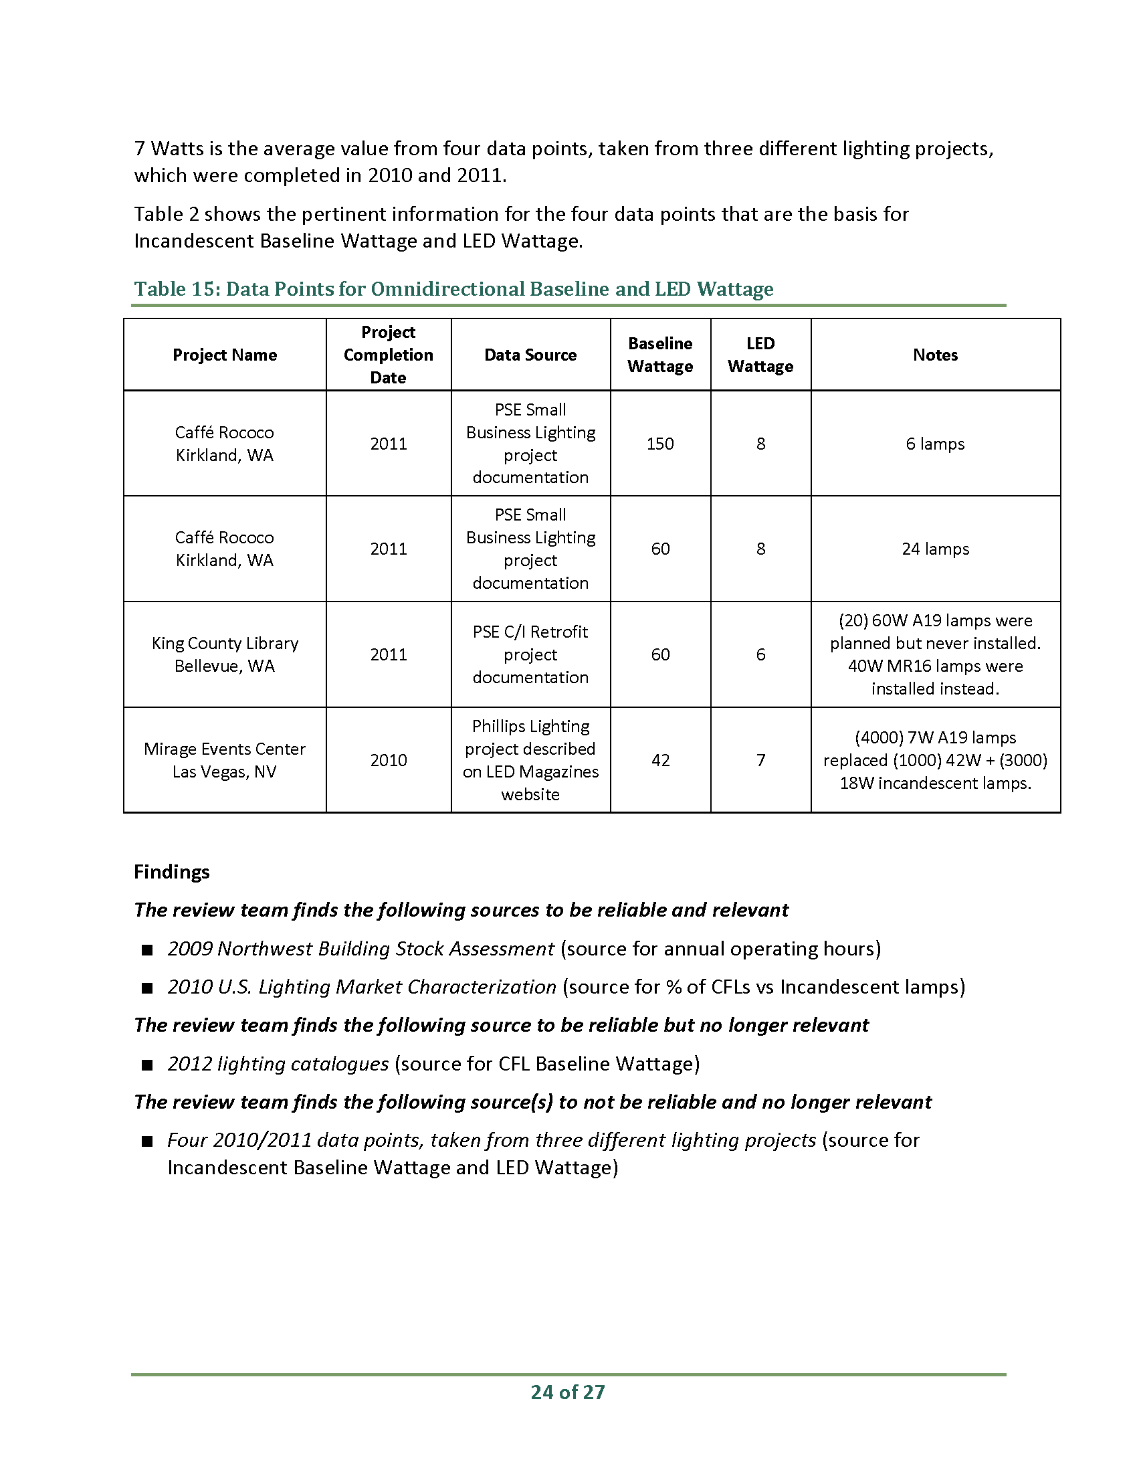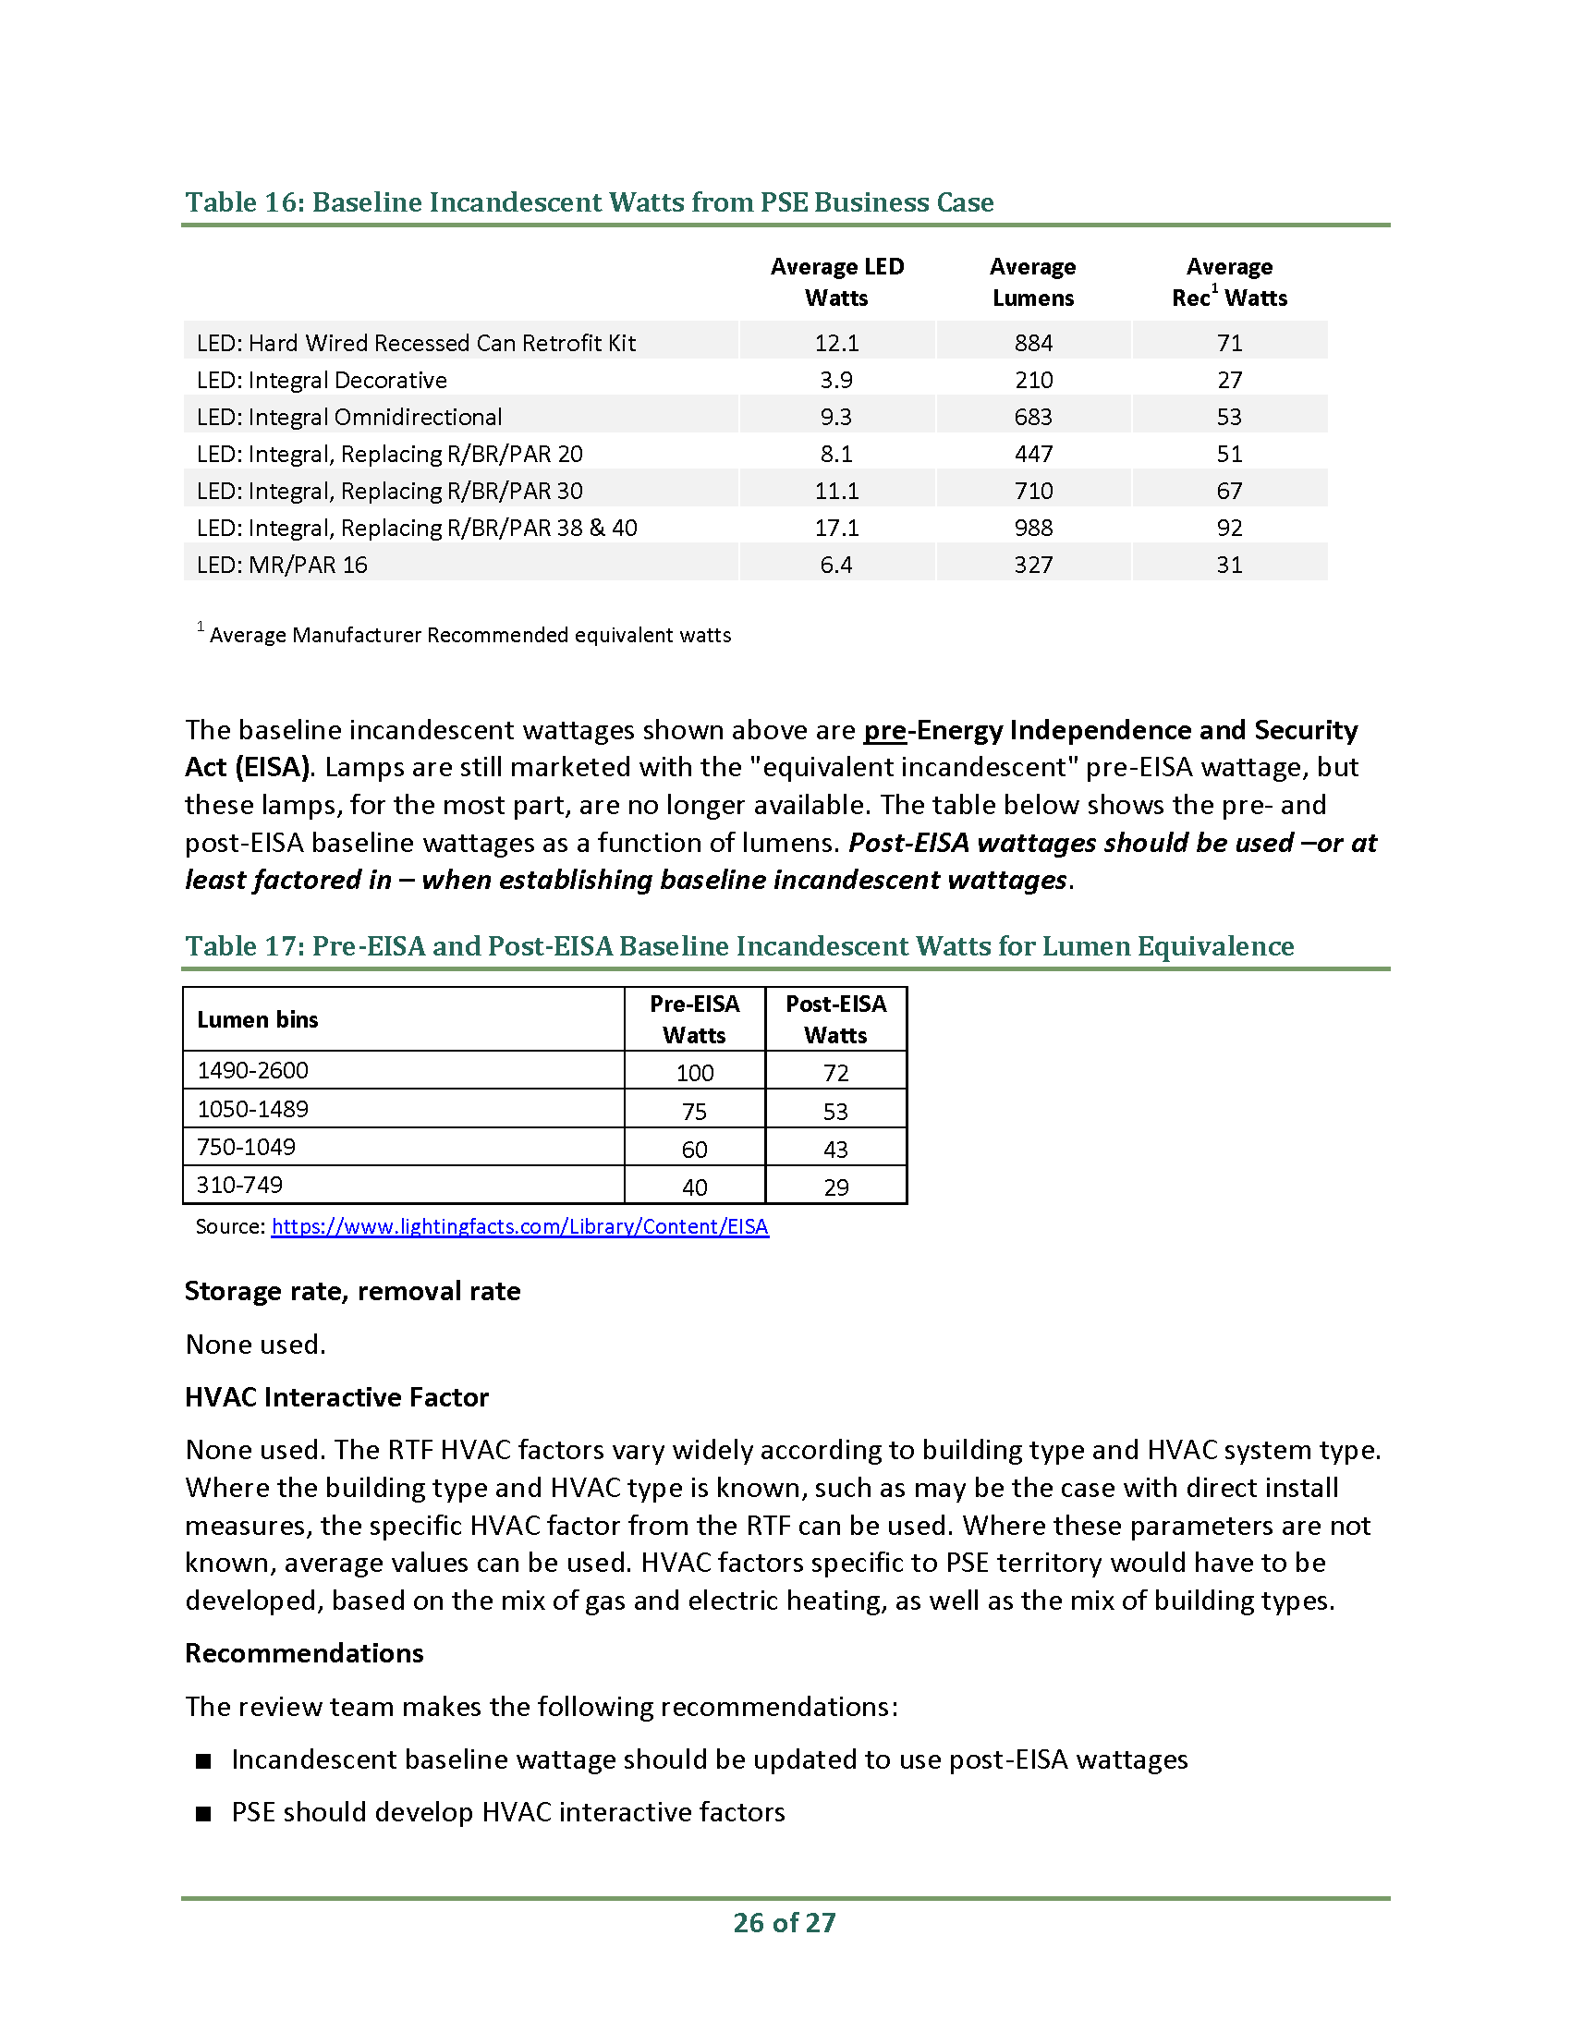

1. Lighting Calculator review

The calculator correctly derives savings for lighting retrofit measures. For prescriptive measures, which are LED installations, the savings derived in the calculator are consistent with the PSE 2015 LED Business Case. The review team has examined this business case, and made two recommendations to be consistent with RTF practices. These same recommendations apply to the prescriptive measures in the lighting calculator:

1. The incandescent portion of the baseline wattage should be based on federal minimum efficacy standards rather than the pre-existing wattage;
2. Savings should incorporate HVAC interactive factors.

For custom measures, the user enters the lighting types and hours for both baseline and installed fixtures If T12 is selected as the custom baseline lighting system, the baseline wattage assigned by the calculator is that of the T12 fixture. Most T12 fixtures can no longer be manufactured or imported to the United States, due to federal regulations, though replacements can still be purchased from inventory.

In most cases, regional practice is to assign the baseline wattage according to “pre-existing conditions.” But for incandescents and T12’s, which have legal restrictions on what can be manufactured, regional practice is to use a “current practice” baseline. Fluorescent fixture purchases were studied by the Bonneville Power Administration (BPA) in order to determine regional current practice. BPA found T12 sales to be vanishingly small, and derived current practice baseline values to be used when T12 fixtures are replaced. For incandescents, RTF practice is for the baseline lamp to be a mix of CFL and incandescents, with the incandescent portion represented by the federal standard lamp rather than the pre-existing lamp.

The same is true where the baseline fixture type is incandescent. If Incandescent is selected as the baseline lighting type, the PSE lighting calculator assigns the wattage to be that of the pre-existing incandescent lamp rather than the wattage of the higher efficacy lamp now required by federal regulations.

Table 15 shows the PSE calculator T12 and incandescent baseline values compared with the BPA values. SBW’s recommendation is that to be consistent with RTF practices, PSE adopt the BPA baseline values.

Table 15: PSE calculator baseline wattage compared with BPA current practice baseline

| Fixture type | PSE Calculator Wattage | BPA Current Practice Wattage |
| --- | --- | --- |
| T12 4’ | 37 | 28.7 |
| T12 8’ Slimline | 69 | 51.7 |
| T12 8’ HO | 105 | 90 |
| Incandescent 40 W | 40 | 29 |
| Incandescent 60 W | 60 | 43 |
| Incandescent 75 W | 75 | 53 |
| Incandescent 100 W | 100 | 72 |

HVAC Interactive Factors: For custom measures, the lighting calculator assigns an HVAC factor according to the type of heating system declared by the user. If gas heat is selected, the HVAC factor assigned by the calculator is 1.0; if electric heat is selected, the HVAC factor is 0.9.

HVAC factors used for commercial lighting by the RTF can be seen in the “Standard Information Workbook” (SIW).[13] Factors vary by building type and HVAC system type. By using a value of 1.0 for gas heated buildings, PSE is ignoring additional savings in cooling energy. These savings average around 7% of the lighting energy direct savings according to the SIW. For buildings with electrical heat and cooling, RTF HVAC factors vary from a reduction of 71% for a hospital with resistance heating to additional savings of 3% for big-box retail with a heat pump system.

The review team’s recommendation is that PSE develop more realistic HVAC factors based on the RTF work.

1. ERR Reviews

November 11, 2015 Memorandum:

Introduction

The purpose of this memorandum is to inform PSE staff of our interim findings from our work to date on PSE Evaluation Response Report reviews, completed as part of Task 5 of the Biennial Electric Conservation Achievement Review (BECAR). This memorandum begins with background information regarding this particular BECAR task and offers a brief summary of each review performed thus far.

Documentation of the first six evaluation report responses has been provided to SBW reviewers including the following: Fuel Conversion, Home Energy Reports, Residential Retail Lighting, Web Enabled Thermostats, Commercial Lighting, and Sealing and Insulation in Multifamily Buildings. A summary of the ERR review for each of these programs is presented below.

Background

The primary BECAR objective for SBW as the independent third-party reviewer is to *assess the extent to which PSE’s reported electric energy savings were achieved***.** To accomplish this objective, the 2014-2015 BECAR includes seven separate tasks. This memorandum addresses Task 5 (PSE ERR Reviews), which encompasses the following:

*Assess whether PSE has undertaken follow-up actions on program evaluation studies completed after the 2012-13 BECAR, based on the Evaluation Response Reports included with each completed program evaluation.*

In keeping with this objective, SBW spent the month of October focused on PSE ERR reviews. Steps subsequent to that were as follows:

* On October 5, SBW received its first batch of ERR from PSE and proceeded to review the evaluations and their respective response reports together.
* On October 21, SBW arranged and held the first series of program manager interviews. These interviews continued to be scheduled through the last week of October based on program manager availability.

This memorandum presents our assessment of the extent to which the programmatic action items described in the PSE internal evaluation report response (ERR) were implemented, particularly those that could have potentially affected future savings values.

ERR Review Summaries

Fuel Conversion

Evaluation Summary

The fuel conversion program is comprised of three sectors of participation (Space and Water Heating, Space Heating Only, And Water Heating Only). The evaluation estimated energy savings and recalculated the sector cost effectiveness as well as the overall program cost effectiveness (see Evaluation Table 1-3 below).

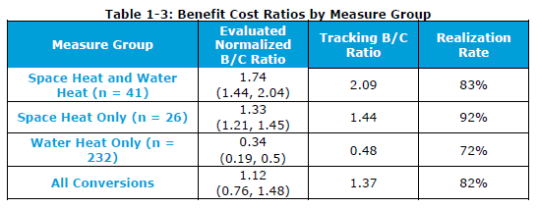

The results of this evaluation were not available until August, 2015, which was after the PSE deadline for implementing program changes for the 2016 year. However, PSE did use some preliminary evaluation results to verify that the cost effectiveness had not changed significantly. Therefore PSE decided to keep their original program numbers for 2016, with a plan to phase in the evaluation savings and cost effectiveness values in 2017.

Action Plan and Review Comments

The PSE action plan for 2017 speaks to removing the barriers of participation by doing away with a minimum kWh consumption requirement for the Space and Water Heating sector of the program. PSE based this plan on the fact that the Water Heating Only program does not have a minimum kWh consumption requirement and it has many more participants (see Evaluation Table 1-1 below).

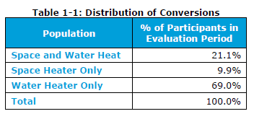

The evaluation addressed minimum kWh requirement in two ways. They calculated the minimum kWh required to achieve a range of cost effectiveness values (see Evaluation Table 7-1 below) and they determined the percent of current participants that would still be able to participate if they set minimum cost effectiveness goals based on the first analysis (see Evaluation Table 7-4 below).

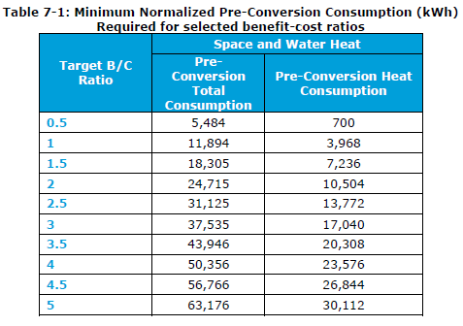

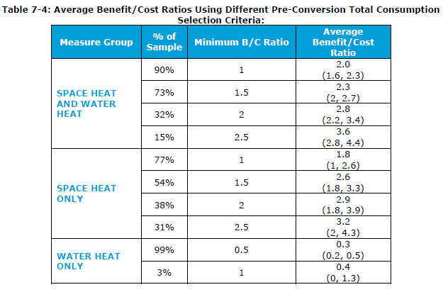

The evaluation developed regression models that indicate a linear relationship between total consumption and cost effectiveness: the more energy a potential participant uses the more cost effective such a conversion is likely to be (the converse being true as well.)

The tables above point toward a potential impact of removing the minimum kWh requirement. The cost effectiveness of this program appears to rely on the Space Heat and Water Heat sector to “keep it afloat” because it is comprised of a smaller number of highly cost effective projects. Removing the minimum consumption requirement will likely mean more participation but it will also mean more participation of lower energy users; in other words, less cost effective participants which will lower the program cost effectiveness, perhaps below 1 depending on participation.

Conclusions

Based on the conversation with the PSE program manager it is clear that the potential impact described above had not been considered. While the DNV GL analysis developed the data in the tables above, it appears that an additional feedback cycle was needed between the DNV GL evaluators and the program manager in order to assist the manager in interpreting the evaluation results. While at first glance the action plan laid out in the ERR appears reasonable, it does not factor in the potential impacts of such a change on the overall program cost effectiveness.

Home Energy Reports

Evaluation Summary

The DNV GL evaluation determined electric and gas savings for Home Energy report program developing new savings numbers that it recommended to be used in on-going years. The evaluation investigated the savings of legacy participants, new participants from a program expansion and carry-over savings of discontinued/suspended customers. These savings numbers are present in the evaluation tables below.

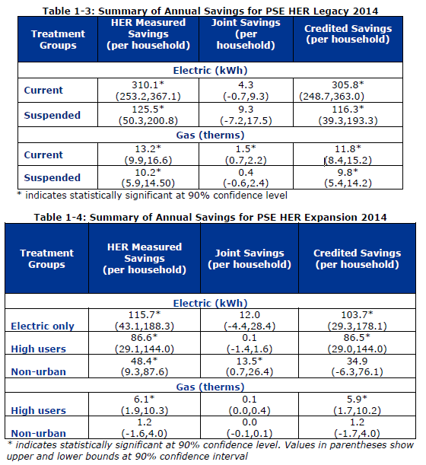

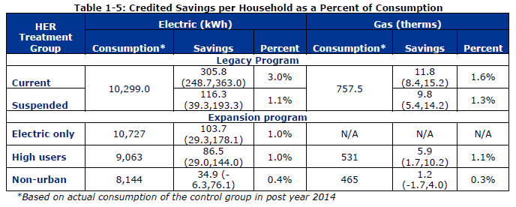

Action Plan and Review Comments

The action plan called for the adoption of the program evaluation savings numbers which, according to the program manager interview, were used in the 2014 ex-post savings claims and in all following HER program savings calculations. Since the time of the evaluation, the program manager has noticed a flat line in annual savings of the original participant group from seven years ago. Low numbers of program “opt outs” demonstrate customer satisfaction with the program. The program has been further expanded to include 100,000 more participants including control group participants. One third of new customers are “electric only” participants. The utility will use the results of this continued study to determine program persistence.

Conclusions

PSE has taken the appropriate steps to adopt these new savings values into their current program while also considering the implications of the DNV GL findings on various forms of program participation. PSE has continued this study as it further expands the program in order to enable further program reassessment.

Residential Retail Lighting

Evaluation Summary

This evaluation was actually a study performed by Itron that sought to estimate the percentage of LED bulbs sold through PSE’s residential lighting discount that were being installed in non-residential locations and to assess the impact of these non-residential installations on the resulting program impact estimates. The study found that 8% of LEDs sold at program retailers were purchased by nonresidential customers which in turn impacted the expect hours of use (HOU) for these bulbs. The changes to the program HOU are presented below.

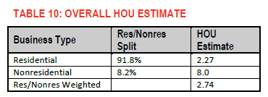

Action Plan and Review Comments

The action plan in response to this evaluation is for PSE to update their program HOUs to the new HOUs in future LED lighting energy savings calculations. Where the previous assumption of 100% residential use of retail residential LED lighting had been used, the study herein indicated a portion of the lighting (8%) actually going to nonresidential applications. This estimate in turn informed an adjustment in the HOUs that resulted in a 20% increase in HOUs for that LED lamp program. The program already uses the RTF lighting energy savings model for this program and simply updated the HOU inputs with this new value for 2016.

Conclusions

PSE appropriately adopted the new HOUs and incorporated them into future program energy savings calculations that they use based on the RTF standard.

Web-Enabled Thermostats

Evaluation Summary

DNV GL performed an impact evaluation on the Web-enabled Thermostats program that sought to measure the associated reduction in natural gas, quantify savings from other interacting PSE measures, and provide a final estimate of 2014 program savings.

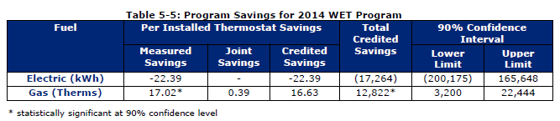

Action Plan and Review Comments

The action items presented in this ERR include utilizing program study savings outcomes as program savings values and the creation of a cost effective rebate to promote adoption of web enabled thermostats. An interview with the program manager confirmed that the evaluation savings are now being used and a $75 rebate has been established in support of this measure. The manager was generally pleased with the evaluation although slightly disappointed with the savings found in the evaluation.

Conclusions

PSE appropriately adopted the new savings values from this impact evaluation and also used them to inform the process of creating a cost effective rebate to encourage further program participation.

Commercial Lighting

Evaluation Summary

This evaluation constituted a subset of a large multi-program evaluation performed by Navigant. As such, SBW had to pull out recommendations that specifically pertained to the commercial lighting programs. The impact evaluation results are presented below in the tables from the Navigant evaluation.

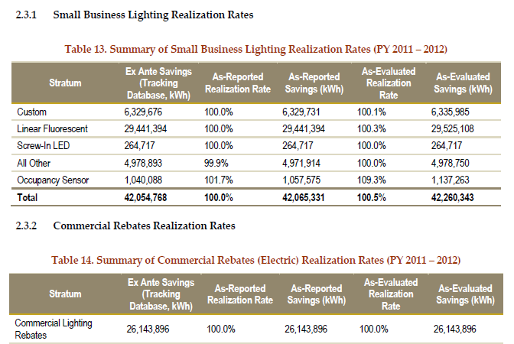

Additionally, a meta-study was performed to develop estimates for operation hour reductions for occupancy sensor measures which are presented in the table below.

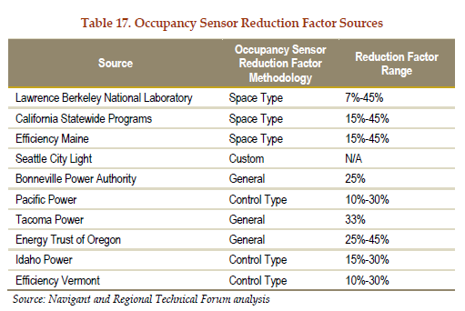

A process evaluation was also performed which sought to evaluate program design, customer and trade ally experience, and overall process implementation. The recommendations from the process evaluation are also discussed in this memorandum.

Impact evaluation related recommendations addressed:

* Program Data Requirements
* Energy Savings Calculations and Documentation

Process evaluation related recommendations addressed:

* Targeted Marketing
* Coordinated Rebate Processing
* Customer Recognition
* Application Process

Action Plan and Review Comments

Some major program organizational changes have occurred since this evaluation took place. Multiple lighting efficiency programs have been consolidated into one primary Business Lighting program and while others have been phased out to prevent apparent “double-dipping” in commercial lighting rebate programs. In addition, offerings such as the Enhanced Lighting Retrofit (ELR) have been phased out due to misapplication by contractors. Notably, PSE found that contractors would quote rebates to customers based on ELR program savings-- which require a comprehensive lighting retrofit -- despite the fact that the customers requested only partial implementation of measures.

Our interview with the program manager interview along with the action plan laid out in the ERR indicate PSE has demonstrated continuous improvement processes, some of which have paralleled evaluation recommendations. These improvements have been incorporated into the development of the new lighting program structure associated with the formation of the Business Lighting program. For example, one impact recommendation for the Business Lighting program focused on data availability and program transparency; PSE is addressing these issues with a data management system contracted to be built and released for use sometime in mid-2016.

Lighting Related Impact Recommendation Responses

Recommendation:

* In the Small Business Lighting Program, PSE can require contractors to submit the rationale behind Annual Operating Hours calculations.

Response:

* An internal Quality Control (QC) section has been developed and added to PSE’s current lighting calculator which requires QC to verify Hours of Use (HOU) estimates and describe HOU estimation methodology.

Recommendation:

* PSE can increase traceability and possibly report more savings if the occupancy sensor reduction factors changed from custom inputs to industry-accepted standards by space type. Review of PSE’s current lighting calculator show these factors being included while the original simplified factors also remain in the line item dropdown lists.

Response:

* As mentioned above, PSE was already developing standardized reduction factors based on RTF and BPA data per space type when the evaluation was taking place and now uses these in its current lighting calculator.

Lighting Related Process Recommendation Responses

Recommendations:

* PSE should leverage existing data from within the company whenever possible to limit the amount of information the customers and trade allies need to provide.
* Provide a transparent and timely system that allows customers and trade allies to see how their rebate is progressing through the PSE process
* PSE should strive to ensure that program trade allies have access to up-to-date, accurate information about measure eligibility and available funding.
* PSE should continue to cultivate personal relationships with trade allies, and should explore ways to better connect customers with trade allies.
* PSE should arm trade allies with easy to understand information and tools that explain clearly the amount of savings in terms of energy and cost.
* Undertake regular market research including penetration analysis for the program
* Assign staff to specific roles to capitalize on their skillsets
* Create “accounts” to add convenience to repeat customers
* Consider implementing an online application

Responses:

* A number of the program recommendations suggested taking additional steps to inform and involve trade allies. PSE has acted on this recommendation by bolstering efforts to support some existing professional networks it already has in place such as the Contractor Alliance Network while also forming outreach focus groups that have been working on supporting out-of-network contractors.
* Another recommendation concerned the use of market penetration research to develop better understanding of potential market opportunities. PSE extended the Commercial Building Stock Assessment analysis toward this purpose while also dedicating an internal focus group to the task of interpreting and creating actionable items based on its results.
* One key recommendation suggested reorganizing the roles of the rebate staff so that administrative staff could take over some of the basic rebate processing tasks in order to free up technical staff to work more directly with M&V work. PSE has undertaken this sort of reorganization while also splitting its lighting programs into small scale (<25000 kWh) and large scale groups. The larger number of small scale projects are verified via a random sampling process that examines 1/3 of the projects. This statistical verification process ensures that enough technical staff are also available to work on M&V of larger projects.
* Regarding the implementation of online applications: PSE performed an informal internal study that involved making an Excel, pdf, and online version of the application to trade allies and participants. The results of this study showed a significant preference for the excel forms ; PSE elected to wait on developing a fully online application until the other support database systems under development are fully in place sometime mid-year 2016.

Conclusion

The Navigant evaluation examined multiple facets of the PSE commercial programs and PSE’s response shows that they incorporated these recommendations into the program reorganization that is currently underway.

Multifamily Air Sealing and Insulation Pilot Program

Evaluation Summary

PSE engaged DNV GL in an impact evaluation of their Sealing and Insulation in Multifamily Buildings Pilot Program. The program currently requires pre/post blower door testing on every project in order to characterize site energy savings. PSE seeks to improve the cost effectiveness of this program by determining appropriate deemed savings values. The pilot program evaluation characterized the savings variability given the current savings estimation practices used by PSE for this program. Recommendations were developed for how PSE should proceed given its desire to improve cost effectiveness of the program by implementing deemed savings where possible and minimizing M&V as well. DNV GL determined target sample sizes needed to develop statistically viable deemed savings, presented in the table below.

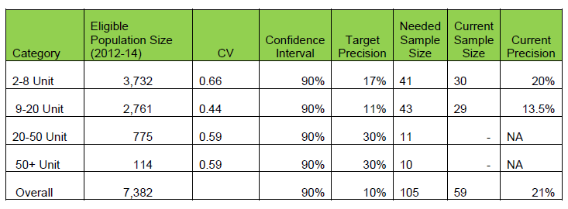

Action Plan and Review Comments

PSE has been continuously collecting data on all of its sites for use in an ongoing study, and according to the program manager, they expect to achieve the sample sizes recommended by the evaluation by mid-2016. Larger sites, which are generally less frequent, will still have savings verified by pre/post measurement and blower door testing. PSE is considering partial testing on typical buildings in project composed of a number of medium sized buildings in order to reduce the cost.

Conclusion

The DNV GL evaluation made clear recommendations regarding target sample sizes needed to develop reasonable deemed savings values based on the variability of the data examined by this evaluation. The action plan and program manager interview demonstrate that PSE clearly understood the evaluation recommendations and are pursuing an action plan that accounts for them.

March 15, 2016 Memorandum:

Introduction

The purpose of this memorandum is to inform PSE staff of the BECAR team’s interim findings from our work to date on PSE Evaluation Response Report (ERR) reviews, completed as part of Task 5 of the Biennial Electric Conservation Achievement Review (BECAR). This memorandum begins with a summary of our findings, then provides background information regarding this particular BECAR task, and finally offers a summary of each review performed thus far.

Overall Summary

During the course of last year, nine separate ERR were provided to the BECAR review team. Reviews of the first five ERR were presented in an earlier memo (dated November 11, 2015). Since that time, the BECAR team has completed reviews of the other four ERR, namely:

* HomePrint Assessment
* Multifamily Retrofit
* Manufactured Home Duct Sealing
* Commercial Rebates and Small Business Lighting, specifically:
  + Pre Rinse Spray Valves and Faucet Aerators
  + HVAC Rebates and Premium HVAC Service

Based on review of the above ERR, it is evident that PSE has sought to follow the recommendations made by the evaluations, including the adoption of new savings values when appropriate. While the evaluation findings have spurred some direct actions, PSE’s own internal process improvement initiatives have provided both impetus and solutions to a significant number of the issues raised in the evaluations.

Background

The primary BECAR objective for SBW as the independent third-party reviewer is to *assess the extent to which PSE’s reported electric energy savings were achieved***.** To accomplish this objective, the 2014-2015 BECAR includes seven separate tasks. This memorandum addresses Task 5 (PSE ERR Reviews), which encompasses the following:

*Assess whether PSE has undertaken follow-up actions on program evaluation studies completed after the 2012-13 BECAR, based on the Evaluation Response Reports included with each completed program evaluation.*

In keeping with this objective, SBW has spent October-December focused on PSE ERR reviews. Steps subsequent to that were as follows:

* On October 5, SBW received its first batch of ERR from PSE and proceeded to review the evaluations and their respective response reports together.
* On October 21, SBW arranged and held the first series of program manager interviews. These interviews continued to be scheduled through the last week of October based on program manager availability.
* On December 12, SBW received the second batch of ERR from PSE and proceeded to review the evaluations and their respective response reports together.
* On December 18, SBW arranged and held the second series of program manager interviews. These interviews continued to be scheduled through the first week of January based on program manager availability.

This memorandum presents our assessment of the extent to which the programmatic action items described in the PSE internal evaluation report response (ERR) were implemented, particularly those that could have potentially affected future savings values.

ERR Review Summaries

HomePrint Assessment Program

Evaluation Summary

PSE engaged DNV GL in an impact and process evaluation of the Homeprint program to identify processes, collect feedback from participants, and develop a savings review of program measures. DNV GL performed interviews and collected surveys to assess the program processes and performed a savings review to develop the impact evaluation. The process evaluation resulted in a number of findings showing high customer satisfaction with the program and high levels of engagement by participants. A series of recommendations were presented that centered around improved program information exchange and communication. The impact evaluation demonstrated lower savings and measure lives than those used in the program, shown in Table 1. They also found significantly higher installation rates than claimed by the program, indicating momentum, shown in Table 2.

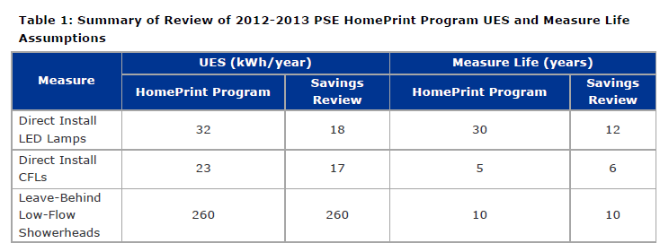

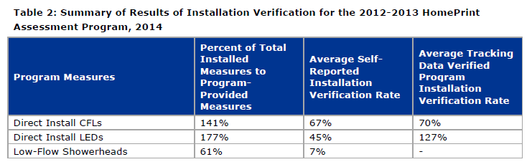

DNV GL recommended the adoption of RTF values for savings and measure lives in place of those being used at the time of the evaluation.

Action Plan and Review Comments

The action plan developed by the program manager indicated that PSE is integrating the process evaluation feedback into ongoing program improvements. PSE has implemented new information management systems and improved its communication protocols. With regard to the impact evaluation findings, PSE has adopted RTF measure lifes and is collaborating with the RTF in developing improved savings values for direct install LED programs.

Conclusions

The program manager interview and action plan developed for this evaluation show that PSE clearly understood the evaluation findings and recommendations and that they have appropriately integrated them into ongoing program process improvement.

Multifamily Retrofit Program

Evaluation Summary

DNV GL performed an impact and process evaluation to verify measure installations, determine a program-level realization rate for energy savings, and provide recommendations aimed at improving program delivery. The results of the impact evaluation are presented in the table below.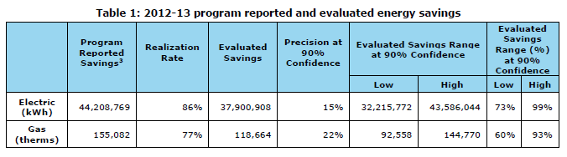The study found reduced savings for both electric and natural gas sources, and also developed the following two key findings regarding measure implementation and persistence:

* Persistence of DI measures was lower than assumed by the program. Persistence was inferred from the results of the installation rate results presented in the table below.

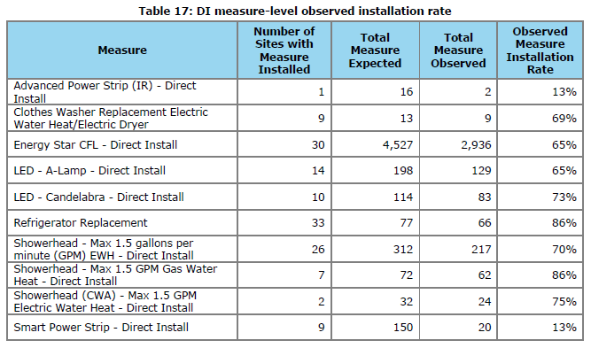

* Power strips were found to have the lowest installation rate of any DI measure at just 13%.

Action Plan and Review Comments

PSE’s action plan addresses the major findings and describes how existing process improvement initiatives have achieved this. The program team strives to ensure that the program is operating at a high level of efficiency and maximizes all opportunities to improve. The majority of the report’s impact and process recommendations were implemented during the 2014-15 program cycle. PSE staff continue to seek out opportunities to improve the customer interactions, as well as track and report savings and program outreach/education.

PSE contests how representative the installation rate findings are because of the limited sample size(a single building) used to develop these rates. Regarding the issues identified for smart power strips, PSE has since moved to a different power strip vendor that utilizes bluetooth technology which facilitates better monitoring on behalf of the end user and potentially could provide information to the utility as well.

PSE has addressed some of its process issues through new internal standards and the use of an intergrated information platform called Energy Orbit, which has streamlined numerous processes within the program including, but not limited, to application, tracking, and project file data.

Other process improvements they have pursued include changes to marketing approaches aimed at regional-level property management firms in order to reduce stalled participation, as well as implementing a customer recognition program called *Strive for Five,* whereby residents and property managers are recognized for their efficiency work.

Conclusions

The action plan and discussions with PSE staff members show that they clearly understood the evaluation findings and appropriately took action to address them. Process improvement initiatives have been underway since 2014 that have integrated key recommendations made in the evaluation, while also seeking new program improvement opportunities.

Manufactured Home Duct Sealing Program

Evaluation Summary

The impact evaluation evaluated the two program offerings (In-park and Out-of-Park) across three levels of duct sealing rigor. The study found statistically significant savings for five of six study levels and realization rates of less than one for all programs except Level 1 Out-of-Park. The process evaluation found that PSE is using sound procedures and has satisfied stakeholders as a result of the program. The process evaluation did identify conflicts of interest associated with the program implementer also being responsible for installation verification and satisfaction survey administration.

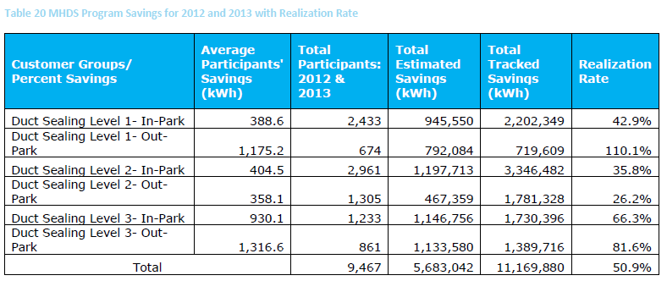

Action Plan and Review Comments

The PSE action plan addresses the key findings of the evaluation through program and process changes. In order to address the low program realization rates, the program has instituted changes including:

1. Use of RTF measure savings values, which are presented in the table below, offer more conservative savings values that more closely align with the evaluation savings. 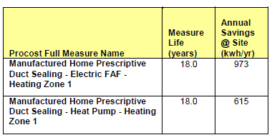
2. In order to facilitate improved standardization of the duct sealing measure implementation, PSE adopted the RTF delivery guidelines for prescriptive air duct sealing.
3. PSE transitioned from a service provider delivery for the Manufactured Homes Duct Sealing program to providing customer incentives offered through PSE CAN contractors
4. Along with these changes, this program has been folded into the Single Family Home Existing Weatherization and HVAC program

PSE addressed the conflict of interest issues observed in the process evaluation by revising the delivery of the QA/QC and customer satisfaction survey functions of the program beginning January 1, 2016. Both elements of the program will be managed by either an independent firm selected to support the program, or PSE staff, as deemed the most efficient and appropriate use of resources. A sample of all homes will receive diagnostics to further evaluate the effectiveness of the installed measures. A refined set of data collection requirements will be established to ensure consistency in the delivery and reporting to PSE to support future evaluation efforts.

Conclusions

The PSE evaluation response and an interview with the program manager demonstrate a solid grasp of the evaluation results embodied by an action plan that address key issues indicated in the evaluation. Rather than further adjusting its savings values down to the average savings estimates found in the impact evaluation, PSE chose to adopt both the RTF measure savings values and measure implementation guidelines. This offers a more conservative savings estimate, while also serving to improve implementation standards.

Pre-Rinse Spray Valves and Faucet Aerators

Evaluation Summary

This evaluation constituted a subset of a large multi-program evaluation performed by Navigant. The BECAR team extracted from that evaluation the recommendations that specifically pertained to the pre-rinse spray valve sub-program. The impact evaluation results are presented below in the tables from the Navigant evaluation.

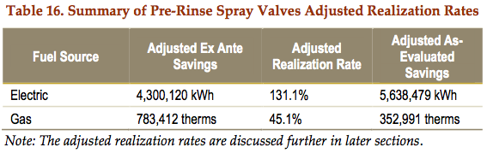

Faucet aerators in the pre-rinse spray valve sub-program were initially found to have very low as-evaluated realization rates due to overestimated prescriptive savings values. After adjusting ex ante savings to account for this, the evaluation resulted in realization rates that deviated significantly from 100 percent, as shown in the table above. These variations in realization rates were primarily due to discrepancies in measure quantities and fuel sources. A summary of the observed in-service rates and actual fuel sources are shown below in tables from the Navigant evaluation.

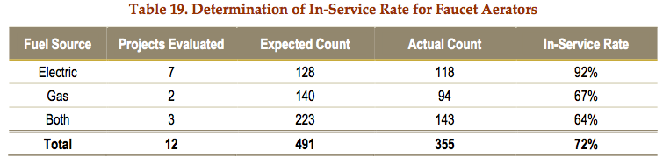

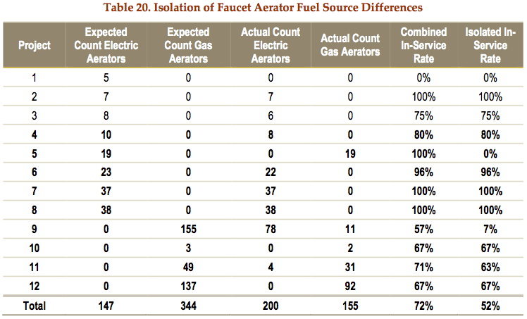

Action Plan and Review Comments

Our interview with the program manager indicates major program organizational changes have occurred since this evaluation took place. The faucet aerator sub-program has been moved to the Small Business Direct Install program, which is better suited to the direct install design of the faucet aerator sub-program. In addition, PSE requested Navigant perform additional follow-on field work and analysis which will help inform the in-service rate for faucet aerator installations.

Our interview with the program manager along with the action plan laid out in the ERR indicate PSE has demonstrated continuous research and improvement in the faucet aerator program, primarily as a result of these evaluation recommendations. These improvements include the transition of the faucet aerators sub-program into the Small Business Direct Install program.

Faucet Aerator Related Impact Evaluation Recommendation Responses

Evaluation Recommendations:

* PSE can diversify the energy savings calculations to include applications other than hospitality and non-hospitality. Conversely, PSE could limit the installation of aerators in non-restroom spaces.
* PSE can increase the reliability or accuracy of energy savings forecasts of commercial faucet aerators by implementing an in-service rate factor in the prescriptive savings methodology. Furthermore, PSE could also set in-service rates based on the building type. Alternatively, as part of the standard installation procedures, PSE can require the contractor to leave a specified number of aerators with the project sponsor at the site.
* PSE should consider augmenting the V-Team’s post-installation inspection procedures for faucet aerator projects.
* PSE can require contractors to provide additional detail for the reporting of faucet aerators.

ERR Responses:

* PSE is conducting additional research on installation locations of faucet aerators and has found that many were installed in locations that will not achieve the savings consistent with current UES assumptions. As a result, PSE is limiting the installation of aerators to public restroom locations. PSE is also considering limiting the installations to certain building types, such as schools, restaurants, and grocery/convenience stores.
* To improve the accuracy and savings of faucet aerators, PSE has updated the business case to include more appropriate UES values, implemented standardized installation procedures for the third party installation contractor, and commissioned a study by Navigant to better understand the low realization rates found for faucet aerators.
* PSE is working with its internal verification team to improve and implement inspection protocols to increase installation confidence. Verification for faucet aerators is also more rigorous now under the Small Business Direct Install program. PSE is considering which data listed in the recommendation is appropriate to include as part of verification and which of those data will continue to be collected by the third party implementer.

Faucet Aerator Related Future Research Recommendation Responses

Evaluation Recommendation:

* PSE can oversee an in-depth process evaluation to complement this impact evaluation.

ERR Response:

* PSE has not conducted an in-depth process evaluation of the faucet aerator sub-program since this recommendation was made. No process evaluation is planned for the 2016-17 cycle, however, interviews with program staff indicate that considerable effort throughout 2015 has been spent examining and improving the program processes.

Conclusion

The Navigant evaluation examined multiple facets of PSE commercial programs, including the pre-rinse spray valve and commercial aerator offerings. PSE’s response to the evaluation findings for these shows that they are actively working to incorporate the corresponding recommendations into the program reorganization that is currently underway.

HVAC Rebates & Premium HVAC Service

Evaluation Summary

This evaluation constituted a subset of a large multi-program evaluation performed by Navigant. The BECAR team extracted the recommendations that specifically pertained to the HVAC rebates and premium HVAC service program. The impact evaluation results for Premium HVAC Service are shown below in the tables from the Navigant evaluation.

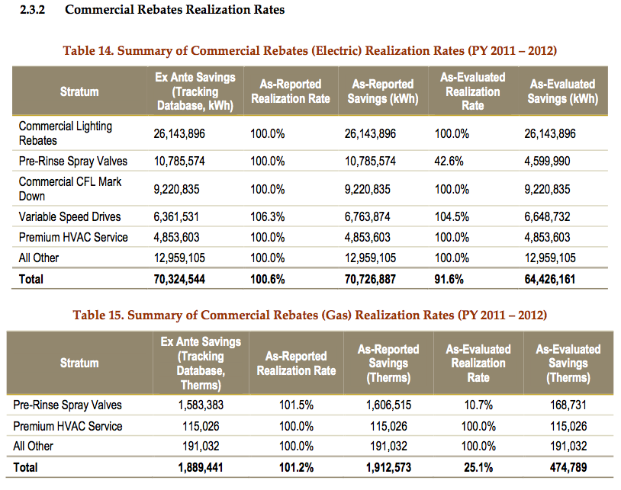

Action Plan and Review Comments

Our interview with the program manager along with the action plan laid out in the ERR indicate PSE has updated the business case to incorporate evaluation recommendations.

HVAC Rebates & Premium HVAC Service Related Impact Recommendation Responses

Evaluation recommendations:

* The Premium HVAC Service sub-program uses a matrix of inputs to estimate energy savings per ton of cooling for eligible units. Although several supplementary files were available for the evaluation, the basis for the estimated energy savings was unavailable. Navigant verified serviced units and inputs to PSE’s energy savings matrix, but the team was unable to review the engineering calculations used to estimate the energy savings. As the best possible evaluation option, Navigant reviewed other sources with similar HVAC service measures. Navigant concluded PSE’s energy savings estimated are *reasonable, though a duplicate or original business case analysis is recommended for future implementation and evaluation*.

ERR responses:

* PSE has updated the business case for the Premium HVAC Service sub-program and all corresponding documentation is stored in the program database. All engineering models, cost effectiveness calculations, and other data sources used in the business case are stored and available for future reference.
* PSE has improved the traceability and reliability of the updated business case by documenting the assumptions of each computer simulation used in the business case, clearly identifying rooftop HVAC equipment energy savings values in four commonly-occurring business types, clearly stating the condition of existing equipment, using PSE and BPA metering data as baseline inputs for computer simulations, and retaining and labeling all documents related to the business case.

Conclusion

The Navigant evaluation examined multiple facets of the PSE commercial programs, including the HVAC Rebates & Premium HVAC Service offerings, and PSE’s response to the evaluation findings for these shows that they incorporated relevant recommendations into their latest business cases for these programs.

1. See Docket UE-132043, PSE 2014-15 Biennial Conservation Plan (BCP) Vol. 1, Table 1c, page 10 for derivation of the EIA Target.
2. **(6) Approved Strategies for Selecting and Evaluating Energy Conservation Savings. (c)**  If Puget Sound Energy uses savings estimates, methods or protocols that differ from those established by the RTF, such estimates, methods or protocols must be based on generally accepted impact evaluation data and/or other reliable and relevant source data that has verified savings levels, and be presented to the CRAG for comment.
3. PSE Guidelines for Measure Revisions, Version 6.25, October 2014.
4. **_PSE 2015 Business Lighting Workbook V3-3-1.xlsx** – Referred to here as the “lighting calculator.”
5. <http://rtf.nwcouncil.org/measures/measure.asp?id=131>
6. <http://rtf.nwcouncil.org/measures/res/ResDHPonFAF_Provisional_v1_2.xlsm>
7. <http://rtf.nwcouncil.org/measures/res/ResSFExistingHVAC_v3_2.xlsm>
8. <http://rtf.nwcouncil.org/meetings/2012/02/ResMHWx_v3_1.xlsm>
9. <http://rtf.nwcouncil.org/measures/res/ResManufacturedHomesWeatherization_ElectricResistance_v4_0.xlsm>
10. <http://rtf.nwcouncil.org/measures/support/files/RTFStandardInformationWorkbook_v2_2.xlsx>
11. HVAC Interaction tab in PSEDeemed_LED Bulbs and Fixtures_v05_20140109.xlsx
12. Because SBW Consulting operates a direct-install program that was part of this evaluation, the review team assigned Evergreen Economics responsibility for the Pre-Rinse Spray Valves and Faucet Aerators to avoid a conflict of interest situation.
13. <http://rtf.nwcouncil.org/measures/support/files/RTFStandardInformationWorkbook_v2_2.xlsx>