|  |  |
| --- | --- |
| **Avista Corp.**  1411 East Mission P.O. Box 3727  Spokane, Washington 99220-0500  Telephone 509-489-0500  Toll Free 800-727-9170 |  |

September 12, 2014

***Via Electronic Mail***

Steven V. King

Executive Director and Secretary

Washington Utilities & Transportation Commission

1300 S. Evergreen Park Drive S. W.

P.O. Box 47250

Olympia, Washington 98504-7250

Re: Docket No. UE-143270 - Comments of Avista Utilities on the “Environmental Protection Agency’s proposed Clean Power Plan regarding subsection 111 (d) of the Clean Air Act.”

Dear Mr. King,

Avista Corporation (“Avista” or “Company”) hereby provides its initial comments on the United States Environmental Protection Agency’s (EPA’s) proposed rule regarding *Carbon Pollution Emission Guidelines for Existing Stationary Sources: Electric Utility Generating Units*, 79 Fed. Reg. 34830 (June 18, 2014) for the state of Washington.

The Company has outlined several areas of EPA’s proposed rules that merit comment by the State of Washington during EPA’s comment period. Avista has not included all issues of jurisdictional or legal concern. These areas focus on practical concerns from a utility perspective on behalf of its Washington customers. We hope these issues are informative to the Commission as the State of Washington formulates its comments to EPA.

**Baseline Emissions Should Be Adjusted to Account for Non-Normal Variances**

EPA should start with a baseline period that is reasonably representative of actual generation and carbon emission levels. While it might be impossible to identify a “one-size-fits-all” baseline year that is universally accepted, a case can be made for selecting a baseline year other than 2012 that makes sense and would not compromise the intent of the proposed rule. Specific to the Pacific Northwest, a single year is unlikely to be representative of a fair “starting point” because of when some plants began operation and hydroelectric variability.[1] Avista does not believe that the baseline should be the same for all states; rather the states should have, within their authority, the ability to determine the appropriate baseline period.

*Impact of Baseline Year on Thermal Operations*

The Pacific Northwest benefits from a large base of emissions-free hydroelectricity generation. Thermal plants constitute a smaller percentage of overall output (~18%) relative to other regions of the country and certain states have very few such plants falling under the EPA proposal. For example, Idaho has only two thermal plants that would be impacted by the EPA proposal. Both plants operated at a low level in 2012, relative to the expected long-term average, because the region experienced an above-average water year. To illustrate the impact on thermal operations due to 2012 being a high hydro year, Chart 1 below shows total natural gas-fired generation by year for the Pacific Northwest states from 2003 through 2012. Natural gas generation is significantly higher in lower water years and lower in higher water years.

*Chart 1 – Pacific Northwest Hydroelectricity and Natural Gas-Fired Generation*

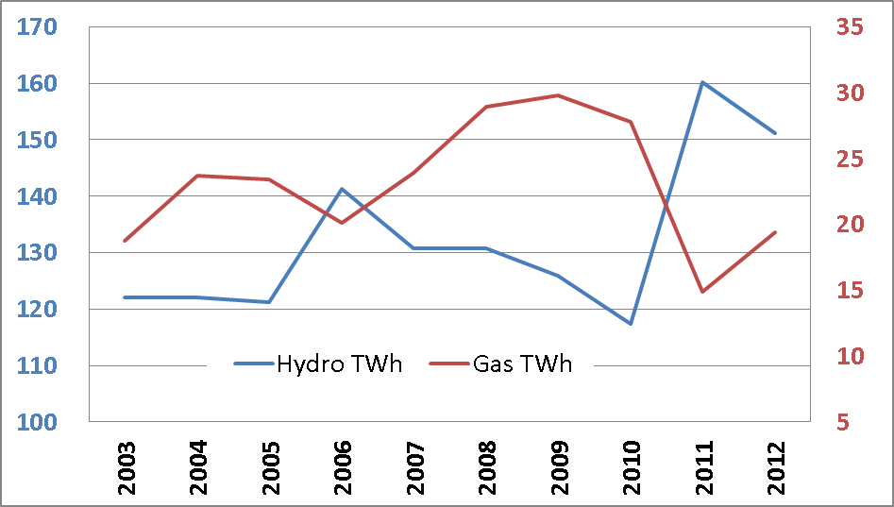

The implications of the 2012 baseline are magnified in Avista’s Idaho service territory because the state has only two natural gas-fired plants falling under proposed 111(d) regulation. One of the two, the 318-MW Langley Gulch plant owned by Idaho Power, came online late in calendar year 2012 and operated at a 15% annual average capacity factor. This level is well below the level operated at similar plants. Having almost identical operating characteristics and integrated similarly in the marketplace, the plant operated in 2012 with a capacity factor of one-third that of Rathdrum Power, the only other Idaho regulated plant. See Chart 2 below:

*Chart 2 – Comparison of 2012 Langley Gulch and Rathdrum Power LLC Plant Operations in Idaho*

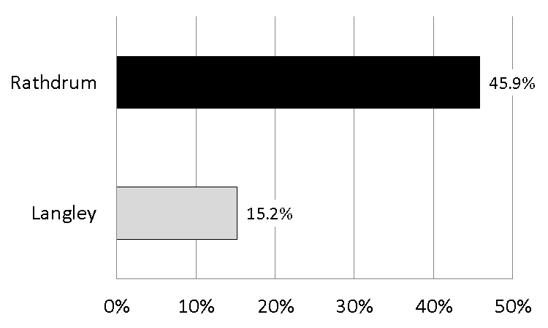

*Impact of Baseline Year on Hydro Operations*

As discussed above, 2012 was an above-average hydro year, causing baseline CO2 emissions in Washington and the Pacific Northwest to be artificially low. 2012 carbon emissions in Washington State were 5.5 million tons lower due to above-average hydroelectricity generation. This figure is large compared to 2012 actual CO2 emissions of approximately 7 million tons for the state, and EPA’s goal of approximately 2.5 million tons by 2030. Other states witness similar impacts, though not as much as Washington. See Chart 3 below:

*Chart 3 – Historical Carbon Emissions by State (millions of CO2 tons)[2]*

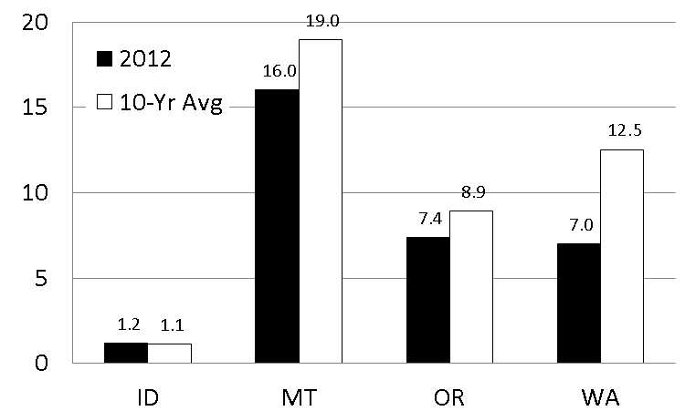

*Proposed Modifications to Baseline*

EPA should provide states an opportunity to expand baseline emissions on a multi-year average. Further, EPA should allow states to adjust baseline emissions from plants that operated for only a portion of the baseline period. This later adjustment could be made by adopting emissions levels of a plant or plants of similar characteristics to the subject plant during the baseline period.

**Final Rule Should Allow for Year-to-Year Hydro Variation**

As a hydro-dependent region, the Pacific Northwest should not be penalized for its use of this non-carbon emitting resource. Chart 4 below details Pacific Northwest hydroelectricity variability from 1989 through 2012. It shows that flow and generation over the past 23 years have varied significantly. Because most Pacific Northwest states benefit from hydroelectricity generation, and have relatively little thermal generation, they must rely largely on building blocks three Renewable Energy (RE) and four Energy Efficiency (EE) of the proposed rule to meet their emission-rate goals.[3]

*Chart 4 – Pacific Northwest Hydroelectricity vs. Dalles Inflow Variability*



Unfortunately, building blocks three and four are not sufficient to economically or operationally compensate for CO2 emission deviations expected as the result of hydroelectricity generation variability. Chart 5 shows CO2 emission variations in Washington State assuming a repeat of calendar years 1929 through 2008.[4] It provides two insights for Washington State, and presumably other hydro-dependent regions. First, it illustrates the importance of setting the baseline year to a level representative of expected average conditions. Out of 80 years, Washington State would never meet EPA’s 2030 target. The 2030 EPA target level appropriate for Washington is nearly 7 million tons, not 2.5 million tons as is included in the proposed rule.

Second, the chart illustrates how much year-to-year variability exists in the historical record; variability we should expect in the future. Total estimated CO2 emissions in a year of high hydroelectricity generation are approximately 3.5 million tons. In a low hydroelectricity generation year, emissions rise to as high as 11 million tons. Understanding this natural variability is critical in setting expectations for what emissions reductions are possible.

*Chart 5 – Estimated Washington State Emissions Variability Across the Hydrological Record[5]*

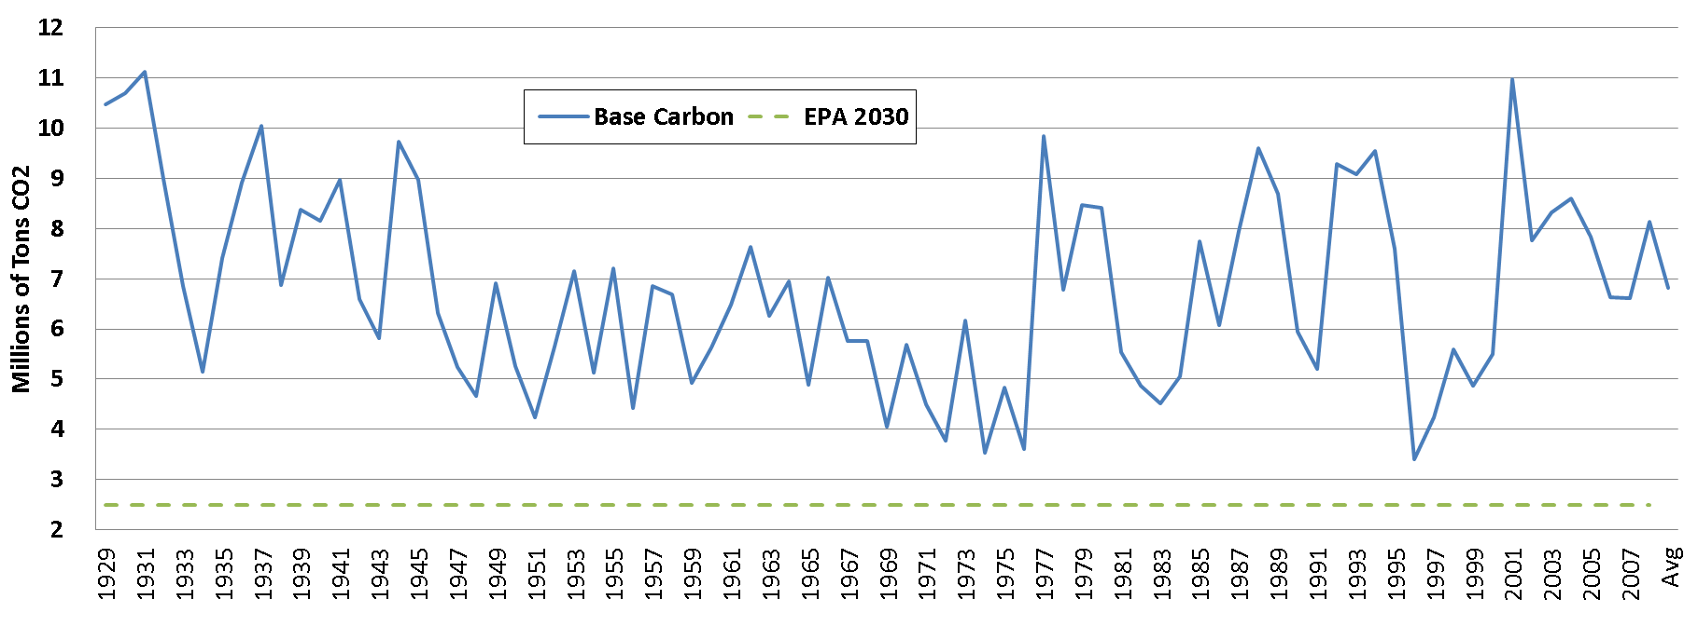

**States Should be Credited for Early Action**

The State of Washington has made significant CO2 reduction efforts, particularly with regard to the early closure of the 1,458 MW Centralia coal-fired plant, and acquiring RE and EE. Other states in the Pacific Northwest have made similar efforts. By including in the Clean Power Plan baseline the full retirement of existing coal-fired power plants, and the historically high rates of aggressive RE and EE adoption, the EPA effectively is penalizing states for having already taken proactive steps to reduce CO2 emissions.

In states where Avista serves retail electricity loads (Washington and Idaho), its implementation of cost-effective EE programs, as demonstrated through Integrated Resource Planning, already has removed “low hanging fruit” opportunities, making additional efforts relatively costly and more difficult to achieve. This is critical to acknowledge for states without operating coal plants that have to rely exclusively on building blocks three and four for compliance. On the other hand, states that have not been aggressive in pursuing RE and EE opportunities have easier implementation paths and lower targets because “low hanging fruit” still exists.

EPA should address the proposal’s inequality between states that have taken early action on CO2 reductions, and those that have not, by removing large efforts such as closing a coal-fired plant from inclusion in the targets, and by giving states credit for other early actions as states might propose in their implementation plans. This should include allowing states to use RE generation and EE measures implemented between 2012 and 2020 to demonstrate post-2020 compliance.

**Interim Goal Should Be Eliminated**

The proposed interim goals create an unfair burden on some states. In Washington and Idaho, where the only options are relying on RE and EE, compliance with the interim goal may require state-level rulemaking that could easily extend to nearly 2020 because of the need to develop legislation. Further, for Washington State, the EPA proposal assumes that the closure of the Centralia coal-fired plant has occurred years ahead of its present schedule. This assumption means the only realistic avenue to meet the interim goal is moving the Centralia coal plant closure up by six-years.

The final rule should not include interim goals. States should be able to determine their own compliance path and, where any interim measurements are required, demonstrate to EPA that the plans are on track to reach final 2030 goals. Eliminating the interim goals, or allowing states to develop their own glide path to 2030, would provide true flexibility in the rule. Allowing states to determine when and how to achieve CO2 emission rate reductions will moderate some of the economic impacts and unintended consequences of the proposed rule.

**Re-dispatch of Coal-Fired Generation Compromises Reliability**

The proposed rule envisions reducing emissions from existing coal-fired generation and shifting to existing gas-fired plants. Although EPA has prepared some reliability analysis as part of its documentation of the proposed rule, its analysis falls short of ensuring basic reliability metrics are met. Re-dispatching all natural gas-fired generation up to 70 percent is not realistic given historical operations. To arrive at an annual 70 percent capacity factor means running a plant higher in some months and lower in other months. Where an existing plant operated in 2012 at a 50 percent capacity factor, to reach this level it had to operate at much higher levels in peak load months during the winter and summer. To illustrate this point, Chart 6 below displays the operating history of two combined-cycle plants used by Avista to serve load in 2012.

*Chart 6 – Historical Operations at Coyote Springs 2 (OR) and Rathdrum LLC (ID)*

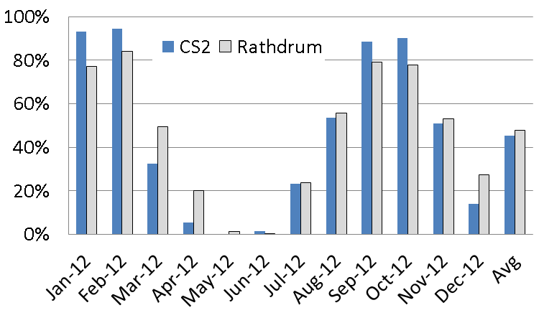

The average capacity factor for the two plants was approximately 50 percent in 2012. To achieve this level, both operated well above 70% in four of the 12 months. These months coincided with peak load levels, meaning that these plants were necessary to ensure system reliability and were not surplus to the system. They would not be available to replace reduced coal-fired output during peak load periods. On an average annual basis it might seem possible that natural gas-fired plants could replace coal-fired generation; a more granular look shows that they will not be able to do so during peak load months. Although these plants are just two in the United States fleet, many or most will have similar operating profiles and not be available as envisioned by EPA in the proposed rule.

The U.S. power grid operates today in approximate load-resource balance, with an operating margin allowing the system to absorb system forced outages and extreme weather events. Where the proposed rule essentially mandates closure or reduced operations at a significant portion of the coal fleet, it is unreasonable to expect the gas fleet to absorb the loss and keep the lights on.

Avista appreciates this opportunity to provide initial comments to the Commission on the proposed EPA rule. The Company looks forward to working with the state to develop comments that will lead to successful implementation of the final rule. If you have any questions regarding these comments, please contact me, at 509.495.4975, or Clint Kalich at 509.495.4532.

Sincerely,

/s/Linda Gervais/

Manager, Regulatory Policy

Avista Utilities

[linda.gervais@avistacorp.com](mailto:linda.gervais@avistacorp.com)

509-495-4975

1. Pacific Northwest is defined as the four states of Idaho, Montana, Oregon, and Washington.
2. Source: EIA; averages based on years ending with 2012 calendar year.
3. Montana, Oregon, and Washington have coal in their fleets today; however, Oregon and Washington intend to close all of their coal-fired generation in the next decade.
4. It is normal practice in the Pacific Northwest to “normalize”, or average, hydroelectric conditions for ratemaking purposes. The full historical hydrology record is considered, as shown here.
5. Avista’s model is based on the EPIS AuroraXMP software package. Avista uses AuroraXMP to model all loads in the Western Interconnect and dispatch individual generation units hourly. The model tracks generation, fuel consumption, and emissions levels, among other items. For this illustration, all variables besides hydroelectricity availability, were assumed to remain constant (e.g., natural gas and coal prices, loads and wind generation). Hydroelectricity generation levels were based on a Bonneville Power Administration database of the Pacific Northwest.