Mark S. Reynolds
NW Region Vice President, Public Policy
1600 7th Avenue, Room 1506
Seattle, Washington 98191
(206) 345-1568

August 24, 2015

Mr. Steven King
Executive Director and Secretary
Washington Utilities and Transportation Commission
1300 S. Evergreen Park Drive SW
Olympia, WA 98504-7250

RE: Docket No. UT-131949
CenturyLink QC Washington Performance Assurance Plan Compliance Filing

Dear Mr. King:

Pursuant to new requirements in the decision on Docket No. UT-131949, approving Qwest Corporation d/b/a CenturyLink QC’s Petition to modify the Performance Assurance Plan and Performance Indicator Definitions, CenturyLink is supplying the following reports to the Commission:

Non-confidential Reports:
271_exhibit(14_state_pid)_washington_excel_all_jul15 - State aggregate performance report

P271_pap_summary_WA_jun2015 - State aggregate payment report

The WUTC records center has agreed that no paper filing is required in this docket as it has historically only been filed electronically due to larger size documents. Lisa Wyse confirmed no paper copy is required.

Please let me know if you have any questions about this information.

Sincerely,
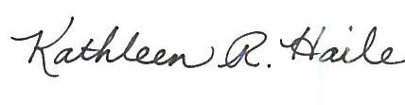
For Mark S. Reynolds
Attachment

