TABLE OF CONTENTS

PURPOSE AND SUMMARY 1

COST OF SERVICE 3

RATE SPREAD 17

RATE UNBUNDLING 19

RESIDENTIAL RATE DESIGN 21

Residential Basic Charge 22

Residential Energy Block Charges 33

GENERAL SERVICE, AGRICULTURAL PUMPING, 50

AND STREET LIGHTING RATE DESIGN 50

RULE D AND SCHEDULE 300 51

**ATTACHED EXHIBITS**

Exhibit No. JRS-14—Cost of Service by Rate Schedule—Summaries

Exhibit No. JRS-15—Cost of Service by Rate Schedule—All Functions

Exhibit No. JRS-16—Effect of Proposed Rate Increase

Exhibit No. JRS-17—Proposed Prices and Billing Determinants

Exhibit No. JRS-18—Monthly Billing Comparisons

Exhibit No. JRS-19—Basic Charge Calculation

Exhibit No. JRS-20—Survey of Monthly Basic Charges in Washington

Exhibit No. JRS-21 —Usage Reduction Due to Elasticity

Exhibit No. JRS-22 —Temperature Normalization Adjustment

Exhibit No. JRS-23 —Residential Consumption Survey

**Q. Are you the same Joelle R. Steward who previously submitted direct testimony in this case on behalf of Pacific Power & Light Company (Pacific Power or Company) in this case?**

A. Yes.

# PURPOSE AND SUMMARY

**Q. What is the purpose of your rebuttal testimony?**

A. The purpose of my rebuttal testimony is to present the class cost of service (COS) study results, rate spread, and rate design proposals reflecting the Company’s revised revenue requirement. I also respond to the direct testimony of Mr. Jeremy B. Twitchell on behalf of the Washington Utilities and Transportation Commission (Commission) Staff, Mr. Glenn A. Watkins on behalf of the Public Counsel Division of the Washington Attorney General’s Office (Public Counsel), Mr. Charles Eberdt on behalf of the Energy Project, Mr. Robert R. Stephens on behalf of Boise White Paper, LLC (Boise), Mr. Steve W. Chriss on behalf of Wal-Mart Stores, Inc. and Mr. Mark E. Fulmer on behalf of The Alliance for Solar Choice (TASC), regarding their positions on COS, rate spread, and rate design.

**Q. Please summarize your testimony.**

A. The findings and recommendations in my rebuttal testimony are:

* The Company’s COS study is consistent with prior Commission direction and presents a reasonable balance between the interests of all parties. Staff’s recommendation to create a separate allocation factor for non-dispatchable generation (i.e., wind resources) in the COS study inappropriately singles out one type of resource and relies on a capacity value for wind that is inconsistent with the west control area. The Company is not opposed to Staff’s recommendation for a direct assignment of customer account managers but I recommend that if it is adopted that the costs be allocated based on the number of customers.
* The Company continues to recommend a rate spread that reasonably balances the interests of all parties as well as the COS results. The Company’s proposed rate spread allocates one half of the overall increase to Schedules 24, 40, and lighting, with the remaining increase spread equally to the rest of the rate schedules.
* For residential rate design, the Company continues to recommend a basic charge of $14.00 per month for Schedule 16 and $8.75 per month for Schedule 17. The Company also recommends that the Commission retain the current two block energy rate structure.
* The proposed $14.00 residential basic charge will allow the Company a better opportunity to recover its fixed costs. The proposed basic charge would recover a portion of the costs related to retail services and distribution investments, which are necessary for the safe and reliable service to all residential customers regardless of usage levels. The proposed basic charge is in line with the average basic charge for customers in Washington.
* Even with the increase in the residential basic charge, the current residential rate structure will continue to be heavily weighted on energy use, thus providing a strong signal for conservation. Nearly 90 percent of an average customer’s bill is based on their overall usage and only 11 percent due to the basic charge.
* Change to the current residential two-block rate structure proposed by Staff should be denied because it: (1) sends a confusing price signal to customers by reducing 45 percent of customer bills, which may encourage increased usage for these customers; (2) is not cost based and appears to be largely designed to be punitive for electric heat customers; (3) will disproportionately impact low income customers; (4) will increase the risk of cost recovery for the Company; and (5) may have unintended consequences of sending an uneconomic price signal to customers for distributed generation, which would have adverse impacts for both the Company and other customers.
* The current residential rate structure already reflects a steeply inverted block rate, particularly when compared to Avista and Puget Sound Energy, and the first block set at 600 kWh already reasonably reflects the average usage in Washington for lighting, appliances, and water heating.
* Staff’s discussion and recommendation that the Commission prejudge potential rate solutions for distributed generation customers is misguided and inappropriate and should be dismissed.
* For non-residential rate design, the Company proposes a higher increase in the demand charge for Schedule 36, in response to Wal-Mart’s proposal; however, in order to moderate intra-class impacts, the Company is proposing a smaller increase in the demand charge than that proposed by Wal-Mart. The proposed rates for all other non-residential rate schedules are consistent with my direct testimony.

# COST OF SERVICE

**Q. Please summarize the methodology used for the Company’s COS study in the initial filing.**

A. In the initial filing the Company’s COS study was based on the same methodologies used in the Company’s 2013 general rate case, Docket UE-130043 (2013 Rate Case). Specifically, for generation and transmission costs the Company classifies costs between demand and energy using the west control area system diversified load factor (SDLF), which results in 43 percent of these costs classified as demand related and 57 percent classified as energy related. The demand-related costs are then allocated to rate schedules using the Company’s highest 100 summer (April-October) and 100 winter (November-March) hourly retail peak loads in the west control area. The energy-related portion is allocated to rate schedules using class annual load (megawatt hours), adjusted for losses. This allocation approach is consistent with prior Commission direction. For distribution and retail service costs, the Company also uses methodologies consistent with prior cases. No party raised concerns with how distribution and retail service costs were treated in the COS study. Accordingly, cost allocations I discuss for this rebuttal testimony refer to only generation and transmission costs.

**Q. Is the Company proposing changes to the COS in this rebuttal filing?**

A. No. The only change reflected in the COS study is to incorporate the rebuttal results of operation for Washington presented in the rebuttal testimony of Ms. Natasha C. Siores. After reviewing the COS changes proposed by Staff, Public Counsel, and Boise, the Company is not proposing methodological changes in the COS study for this proceeding. The Company’s COS study fairly balances the study results given the range of approaches proposed by the parties. Furthermore, the Company’s proposed rate spread, which is guided by the COS study, fairly balances the impacts for all customer classes. Exhibit No. JRS-14 contains summary tables from the Company’s COS study for the state of Washington based on the revised revenue requirement proposed in this rebuttal filing. Exhibit No. JRS-15 displays the COS study in more detail by class and function: page 1 summarizes the total COS by class, pages 2 through 6 contain a summary by class for each major function, and pages 7 through 9 contain the unit costs by function and class.

**Q. How do the results from the Company’s COS study compare with the COS approaches advocated by the other parties?**

A. Table 1 compares the Company’s COS results and parity ratios (Scenario 3) with Public Counsel’s (Scenario 1), Staff’s (Scenario 2), and Boise’s proposals (Scenario 5) based on the Company rebuttal revenue requirement. Scenario 4 (Hybrid) is a hybrid method that shows the impact on COS results if classification is treated consistently with the West Control Area inter-jurisdictional allocation methodology (WCA). Consistency between the class COS and the jurisdictional cost allocations is another approach that would be reasonable in order to align the costs allocated to customers with the drivers that allocate costs to Washington.



**Q. What general conclusions can you draw from the comparison of the various COS proposals in this case?**

A. As shown in Table 1, the Company’s proposal (Scenario 3) falls in the middle, between the proposals of Staff and Public Counsel on the one hand, and Boise on the other. The Company’s proposal appropriately balances the interests of all customer classes and its central position as compared to Staff and intervenors further demonstrates the overall reasonableness of the Company’s position.

**Q. What changes does Public Counsel propose for the COS study?**

A. For the most part, Public Counsel agrees with the Company’s current SDLF or load factor methodology for classifying costs between demand and energy but with caveats on the reasonableness and stability of the method.[1] Public Counsel makes several proposals that may be substituted including a forward-looking load factor such as the one provided in the Integrated Resource Plan (IRP), an average of multiple hours’ highest peak loads within a single year, or multiple years annual peak loads.

**Q. Public Counsel raises a concern about a potential anomaly between the 2013 peak load data that the Company used in its SDLF calculation and the 2014 and 2015 forecast peak load data in the 2013 IRP. Specifically, Public Counsel argues that if the forecast load factor from the IRP were used then 28 percent of costs would be classified as demand related rather than 43 percent.[2] Is this an anomaly as Public Counsel suggests?**

A. No. The forecast coincident peak in the IRP looks at the loads of the west control area at the time of the Company’s entire system peak, which includes the west control area loads and all other states within the Company’s system (Utah, Wyoming, and Idaho). The difference in the IRP coincident peaks and the peak utilized by the Company can simply be attributed to the different peak times of the west control area and the entire PacifiCorp system. The west control area coincident peak would be 3,361 megawatt (MW) at the time of the PacifiCorp system peak, a value significantly closer to those in the IRP forecasts.

**Q. Public Counsel proposes classifying generation and transmission costs as 30 percent demand related and 70 percent energy related as a closer approximation of the IRP load factor. What effect does this have on COS results when compared with the Company’s filed COS study?**

A. Scenario 1 in Table 1 above illustrates the impact on COS results of classifying these costs as 30 percent demand related and 70 percent energy related. As would be expected, when classifying more costs as energy related, costs are shifted from lower load factor customers (residential) to higher load factor customers (industrial or large general service).

**Q. Is using a 30/70 percent split between demand and energy an appropriate methodology for class COS in Washington?**

A. No. The Company does not use system peaks to allocate costs in Washington; therefore, this approach is unreasonable and is inconsistent with the WCA.

**Q. What recommendations does Staff propose for the COS study?**

A. Staff proposes classifying non-dispatchable generation (NDG) costs primarily as energy related and directly assigning the costs of corporate account managers (CAM) to large industrial customers.

**Q. Please describe Staff’s proposed NDG allocation factor.**

A. Staff proposes a new allocation factor to classify and allocate costs specifically related to solar and wind resources. Staff recommends that a larger portion of the costs of these resources be classified as energy related with the demand-related portion to be determined by a capacity credit developed for the Company’s IRP. In support of this position Staff argues that since compliance with the Renewable Portfolio Standard (RPS) is energy based it is more consistent to assign costs based on customer energy usage. Additionally, while Staff recognizes that the impact on COS results is small right now, Staff claims that the impact is expected to increase with the growth of wind in the Company’s portfolio.[3]

**Q. Do you agree with Staff’s proposed NDG allocation factor?**

A. No. I disagree with the NDG proposal for a numbers of reasons. First, as explained in my direct testimony, the fleet of generation resources is comprised of multiple generation types and the Company’s proposed classification recognizes the combined nature of these resources, which together are designed to meet peak load and supply the energy needs of its customers. Singling out one type of resource while continuing to use a factor developed for the entire fleet for all other resources will bias the results.[4] To be consistent, treating NDG differently would require the classification of all generation and transmission resources to be reassessed in both the WCA and the class cost of service methodology. This point is further supported by Public Counsel.[5]

Second, Staff’s use of a wind capacity value of 18.1 is not consistent with the WCA. When a wind capacity value relevant to the west control area is used, the impact of the change in the COS results is de minimis.

Third, while wind may make up a larger percentage of the Company’s resources in the future, the Company’s 2013 IRP Preferred Portfolio does not have any new wind resources being installed until 2024.[6] Because the adoption of Staff’s proposed NDG factor results in only minimal changes in the COS results and would not alter the Company’s proposed rate spread and rate design, there is no need to reflect this change at this time in light of the principled concerns of this approach.

**Q. If all resource types were to be looked at separately for their contribution to peak, similar to how Staff proposes to treat wind resources, would that alter the classification of demand?**

A. Yes. Table 2 lists the generation resources included in the west control area. Included in the table for each generation resource is the 2013 energy, installed nameplate capacity rating, capacity factor, peak hour output, and calculated coincident peak hour load factor. The coincident peak load factor is a similar calculation to the SDLF used for classifying generation costs. The west control area peak hour occurred on December 9, 2013 at 8:00 am. This table shows on a total west control area basis that the classification of demand and energy could logically be split equally at 50 percent. Looking at wind individually, it has a coincident peak load factor of 37.5 percent in the west control area, which would be a better proxy for its capacity value.



**Q. What is the source of Staff’s proposed 18.1 percent wind capacity value?**

A. The 18.1 percent wind capacity value is from the Company’s 2014 Wind and Solar Capacity Contribution Study. The study is being utilized in the Company’s 2015 IRP.

**Q. Should the 18.1 percent capacity value of the Company’s system wind resources be used for the Company’s west control area wind resources?**

A. No. First, the 18.1 percent capacity value for wind is for PacifiCorp’s entire system which includes 2,117 MW of wind capacity made up of east and west owned wind and east and west non-owned wind. The west control area owned wind resources include Marengo I and II (210 MW), Goodnoe Hills (94 MW) and Leaning Juniper 1 (101 MW) for a total of 405 MW, which is included in the west-owned wind category. The referenced IRP study calculated separate east and west balancing authority area (BAA) wind contribution values, which are shown in Table 3. The 18.1 percent peak capacity contribution factor is a weighted average of the two balancing areas. The West BAA has a wind peak contribution factor of 25.4 percent. Therefore, if this study were to be used to assign a capacity value to wind, 25.4 percent would be a more accurate capacity value as it is calculated for the West BAA, which includes the west control area wind farms.



Second, the methodologies of the Peak Capacity Contribution Value for Wind and the SDLF are not consistent. From page 1 of the 2014 Wind and Solar Capacity Contribution Study:

The study evaluates the relationship between reliability across all hours in a given year, accounting for variability and uncertainty in load and generation resources, and the cost of planning for system resources at varying levels of planning reserve margin. In this way, PacifiCorp’s planning reserve margin LOLP study is the mechanism used to transform hourly reliability metrics into a resource adequacy target ***at the time of system coincident peak*** [emphasis added]. This same LOLP study was utilized for calculating the peak capacity contribution using the CF Method.

The west control area peak hour from which the SDLF is derived is not the same as the system coincident peak evaluated in the study and thus the study should not be utilized to determine west control area wind resources’ contribution to west control area coincident peaks. To be consistent with the west control area, one would use the capacity value of the west control area wind resources during the west control area system peak hour of December 9, 2013 at 8:00 am. As shown in Table 2 above, during this peak hour, the west control area wind farms’ output was 152 MW, or 37.5 percent of the installed 405 MW of capacity. As previously noted, this would have a de minimis impact on the COS results.

**Q. As part of the reasoning for the proposed NDG allocation factor, Staff explains that west control area states have adopted energy-based RPS. Is there a reason for this?**

A. Washington’s RPS is logically tied to energy sales as it is simple, easy to understand and administer. Any RPS program based on demand or a classification split between demand and energy would seem overly complicated. Therefore, this RPS-based argument should have no bearing.

**Q. Please explain Staff’s recommendation regarding the allocation of costs for corporate account managers (CAMs).**

A. Staff proposes that expenses related to CAMs be directly assigned to Schedule 48T since CAMs are assigned to only large customers (loads over 750 kW).

**Q. Is the Company opposed to the direct assignment of these costs?**

A. No. However, the impact of the proposed change is minimal at only about $185,000.[7] Furthermore, as explained in my direct testimony, singling out one customer service cost for one type of customer and isolating individual cost drivers to specific types of customers would be complex and burdensome.

**Q. If the CAM direct assignment is adopted by the Commission, how do you propose these costs to be allocated?**

A. If adopted by the Commission, I propose that the CAM costs be allocated to Schedule 48T and the Dedicated Facilities rate schedules based on the number of customers on those rate schedules. Table 4 illustrates the impact of this change from the initial filed cost of service study.



**Q. What methodology does Boise propose regarding the classification and allocation of generation and transmission costs?**

A. Boise proposes classifying 100 percent of fixed generation costs as demand related and 100 percent of variable costs as energy related because, Boise argues, production investment is primarily driven by the need for capacity and customer peak demands. The variable costs primarily include fuel-related net power costs and purchased power with all other costs considered fixed.[8] Table 5 illustrates the proportional split between fixed and variable generation and transmission costs with Boise’s proposal.



For allocation of demand-related costs, Boise argues that the Company provides no basis for allocating these costs with the top 100 winter and 100 summer peak hours and proposes using only the top four coincident peaks, consisting of the two highest summer months (July and August) and the two highest winter months (December and January).

For transmission costs, Boise proposes to classify all transmission as 100 percent demand related with allocations to rate schedules based on the 12 monthly coincident peaks. Boise argues that the transmission system is built to only meet peak demand and not the energy needs of its customers.

**Q. How does Boise’s proposal affect the COS results and compare with the Company’s filed COS study?**

A. Scenario 5 in Table 1 above illustrates the impact on COS results based on Boise’s recommendation. As expected, the residential class (being a lower load factor customer class) would receive a large increase in its COS while the rest of the customer classes would experience a decrease compared to the Company’s approach.

**Q. Do you agree with Boise’s methodology for classifying and allocating generation and transmission costs?**

A. Not at this time but I do agree Boise’s methodology could be explored further. As I have addressed in my direct testimony and earlier in rebuttal of Staff, the Company’s generation portfolio in the west control area consists of multiple types of generation sources such as coal, natural gas, hydro, and renewables and these resources produce the dual products of capacity and energy. The current methodology recognizes that production investments are utilized to meet peak demand and supply energy to customers. On a near-term basis, the only costs that will vary with energy use are net power costs.

I find it reasonable to classify a portion of transmission costs as energy related. For instance, FERC Account 565 (Wheeling) is a net power cost account that could be considered a variable cost in the same manner as Boise proposes the treatment of other net power cost accounts. Further, the Company has historically viewed the transmission system as an extension of the generation system. The National Association of Regulatory Utility Commissioners (NARUC) Cost Allocation Manual simply states:

After transmission costs are separated into appropriate demand or energy allocation categories, it is necessary to then select a method of assigning cost allocation responsibility to various customers. In general, customers are allocated a portion of the fully distributed (embedded) cost of the transmission system on a basis similar to the way production costs are allocated. The reason for this is that the transmission system is essentially considered to be an extension of the production system, where the planning and operation of one is inexorably linked to the other. Thus, the major factors that drive production costs, it is argued, tend to drive transmission costs as well.[9]

Overall, when looking at the Company’s entire generation portfolio, I do agree that more generation costs could be classified as demand related as is evident by the capacity factors of all generation sources in Table 2 above. A 50/50 demand/energy split is supported by the fact that the overall capacity factor of generation resources included in the west control area was approximately 51 percent for 2013.

**Q. Why does the Company use 100 summer and 100 winter peaks for allocating generation and transmission costs?**

A. Historically, the Commission has expressed a desire for a wider range of coincident peak hours for the allocation of these costs. The Commission has stated:

Generally, the proper period over which to allocate the demand-related costs of peaking resources is the hours when they are expected to be used. The 200 hour proposal by the company is reasonably representative of the system peak and the actual resources put into place to serve that peak.[10]

In Docket UE-100749, Industrial Customers of Northwest Utilities (ICNU) proposed using the coincident peaks that were within 5 percent of the annual system peak. In its order, the Commission rejected this methodology by stating:

As we have in the past when presented with a precise revision to peak demand, we conclude that this is too narrow a range. We agree with PacifiCorp that ICNU’s proposal could produce volatility in results depending on the test period. While it is reasonable to allocate the costs of peaking resources based on the hours those resources will actually be used to serve load, the allocation method should be flexible enough to incorporate the variable peaks experienced in Washington. PacifiCorp experiences both a summer peak and a winter peak, and its proposal to include 100 summer hours and 100 winter hours to determine peak demand recognizes how resources are used.[11]

**Q. Is the Company’s methodology similar to Boise’s four coincident peak methodology?**

A. The Company’s current methodology of allocating demand-related costs is similar to Boise’s proposal while wholly embracing the Commission’s desire for a wider range of peaks that represent a summer and winter peaking system. For instance, when taking a closer look at the 100 summer and 100 winter peaks, the Company currently uses three summer months and three winter months for allocating demand-related costs. Table 6 illustrates that a large majority of the 200 peaks (191 out of 200) fall within July, August, December, and January, the same months proposed by Boise.



**Q. Please summarize your position on COS.**

A. The Company’s primary objective for COS is to find a balanced outcome between different competing methodologies and to achieve a sustainable approach that the Company will be able to apply consistently across the years in order to avoid COS swings from case to case. A number of methodologies may be considered when assigning cost to different rate classes. Some methodologies will benefit some customer classes while other methodologies will benefit others. In light of these considerations, the Company believes it’s COS study fairly assigns cost and achieves balanced results.

# RATE SPREAD

**Q. Based on the rebuttal revenue requirement filed in this case, what is the Company’s rate spread proposal?**

A.After reviewing the range of positions on COS results, the Company makes no change to the proposed rate spread methodology as filed in my direct testimony. Specifically, the Company proposes to: (1) allocate an increase based on one-half of the overall increase to the schedules that the cost of service study indicates require a significantly smaller revenue increase (Schedules 24, 40, and lighting schedules); and (2) the remaining increase is then spread equally to the rest of the rate schedules. Exhibit No. JRS-16, Table A (page 1), shows the effect of the proposed rebuttal base rate increase of $31.9 million. Table B (page 2), shows the effect of updated deferral costs of $5.9 million discussed in Ms. Siores’s rebuttal testimony, which the Company proposes to recover through Schedule 92, Deferral Adjustment. Table C (page 3), shows the combined effects of the requested rebuttal base revenue increase and the amortization of the rebuttal deferrals in Schedule 92.

As discussed above, in light of the range of positions on COS results, the Company continues to believe the proposed rate spread reasonably balances the interests of all parties as well as the cost of service. Public Counsel generally supported the Company’s proposed rate spread.

**Q. Staff, Boise, and Wal-Mart propose modifications to the Company’s rate spread proposal. Please respond.**

A.Table 7 shows each party’s proposed increase by rate schedule as a percent of the overall increase.



Staff proposes a rate spread based on each rate schedule’s relative proportion to COS, or parity ratio. Similar to the Company, Staff proposes higher increases to the schedules that are below COS and a smaller increase to general service, however, Staff proposes no increase to small general service, agricultural pumping and street lighting schedules.[12] Staff’s proposal attempts to move all schedules to within five percent of parity,[13] whereas the Company’s proposal made more moderate movements to COS for all rate schedules.

Boise proposes no rate schedule receive an increase greater than 1.12 times the overall average, which results in an increase equal to the Company’s for the residential and large general service rate schedules. The residual increase would be allocated to the other schedules based on their relative parity to COS.

Wal-Mart proposes the same increase to residential and Schedule 48 Dedicated Facilities with the residual allocated to all other rate schedules based on their relative parity to COS.

In light of the parties’ proposals, the Company’s proposed rate spread is a reasonable compromise that makes movement to COS for all rate schedules.

# RATE UNBUNDLING

1. **In your direct testimony the Company proposed to unbundle rates by function when developing rates. Did the Company prepare unbundled rates for this rebuttal filing as well?**
2. Yes. As explained in my direct testimony, the Company proposes to unbundle rates by function—generation, transmission, and distribution—in the tariff and has used the same approach for the updated proposed rates in this rebuttal filing. Unbundling provides for greater transparency between COS and rate design. No party appears to oppose how the Company proposed to unbundle rates, although no party other than Wal-Mart remarked on it in testimony. Wal-Mart supports the Company’s proposal to unbundle rates and reflect the unbundled rates in the tariff; however, Wal-Mart recommends that the Commission require the Company to reflect the unbundled rates in customer bills or set a timeframe for the Company to implement the changes required to do so.[14]

**Q. What is the Company’s response to Wal-Mart’s proposal to show the unbundled rates on customer bills?**

A.The Company supports increased transparency in rates and accordingly is willing to work with parties to add greater cost transparency on bills for non-residential customers through unbundled rates. For residential customer bills, it will be important to incorporate customer education prior to making changes on the bills in order to minimize customer confusion. As such, any roll out in reflecting unbundled rates on bills will need to be staggered between residential and non-residential customer bills.

**Q. Is the Company proposing any other tariff changes from its initial filing for the unbundled rates?**

A.Based on a comment made by a customer at the public hearings, the Company will modify the tariff pages that show the unbundled rates to spell out the acronym NPC, or net power costs, or otherwise define the term on the tariff pages. The Company agrees with the customer’s comment that this cost element can be articulated in a better manner on the tariff page.

# RESIDENTIAL RATE DESIGN

**Q. Please summarize Staff’s proposed residential rate design.**

A. Staff proposes to increase the monthly residential basic charge from $7.75 to $13.00. The remainder of the allocated increase will be recovered through the energy charges. Staff proposes modifying the inverted block energy charges by increasing the size of the first block from 600 to 800 kilowatt hour (kWh), setting a second block from 801-1,700 kWh and adding a third block for kWh usage over 1,701. The current residential block structure consists of two blocks: one for the first 600 kWh and the second for all additional kWh.

**Q. Please summarize Public Counsel’s, the Energy Project’s, and TASC’s proposed residential rate designs.**

A. Public Counsel and the Energy Project recommend no increase to the current residential basic charge of $7.75 per month. TASC recommends a maximum residential basic charge of $9.00. No other parties address the residential block structure.

**Q. Is the Company proposing any changes to the residential rate design proposed in your direct testimony based on the testimony from Staff, Public Counsel, TASC, or the Energy Project?**

A.No. The Company continues to support an increase in the basic charge to $14.00 per month for Schedule 16 and $8.75 per month for Schedule 17. I will show that the $14.00 per month basic charge is supported using both the Company’s and Staff’s calculations and is necessary to address the growth in distributed generation (DG) and the changing industry landscape resulting from increased customer generation. The Company also proposes to retain the current inverted energy block rate structure. This rate design represents the best balance between cost causation, equity, economically efficient price signals for conservation, and minimizing customer impacts, particularly for low income customers. Staff’s proposed changes in the rate design for the energy block rates are contradictory to its stated intent of encouraging conservation, are not cost-based, and will not improve fixed cost recovery for the Company. Other parties’ proposals to limit the increase in the basic charge continue to ignore cost causation in the generic name of gradualism. In the following sections I will first respond to parties’ testimony on the customer charge, followed by my response to Staff’s proposed change in the block rate structure. Exhibit No. JRS-17 contains the proposed prices and billing determinants used in calculating the proposed prices. Exhibit No. JRS-18 contains monthly billing comparisons for the revised proposed prices at different usage levels for each rate schedule.

## **Residential Basic Charge**

**Q. Please explain the Company’s proposed residential basic charge.**

A. The Company’s rebuttal filing continues to support a cost-based basic charge of $14.00 per month. The proposed charge is derived from the filed COS study, Exhibit No. JRS-15. As explained in my direct testimony, fixed costs (i.e., costs that do not significantly vary with usage) are appropriate costs to include in determining the level of the residential basic charge. In this proceeding, the Company has proposed to limit these fixed costs to those related to local distribution and retail service costs. The distribution costs include meters, service lines, transformers, poles, and conductors. The retail service costs include meter reading, billing, and customer services. The COS study supports a basic charge of $28.00 for these costs. The Company’s proposal is to increase the current basic charge of $7.75 per month to $14.00, which would collect half of these costs in the monthly basic charge. Moving the basic charge to collect half of these costs fairly recognizes that a minimum level of these facilities and services is required for the provision of electric service to any residential customer, regardless of size.

**Q. How does Staff support its proposed $13.00 residential basic charge?**

A. Staff similarly relies on the COS to support its $13.00 customer charge. In its basic charge calculation, Staff includes the full costs for retail services and distribution facilities for meters, service lines, and transformers in its average cost per customer calculation.

**Q. Using the Company’s proposed revenue requirement, what basic charge is supported when using the same cost elements that Staff included in its residential basic charge?**

A. As shown in Exhibit No. JRS-19, a basic charge of $14.10 is supported using Staff’s cost elements but updated to reflect the Company’s proposed revenue requirement. Staff’s method shows another way that a $14.00 customer charge is justified and cost based.

**Q. Are there additional policy justifications for increasing the basic charge?**

A. Yes. As described in the testimony of Mr. R. Bryce Dalley, the Company, and the electric utility industry as a whole, is in a period of significant transformation. Many states, including Washington, have adopted new laws and policies designed to reduce reliance on traditional, fossil fuel generators in favor of renewable and DG.[15] These policy changes have created, and will continue to create, major challenges for the Company. The Company’s proposed basic charge is intended, in part, to support the Company and ensure that the Company is well positioned to respond to growing customer generation. For example, since 2013, the test period for this case, there has been a 60 percent increase in the number of net metering customers through October 31, 2014.

**Q. How does the Company’s proposed basic charge support the Company in the face of increasing DG?**

A. A basic charge that more accurately reflects the Company’s actual fixed costs, as recommended by the Company and Staff, helps to mitigate cost-shifting caused by the growth in customer generation and ensures that the Company has a reasonable opportunity to recover its fixed costs from customer generators.

**Q. Has the Commission recognized that customer generation can result in cost-shifting to non-generating customers and compromise a utility’s ability to recover its costs?**

A. Yes. In a 2011 report analyzing the impact of DG, the Commission observed that the development of laws and policies to promote DG must protect customers, including protection from cost-shifts between rate classes and types of customers, and ensure sufficient returns for utility investors.[16]

**Q. Is the Company’s recommended basic charge consistent with the average residential basic charges in Washington?**

A. Yes. The average residential basic charge in Washington is $15.69 per month. Exhibit No. JRS-20 shows the current residential basic charges for other Washington utilities. In addition, it is my understanding that the Wisconsin Public Service Commission recently approved an 83 percent increase in the fixed charge for customers of Wisconsin Public Service Corporation, increasing the fixed charge to $19.[17]

**Q. What justification does TASC give for its maximum residential basic charge of $9.00?**

A. TASC argues that the only costs that should be included in the basic charge are those for retail services, meters, and service lines. TASC also argues that gradualism should prevail in any decision to raise the basic charge.

**Q. What justification does Public Counsel give for maintaining the basic charge at its current level?**

A. Public Counsel argues that only marginal customer costs, which only include costs that vary as a result of a new customer, should be recovered through the customer charge. Accordingly, Public Counsel includes only services, meters and incremental billing and accounting costs in the customer charge.

**Q. Public Counsel excludes corporate overhead costs from its calculation of a residential basic charge.[18] Do you agree that these costs should be excluded?**

A. No. First, to be clear, the corporate overhead costs included in the basic charge calculation are only the portion of overhead costs that are allocated to customer-related distribution costs in the COS study; they are not all overhead costs as may be inferred from Public Counsel’s testimony.

Second, Public Counsel’s only rationale for removing these costs is that the Company is “in the business of providing electricity to meet the energy needs of its customers” and that “customers do not subscribe to PacifiCorp’s services simply to be ‘connected.’”[19] This is an inadequate rationale. Overhead costs are a necessary part of doing business. The Company cannot provide electricity to customers unless they are connected. The costs of connecting and serving those customers—through meters, services, poles, conductors, transformers, and customer services—cannot exist without overhead costs. It is appropriate to include the allocated share of overhead costs for the elements included in the calculation of the basic charge.

**Q. What justification does the Energy Project give for maintaining the customer charge at its current level?**

A. The Energy Project generally opposes increases to the basic charge on the grounds that it diminishes a customer’s ability to control their bill. As described below, the vast majority of a typical customer bill will still reflect variable costs over which customers have some control.

**Q. Public Counsel and TASC argue that poles, wires, and distribution transformers represent marginal costs that are variable in nature. Do you agree?**

A. No. Poles and conductors (P&C) and transformers, along with other distribution assets such as meters, services and substations are fixed costs that are required to provide a minimum level of service to all customers. These assets will not vary in cost in the near term; once installed these are long-term, fixed investments necessary for the provision of service to customers. The most recent depreciation study approved by the Commission shows depreciation lives of 52, 60, and 43 years for poles, conductors, and transformers, respectively.[20] Accordingly, these investments are not variable in nature, as asserted by Public Counsel and TASC. The costs for these facilities do not go away when usage levels decrease, whether the decrease is related to weather, behavioral changes, the adoption of energy efficient appliances, or the installation of DG. At a minimum, recovering half of these costs through the basic charge more fairly balances cost recovery for the Company and the investments necessary for the provision of electric service.

**Q. How do Public Counsel and TASC propose that P&C and transformer costs be recovered by the Company?**

A. Both Public Counsel and TASC propose that P&C and transformers be recovered through the volumetric energy charge for residential customers. However, even the NARUC Cost Allocation Manual recognizes that there is no energy component for distribution costs, stating “Because there is no energy component of distribution related costs, we need consider only the demand and customer components.”[21] Accordingly, for most other rate schedules these costs are recovered through a combination of basic charges and demand charges. Without a demand charge

component for residential customers, a balance between the basic charge and the energy charges represents the fairest, most cost-based rate design.

**Q. Are poles, conductors, and transformers a customer-related component of distribution line transformers?**

A. Yes.  Like a meter or service drop, there is a large portion of the distribution line conductors and distribution transformer costs that are fixed and do not vary with the capacity of the equipment.  A large portion of the total cost of distribution equipment is associated with the embedded cost for manufacturing equipment, production processes and transportation of material, which is required to meet federal safety standards and/or industry manufacturing standards. This cost is fixed and does not vary with capacity. For example, a 25 KVA single phase pad-mount transformer and a 50 KVA single phase pad-mount transformer, which are commonly installed in residential subdivisions, have average installed costs of $5,212 and $5,598, respectively.  Although, the 50 KVA transformer provides double the demand capacity of the 25 KVA transformer, it only costs about 5 percent more.  Clearly, a large proportion of the cost of these transformers in this example do not vary with capacity and are fixed costs necessary to serve customers. A similar relationship exists for distribution poles and distribution line conductors in that the large majority of these equipment costs are customer-related fixed costs associated with manufacturing equipment, production processes and transportation of material. Without these fixed cost components, the base utility system infrastructure required to provide safe and reliable service to customers, independent of demand, would not be there.

**Q. For perspective, how do the different cost elements for service to an average residential customer compare to how costs are recovered from the average residential customer?**

A. Table 8 below shows what costs make up an average residential bill. Of these costs only net power costs, which make up approximately 42 percent of the residential costs, will truly vary in the near term with changes in usage. The other cost components, which make up 58 percent of the total residential costs, are more fixed in nature; the only thing that changes in the near term for the non-net power costs is who pays for those costs. In contrast, Table 9 below shows how costs are recovered through charges on the bill. This shows that with the proposed rates, only 11 percent of the average residential customer’s bill is fixed with the remaining 89 percent is variable.

**Table 8**

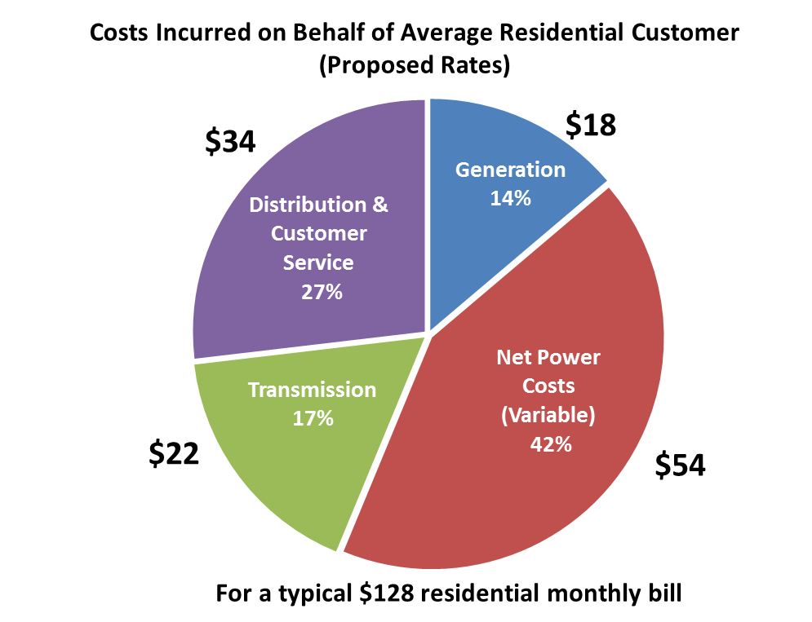

**Table 9**

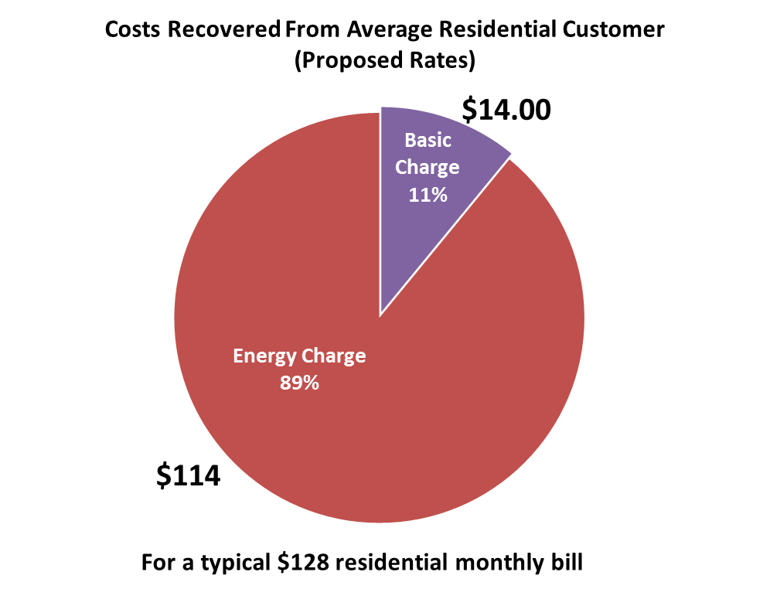

**Q. Public Counsel states that pricing structures that are weighted heavily on fixed charges are inferior from a conservation and efficiency standpoint than pricing that requires consumers to incur more cost with additional consumption.[22] Is the proposed residential pricing structure heavily weighted on fixed charges?**

A. No. In contrast, the proposed pricing structure is heavily weighted toward variable charges, as is clearly show in Table 9 above.

**Q. Public Counsel, the Energy Project and TASC argue that the proposed increase in the residential customer charge dampen customer’s price signal for conservation. Do you agree?**

A. No. As I showed in my initial testimony, under the Company’s proposed rates, 89 percent of the average customer’s bill will still be based on volumetric energy rates. For a small user half the size of an average user, 77 percent of the bill is related to energy charges; and a high user twice the size of an average user will have 95 percent of the bill related to energy charges. As previously noted, the proposed charge recovers only a portion of the distribution and customer service costs with the remaining costs in the energy rates, along with *all* of the costs related to generation and transmission. All residential customers—and high use in particular—will continue to have a strong motivation to conserve or pursue energy efficient technology and achieve bill savings.

**Q. Public Counsel and TASC argue that the Company’s proposed residential customer charge violates the Commission’s policy for gradualism. Do you agree?**

A. No. The Company’s proposal does take into account the principle of gradualism. The proposed charge does not include the fixed costs related to transmission and generation and only includes half of the distribution and retail costs in the proposed charge. The generic, nonspecific argument of gradualism is insufficient to perpetuate on-going intra-class cross-subsidies. Aligning rate design with underlying cost causation improves efficiency because it sends proper price signals and ensures equity among customers by eliminating subsidies. Moreover, the increase in the basic charge is neither unduly impacting small use customers, compromising the price signal for efficiency, nor is out of line with what other residential customers pay across the state.

**Q. Mr. Watkins uses the Federal Energy Regulatory Commission’s (FERC) adoption of a “Straight Fixed Variable” (SFV) pricing method in Order 636, which was intended for natural gas transmission pipeline companies, to suggest that the Company’s proposed rate structure could hinder energy efficiency goals.[23] Do you agree that this is an appropriate comparison?**

1. No. This comparison is irrelevant for many reasons. First, the Company did not propose a SFV pricing structure. The Company is merely proposing an increase in the residential basic charge to better reflect customer-related fixed costs. A SFV pricing structure would result in a considerably larger fixed customer charge component than the Company’s proposal of $14.00, after taking into account all generation, transmission and distribution related fixed costs. Second, the purpose of FERC’s adoption of SFV for pipeline companies was to eliminate potential distortions in pipeline rate structures and stimulate competition at the wellhead for a national gas market. FERC’s action for natural gas pipelines is simply not analogous to electric residential consumers and rates. The purchasing decisions by gas transportation customers and residential electricity customers are very different in scale and scope.

## **Residential Energy Block Charges**

**Q. Please summarize your concerns with Staff’s proposal to revise the energy charge block structure to move the first block from 600 kWh to 800 kWh per month and add a third block for usage over 1,700 kWh.**

A. First, Staff’s proposed energy rate design is inconsistent with its stated intent “to create a clearer price signal for residential customers to be more efficient and to follow the principles of cost causation.”[24] In actuality, Staff’s proposed rates will send a confusing price signal and may encourage increased consumption to a large number of customers, and is not cost-based but merely punitive for electric heat customers.

Second, Staff ignores the fact that the Company’s current rate design already sends a significant price signal to large users, particularly when compared to the other investor-owned utilities in Washington. Additionally, the current first block at 600 kWh per month already represents a reasonable level for essential end uses such as lighting and appliances for Washington.

Third, with the growth in customer generation, it is important to consider unintended consequences of rate design. Staff’s proposed tail block would send an uneconomic price signal and benefit to customers with DG which will contribute to cost shifting to customers without DG.

**Q. Before addressing your concerns with Staff’s proposed rates, do you have other comments or corrections to Staff’s testimony?**

A. Yes. First, I would just point out that Staff’s residential rate calculation uses residential billing units inconsistent with the test year billing units used by the Company in this proceeding for both the calculation of present revenues for the results of operations and the development of residential rates. It appears that Staff left out the number of and net billed kWh for residential net metering customers in its billing units and double counted the temperature adjustment for residential Schedule 18. This results in different billing determinants and a different present revenue than reflected in the results of operations. Since this appears to be an inadvertent error by Staff in the preparation of its filing, the Company’s billing units should be relied on for calculation of final rates in compliance with a Commission order in this proceeding.

Second, Staff incorrectly states that the Company’s rate proposal would actually decrease rates for the highest residential users.[25] Staff refers to Exhibit No. JRS-9 in support of this statement. However, Staff apparently misunderstands this exhibit. Exhibit No. JRS-9 shows a comparison of monthly bill impacts for small, average, and large users under the Company’s proposed rates versus a scenario where the basic charge remained unchanged and the residential increase was entirely applied to the energy charges. It does not show the impacts of the Company’s proposed rates that include an increase to both the basic charge and energy charges. With the Company’s proposed rate design, large users will see a rate increase, as is clearly shown on page 1 in Exhibit No. JRS-7 for the initial filing and on page 1 in Exhibit No. JRS-18 for this rebuttal filing.

**Q. Please explain your first concern that Staff’s proposed rate design is consistent with its intent to send a clearer price signal.**

A. Staff’s proposed residential rate design actually reduces bills for a significant number of customers, which would produce a confusing price signal at a time when costs to the residential class are increasing. Table 10 below shows that 45 percent of customer bills—those with usage between 851 and 1,950 kWh per month—would see a reduction in their bills. These bill reductions widely span the average customer usage at 1,300 kWh per month. This reduction is due to Staff’s lower rate for usage between 800 and 1,700 kWh and the shift in costs to the highest use customers compared to the current rate design. Staff readily acknowledges this bill reduction for average customers[26] but fails to explain or provide any analysis to support lower costs for average users.

**Table 10**

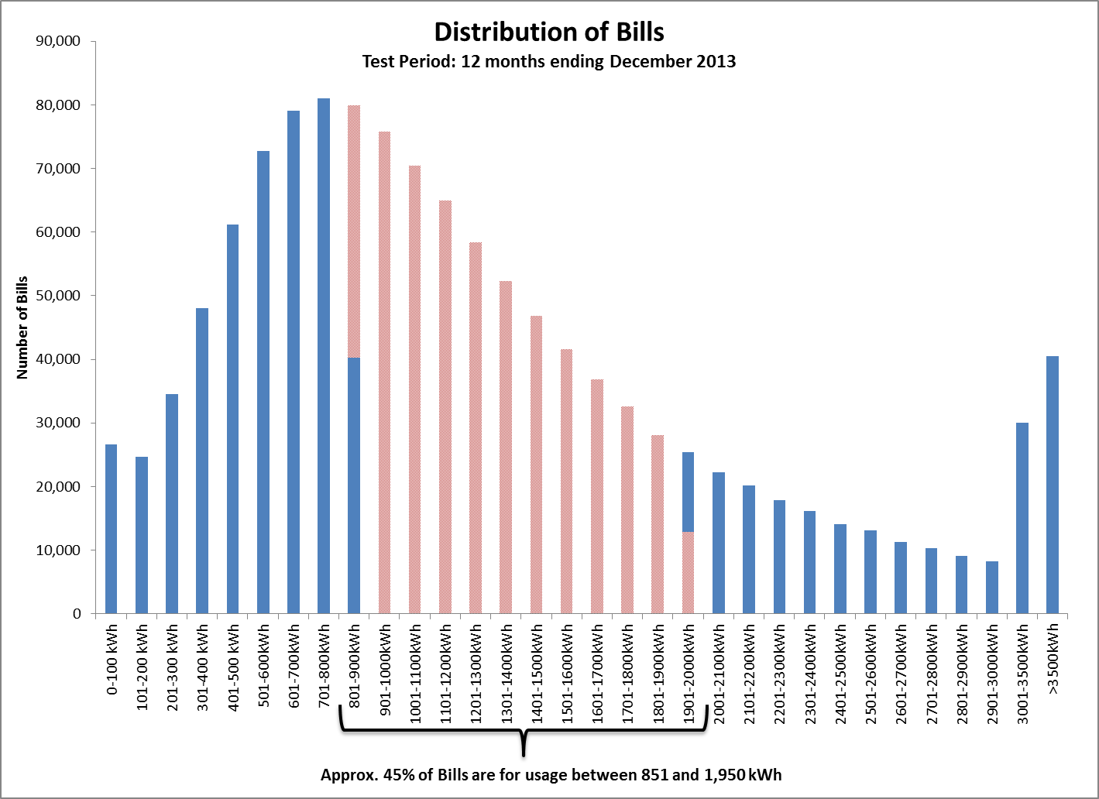

**Q. Does Staff provide any cost-based analysis to support revising the current two block rate design to include a third block for all usage over 1,700 kWh?**

A. No. Staff merely states that it is cost-based but Staff’s only analysis is to show that average usage during four winter months (November - February) is approximately 1,700 kWh.[27] Table 11 below shows the monthly distribution of bills over 1,700 kWh for Schedule 16 customers. This table shows that approximately 72 percent of Schedule 16 bills that exceeded 1,700 kWh (over 205,000 bills) occurred during the winter months of November through April. This new rate block therefore appears to be an attempt to penalize electric heat customers.

**Table 11**

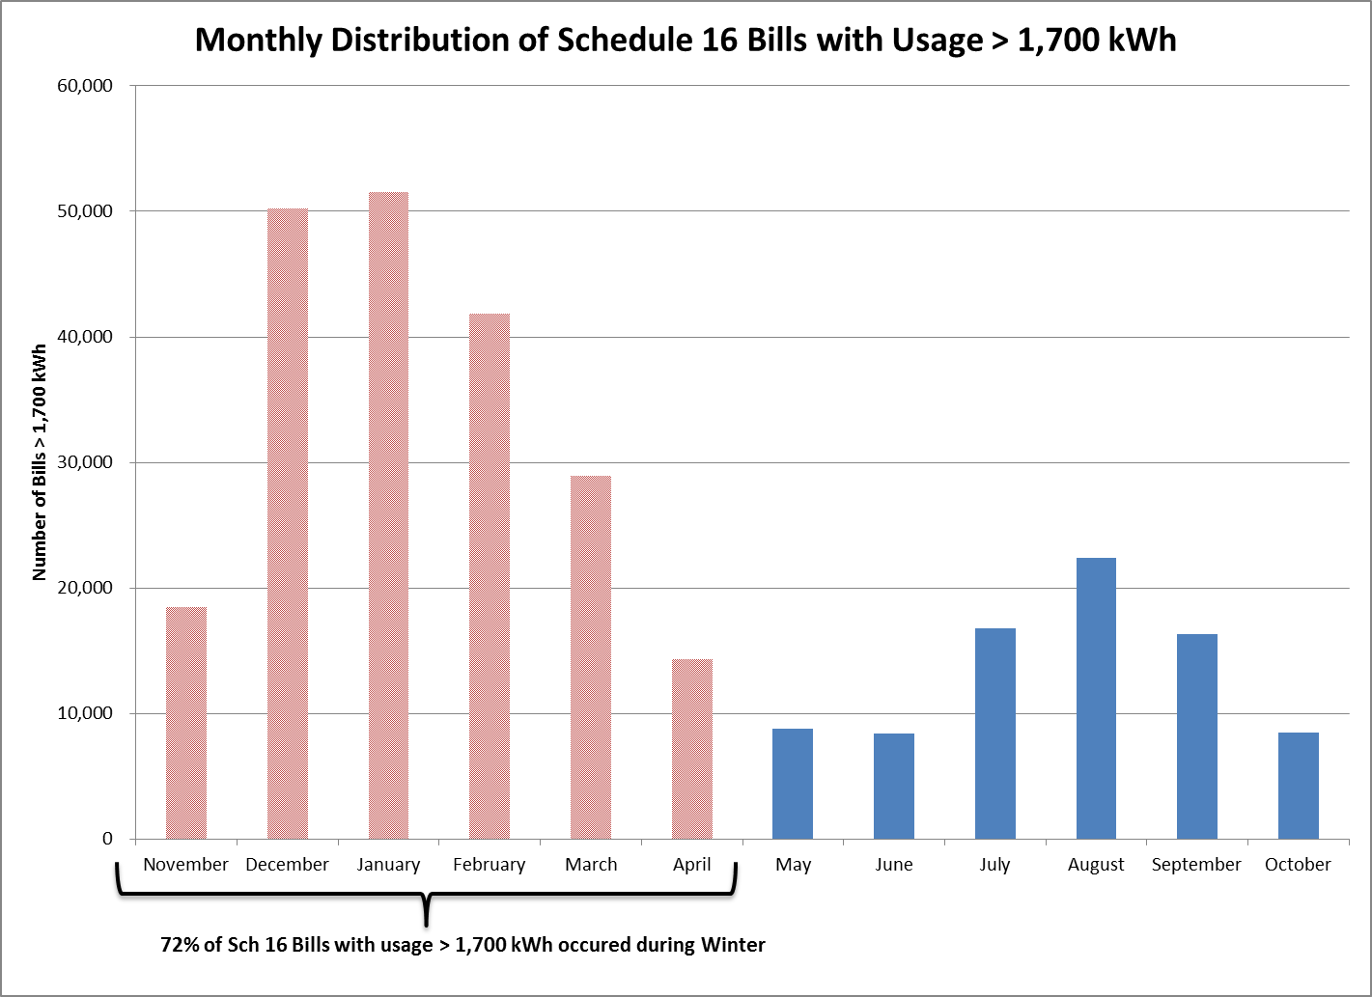

**Q. Will low income customers be adversely impacted under Staff’s proposed rate design?**

A. Yes. I’m concerned that Staff’s rate design proposal to add a third block for usage over 1,700 kWh per month will have a greater impact on low income customers. Table 12 below is similar to Table 11 above except Table 12 shows the percent of customers on Schedule 17, the Company’s Low Income Bill Assistance Program (LIBA), who have bills that exceed 1,700 kWh per month. This table shows that 85 percent of Schedule 17 low income bills exceeded 1,700 kWh (over 10,000) in the winter. For low income customers in particular, it is likely harder to find alternatives to electric heat that would allow them to manage their bills without compromising comfort and health.

**Table 12**

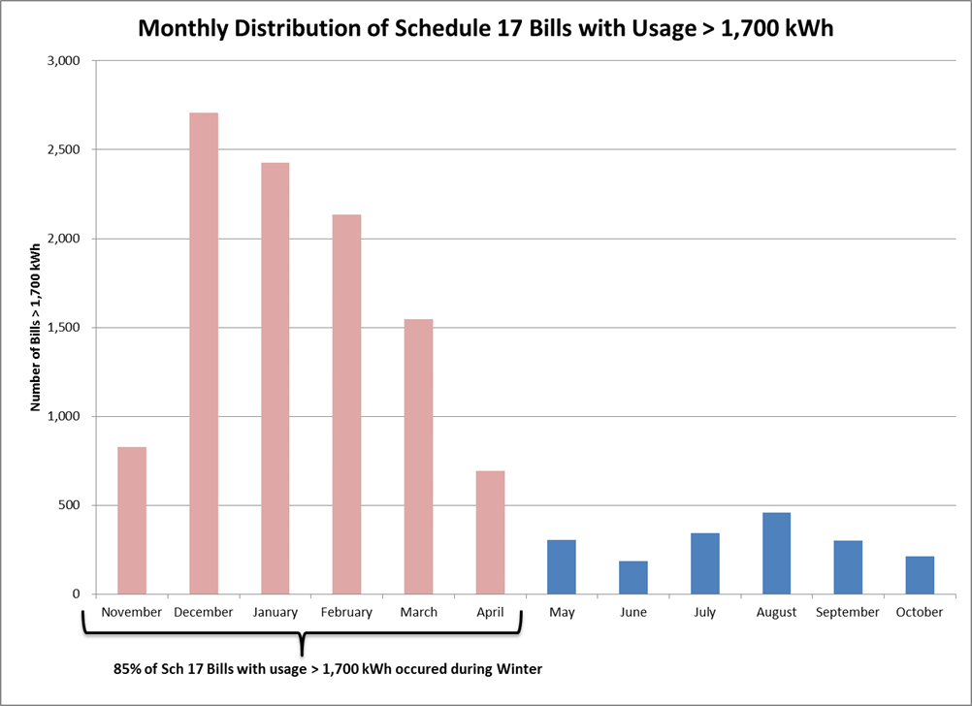

**Q. Does Staff provide any analysis about how customers may respond to its price signal for the third block?**

A. Staff provides an analysis of the potential reduction in usage for the third block based on price elasticity of demand. Staff uses elasticities for residential customers in Washington from a 2006 National Renewable Energy Laboratory report and calculates a potential short-run load reduction of 0.23 percent or 3,759 MWh and a long-run load reduction of 0.47 percent or 7,660 MWh in its proposed third block.

**Q. Do you have any concerns with this analysis?**

A. Yes. Staff only applied this elasticity analysis to usage over 2,000 kWh. Staff did not apply this same analysis to the usage levels that would experience a bill reduction under Staff’s proposed rate design. Elasticity works in both directions—a reduction in price may result in an increase in demand and an increase in price may result in a reduction in demand—and the elasticity factors used by Staff are not exclusive to high usage.

Using Staff’s methodology, the Company recalculates Staff’s long-run reduction due to elasticity to be 8,523 MWh, or 0.53 percent, based on the bill changes for all customers. This includes a net increase of 2,674 MWh for the customers with usage between 851 and 1,950 kWh per month who would see a bill reduction under Staff’s proposal. In contrast, under the Company’s proposed rates, which balance the cost increase to all usage levels, the long-run reduction from elasticity would be 28,919 MWh, or 1.8 percent of load. Even after attempting to account for the difference in the overall revenue requirement proposed by the Company and Staff, the Company’s proposed rate design results in a higher overall reduction in use since a higher rate would apply to more kWh. These calculations are shown in Exhibit No. JRS-21.

**Q. Staff argues that under its rate design the Company will face less risk of fixed cost recovery. Do you agree?**

A. No, I disagree for a couple of reasons. For one, Staff’s table on page 28 in Exhibit No. JBT-4 that purports to show improved revenue stability from Staff’s rate design is misleading because of the change in kWh in the 1st block. By increasing the first block from 600 kWh to 800 kWh per month, the percent of revenue recovered in that block under Staff’s proposal goes up because there are more kWh in that block, not because there is more stable cost recovery. The percent of revenue from the basic charge and usage under 600 kWh is similar under both the Company’s proposal and Staff’s proposal. The percent of revenue from usage over 1,700 kWh, however, is the key difference with Staff’s rate design resulting in 22 percent of revenue compared to the Company’s 18 percent.

**Q. Would weather influence usage in this tail block, and therefore influence the Company’s cost recovery?**

A. Absolutely. Since usage over 1,700 kWh per month is largely tied to electric heat in winter, then temperature will influence usage and therefore recovery of costs. Rates are designed based on revenue and usage that has been normalized for weather, however, weather is hardly ever “normal”. Exhibit No. JRS-22 shows the temperature adjustments that have been applied to normalize residential usage in the last five cases. This exhibit shows that temperature adjustments for the residential class range between a reduction to test period load of 84,467 MWh and $5.6 million in revenue in UE-100749 to an increase of 46,034 MWh and $3.2 million in UE‑111190. Winter temperature is the largest driver of these adjustments and represents 70 percent and 86 percent, respectively, of the total adjustments to the test period load for these cases. Pushing more revenue recovery into this temperature sensitive usage block will make the Company more subject to weather for the recovery of fixed costs.

**Q. Staff argues that only a small portion of fixed costs are in the third block rate. Do you agree?**

A. No. As I previously noted the only costs that will vary with changes in consumption in the near term are net power costs. Staff’s proposed third block rate is approximately 12 cents/kWh. Net power costs, however, are approximately 3.7 cents/kWh on average. So while Staff argues that “any reduction in usage in this block should strongly correlate with a reduction in the Company’s energy-based expenses such as fuel and purchased power,”[28] there is an over 8 cents/kWh differential between the rate and variable net power costs. For any reduction in usage, the Company will under recover 8 cents in other costs.

**Q. Please explain how the current two-block rate structure already sends a significant price signal to large use customers.**

A. The Company’s current residential rate design already reflects a steeply inverted block rate that results in a higher average price for large users. As Table 13 below shows, the Company’s current second tier energy rate is 58 percent higher than the first tier. The Company’s rebuttal proposal retains this differential. For perspective, Table 13 compares the Company’s rates to the rates of the other investor-owned utilities in Washington.

**Table 13**



This shows that the second tier for Puget Sound Energy’s (PSE) residential customers, which is also set for 0-600 kWh, is 22 percent higher than the first tier and results in a significantly flatter rate structure.[29] Avista, which has three residential energy tiers, has an even flatter rate structure with the second tier (for usage between 800-1500 kWh) only 16 percent higher than the first tier and the third tier only 17 percent higher than the second tier.[30] The difference between the first and third tiers for Avista is 36 percent, which is significantly less than the differential in the Company’s current rate design. This all results in the differentials between the average rates for low and high users to be greater under the Company proposal than under the rate designs of PSE or Avista. However, based on average rate data for the 12 months ending June 2014 from the Edison Electric Institute (EEI), the Company has the lowest overall average rate of the three investor-owned utilities in Washington (Company – 8.21 ¢/kWh; PSE – 10.35 ¢/kWh; Avista – 8.74 ¢/kWh).

Staff’s proposed rate design will increase the differential in the rate between the first and third blocks to 85 percent, resulting in bills for electric heat customers in Pacific Power’s service area being close to or higher than bills for comparably sized customers at other utilities. For Pacific Power’s customers that rely on electric heat in winter, this begs a question of fairness, particularly in light of the fact that Pacific Power is the lowest overall cost utility when compared to Avista and PSE. Finally, because 85 percent of Pacific Power’s low-income bills over 1,700 kWh occurred during the winter, the time during which electric heat is critical, these customers would be disproportionately affected.

**Q. In addition to creating a third block, Staff also proposes to increase the size of the first block from 0-600 kWh to 0-800 kWh because Staff argues that usage under 800 kWh is inelastic and that customers have limited capacity for efficiency gains when it comes to basic needs.[31] Do you agree with this proposal?**

A. No. The Company’s energy efficiency programs target many types of end uses—not just electric heat—so altering this rate design may actually undermine those energy efficiency program efforts. Moving more usage into the first block reduces the conservation price signal because more consumption can occur at a lower rate. There is no compelling reason to send this confusing price signal to customers, particularly in light of Washington Initiative I-937. It also doesn’t reflect on-going changes in national and state codes and standards for end-uses and buildings that are driving down use. For instance, the Energy Independence and Security Act of 2007 laid out changes in Federal Lighting Standards that have phased out incandescent bulbs down to 40 watts by 2014.  This change in lighting standards has promoted the use of compact fluorescent and light emitting diode bulbs that reduce energy usage over incandescent bulbs by up to 75-82 percent.

Additionally as I noted in my rebuttal to Staff’s similar proposal in the 2013 Rate Case, using upper-end national data to reset the tier level is incompatible with Washington’s (and the Pacific Northwest’s) historically aggressive energy efficiency efforts and building codes and may not be reflective of what the less elastic essential end-uses are in the Company’s Washington service area today. Table 14 below provides the end-use saturation levels and estimated kWh use by end use that was an input into the Company’s conservation potential study used in the 2013 IRP. The end-use saturation levels come from the Company’s recent residential consumption survey, which was filed with the Commission on July 31, 2014, in Docket UE‑130043 in compliance with Order 05. This table shows that based on more current and localized data for the most common types of appliance end-uses and lighting are well under 600 kWh per month compared to the high end national HUD data used by Staff. Even with the addition of electric water heat, which has a relatively high level of saturation in the Company’s Washington service area, a first block of 600 kWh is reasonable.

**TABLE 14**



**Q. Speaking of the residential consumption survey, has the Company evaluated the results to see if a discernable pattern emerges to characterize customers who have usage over 1,700 kWh per month?**

A. Yes. The Company compared responses from customers who had a bill for usage over 1,700 kWh to responses from all customers. The responses are summarized in Confidential Exhibit No. JRS-23. Some of the interesting findings are:

* High usage customers are more likely to have electric heat.
* High usage customers are more likely to have a single-family home or a manufactured home.
* High usage customers are more likely to have more people in the home. (Q47)
* High usage customers are more likely to have a larger square footage home.
* High usage customers are not more likely to keep track of their usage, be aware of how many kWh they use, or be aware of the tiers. (Q35, Q38, 42).
* Over 50 percent of customers, including high usage customers, indicate that the tiers have not influenced their usage. (Q44).

**Q. Please discuss your third concern about the unintended consequences of Staff’s proposed rate design.**

A. With the growing interest in customer DG and net metering, described above, the company believes major changes in rate structure need to carefully consider the unintended consequences of uneconomic price signals that such rate structures may create. With net metering, customers receive a benefit equal to the energy rate avoided for the DG output that offsets contemporaneous use. They also receive a benefit equal to the energy rate that is applied to the excess DG output during times when output exceeds consumption. The energy rates, therefore, become important price signals and incentives for net metering customers. With Staff’s proposed rate design that creates a 12 cents/kWH rate (at its proposed revenue requirement) in the third block, that rate becomes an incentive or benefit for large customers either currently with or interested in DG. Because that rate includes fixed costs in addition to variable costs, (even if the company’s proposed basic charge is approved) it will lead to greater cost shifting to other customers as DG grows.

While the Commission has an on-going investigatory docket, UE-131883, on the costs and benefits of DG, there has been no finding or determination on the costs and benefits at this time. Accordingly, a major revision to the current residential rate structure is premature without consideration of whether it sends a price signal consistent with the costs and benefits of DG, particularly in light of the Commission’s prior observations in Docket UE-110667 on cost-shifting due to DG.

**Q. On the topic of DG, how do you respond to Staff’s discussion in response to your direct testimony that the Company is conducting a load research study for DG customers and may propose a new rate design in a future case?**

A. I found Staff’s response and recommendation confounding and inaccurate. First, I find it perplexing that Staff would prejudge a rate proposal, ask the Commission to prejudge it, and indicate a higher burden of proof would be required on something that hasn’t yet been filed. The purpose of that part of my testimony was to inform the Commission that the Company is conducting load research to inform future rates. Unlike Staff, the Company is not asking the Commission to take any action on this topic at this time without the benefit of supporting data.

Second, Staff inaccurately characterized my testimony and the three-part rate design that includes a demand rate component. Staff states: “A three-part rate design includes the basic charge and volumetric usage charge that residential customers already pay, but adds a demand charge that assesses an additional fee based on the customer’s peak usage during the billing cycle.”[32] In actuality, a demand charge is not an additional fee assessed on top of what customers already pay. All rates for this partial requirements customer class would be redesigned and developed consistent with the costs of serving customers: demand-related costs would be recovered through demand charges, customer-related costs through customer charges, and energy-related costs through energy charges. This type of rate design is already used extensively in all nonresidential rate schedules so should therefore not be novel to Staff.

Third, Staff imputes to the Company an argument on the rationale for a future rate that the Company did not make when it points to “The Duck Curve” and then argues that the three-part rate design would not reflect the operations of Pacific Power’s west control area system.[33] Again, the Company is collecting data to inform the discussion and is not proposing a rate based on studies in other jurisdictions. Additionally, Staff apparently fails to understand that with a three-part rate that includes a peak-based demand charge, to the extent a DG customer reduces load during the peak, the customer will receive the benefit of those cost-based savings by avoiding peak charges.

Fourth, Staff’s analysis vastly over-simplifies cost drivers by concluding that DG customers help meet peak load because the peak occurs during daylight hours, which is when DG is producing. The peak occurs in an hour, not merely in the broader period of daylight. And in the west control area, the peak occurs in winter, which is when output from solar DG is significantly less. In fact, the graph below shows the peak winter day during the test period for the residential average load profile, assumed DG production and net usage.

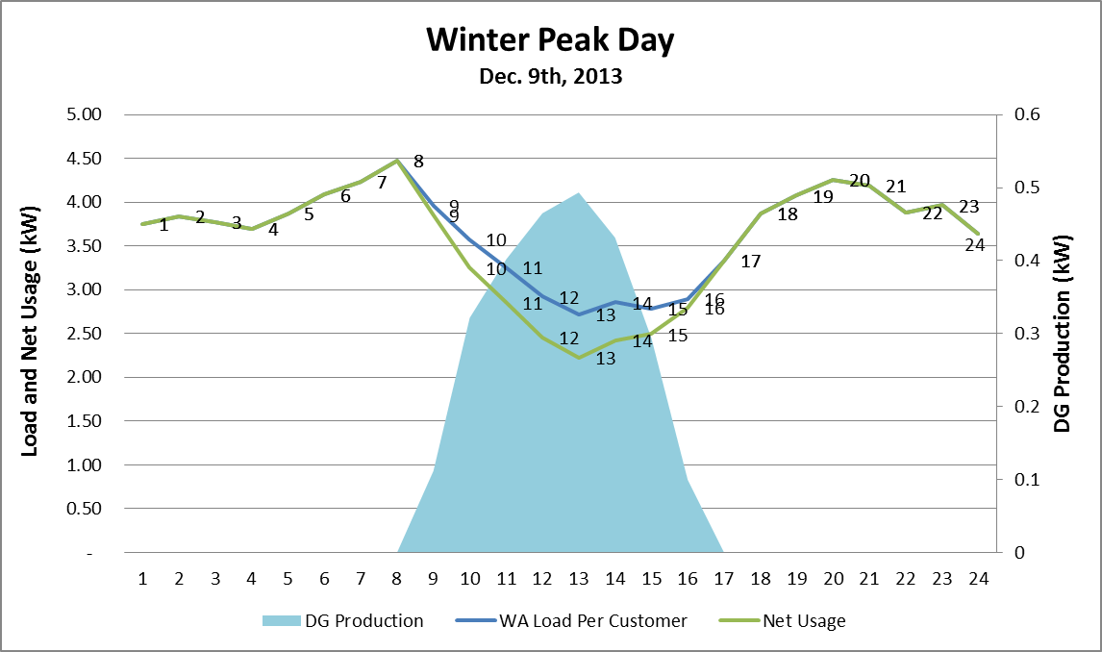

The winter peak day shows a few important things.  First, during the peak hour of 8:00 am, DG production is not yet producing so it is not helping the Company meet load.  Second, the west control area typically produces two peaks in a day, one in the morning and one in the evening.  This same day also had the highest ranked evening peak of the year at the hour of 7:00 pm.  DG production during this hour was also zero and thus not contributing energy to meet load.  Lastly, the blue area of the chart is the assumed DG production.  This is based off of an assumed 4 kW system in Yakima using the PVWatts Solar calculator.  The chart clearly shows that solar DG production does not align with the morning or evening peaks. My point in providing this graph is that, again, actual data will help inform the discussion and therefore, Staff’s rush to judgment should be dismissed.

Lastly, Staff states several times that its proposed rate spread will address many of the issues associated with DG. Rate spread is an allocation of revenues to a class. DG issues, on the other hand, are a rate design issue so I fail to see how Staff’s rate spread has any relationship to DG.

# GENERAL SERVICE, AGRICULTURAL PUMPING,

# AND STREET LIGHTING RATE DESIGN

**Q. Is the Company proposing any changes in this rebuttal filing to rate designs for the general service, agricultural pumping, and street lighting schedules?**

A. The Company is proposing one change to rate design for general service Schedule 36, in response to Wal-Mart’s testimony. Staff proposed for those classes receiving an increase to allocate the increase evenly across the usage-based rates within the class, except for the basic charge for the Dedicated Facilities class. The Company is proposing no change from the approach in its original filed case which allocated more of the increase to demand to move cost components closer to cost of service.

**Q. Please explain the rate design changes for Schedule 36 proposed by Wal-Mart.**

A. Wal-Mart proposed an unbundled generation demand rate equal to 50 percent of a generation demand rate calculated by dividing generation demand costs by the Schedule 36 NCP kW found in the “Unit Costs” tab of Exhibit No. JRS-15. Likewise a proposed unbundled transmission demand rate equal to 50 percent of a transmission demand rate calculated by dividing transmission demand costs by the Schedule 36 NCP kW.

**Q. What is the Company’s response to Wal-Mart’s proposal?**

A. The Company agrees in part with Wal-Mart’s proposed rate design, however, the Company is proposing a more gradual movement in increasing the demand charge for Schedule 36 in light of bill impacts. Specifically, the Company proposes a movement that is half way between a rebuttal rate calculated the same as the original filing of $3.49 or approximately 40 percent of total generation demand and Wal-Mart’s 50 percent generation demand proposal or $4.38. The proposed rate of $3.94 is approximately 45 percent of total generation demand costs. The transmission demand rate is calculated using the same approach as applied above but for transmission demand.

# RULE D AND SCHEDULE 300

**Q. The Company proposed changes to Rule D and Schedule 300 in the direct testimony of Company witness Ms. Barbara A. Coughlin. Does the Company continue to support the tariff revisions proposed in Ms. Coughlin’s testimony?**

A. Not entirely. In response to concerns raised by the parties, the Company is willing to withdraw its proposal for the Collection Agency to charge the customer as reflected in the changes proposed for Rule 11D, its proposal for changes to the Field Visit Charge language in Rule 11D, and its proposal to increase the Connection Charge and Reconnection Charge. In doing so, an adjustment of $83,324 to increase revenue requirement is being made.

**Q. Why is the Company withdrawing these proposed tariff revisions?**

A. In the Company’s last rate case it presented a similar proposal to increase the Connection and Reconnection Charges. Parties in that case were concerned that the Company’s proposal to increase the Connection and Reconnection Charges was based on estimates from a study rather than the actual cost of the work performed. The Company voluntarily withdrew its tariff filing to gather actual data and undertake additional analysis to demonstrate the validity of actual costs. At that time the Company committed to bring forward Connection and Reconnection Charges based on actual data and analysis, which has been done in this case. However, parties again expressed concern over the magnitude of the proposed increase based on the Company’s actual data. Therefore, the Company is willing to withdraw the proposal.

**Q. There are other tariff changes proposed in Ms. Coughlin’s direct testimony that have not been discussed in this rebuttal testimony. Did parties raise concerns in testimony for (1) implementation of a non-radio frequency meter charge (Rule 8 and Schedule 300); (2) increasing the Unauthorized Reconnection/Tampering Charge (Schedule 300); (3) modification of the Facilities Charge (Schedule 300); or (4) modification of the title of Returned Check Charge (Schedule 300)?**

A. No. The Parties did not object to any of the Company’s other proposed changes and the Company continues to support these proposed changes.

**Q. Does this conclude your rebuttal testimony?**

A. Yes.

1. Testimony of Glenn A. Watkins, Exhibit No. GAW-1T at 10:18-21.
2. *Id*. at 12:1-11.
3. Testimony of Jeremy B. Twitchell, Exhibit No. JBT-1T at 18.
4. In direct testimony Staff rejects the Company’s proposed Renewable Resource Tracking Mechanism (RRTM) because it is designed to address a single factor of the utility’s net power costs. *Id*. at 14:1-4. Ironically, Staff’s proposed NDG allocation factor singles out for special treatment the same specific resource type in the Company’s COS study.
5. Testimony of Glenn A. Watkins, Exhibit No. GAW-1T at 14:19 – 15:7.
6. PacifiCorp’s 2013 Integrated Resource Plan, Docket UE-120416, 2013 Integrated Resource Plan, Volume 1 at Table ES.3, at page 11 (April 30, 2013).
7. It is worth noting that elsewhere Staff described an amount of $254,000 as almost infinitesimal. *See* Testimony of Roger Kouchi, Exhibit No. RK-1T at 7:18-20.
8. The FERC accounts considered to be variable by Boise were 501, 501NPC, 503, 518, 547NPC, and 555 (in part). Responsive Testimony of Robert R. Stephens, Exhibit No. RRS-1T at 20, footnote 14.
9. National Association of Regulatory Utility Commissioners, *Electric Utility Cost Allocation Manual*, (January 1992), p. 75.
10. *Wash. Utils. & Transp. Comm’n v. Puget Sound Power & Light Company*, Dockets UE-920433, UE-920499 and UE-921262, Ninth Supplemental Order on Rate Design Issues at 12 (August 17, 1993).
11. *Wash. Utils. & Transp. Comm’n v. PacifiCorp*, Docket UE-100749, Order No. 06 at 104-105 (Mar. 25, 2011).
12. Testimony of Jeremy B. Twitchell, Exhibit No. JBT-1T at 22.
13. *Id.*
14. Responsive Testimony of Steve W. Chriss, Exhibit No. SWC-1T at 9.
15. *See, e.g.,* *In the Matter of Amending and Repealing Rules in WAC 480-108 Relating to Electric Companies-Interconnection With Electric Generators*, Docket UE-112133, Interpretive Statement Concerning Commission Jurisdiction and Regulation of Third-Party Owners of Net Metering Facilities (July 30, 2014).
16. *UTC Report on the Potential for Cost-Effective Distributed Generation in Areas Served by Investor-Owned Utilities in Washington State*, Docket UE-110667 at 5 (October 7, 2011). The Commission observed that, “net metering provides a type of incentive for individual consumers because it shifts costs from the individual ratepayer to the utility, and ultimately to the other ratepayers of that utility, due to the need to maintain sufficient capacity to meet that individual customer’s load while his or her net metered system is not generating electricity.” *Id.* at 29.
17. <http://www.jsonline.com/business/state-regulators-approve-83-in-green-bay-utilitys-fixed-charge-b99385986z1-281824701.html>.
18. Testimony of Glenn A. Watkins, Exhibit No. GAW-1T at 27:12-14.
19. *Id*. at 28:1-4.
20. *See* FERC Account 364 (Poles, Towers, and Fixtures), Account 365 (Overhead Conductors), and Account 368 (Transformers) in Docket No. UE-130052, Order Granting Accounting Petition (December 27, 2013).
21. National Association of Regulatory Utility Commissioners, *Electric Utility Cost Allocation Manual*, (January 1992), p. 89.
22. Testimony of Glenn A. Watkins, Exhibit No. GAW-1T at 24:2-5.
23. Testimony of Glenn A. Watkins, Exhibit No. GAW-1T at 22-23.
24. Testimony of Jeremy B. Twitchell, Exhibit No. JBT-1T at 27:18-20.
25. Testimony of Jeremy B. Twitchell, Exhibit No. JBT-1T at 5:1-2.
26. Testimony of Jeremy B. Twitchell, Exhibit No. JBT-1T at 29:3-12.
27. Testimony of Jeremy B. Twitchell, Exhibit No. JBT-1T at 28:17-20.
28. Testimony of Jeremy B. Twitchell, Exhibit No. JBT-1T at 33:22 – 34:1.
29. *See* Puget Sound Energy, Inc., Tariff WN U-60, Schedule 7, effective November 16, 2013, and Schedule 141, effective January 1, 2014.
30. *See* Avista Corporation Tariff WN U-28, Schedule 1, effective January 1, 2014.
31. Testimony of Jeremy B. Twitchell, Exhibit No. JBT-1T at 28:1-13.
32. Testimony of Jeremy B. Twitchell, Exhibit No. JBT-1T at 37:1-5.
33. Testimony of Jeremy B. Twitchell, Exhibit No. JBT-1T at 37-40.