Report to the Washington Utilities and Transportation Commission

## Electric Service Reliability - Major Event Report

# Event Date: May 21, 2016

Date Submitted: August 3, 2016

Primary Affected Locations: Walla Walla

Primary Cause: Loss of Transmission

Exclude from Reporting Status: Yes

Report Prepared by: April Brewer

Report Approved by: Heide Caswell / David O’Neil / Kevin Putnam

**Event Description**

On May 21, 2016, Walla Walla, Washington, experienced a system average interruption frequency index-driven (SAIFI)-based major event when a helicopter collided into a transmission line. The outage affected 4,175[1] customers with all customer restorations completed within 7 hours 43 minutes. Sustained interruptions were experienced by approximately 15% of the Walla Walla operating area’s customers.

|  |  |
| --- | --- |
| **Event Outage Summary** | |
| **# Interruptions (sustained)** | 6 |
| **Total Customer Interrupted (sustained)** | 4,175 |
| **Total Customer Minutes Lost** | 277,942 |
| **Event State SAIDI** | 2.09 Minutes |
| **CAIDI** | 67 |
| **Major Event Start** | 5/21/16 12:00 AM |
| **Major Event End** | 5/21/16 11:59 PM |

**Restoration Summary**

At 8:36 am on May 21, 2016, a helicopter spraying fields became entangled in the 69kV line which feeds the Mill Creek substation in Walla Walla de-energizing feeds to Waitsburg, Dayton, and Pomeroy substations. The incident also damaged a section of distribution underbuild along this span.

Crews were quickly dispatched to the area, based on fault location relay information, whereupon they begin patrolling the line. Meanwhile dispatch was able to restore power to the Pomeroy and Dayton substation through SCADA, energizing three circuits and power to 3,102 customers within 37 minutes. Once crews located the damage, and work repairs were assessed, field personnel were then able to manually close the circuit breaker restoring power to the Waitsburg substation and energize service to 1,057 customers; their power was restored within 2 hours 28 minutes. Service was restored to the final 16 customers, in 7 hours 42 minutes, when damage to the distribution underbuild was repaired.

Restoration activities utilized five operations personnel.

There were no company or commission customer complaints made regarding the major event.

**Restoration Intervals**

|  |  |  |  |
| --- | --- | --- | --- |
| **Total Customers Sustained** | **< 3 Hrs.** | **3 - 24 Hrs.** | **24+ Hrs.** |
| **4,175** | 4,159 | 16 | 0 |

**Restoration Resources**

|  |  |
| --- | --- |
| **Resources** | |
| **Journeymen** | 5 |

|  |  |
| --- | --- |
| **Materials** | |
| **Conductor** | 400 ft |

**State Estimated Major Event Costs**

|  |  |  |  |
| --- | --- | --- | --- |
| **Estimate $** | **Labor** | **Materials** | **Total** |
| **Capital** | $5,785 | $619 | $6,404 |
| **Expense** | $0 | $0 | $0 |
| **Total** | **$5,785** | **$619** | **$6,404** |

**Major Event Declaration**

Pacific Power is requesting designation of this event and its consequences to be classified as a “Major Event” for exclusion from underlying network performance reporting. This major event exceeded the company’s current Washington system average interruption frequency index-driven (SAIFI) threshold of 10% total operating area customers served sustained interruptions (4,175 customers interrupted out of 28,310 Walla Walla operating area customers, or 15% of the operating area customers) simultaneously in a 24-hour period.

**Event Detail**

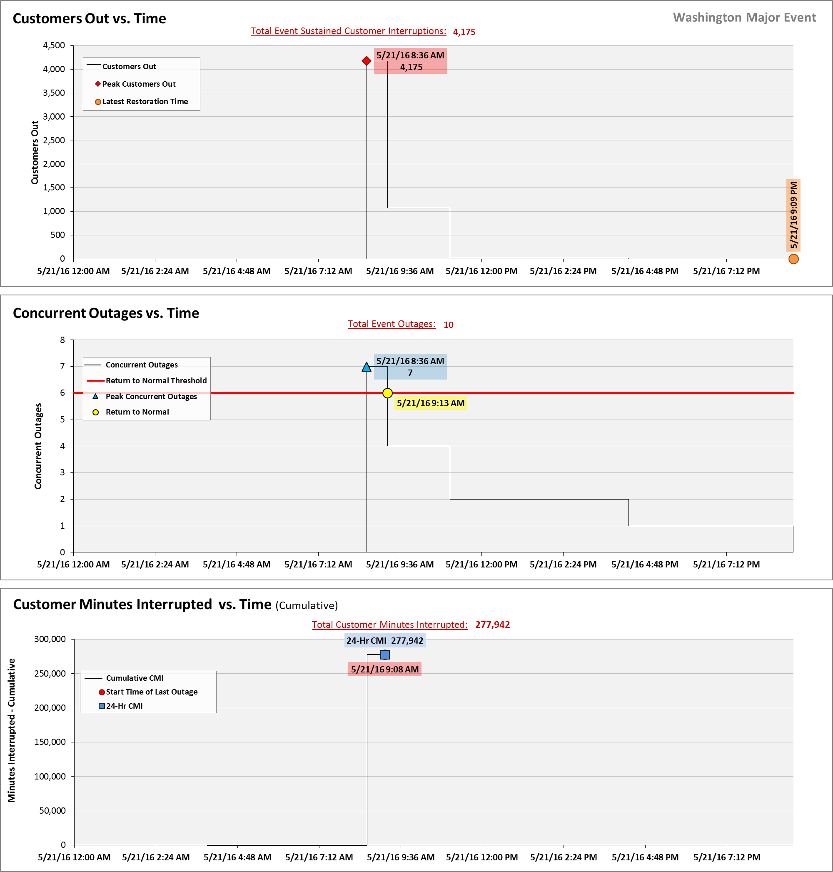

**SAIDI, SAIFI, CAIDI by Reliability Reporting Region**

Please see the attached system-generated reports.

1. A SAIFI-based major event threshold (as identified in PacifiCorp’s reporting plan, pursuant to Washington Administrative Code (WAC) 480-100-393 & 398 Electric Reliability Annual Monitoring and Reporting Plan) is defined as an event in which more than 10% of an operating area’s customers are simultaneously without service as a result of a sustained interruption. Walla Walla operating area’s Calendar 2016 Frozen Customer Count is 28,310 customers.