June 9, 2010

Mr. David Danner, Executive Director and Secretary

Washington Utilities & Transportation Commission

1300 S. Evergreen Park Drive SW

P.O. Box 47250

Olympia, WA 98504-7250

Re: Docket No. UT-100820 – In the Matter of the Joint Application of Qwest and CenturyTel for Approval of Indirect Transfer of Control of Qwest.

Dear Mr. Danner:

As the Commission is aware, CenturyLink and Qwest have submitted filings in numerous jurisdictions seeking regulatory approval of their proposed merger (see response to Bench Request No. 1 for a list of those jurisdictions). These various proceedings will inevitably involve some degree of common intervenors and witnesses. Therefore scheduling conflicts can become a concern.

As the Commission contemplates the issuance of a procedural schedule for its review of this matter, CenturyLink and Qwest thought it might be helpful to be aware of potential conflicts with hearing dates set in other jurisdictions as those dates become known. To that end please be advised that at yesterday’s prehearing conference, the Oregon Public Utility Commission set a hearing date as follows:

October 20-21, 2010

CenturyLink and Qwest expect additional hearing dates, and therefore witness commitments to be established in other jurisdictions in the near future. We will endeavor to update the Commission as those become known until such time as the Washington schedule is established.

Sincerely,

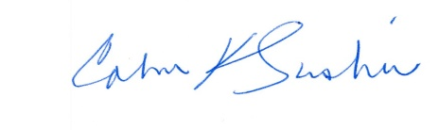

Calvin K. Simshaw