**BEFORE THE WASHINGTON UTILITIES AND TRANSPORTATION COMMISSION**

|  |  |  |
| --- | --- | --- |
| In the Matter of the Joint Application of  QWEST COMMUNICATIONS INTERNATIONAL INC. AND CENTURYTEL, INC.  For Approval of Indirect Transfer of Control of Qwest Corporation, Qwest Communications Company LLC, and Qwest LD Corp. |  | DOCKET NO. UT-100820  QWEST’S AND CENTURYLINK’S JOINT ANSWER TO SPRINT’S MOTION TO COMPEL |

1. The Joint Applicants, Qwest Communications International, Inc. (“Qwest”) and CenturyTel, Inc. (“CenturyLink”) (collectively, “Joint Applicants”) hereby respond to the motion of Sprint Nextel Corporation (“Sprint”) to compel responses to data requests numbers 5, 13, 14, 41 and 42 propounded by Sprint in this proceeding.

## Request No. 5

1. The motion to compel as it pertains to Sprint’s Request No. 5 appears to be moot. In its motion, Sprint recites its agreement to “narrow its request such that QC and CenturyLink not be required to provide revenue numbers for specific services,”[1] observes that Qwest and CenturyLink have provided or agreed to provide intrastate revenues, and contends that “interstate revenues from Washington services are relevant” to its claims. Sprint’s clarification in its Motion is helpful, and provides additional clarity to the parties’ agreement negotiated prior to the motion to compel.
2. With this clarification, the motion is moot. Qwest and CenturyLink have provided aggregated intrastate and interstate revenues to Sprint. Qwest is providing this information today, and CenturyLink provided interstate revenue information on August 13, the same day the Motion to Compel was filed.

## Requests 13 and 14

1. Requests 13 and 14 seek information on interstate switched access revenue and special access revenue that the Applicants’ ILEC entities obtained from affiliated IXCs of the other side of the merger. The requests are not supportable from either a factual or legal viewpoint. Legally, these services are not subject to regulation by the Commission – they are interstate services.[2] Such revenues are not relevant to a determination of any issue properly in dispute in the pending Application. Because the Applicants are not proposing, and the transaction does not result in any change to access charge rates, access charges are not relevant to the Commission’s review and consideration of this merger. This is entirely consistent with the Commission’s recent actions in the CenturyLink-Embarq merger [3]or the Frontier-Verizon merger.[4] In neither of those cases did the Commission review or adjust access charges. The Commission’s practice of not addressing switched access issues in its consideration of merger applications should apply with extra force as it pertains to primarily interstate services.
2. Sprint’s arguments to the contrary are unavailing because they are based on a false factual premise. Sprint argues: “Responses to these requests should be required because they will allow Sprint to demonstrate the amount of access charge savings that the merged company will retain when access charge payments become intracompany payments rather than payments from QC entities to CenturyLink entities and vice versa.” But as made clear in Qwest’s Application at ¶ 7:

The Transaction contemplates a parent-level transfer of control of QCII only. Qwest Corp, QCC, QLDC, and the CenturyLink Washington Operating Subsidiaries[5] will continue as separate carriers and each will continue to have the requisite managerial, technical and financial capability to provide services to its customers. Immediately upon completion of the Transaction, end user and wholesale customers will continue to receive service from the same carrier, at the same rates, terms and conditions and under the same tariffs, price plans, interconnection agreements, and other regulatory obligations as immediately prior to the Transaction…

1. And as further made clear in other responses Qwest and CenturyLink provided to Sprint discovery requests,[6] QC and the CenturyLink entities will continue to charge each other pursuant to switched access and other tariffs and agreements, and reductions in such payments are not part of the synergy savings the companies hope to achieve. Because access charge payments will not change, Sprint’s stated justification for the relevance of reviewing revenues outside the Commission’s jurisdiction is not factually supportable.

## Requests 41 and 42

1. Requests 41 and 42 are also moot. These requests seek information regarding access lines and revenues CenturyLink has in Qwest territory, and vice versa. As recited in the Motion, Qwest provided this information, but designated it Highly Confidential. The Motion requested designation as Confidential. Qwest amended its designation of the information to Confidential on August 13.
2. The Motion recites that CenturyLink had not provided access line counts or revenues, but only customer counts. CenturyLink updated its response with access line counts and revenues, designated as Confidential, on August 13. Thus, the Motion is moot as to these requests.
3. WHEREFORE, Joint Applicants request that the Commission deny Sprint’s motion to compel.

Respectfully submitted this 20th day of August, 2010.

CENTURYLINK QWEST

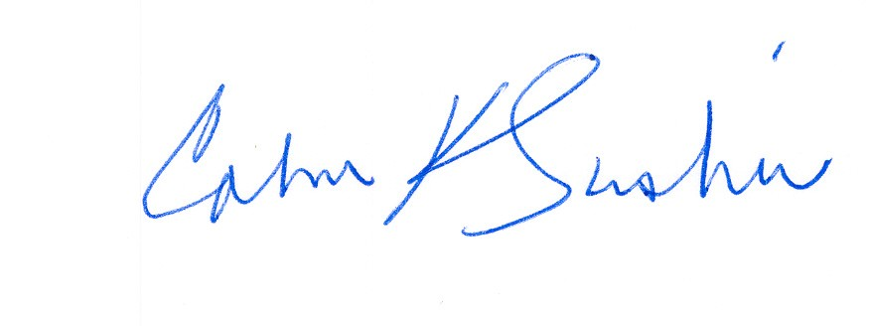

__________________________ ___________________________

Calvin K. Simshaw Lisa A. Anderl (WSBA # 13236)

CenturyLink Qwest Law Department

805 Broadway 1600 – 7th Ave., room 1506

Vancouver, WA 98660 Seattle, WA 98191

[calvin.simshaw@centurylink.com](mailto:calvin.simshaw@centurylink.com) [lisa.anderl@qwest.com](mailto:lisa.anderl@qwest.com)

1. Sprint Motion ¶ 7.
2. Special access services are chiefly interstate services, but not exclusively so.
3. Docket No. UT-082119
4. Docket No. UT-090842.
5. The CenturyLink Washington operating subsidiaries are: CenturyTel of Washington, Inc., CenturyTel of Inter-Island, Inc., CenturyTel of Cowiche, Inc., CenturyTel Long Distance, LLC, CenturyTel Solutions, LLC, CenturyTel Fiber Company II, LLC, United Telephone Company of the Northwest, and Embarq Communications, Inc., collectively referred to as the “CenturyLink Washington Operating Subsidiaries” or in the case of CenturyTel of Washington, Inc., CenturyTel of Inter-Island, Inc., CenturyTel of Cowiche, Inc., and United Telephone Company of the Northwest, collectively referred to as the “CenturyLink Washington ILECs.”
6. Sprint request No. 47. A copy of the response is attached as Exhibit A.