BEFORE THE WASHINGTON
UTILITIES AND TRANSPORTATION COMMISSION
In the Matter of  PUGET SOUND ENERGY  Petition for Waiver from Certain  Request for Proposals Requirements | Docket No. UE-160387  Puget Sound Energy’s Amended Petition for Waiver of Certain Requirements Related to Requests for Proposals Contained in WAC 480-107
- In accordance with WAC 480-107-002(3) and WAC 480-07-370(b), Puget Sound Energy (“PSE”) submits this amended petition to the Washington Utilities and Transportation Commission (the “Commission”) for a waiver of certain requirements related to requests for proposals (“RFP”) contained in WAC Chapter 480-107.
- PSE is an electric company and public service company in the State of Washington within the meaning of RCW 80.04.010, and is subject to the Commission’s jurisdiction with respect to its prices and terms of electric service to retail customers in Washington. PSE provides electric service to approximately 1.1 million retail customers in Washington.
- PSE is engaged in the business of providing electric and gas service within the State of Washington as a public service company, and is subject to the regulatory authority of the Commission as to its retail rates, service, facilities and practices. Its full name and mailing address for purposes of this proceeding are:
Puget Sound Energy, Inc.  Attn: Kenneth Johnson  Director, State Regulatory Affairs  P.O. Box 97034  Bellevue, Washington 98009-9734  Phone: 425.456.2110  Email: ken.s.johnson@pse.com | Puget Sound Energy, Inc.  Attn: Sheri Maynard  Assoc. Energy Resource Planning &  Acquisition Analyst  P.O. Box 97034  Bellevue, Washington 98009-9734  Phone: 425.462.3114  Email: sheri.maynard@pse.com
- REQUEST FOR WAIVER OF REQUIREMENT TO FILE
REQUEST FOR PROPOSALS FOR SUPPLY-SIDE RESOURCES
- On November 25, 2015, PSE filed its 2015 Integrated Resource Plan (the “2015 IRP”) with the Commission in Docket No. UE-141170 pursuant to WAC 480-100-238. The 2015 IRP identified an electric peak capacity need for PSE of 154 megawatts (MW) in 2017, as shown on Figure 6-10 of the 2015 IRP, which is reproduced below:
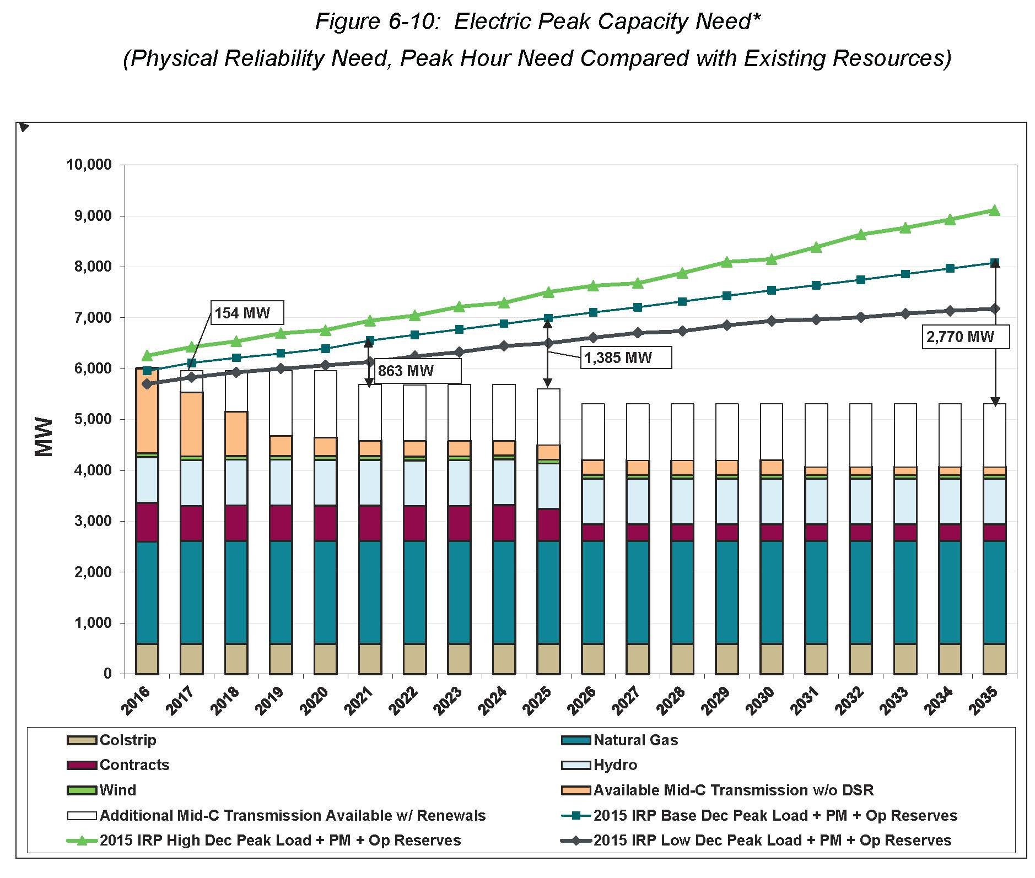
(2015 IRP at page 6-18.) The 2015 IRP identified the following items, among others, in the electric action plan:
1. Acquire energy efficiency.
Develop 2-year targets and implement programs that will put us on a path to achieve an additional 411 MW of energy efficiency by 2021.
2. Acquire demand-response.
Develop and implement a demand-response acquisition process and issue a Request for Proposal (RFP). The analysis supports the addition of demand-response by 2021, but these programs don’t fit existing energy efficiency or supply-side resource models.
3. Supply-side resources: Clarify before issuing an all-source RFP.
Energy efficiency and demand-response additions appear sufficient to meet incremental capacity need until 2021 and additional renewables are not needed until 2023. PSE intends to issue an all-source RFP in 2016, subject to an update to resource needs, most likely in early summer of 2016. This postponement will provide time to incorporate an updated regional adequacy assessment into our resource need, which is scheduled to be completed by the NPCC in the second quarter of 2016.
(2015 IRP at page 1-10.)
- As identified in the quoted language from the electric action plan in the 2015 IRP, PSE’s energy efficiency and demand-response additions appear sufficient to meet incremental capacity need until 2021, and additional renewables are not needed until 2023. In particular, PSE projects the acquisition of 411 MW of conservation and 121 MW of demand response by 2021. (2015 IRP at pages 1-17 and 2-7.) PSE projects that these combined 532 MW of conservation and demand response resources will meet all projected needs until 2021, when PSE projects the need for 277 MW of supply-side resources. (2015 IRP at pages 1-17 and 2-7.)
- Additionally, as indicated in the quoted language from the electric action plan in the 2015 IRP, PSE intends to issue an all-source request for proposals in 2016, subject to an update to resource needs. (2015 IRP at page 1-10.) PSE will update its load forecast in the summer of 2016. PSE will also update its capacity need in light of the new load forecast and a new assessment of regional adequacy—expected to be issued by the Northwest Power and Conservation Council in May 2016—prior to deciding whether to issue an all-source request for proposals in 2016.
- WAC 480-107-002(3) permits the Commission to grant exceptions to the rules governing request for proposals, but only where such exceptions are “consistent with the public interest, the purposes underlying regulation, and applicable statutes.” Additionally, WAC 480-107-015(3)(a) provides that the requirement for requests for proposals do not apply when a utility’s integrated resource plan, prepared pursuant to WAC 480-100-238, demonstrates that the utility does not need additional capacity within three years. Although PSE’s 2015 IRP did project a need for 154 MW of capacity by 2017, PSE projects that such need will be met by PSE’s conservation and demand response resource acquisitions. Therefore, there is no need, at this time, for PSE to conduct a request for proposal of supply-side resources for the 2016-2018 period, and PSE’s request for a waiver of WAC 480-107-015(3)(b) with respect to the issuance of a request for proposal for supply-side resources is consistent with the public interest, the purposes underlying regulation, and applicable statutes.
- For the reasons discussed above, PSE requests a waiver of 480-107-015(3)(b) with respect to the issuance of a request for proposal for supply-side resources.
- This amended waiver reflects input from PSE’s Conversation Resource Advisory Group (“CRAG”); more accurately describes the process, timing and issuance of PSE’s Biennial Conversation Plan; and provides additional detail as to the reasons behind PSE request to extend the deadline to file PSE’s demand response RFP.
- REQUEST FOR WAIVER OF REQUIREMENT TO FILE
REQUEST FOR PROPOSALS FOR CONSERVATION RESOURCES
- On November 25, 2015, PSE filed its 2015 Integrated Resource Plan (the “2015 IRP”) with the Commission in Docket No. UE-141170 pursuant to WAC 480-100-238. The 2015 IRP informed PSE’s ten-year electric conservation potential and its two-year electric conservation target.
- On October 29, 2015 PSE filed its 2016-2017 Biennial Conservation Plan with the Commission in Docket No. UE-152058. The 2016-2017 Biennial Conservation Plan identified (i) a 2016-2025 ten-year achievable conservation potential of 2,770,663 megawatt-hours (“MWh”) and (ii) a 2016-2017 biennial electric conservation target of 537,078 megawatt-hours (MWh) for PSE. On December 17, 2015, the Commission issued Order 01 in Docket No. UE-152058 in Docket No. UE-152058 that approved PSE’s 2016-2025 achievable conservation potential and its 2016-2017 biennial conservation target, subject to conditions attached as Appendix A to the Order. Consistent with PSE’s established procedure for setting its biennial conservation targets and acquiring conservation resources, PSE issued two requests for proposals (“RFPs”) in 2015 for energy efficiency programs. The RFPs were issued in June, in order to allow sufficient time to evaluate responses and implement programs in 2016 for the biennium. The RFPs were issued prior to the filing of the final 2015 IRP due to two Commission-approved IRP filing delays. PSE ensured that its CRAG was aware of these activities throughout the 2016-2017 biennial planning process. Subsequent to Commission approval of the 2016-2017 biennial conservation target, PSE selected vendors and implemented the selected programs.
- PSE will update the conservation target for 2018-2019 consistent with guidance provided in its 2017 Integrated Resource Plan (the “2017 IRP”) and with the involvement of the CRAG. PSE will reflect the 2018-2019 conservation target in its 2018-2019 Biennial Conservation Plan. In or about June 2017, PSE will undertake an all-source RFP process similar to that used in 2015 to assess potential programs that can acquire conservation resources beginning in 2018.
- As discussed above, WAC 480-107-002(3) permits the Commission to grant exceptions to the rules governing request for proposals where such exceptions are consistent with the public interest, the purposes underlying regulation, and applicable statutes. As a result of its 2015 RFP process, concluded prior to the filing of its 2015 IRP, PSE has already engaged applicable conservation program vendors that will procure the necessary conservation resources for the 2016-2017 period. Therefore, there is no need at this time for PSE to conduct a request for proposal of conservation resources for the 2016-2017 period. PSE’s request for a waiver of WAC 480-107-015(3)(b) with respect to the issuance of a request for proposal for conservation resources is consistent with the public interest, the purposes underlying regulation, and applicable statutes.
- PSE requests a waiver of WAC 480-107-015(3)(b) with respect to the issuance of a request for proposal for conservation resources because PSE has already conducted the necessary requests for proposals and procured the necessary conservation resources to meet the 2016-2017 target.
- REQUEST FOR WAIVER OF REQUIREMENT TO FILE
REQUEST FOR PROPOSALS FOR DEMAND RESPONSE RESOURCES
- PSE plans to file a request for proposals for demand response resources with the Commission no later than June 15, 2016. PSE acknowledges that the filing of such request for proposals will be outside of the 135-day period required by WAC 480-107-135(3)(b).
- As discussed above, WAC 480-107-002(3) permits the Commission to grant exceptions to the rules governing request for proposals where such exceptions are consistent with the public interest, the purposes underlying regulation, and applicable statutes. Although PSE has previously filed demand response RFPs for commercial and industrial programs, this demand response RFP will be the first demand response RFP filed by PSE that will also target residential programs. In connection with this demand response RFP, PSE is engaged in a strategic planning process and has engaged outside consultants to assist. PSE expects to complete that portion of the strategic planning process that clarifies resource characteristics and customer engagement in early June. PSE will incorporate that information into the demand response RFP for filing on or before June 15, 2016.
- Therefore, PSE requires more time to complete the details of the acquisition process for the demand response resources and develop and file the demand response request for proposals, and PSE’s request for a waiver of WAC 480-107-015(3)(b) to allow PSE to file a request for proposal for demand response resources with the Commission no later than June 15, 2016, is consistent with the public interest, the purposes underlying regulation, and applicable statutes.
- For the reasons discussed above, PSE requests a limited waiver of 480-107-015(3)(b) that would allow PSE to file a request for proposals for demand response resources with the Commission no later than June 15, 2016.
- CONCLUSION
- As discussed above, PSE respectfully requests that the Commission grant PSE’s petition with respect to each of the following:
(i) waiver of 480-107-015(3)(b) with respect to the issuance of a request for proposal for supply-side resources because PSE does not project a need for supply-side resources for the 2016-2018 period;
(ii) waiver of WAC 480-107-015(3)(b) with respect to the issuance of a request for proposal for conservation resources because PSE has already selected and engaged third party vendors that will contribute to the procurement of the necessary conservation resources for the 2016-2017 biennium; and
(iii) a limited waiver of 480-107-015(3)(b) that would allow PSE to file a request for proposals for demand response resources with the Commission no later than June 15, 2016.
Dated this 20th day of April 2016.
PUGET SOUND ENERGY
/s/ Ken Johnson
Ken Johnson
Director, State Regulatory Affairs

VERIFICATION
STATE OF WASHINGTON )
) ss.
COUNTY OF KING )
Roger Garratt, being first duly sworn, upon oath, deposes and states:
I am Director of Strategic Initiatives for Puget Sound Energy, I have read the Petition and believe the same to be true and correct to the best of my knowledge.
/s/ Roger Garratt
Roger Garratt
SUBSCRIBED AND SWORN to before me this 19th day of April, 2016.
/s/ Cindy Main
NOTARY PUBLIC in and for the State of
Washington, residing at Kirkland, Washington
My Commission Expires: 9-29-2019
Cindy Main
[Print Notary Name]

