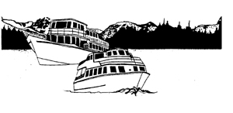

Lady of the Lake P.O. Box 186 Chelan, WA 98816

[info@ladyofthelake.com](mailto:cindy@ladyofthelake.com) www.ladyofthelake.com

509-682-4584

## **Public Notice of change to Lady Express service as of August 28, 2015**

August 25, 2015

To whom it may concern:

We regret to inform you that we have submitted a request to our regulating agency, the Washington Utilities & Transportation Commission, to discontinue the additional summer service of the Lady Express until further notice due to the massive fire storms happening in the Lake Chelan area. This vessel schedule normally ends on September 15th. The daily service of the Lady of the Lake II will continue. We are and have been experiencing very low passenger counts since the beginning of August with the start of the Wolverine fire. We have maintained our schedules in hopes that conditions would change, but with no change in sight, the prudent thing to do is to drop down to one boat that will continue to provide daily service and fulfill our transportation obligation on Lake Chelan.

We would like to resume the Lady Express summer service if conditions change. However, the schedule we are asking to suspend normally ends on September 15th, which will be just 19 days from the date we would suspend service.

We have submitted our concerns and request for a change/interruption/discontinuance of service and plan to the Washington Utilities and Transportation Commission, as they are the regulators of our service.

Again, we apologize for any inconvenience this may cause. We have no control or remedy for the situation that is occurring.

Sincerely,

# Jack Raines, President

Lake Chelan Recreation, Inc.