Report to the Washington Utilities and Transportation Commission

## Electric Service Reliability - Major Event Report

# Event Date: October 5, 2015

Date Submitted: January 11, 2016

Primary Affected Locations: Yakima

Primary Cause: Loss of Transmission

Exclude from Reporting Status: Yes

Report Prepared by: April Brewer

Report Approved by: Heide Caswell / David O’Neil / Steve Henderson / Kevin Putnam

**Event Description**

On October 5, 2015, Yakima, Washington, experienced a system average interruption frequency index-driven (SAIFI)-based major event when an unplanned loss of supply event occurred. The outage affected a total of 23,319 customers; of those, 9,506 customers experienced a momentary outage lasting less than 5 minutes. The 13,834[1] customers who experienced a sustained interruption were restored in large blocks at 36 minutes (about 3,000 customers) and 55 minutes (about 11,000 customers).

Sustained interruptions were experienced by approximately 17% of the Yakima operating area’s customers and approximately 10% of the Company’s Washington customers.

|  |  |
| --- | --- |
| **10/05/15 Outage Summary** | |
| **# Interruptions (sustained)** | 18 |
| **Total Customer Interrupted (sustained)** | 13,834 |
| **Total Customer Minutes Lost** | 698,661 |
| **Event SAIDI** | 5.09 Minutes |
| **CAIDI** | 51 |

**Restoration Summary**

At 9:58am on October 5, during switching for the Pomona Heights project, a flash occurred on a switch at Tieton tap. When dispatch attempted to operate the switch to close, the switch was unable to operate to close and with the relaying scheme temporarily in place, circuit breakers at Union Gap, Tieton, and Pomona Heights opened, and customers served from Pomona Heights, Selah, Wenas, Naches, Tieton and Wiley substations were interrupted. Service was restored within just a few minutes to Pomona Heights, Selah and Wenas substations, while the outage at the Naches Plant Substation lasted 36 minutes and 55 minutes at Wiley and Tieton substations. Equipment that was damaged during the event was repaired immediately.

Restoration activities utilized 6 operations personnel. 100% of the sustained customer interruptions for the event were restored within 55 minutes.

There were no company or commission customer complaints made regarding the major event.

**Restoration Intervals**

|  |  |  |  |
| --- | --- | --- | --- |
| **Total Customers Sustained** | **< 3 Hrs.** | **3 - 24 Hrs.** | **24+ Hrs.** |
| **13,834** | 13,829 | 0 | 0 |

**Restoration Resources**

|  |  |
| --- | --- |
| **Resources** | |
| **Substation Crewmembers** | 6 |

**State Estimated Major Event Costs**

|  |  |  |  |
| --- | --- | --- | --- |
| **Estimate $** | **Labor** | **Materials** | **Total** |
| **Capital** | $0 | $0 | $0 |
| **Expense** | $7,189 | $624 | $7,713 |
| **Total** | **$7,189** | $624 | **$7,713** |

**Major Event Declaration**

Pacific Power is requesting designation of this event and its consequences to be classified as a “Major Event” for exclusion from underlying network performance reporting. This major event exceeded the company’s current Washington system average interruption frequency index-driven (SAIFI) threshold of 10% total operating area customers served sustained interruptions (13,834 customers interrupted out of 83,410 Yakima operating area customers, or 17% of the operating area customers) in a 24-hour period.

**Event Detail**

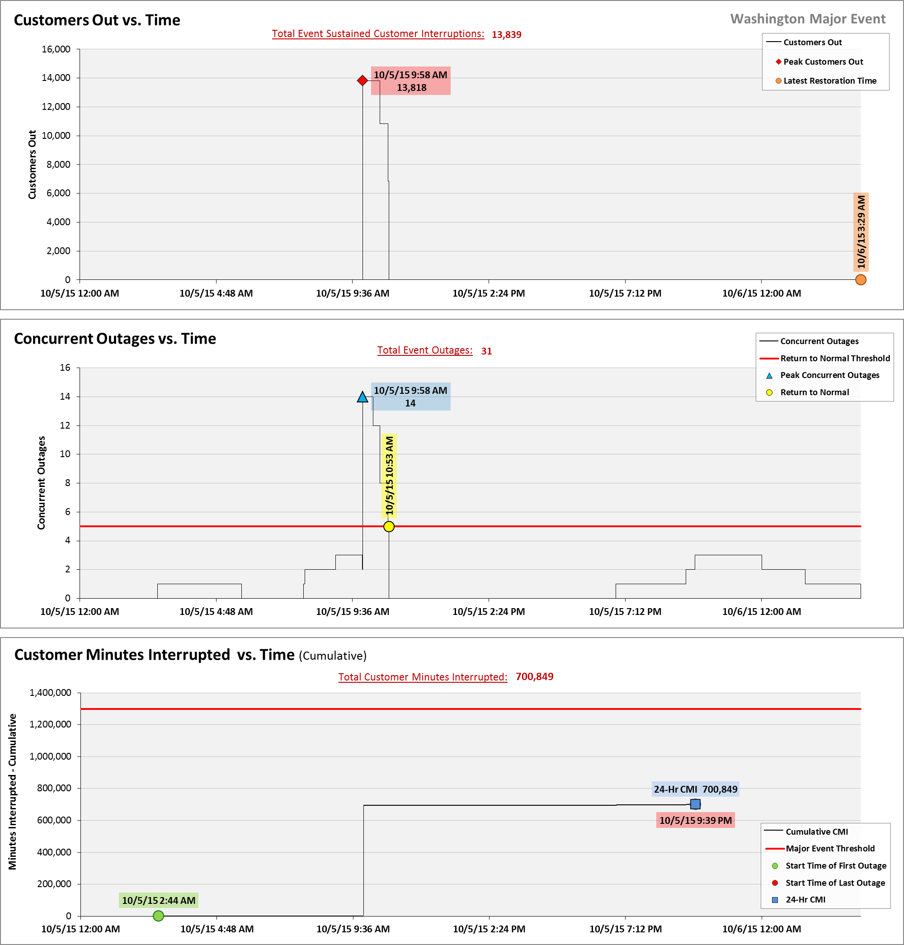

**SAIDI, SAIFI, CAIDI by Reliability Reporting Region**

Please see the attached system-generated reports.

1. The SAIFI-based major event threshold (as identified in PacifiCorp’s reporting plan, pursuant to Washington Administrative Code (WAC) 480-100-393 & 398) requires at least 10% of an operating area’s customers are without service as the result of a sustained interruption (greater than five minutes in duration). Yakima operating area’s Calendar 2015 Frozen Customer Count is 83,410 customers.