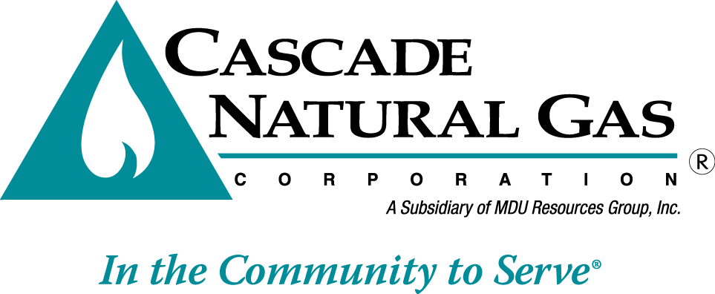 | 8113 W. GRANDRIDGE BLVD., KENNEWICK, WA 99336-7166  TELEPHONE 509-734-4500 FACSIMILE 509-737-7166  www.cngc.com

VIA ELECTRONIC MAIL
records@utc.wa.gov

February 23, 2017

Steven King, Executive Director and Secretary
Washington Utilities and Transportation Commission
Attn: Records Center
1300 S. Evergreen Park Drive SW
Olympia, WA 98504

Re: UG-150593– Cascade Natural Gas Corporation’s Certificated Service Territory

Dear Mr. King:

Cascade Natural Gas Corporation (Cascade or Company) files this letter in response to a request from Washington Utilities and Transportation Commission Staff that Cascade supplement Docket No. UG 150593 with a short description of the area described in each Appendix to the Company’s certificated service territory. Such descriptions are as follows:

A-1: Whatcom County/Benton County
A-2: Skagit County
A-3 Grays Harbor County/Snohomish County
A-4 Kitsap County
A-5 Mason County
A-6 Chelan County
A-7 Douglas County
A-8 Yakima County
A-9 Cowlitz, Clark & Benton Counties
A-10 Snohomish County
A-11 Benton County
A-12 Benton, Franklin & Walla Walla Counties
A-13 Walla Walla
A-14 Asotin, Benton, Douglas & Chelan Counties
A-15 Grant County
A-16 Adams County/Grant County
A-17 Chelan, Douglas, Grant & King Counties
A-18 Whatcom County
A-19 Snohomish County
A-20 Snohomish County
A-21 Snohomish County/ Island County
A-22 Whatcom County
A-23 Whatcom County

If you have any questions regarding this report, please contact me at (509) 734-4593.

Sincerely,

Michael Parvinen
Director, Regulatory Affairs

cc: Betty Erdahl, WUTC Staff

