

**STATE OF WASHINGTON**

WASHINGTON UTILITIES AND TRANSPORTATION COMMISSION

***1300 S. Evergreen Park Dr. S.W., P.O. Box 47250 ● Olympia, Washington 98504-7250***

***(360) 664-1160 ● TTY (360) 586-8203***

December 18, 2012

David W. Danner, Executive Director and Secretary

Washington Utilities and Transportation Commission

1300 S. Evergreen Park Dr. SW

P. O. Box 47250

Olympia, Washington 98504-7250

RE: *Washington Utilities and Transportation Commission v. Eric Stewart d/b/a Ironman Moving Services*

Commission Staff’s Response to Application for Mitigation of Penalties

Docket TV-120944

Dear Mr. Danner:

On July 24, 2012, the Washington Utilities and Transportation Commission issued a $2,100 Penalty Assessment in Docket TV-120944 against Eric Stewart d/b/a Ironman Moving Services (Ironman Moving) for 21 violations of Washington Administrative Code (WAC) 480-15-480, which requires permitted household goods companies to furnish annual reports to the commission no later than May 1 each year. [1]

On August 22, 2012, Ironman Moving wrote the commission requesting mitigation of penalties (Mitigation Request). In its Mitigation Request, Ironman Moving does not dispute that the violation occurred. [2] The company states, “I was under the impression I had until June 1st to file and be within compliance.”

It is the company’s responsibility to ensure that the regulatory fee is paid and the annual report is filed by the May 1 deadline. On February 29, 2012, Annual Report forms and Regulatory Fee packets were mailed to all regulated permitted household goods companies. [3] The cover letter informed the regulated company it must complete the annual report form, pay any regulatory fees, and return the material by May 1, 2012, to avoid enforcement action. On May 15, 2012, the commission mailed a letter to those companies that had not yet filed an annual report notifying them that, to date, they had incurred a penalty of $900. [4] The letter went on to explain that companies who filed their annual reports no later than May 25, 2012, would receive mitigated penalties of $25 per day. An additional penalty of $25 per day would be assessed for each instance in the previous five years that the company received a penalty for filing a late report, up to a maximum of $100 per day.

Ironman Moving filed its annual report on May 25, 2012, which is 18 business days past the deadline of May 1, 2012. The penalty was mitigated from $100 per day to $25 per day, for a penalty of $450. Ironman Moving received penalties for filing a delinquent annual report in 2006, 2007, 2008, 2010 and 2011. The prior penalties increase the 2011 penalty by an additional $100 per day. Ironman Moving received a $2,100 maximum penalty.

Staff does not support mitigating the assessed penalty of $2,100. Ironman Moving failed to file its response within the 15 day timeframe required for the commission to consider mitigation. In addition to failing to file its 2011 annual report timely, Ironman Moving has received penalties for failing to comply with WAC 480-15-480 in 2006, 2007, 2008, 2010 and 2011. Staff recommends denying the mitigation request.

If you have questions regarding this recommendation, please contact Mathew Perkinson, Compliance Investigator, at (360) 664-1105, or at mperkinson@utc.wa.gov.

Sincerely,

Sharon Wallace, Assistant Director

Consumer Protection and Communications

**Attachment A**

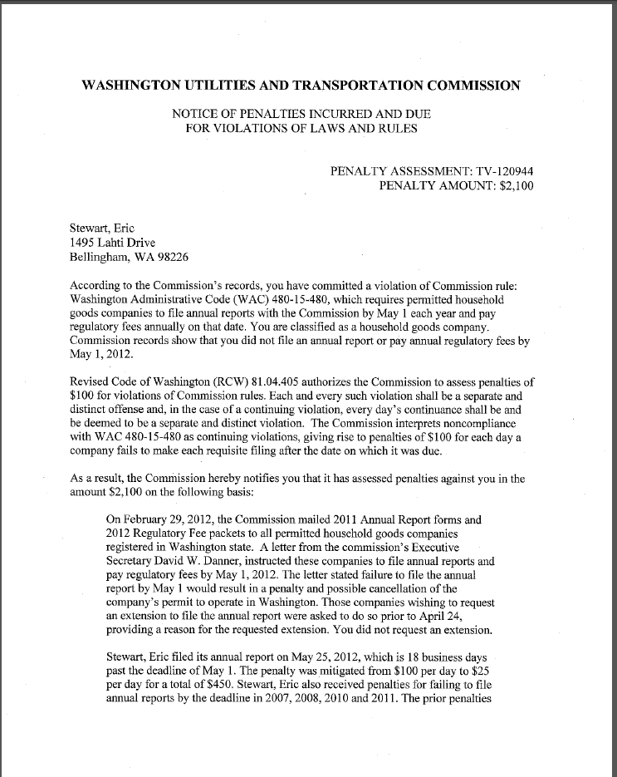

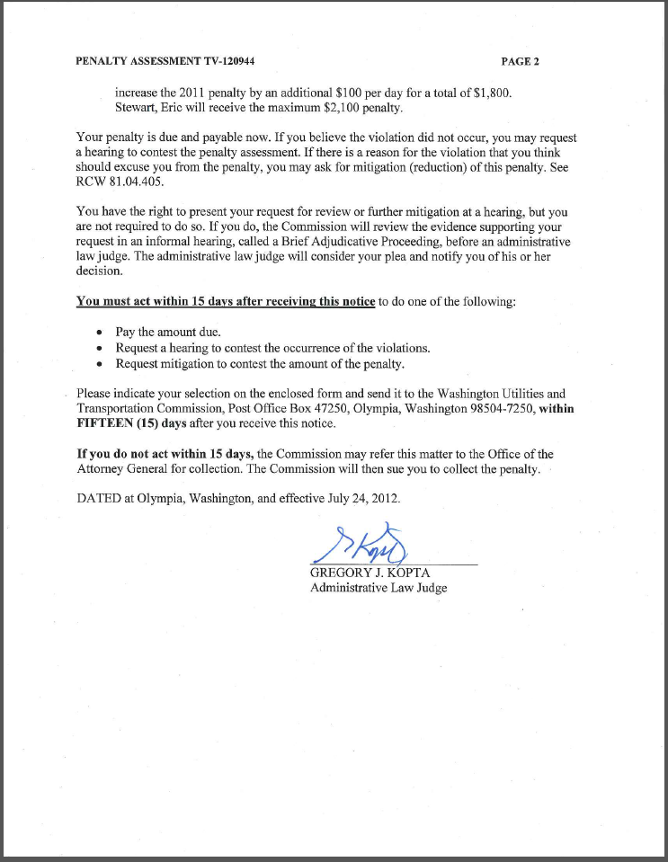

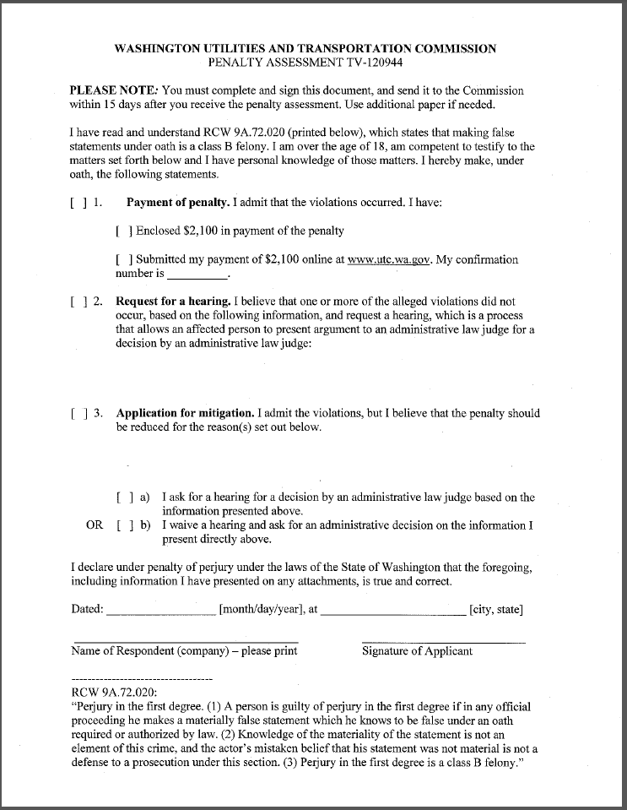

**Attachment B**

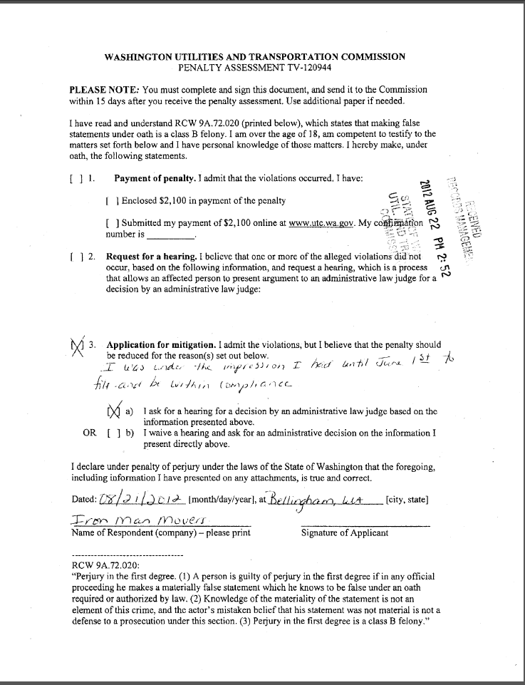

**Attachment C**

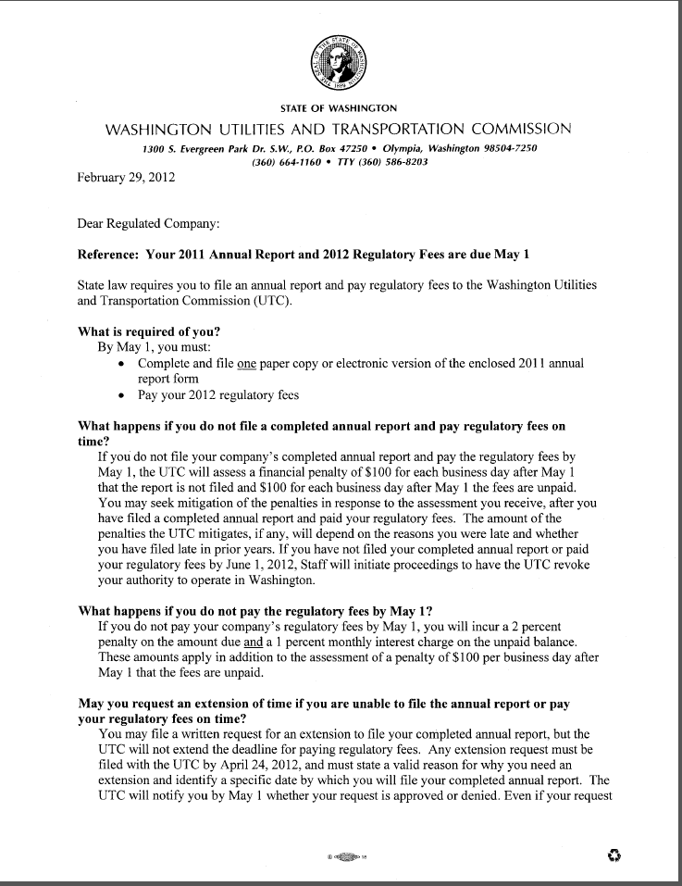

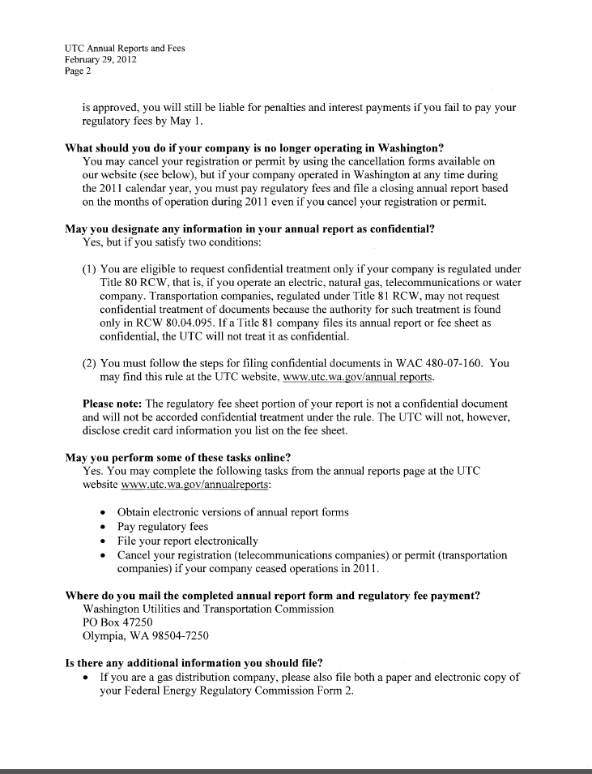

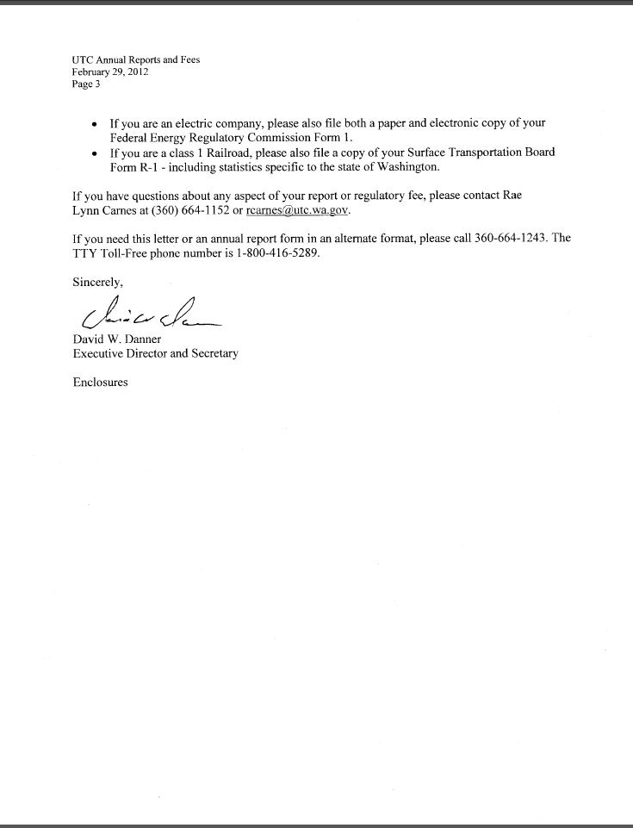

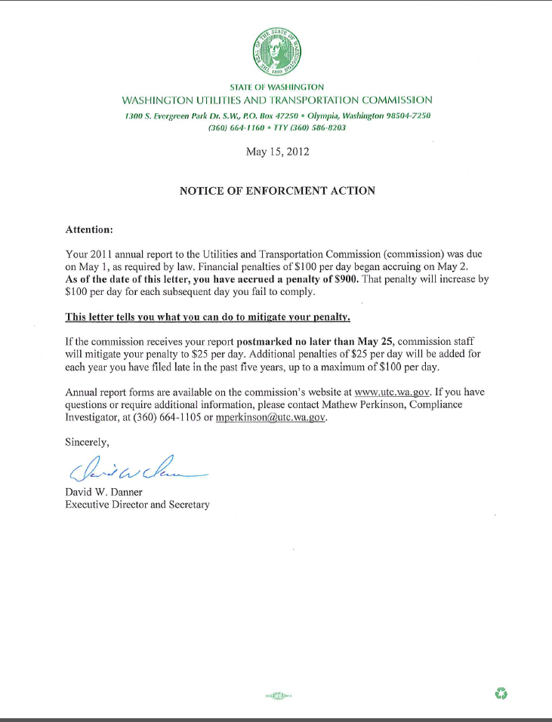**Attachment D**

1. See attachment A for a copy of the penalty assessment sent on July 24, 2012 to Ironman Moving.
2. See attachment B for a copy of Ironman Moving’s Mitigation Request received by the commission on August 22, 2012.
3. See attachment C for a copy of the letter sent to all regulated companies on February 29, 2012.
4. See attachment D for a copy of the enforcement letter sent to the company on May 15, 2012.