

**STATE OF WASHINGTON**

WASHINGTON UTILITIES AND TRANSPORTATION COMMISSION

***1300 S. Evergreen Park Dr. S.W., P.O. Box 47250 ● Olympia, Washington 98504-7250***

***(360) 664-1160 ● TTY (360) 586-8203***

March 20, 2013

Steven V. King, Acting Executive Director and Secretary

Washington Utilities and Transportation Commission

1300 S. Evergreen Park Dr. SW

P. O. Box 47250

Olympia, Washington 98504-7250

RE: *Washington Utilities and Transportation Commission v. Team Forks, LLC*

Commission Staff’s Response to Application for Mitigation of Penalties

Docket TE-130215

Dear Mr. King:

On March 5, 2013, the Washington Utilities and Transportation Commission issued a $200 Penalty Assessment in Docket TE-130215 against Team Forks, LLC (Team Forks) for two violations of WAC 480-30-071, which requires Charter and Excursion companies to file annual safety reports with the Commission by December 31 each year; and WAC 480-30-076, which requires such companies to pay regulatory fees annually on that date. [1]

On March 11, 2013, Team Forks responded to the commission, requesting mitigation of the penalty. In its Mitigation Request, Team Forks does not dispute that the violations occurred and states, “I believe this was a misunderstanding due to my admitted extreme confusion re DOT and UTC forms and offices – I had called the wrong office apparently and was told we did not need to respond to the email we had received from some rip off company about filing an interstate thing & we are not interstate. Later, I realized my mistake and called several times (your office) about it. People were on vacation and unavailable for two days. I explained to the lady I finally reached in my panic our [sic] your rude letter. My husband was diagnosed with Esophogeal [sic] Cancer just before all this. I admit I am and was not thinking straight. We closed the tour company as of 3-1-2013. We hadn’t been able to do the tours since about Feb. 1. Charlene Cross Leppell will be putting everything in her name and keeping it going, hopefully. I think it is absolutely rude and non sensical [sic] to charge so much for what was a simple mistake and the charges do ­not correspond to the info not sent. I request a review of this matter. We are on our way to Bremerton, where we have to live for up to 6 wks. While Randy gets Radiation/Chemo please do not add to this horrid time with more.”[2]

It is the company’s responsibility to ensure that the regulatory fee is paid and the annual report is filed by the December 31 deadline. On November 15, 2012, the commission mailed 2012 Annual Safety Report forms and 2013 Regulatory Fee packets to Charter and Excursion companies registered in Washington state. A letter from the commission’s Assistant Director for Transportation Safety, David Pratt, instructed these companies to file annual reports and pay regulatory fees by December 31, 2012. The letter stated failure to file the annual report by December 31 would result in a penalty and possible cancellation of the company’s permit to operate in Washington. Those companies wishing to request an extension to file the annual report were asked to do so prior to December 31, providing a reason for the requested extension. No extension was requested.[3]

On January 7, 2013, the commission issued a notice to companies that had not yet filed their annual report and paid regulatory fees, informing these companies that they were subject to enforcement action, including the assessment of penalties beginning to accrue on that date. Companies that filed their annual reports and paid regulatory fees after January 7, 2013, but on or before January 18, 2013, are subject to penalties that the commission uses its discretion to mitigate to $25 per day if the company had not made these filings late in prior years. Companies that were late in prior years are subject to an additional $25 per day for each year in which they were late up to a total of $100 per day. For first time late-filers who filed their report after January 18, the commission will mitigate the penalties to 50 percent of the maximum permissible amount. No further mitigation will be granted unless the company provides new information that is unrelated to these factors. Mitigation will not be granted on the basis that a company was unaware a report must be filed.[4]

Team Forks filed its 2012 Annual Safety Report and paid its 2013 Regulatory Fee on January 17, 2013. That date is eight business days past the January 7, 2013, notice date when penalties began to accrue, resulting in a potential penalty assessment of $800 ($100 per day times eight days). Team Forks is a first time late-filer and, therefore, is subject to a mitigated penalty of $25 per day for eight days for a total penalty assessment of $200.

Staff would not typically support mitigation of the penalty because the company has already received mitigation. Nevertheless, staff supports waiving any and all penalties because Team Forks has never received a penalty in the past and was faced with unusual medical circumstances which contributed to the delinquent annual report filing.

If you have questions regarding this recommendation, please contact Mathew Perkinson, Compliance Investigator, at (360) 664-1105, or at mperkinson@utc.wa.gov.

Sincerely,

Sharon Wallace, Assistant Director

Consumer Protection and Communications

**Attachment A**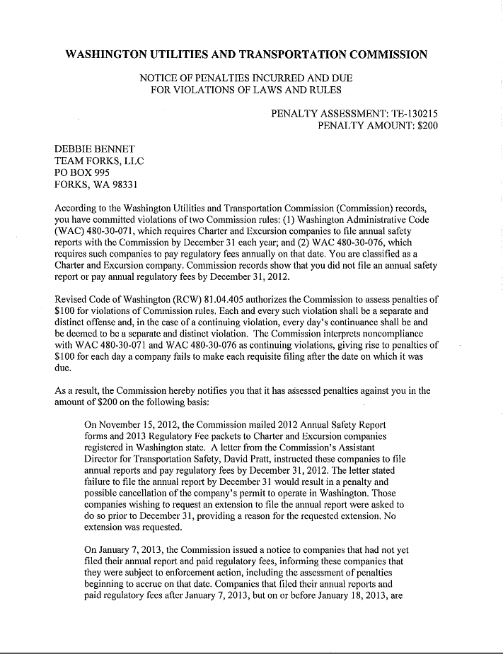

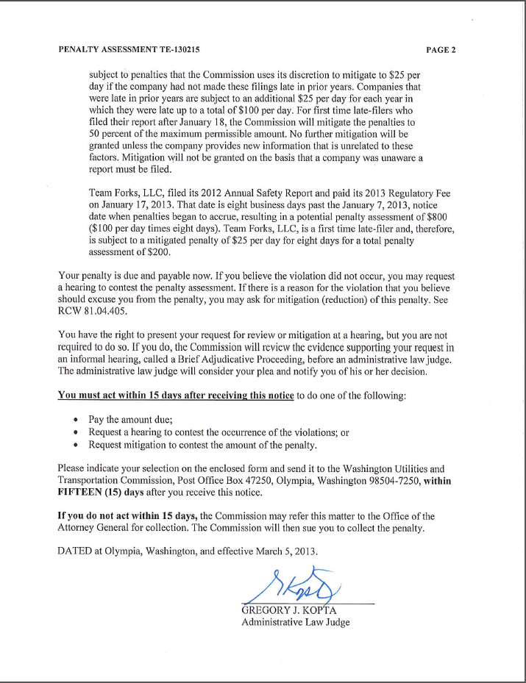

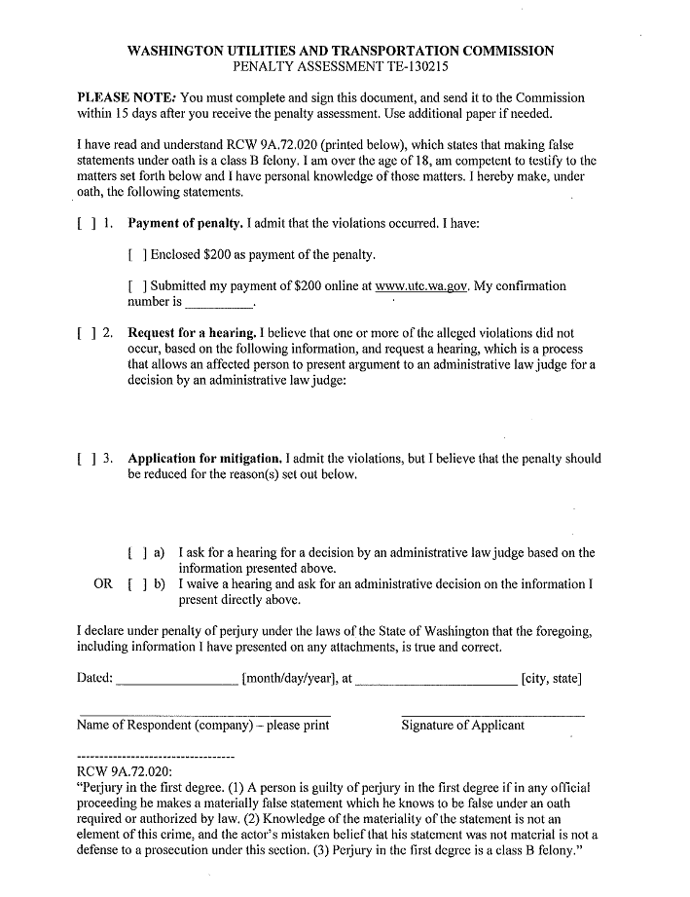

**Attachment B**

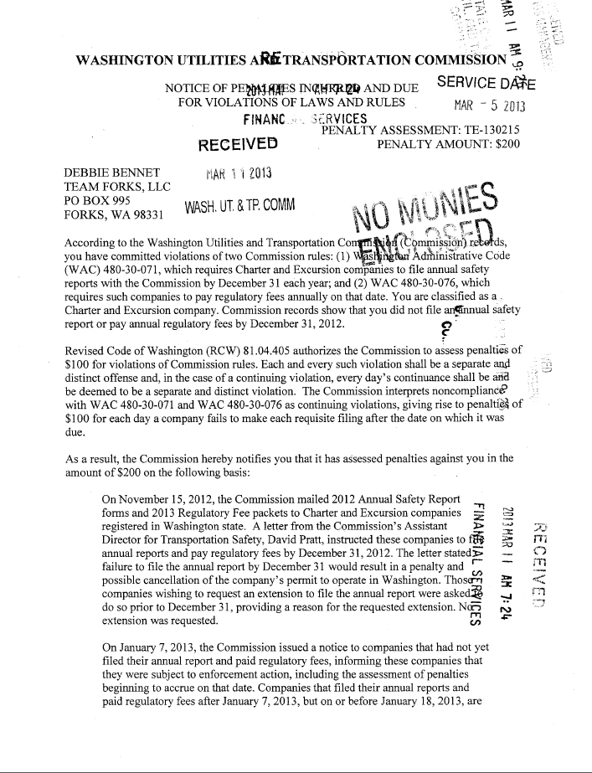

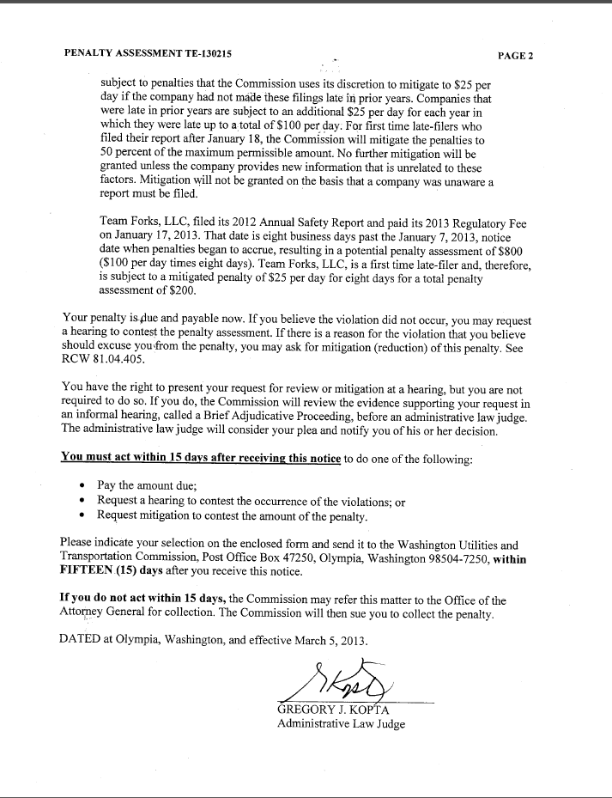

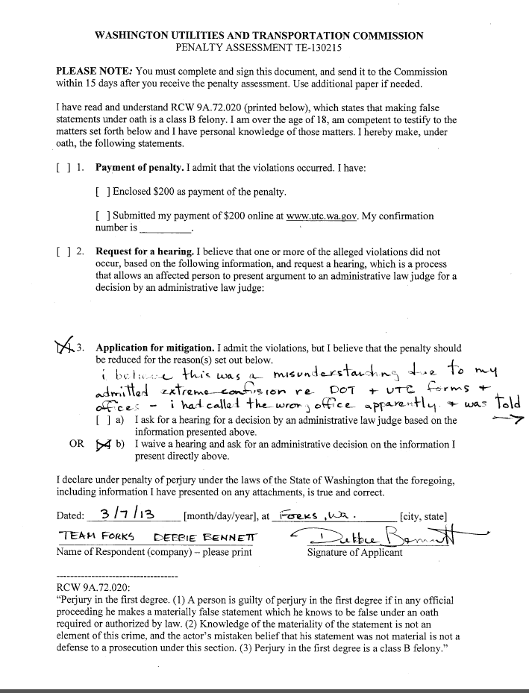

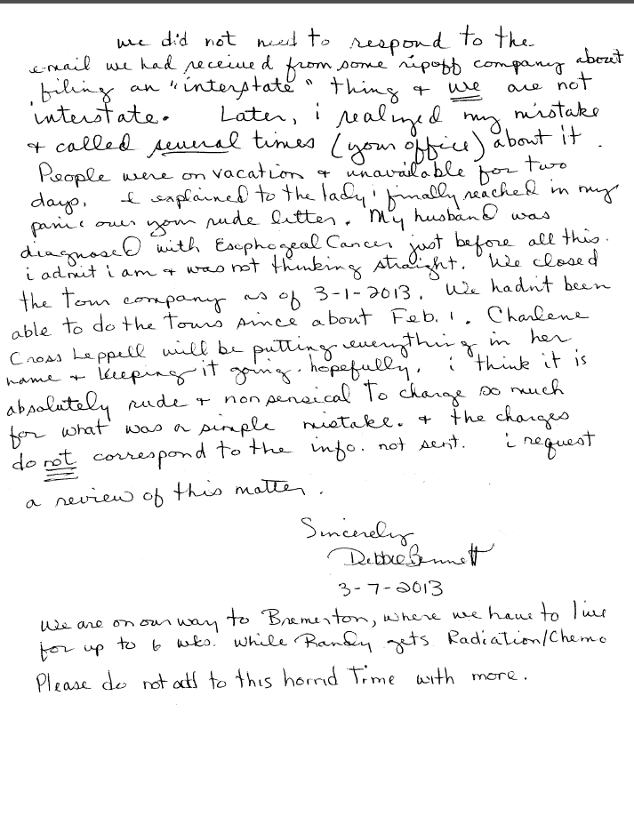

**Attachment C**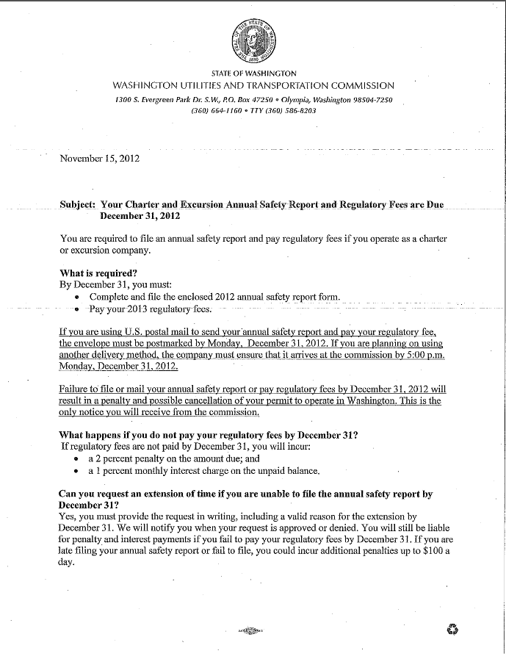

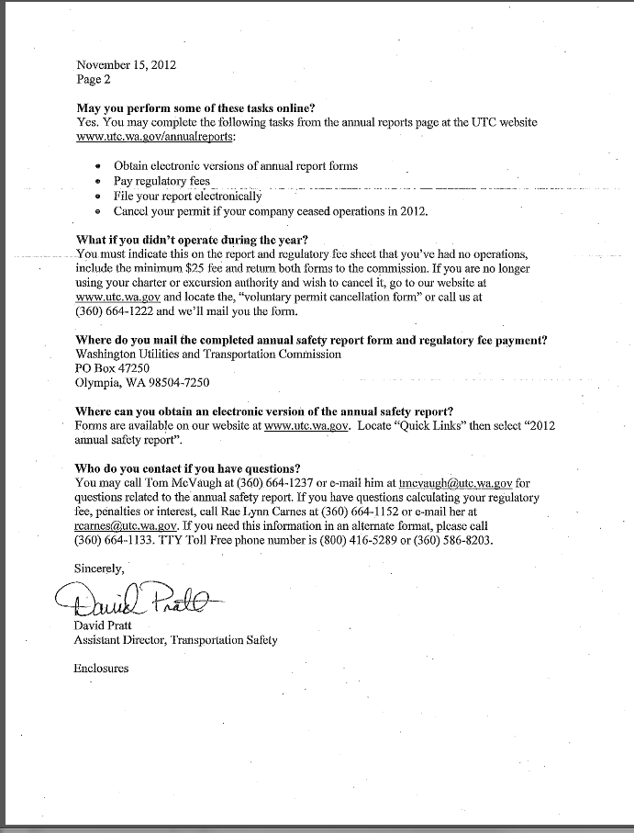

**Attachment D**

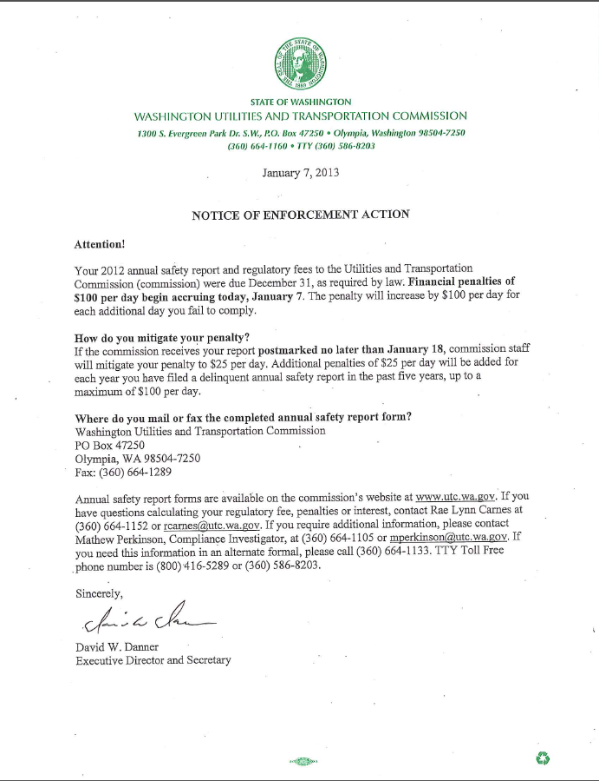

1. See Attachment A for a copy of the penalty assessment sent to Team Forks, LLC.
2. See Attachment B for a copy of the letter submitted by the company on March 11, 2013.
3. See Attachment C for a copy of the letter sent to all regulated companies on November 15, 2012.
4. See Attachment D for a copy of the Enforcement letter sent to all delinquent companies on January 7, 2013.