June 16, 2014

Steven V. King, Executive Director and Secretary

Utilities and Transportation Commission

1300 S. Evergreen Park Dr. SW

P.O. Box 47250

Olympia, WA 98504-7250

RE: *Washington Utilities and Transportation Commission v. Career Path Services Employment & Training*

Commission Staff’s Response to Application for Mitigation of Penalties TN-141038

Dear Mr. King:

On May 23, 2014, the Utilities and Transportation Commission issued a $1,000 Penalty Assessment in Docket TN-14038 against Career Path Services Employment & Training for 10 violations of Washington Administrative Code (WAC) 480-30-080, which requires nonprofit special needs transportation provider companies to furnish annual reports to the commission no later than May 1 each year.1

On June 2, 2014, Career Path Services wrote the commission requesting mitigation of penalties (Mitigation Request).2 In its Mitigation Request, Career Path Services does not dispute that the violation occurred. The company states, “This report is handles by our Safety Team as part of the overall safety program, but no one in any department in our office reports seeing the WUTC mailing”. The request continues, “…we have already calendared the submission of our 2014 report so we will not have an issue with non-compliance again.”

It is the company’s responsibility to ensure that the regulatory fee is paid and the annual report is filed by the May 1 deadline. On February 28, 2014, Annual Report packets were mailed to all regulated nonprofit special needs transportation provider companies. The instructions for annual report completion page of the annual report informed the regulated company that it must complete the annual report form, pay the regulatory fees, and return the materials by May 1, 2014, to avoid enforcement action.

UTC Annual Reports

June 16, 2014

Page 2

On June 13, 2014, Career Path Services filed the 2013 annual report and paid the required regulatory fees on June 5, 2014. The company has been active since September 27, 1995. The company was delinquent in filing the 2011 annual report and received partial mitigation for that offense. Staff supports the company’s request for mitigation to $250 which is 25% of the assessed penalty with the understanding that future violations may not result in a favorable recommendation for mitigation.

If you have any questions regarding this recommendation, please contact Amy Andrews, Regulatory Analyst, at (360) 664-1157, or [aandrews@utc.wa.gov](mailto:aandrews@utc.wa.gov).

Sincerely,

Sondra Walsh, Director

Administrative Services

ATTACHMENT A

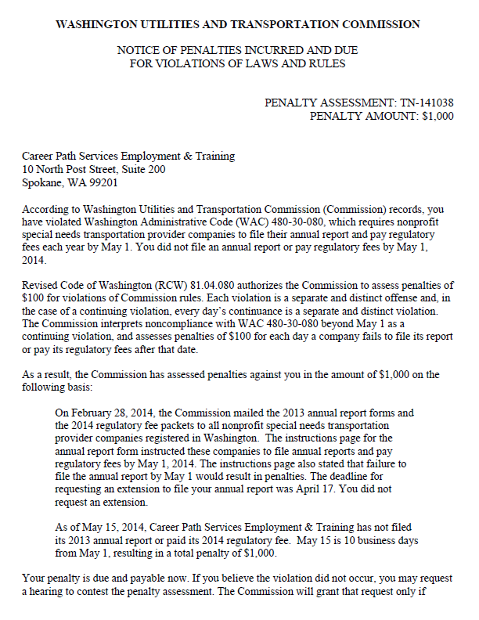

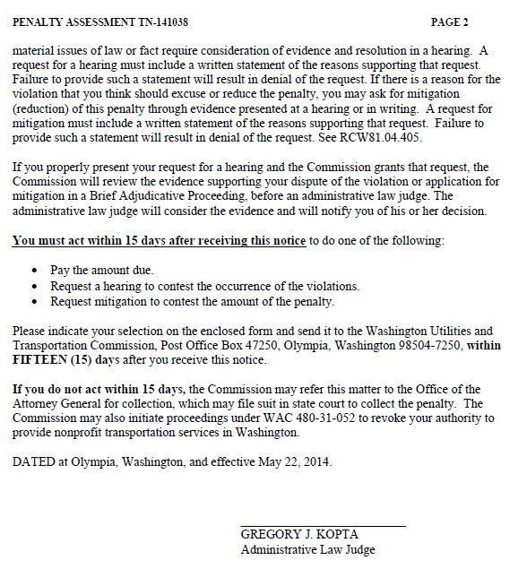

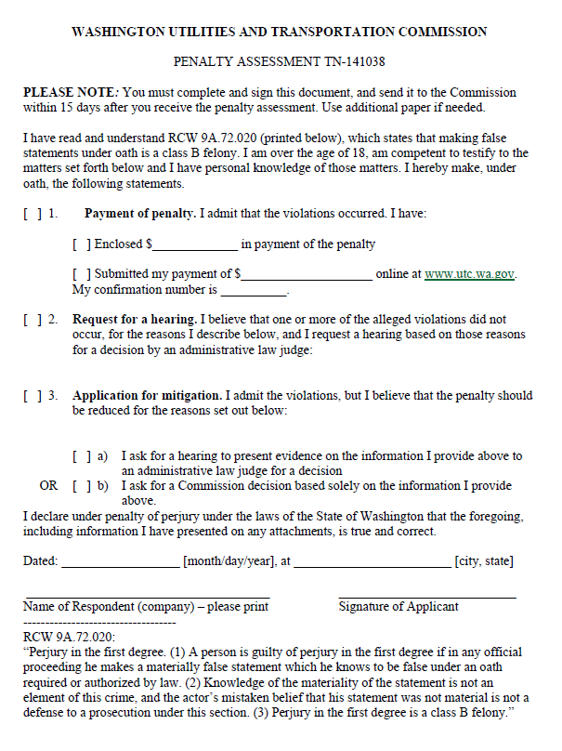

ATTACHMENT B

