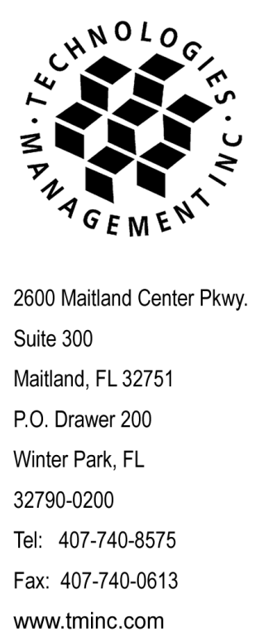January 7, 2009

**Via Overnight Delivery & Electronic Filing**

Ms. Carol J. Washburn, Executive Secretary

Washington Utilities & Transportation Commission

1300 S. Evergreen Park Drive, SW

Olympia, WA 98504-7250

**RE: Elimination of “Mundo Telecom” Trade Name on behalf of Network Communications International Corp.**

Dear Ms. Washburn:

Enclosed for filing please find an original of this letter to notify the Commission that Network Communications International Corp. has never conducted business in the State of Washington under the Trade Name of “Mundo Telecom” and has withdrawn its registration from the Secretary of State. Please change your records accordingly to incorporate this update.

The Company will continue use of the trade name 1800Call4Less.

Please acknowledge receipt of this filing by date-stamping the extra copy of this cover letter, and returning it to me in the self-addressed, stamped envelope provided for that purpose. Any questions you may have regarding this filing may be directed to my attention at (407) 740-3004 or [rnorton@tminc.com](mailto:rnorton@tminc.com).

Sincerely,



Robin Norton

Consultant to Network Communications International Corp.

RN/lm

cc: Stephanie Jackson - NCIC - (cover letter only)

file: NCIC - WA

tms: WAx0901