July 7, 2014

Steven V. King, Executive Director and Secretary

Utilities and Transportation Commission

1300 S. Evergreen Park Dr. SW

P.O. Box 47250

Olympia, WA 98504-7250

RE: *Washington Utilities and Transportation Commission v. Puget Services, L.L.C.*

Commission Staff’s Response to Application for Mitigation of Penalties TV-140984

Dear Mr. King:

On June 6, 2014, the Utilities and Transportation Commission issued a $1,000 Penalty Assessment in Docket TV-140984 against Puget Services, L.L.C. (dba Eco-Movers) for 10 violations of Washington Administrative Code (WAC) 480-15-480, which requires household goods carrier companies to furnish annual reports to the commission no later than May 1 each year.1

On June 20, 2014, Puget Services L.L.C. wrote the commission requesting mitigation of penalties (Mitigation Request).2 In its Mitigation Request, Puget Services L.L.C. does not dispute that the violation occurred. The company states, “We admit that we did not complete our annual report in full but ask the commission to consider mitigating factors in this case. Eco-Movers did mail out the annual report on May 1st but was contacted by Amy Andrews of the UTC on May 6, 2014 letting us know the we had not entered our intrastate mileage. We send the intrastate mileage to Amy on 5/14/14.”

It is the company’s responsibility to ensure that the regulatory fee is paid and the annual report is filed by the May 1 deadline. On February 28, 2014, Annual Report packets were mailed to all regulated household goods companies. The instructions for annual report completion page of the annual report informed the regulated company that it must complete the annual report form, pay the regulatory fees, and return the materials by May 1, 2014, to avoid enforcement action.

UTC Annual Reports

July 7, 2014

Page 2

On May 6, 2014, Puget Services, L.L.C. filed an incomplete 2013 annual report and paid the regulatory fees and late payment penalty on May 6 and May 13 respectively. On May 14, 2014, Puget Services, L.L.C. submitted the completed 2013 annual report data. The company has been

active since March 8, 2010. The company was delinquent in filing the 2012 annual report and received an automatic mitigation to $25 per day. Staff does not support the company’s request for mitigation due to prior violation of WAC 480-15-480. However, as the completed annual report was received as of May 14, 2014, commission staff does recommend the penalty be reduced to $900 to reflect the correct number of business day of the delinquent report.

If you have any questions regarding this recommendation, please contact Amy Andrews, Regulatory Analyst, at (360) 664-1157, or [aandrews@utc.wa.gov](mailto:aandrews@utc.wa.gov).

Sincerely,

Sondra Walsh, Director

Administrative Services

ATTACHMENT A

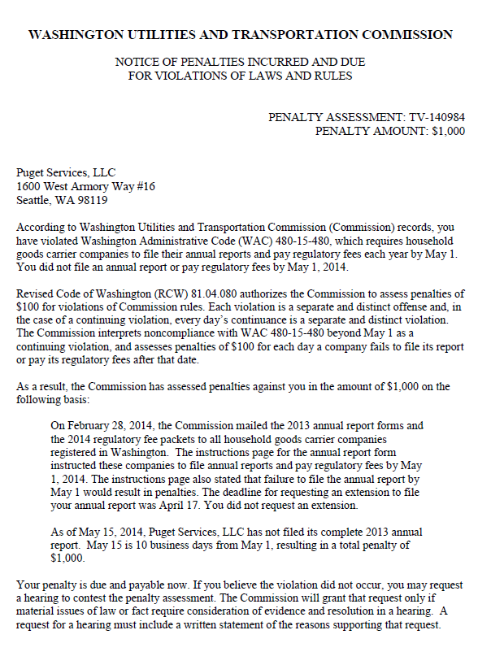

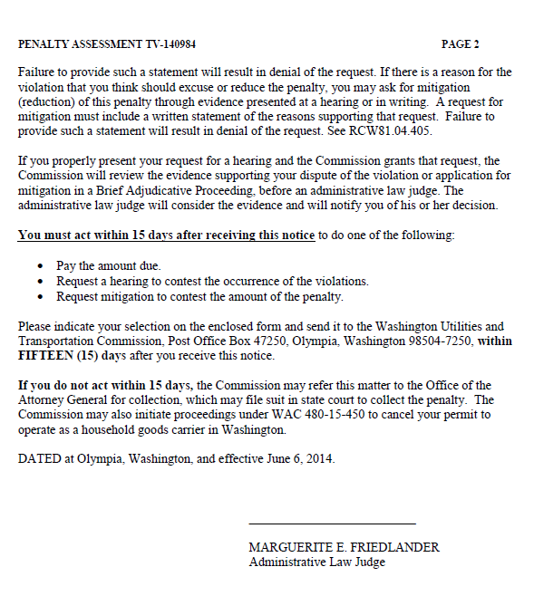

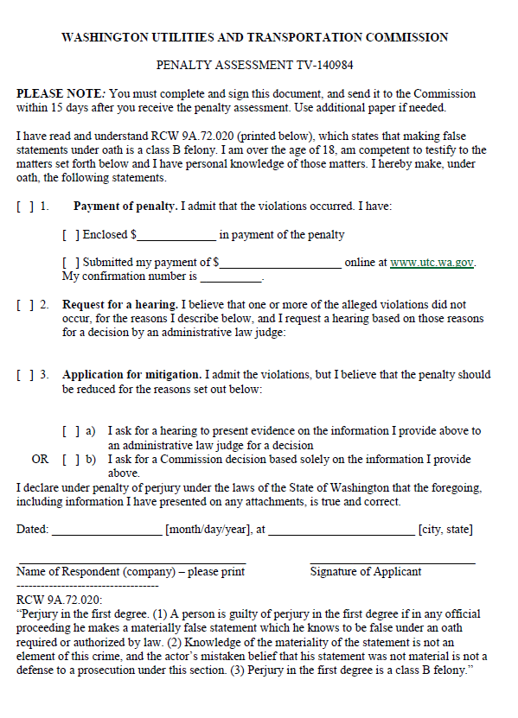

ATTACHMENT B

