|  |  |  |
| --- | --- | --- |
|  | | |
| **Memo to:** | **Memo No:** |  |
| Jim Perich-Anderson (PSE) | **From:** | DNV GL - Energy |
| **Date:** | 05-25-2016 |
| **Copied to:**  Valerie Richardson | **Prep. By:** | Romilee Emerick  Ken Agnew |
|  | | |

# 2015 Home Energy Report Evaluation Summary

Puget Sound Energy (PSE) implemented the Home Energy Reports (HER) Legacy Program in 2008. The HER Program delivers customized information on energy consumption to participating households and compares the household’s energy consumption to that of similar neighboring homes. In addition, the report provides personalized tips on how to save energy based on the energy usage and house profile. The HER Program was designed to motivate households to reduce energy consumption through behavioral changes and participation on other PSE energy efficiency programs.

The program was structured as a randomized controlled trial wherein the eligible population was randomly assigned to the treatment and control groups. Around 40,000 dual fuel, single family homes were randomly selected to receive the report while 44,000 dual fuel, single family homes did not receive the report and were assigned as the control group. All households in the treatment group received the report either monthly or quarterly for two years. At the start of the third year of the HER Program, approximately 10,000 treatment group households were randomly selected to stop receiving the reports. This created a second treatment group (suspended) designed to test the persistence of report-based savings after the cessation of reports. The rest of the households in treatment group (current) still receive the home energy reports either monthly or quarterly.

In March 2014, PSE expanded the HER program to include 140,000 additional households. The HER Expansion program targeted three groups namely the High users group, Non-urban group and Electric only group. Similar to the HER Legacy program, the HER Expansion program follows an experimental design with 105,000 randomly selected treatment households and 35,000 households randomly selected in the control group. In May 2015, PSE added a Refresh Group that consists of households from the remaining population of the HER Expansion pool. The Refresh Group consists of approximately 25,000 treatment households and 10,500 control households that were randomly selected to replace households that were dropped out from the program due to customer attrition.

## Evaluation Objectives

The main goal of this impact evaluation is to estimate HER Legacy and Expansion Program savings for year 2015[1]. Specifically, the main objectives are as follows:

1. Measure the reduction in electric and natural gas consumption between the control groups and the HER treatment groups.
2. Quantify joint savings from HER-related increased uptake of other PSE energy efficiency programs which may be present in the measured consumption reduction:
   * An increase in the number of participants and/or extent of participation in PSE rebate programs due to the HER
   * A HER-related increase in the number of purchased CFL or LED bulbs and fixtures supported by PSE and NEEA upstream lighting programs
3. Provide an estimate of 2015 HER savings for Legacy and Expansion programs adjusted for double counted savings resulting from participation in PSE rebate and upstream lighting programs in previous HER years

This evaluation used historical consumption data[2] to measure the difference in consumption between the treatment and control groups. Savings estimates were also measured for the different treatment sub-groups, namely the current and suspended groups for the HER Legacy program and Relative High Users, Non-urban and Electric only groups for the HER Expansion program.

This evaluation also quantified the potential for double counting energy savings due to participation in other PSE rebate and upstream programs. DNV GL used the PSE program tracking data to quantify joint savings due to participation in other PSE rebate programs. For the upstream programs where there is no tracking data, DNV GL will use a web-based participant survey to quantify joint savings[3].

## Findings – Measured Savings and Rebate Savings

The primary goal of this evaluation was to develop the 2015 PSE HER Program credited savings estimates free of joint savings due to participation in other PSE energy efficiency programs. There are three components to estimating credited savings. The first component is the HER measured savings which refers to the impact of HER on average household consumption. The second and third components are the rebate program and upstream retail lighting joint savings. These two joint savings components represent report-induced savings from the increased uptake of PSE tracked rebate programs and increased purchase of CFL and LED bulb and fixtures through the PSE-supported “upstream” lighting program. To avoid double counting, credited savings are calculated by removing the rebate and upstream joint savings from the HER measured savings.

The 2015 credited savings reported in this memo removed joint savings from downstream rebate programs only. Estimates from upstream joint savings are not yet available. To provide a conservative estimate of program savings for HER, DNV GL applied another 5% reduction in program savings after deducting joint savings estimates from downstream program.

Table 0‑1 and Table 0‑2 provide the wave-level and overall electric and gas savings estimates, respectively. Total program savings for electric and gas are statistically significant at the wave-level and overall for both Legacy and Expansion programs.

Table 0‑1: Total Credited Electric Savings for 2015 HER Programs

|  |  |  |  |  |  |
| --- | --- | --- | --- | --- | --- |
| **HER Treatment Group** | **Electric (kWh)** | | | | |
| **Per Household** | **No. of treatment** | **Total Savings** | **Lower Limit 90% CI** | **Upper Limit 90% CI** |
| **Legacy - Current** | 285 | 14,629 | 4,169,827 | 3,318,747 | 5,020,907 |
| **Legacy - Suspended** | 92 | 7,300 | 668,764 | 108,471 | 1,229,057 |
| **Expansion - Electric only** | 196 | 22,291 | 4,362,657 | 2,673,019 | 6,052,295 |
| **Expansion - High Users** | 213 | 21,924 | 4,678,589 | 3,008,726 | 6,348,453 |
| **Expansion - Non Urban** | 119 | 31,241 | 3,711,676 | 2,262,999 | 5,160,354 |
| **Expansion – Refresh Group** | Not evaluated | 24,998 | Not evaluated | Not evaluated | Not evaluated |
|  | 181 | 97,385* | 17,591,513 | 14,424,691 | 20,758,336 |

*\*Total number of treatment excludes Expansion – Refresh Group, which was added in May 2015.*

Table 0‑2: Total Credited Gas Savings for 2015 HER Programs

|  |  |  |  |  |  |
| --- | --- | --- | --- | --- | --- |
| **HER Treatment Group** | **Gas (therms)** | | | | |
| **Per Household** | **No. of treatment** | **Total Savings** | **Lower Limit 90% CI** | **Upper Limit 90% CI** |
| **Legacy - Current** | 12 | 14,629 | 173,064 | 121,927 | 224,201 |
| **Legacy - Suspended** | 7 | 7,300 | 52,879 | 14,555 | 91,204 |
| **Expansion - High Users** | 9 | 21,924 | 199,091 | 111,055 | 287,127 |
| **Expansion - Non Urban** | 4 | 31,241 | 124,612 | 43,247 | 205,977 |
| **Expansion – Refresh Group** | Not evaluated | 24,998 | Not evaluated | Not evaluated | Not evaluated |
| **ALL** | 7 | 75,094* | 549,646 | 379,297 | 719,996 |

*\*Total number of treatment excludes Expansion – Refresh Group, which was added in May 2015.*

The summary of measured savings and joint savings results for Legacy and Expansion programs are presented in

Table 0‑3 and

Table 0‑4, respectively. As previously mentioned, estimates from upstream joint savings are not yet available. DNV GL applied another 5% reduction in program savings after deducting joint savings estimates from downstream programs to provide a conservative estimate of upstream joint savings. All treatment groups produced statistically significant electric and gas savings in 2015 for both Legacy and Expansion programs.

Table 0‑3: Summary of Annual Savings for PSE HER Legacy 2014

|  |  |  |  |  |  |
| --- | --- | --- | --- | --- | --- |
| **Treatment Groups** | **HER Measured Savings**  **(per household)** | | **Joint Savings – Downstream**  **(per household)** | **5% Adjustment (per household)** | **Credited Savings**  **(per household)** |
|  | | **Electric (kWh)** | | | |
| **Current** | 306.2* (245.2,367.2) | | 6.2*  (0.7,11.7) | 15.0 | 285.0* (226.9,343.2) |
| **Suspended** | 101.5*  (21.0,181.9) | | 5.0  (-2.5,12.5) | 4.8 | 91.6*  (14.9,168.4) |
|  | | **Gas (therms)** | | | |
| **Current** | 14.2*  (10.6,17.8) | | 1.8*  (0.9,2.6) | 0.6 | 11.8*  (8.3,15.3) |
| **Suspended** | 9.3*  (3.9,14.7) | | 1.7*  (0.5,2.8) | 0.4 | 7.2*  (2.0,12.5) |

*\* indicates statistically significant at 90% confidence level. Values in parentheses show*

*upper and lower bounds at 90% confidence interval*

Table 0‑4: Summary of Annual Savings for PSE HER Expansion 2014

|  |  |  |  |  |
| --- | --- | --- | --- | --- |
| **Treatment Groups** | **HER Measured Savings**  **(per household)** | **Joint Savings**  **(per household)** | **5% Adjustment**  **(per household)** | **Credited Savings (per household)** |
| **Electric (kWh)** | | | | |
| **Electric only** | 217.2* (138.2,296.2) | 11.2  (-0.1,12.5) | 10.3 | 195.7*  (119.9,271.5) |
| **High users** | 226.7* (146.6,306.7) | 2.0  (-2.5,22.4) | 11.2 | 213.4*  (137.2,289.6) |
| **Non-urban** | 128.8*  (80.1,177.5) | 3.7*  (1.1,6.5) | 6.3 | 118.8*  (72.4,165.2) |
| **Refresh Group** | Not evaluated | Not evaluated | Not evaluated | Not evaluated |
| **Gas (therms)** | | | | |
| **High users** | 10.4*  (6.2,14.6) | 0.8*  (0.4,1.3) | 0.5 | 9.1*  (5.1,13.1) |
| **Non-urban** | 4.3*  (1.6,7.0) | 0.1  (-0.2,0.4) | 0.2 | 4.0*  (1.4,6.6) |
| **Refresh Group** | Not evaluated | Not evaluated | Not evaluated | Not evaluated |

*\* indicates statistically significant at 90% confidence level. Values in parentheses show*

*upper and lower bounds at 90% confidence interval*

Table 0‑5 summarizes the HER program results with respect to average consumption. The current treatment group produced credited savings at 2.8% and 1.5% for electric and gas, respectively. Even after five years of not receiving the report, the suspended treatment group still produced statistically significant savings but those savings were only just over one-fourth of the electric savings of the current treatment group. This difference in savings between the current and suspended groups was statistically significant at 90% confidence level. With respect to gas savings, the suspended treatment group has maintained over half of the gas savings of the current group.

Table 0‑5: Credited Savings per Household as a Percent of Consumption

|  |  |  |  |  |  |  |
| --- | --- | --- | --- | --- | --- | --- |
| **HER Treatment Group** | **Electric (kWh)** | | | **Gas (therms)** | | |
| **Consumption\*** | **Savings** | **Percent** | **Consumption\*** | **Savings** | **Percent** |
| **Legacy Program** | | | | | | |
| **Current** | 10,117 | 285.0 (226.9,343.2) | 2.8% | 781 | 11.8 (8.3,15.3) | 1.5% |
| **Suspended** | 91.6 (14.9,168.4) | 0.9% | 7.2 (2.0,12.5) | 0.9% |
| **Expansion program** | | | | | | |
| **Electric only** | 13,472 | 195.7 (119.9,271.5) | 1.5% | N/A | N/A | N/A |
| **High users** | 11,131 | 213.4 (137.2,289.6) | 1.9% | 777 | 9.1 (5.1,13.1) | 1.2% |
| **Non-urban** | 9,969 | 118.8 (72.4,165.2) | 1.2% | 690 | 4.0 (1.4,6.6) | 0.6% |
| **Refresh Group** | Not evaluated | Not evaluated | Not evaluated | Not evaluated | Not evaluated | Not evaluated |

*\*Based on actual consumption of the control group in calendar year 2015*

The three HER Expansion groups started receiving the reports in March 2014 and percent savings fall within the magnitude of 1% to 3% savings that are expected from the HER program. High user groups generated the highest savings of around 1.9% electric savings and 1.2% gas savings while Non-urban group produced the lowest electric and gas savings.

show the measured electric and gas savings for the Legacy program from 2009 to 2015. The electric savings for the active Legacy HER group (Current) increase through the fifth year of the program, 2013. The Current group savings appear to have flattened or diminished since then but this apparent trend is not statistically significant as of the current program year, 2015.   In addition, it should be noted that HER savings are not weather-normalized, so may reflect natural variation in local eather.  Compared to electric savings, Current group gas savings remained relatively flat and ranged from 13 to 15 therms per household in the last 7 years. Evaluation results show that both electric and gas savings for Legacy households still receiving the reports remain at a level similar to previous years.

Figure 0‑1 show the measured electric and gas savings for the Legacy program from 2009 to 2015. The electric savings for the active Legacy HER group (Current) increase through the fifth year of the program, 2013. The Current group savings appear to have flattened or diminished since then but this apparent trend is not statistically significant as of the current program year, 2015.   In addition, it should be noted that HER savings are not weather-normalized, so may reflect natural variation in local eather.  Compared to electric savings, Current group gas savings remained relatively flat and ranged from 13 to 15 therms per household in the last 7 years. Evaluation results show that both electric and gas savings for Legacy households still receiving the reports remain at a level similar to previous years.

Figure 0‑1: Measured HER Electric and Gas Savings for Legacy, 2009-2015

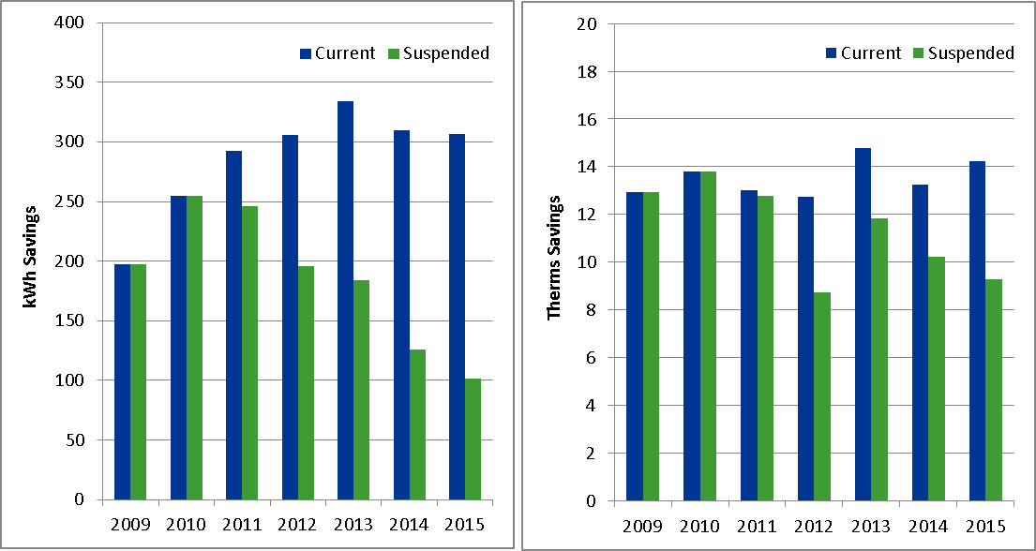

The HER program exhibits two different kinds of persistence. Households in the current group that continued to receive reports through the seventh year generated savings at or above levels established in the first two years of the program. Households in the suspended group that were in their fifth year of not receiving reports still generated statistically significant savings and at least half of the first year savings of the current treatment group. Interestingly, measured electric savings of the suspended group continued to drop to almost one-fourth of what the current treatment group was saving while measured gas savings of the suspended group are still over half of the measured savings of the current treatment group.

1. Program savings from the Refresh group are not included in the 2015 HER evaluation but will be included in the next round of PSE HER evaluation.
2. Compared to previous PSE HER evaluation that used daily consumption data all throughout the analysis period, this evaluation used 2015 monthly billing data that Opower provided back to PSE. DNV GL will update the analysis once the daily consumption data becomes available for the calendar year 2015.
3. Results from the web survey to quantify upstream savings are not yet available and will be incorporated in the final report for 2015 PSE HER.