October 22, 2012

David W. Danner, Executive Director and Secretary

Washington Utilities and Transportation Commission

1300 S. Evergreen Park Dr. SW

P. O. Box 47250

Olympia, Washington 98504-7250

RE: *Washington Utilities and Transportation Commission v. Bellingham Transfer & Storage, Inc.*

Commission Staff’s Response to Application for Mitigation of Penalties

Docket TV-120916

Dear Mr. Danner:

On July 23, 2012, the Washington Utilities and Transportation commission issued a $375 Mitigated Penalty Assessment in Docket TV-120916 against Bellingham Transfer & Storage, Inc. for 15 violations of Washington Administrative Code (WAC) 480-15-480, which requires permitted household goods companies to furnish annual reports to the commission no later than May 1 each year.

On August 10, 2012[1], Bellingham Transfer & Storage, Inc. wrote the commission requesting mitigation of penalties (Mitigation Request). In its Mitigation Request, Bellingham Transfer & Storage, Inc. does not dispute that the violation occurred. The company states, “I am asking forgiveness of the penalty in the amount of $375 for late filing of our quarterly report. Our principal officer was admitted to the hospital in February of this year and was on life support for upward of 3 weeks. Thankfully she is now recovering at home. However during this time we ran the office a bit haphazardly as we are all family and had to split our time between here and caring for Sandy. And her job she does here also fell on our shoulders. I ask you to reconsider this late penalty as it would also be a hardship on our already struggling small business.”

It is the company’s responsibility to ensure that the regulatory fee and the annual report are filed by the May 1 deadline. On February 29, 2012[2], Annual Report forms and Regulatory Fee packets

were mailed to all regulated permitted household goods companies. In addition to other information, the cover letter informed the regulated company it must complete the annual report form, pay any regulatory fees and return the material by May 1, 2012, to avoid enforcement action. On May 15, 2012[3], the commission mailed a letter to those companies that had not yet filed an annual report notifying them that, to date, they had incurred a penalty of $900. The letter went on to explain that companies who filed their annual reports no later than May 25, 2012, would receive mitigated penalties of $25 per day, with an additional $25 per day for each instance in the previous five years that the company received a penalty for filing a late report.

Bellingham Transfer & Storage, Inc. filed its annual report on May 22, 2012, which is 15 business days past the deadline of May 1, 2012. The penalty was mitigated from $100 per day to $25 per day for a total of $375. Bellingham Transfer & Storage, Inc. has held permanent household goods authority since June 2006 and has never received a penalty for filing a delinquent annual report in the past.

Staff would not typically support mitigation of the penalty because the company has already received mitigation. Nevertheless, staff supports waiving any and all penalties because Bellingham Transfer & Storage, Inc. has never received a penalty in the past and was faced with unusual medical circumstances which are the primary reason for the delinquent annual report filing.

If you have questions regarding this recommendation, please contact Mathew Perkinson, Compliance Investigator, at (360) 664-1105 or at mperkinson@utc.wa.gov.

Sincerely,

Sharon Wallace, Assistant Director

Consumer Protection and Communications

**Attachment A**

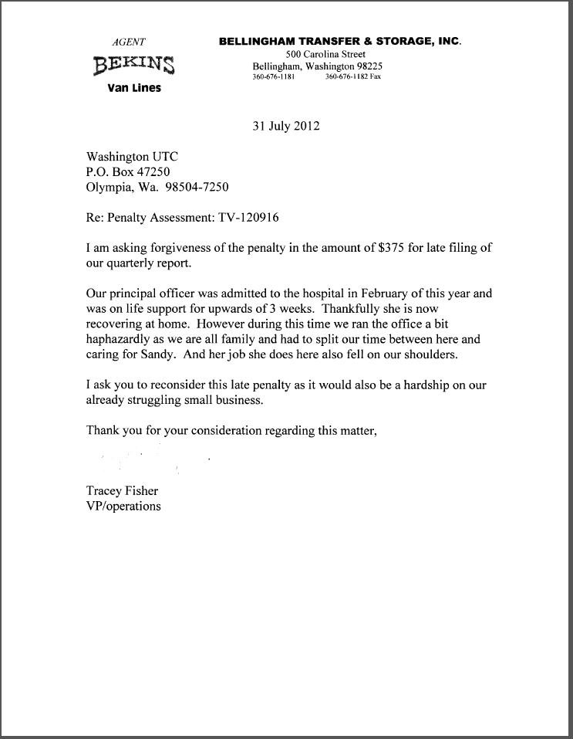

**Attachment B**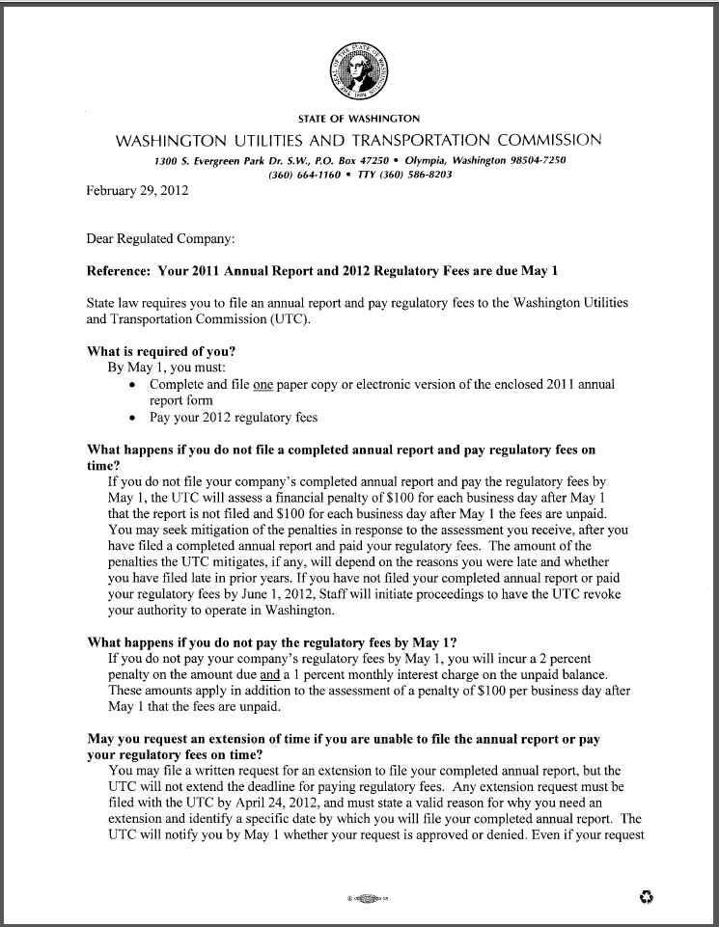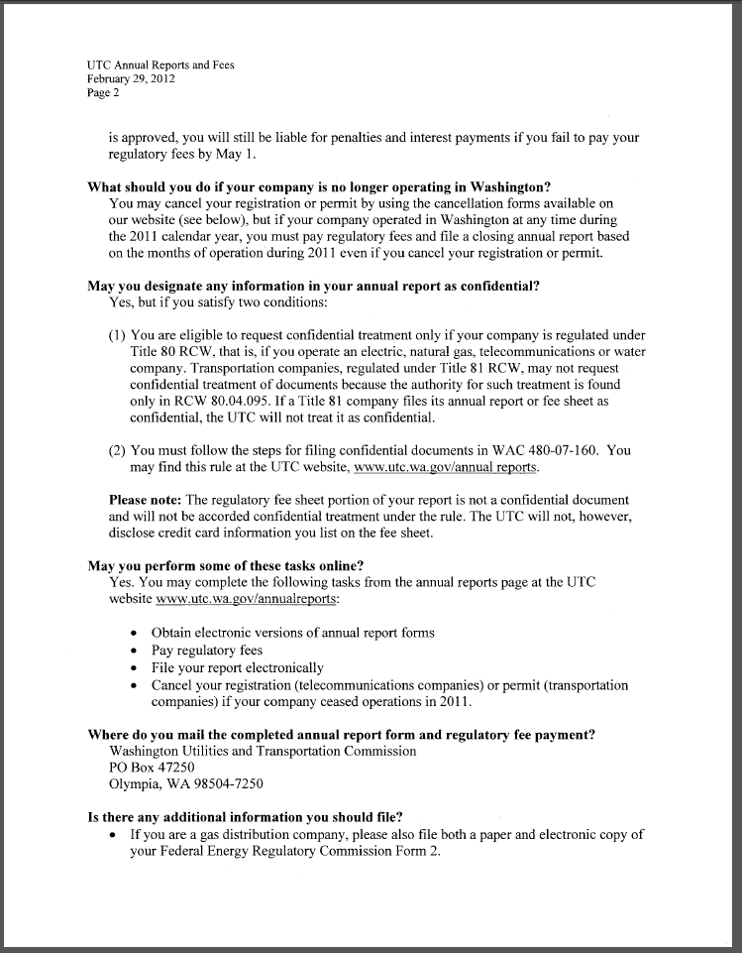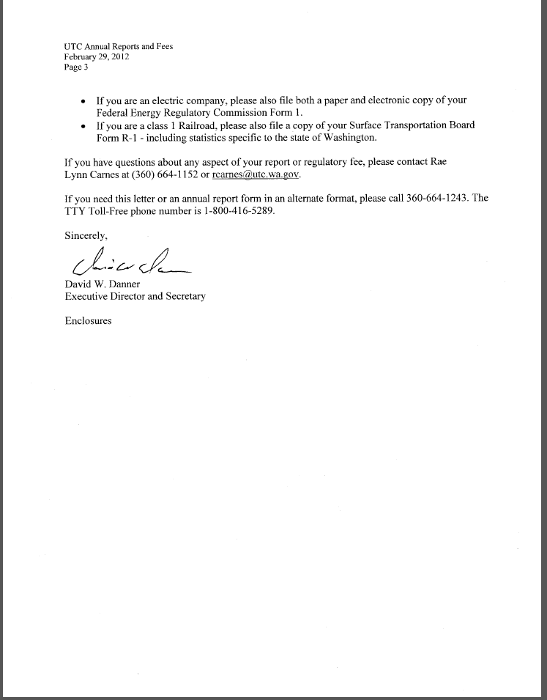

**Attachment C**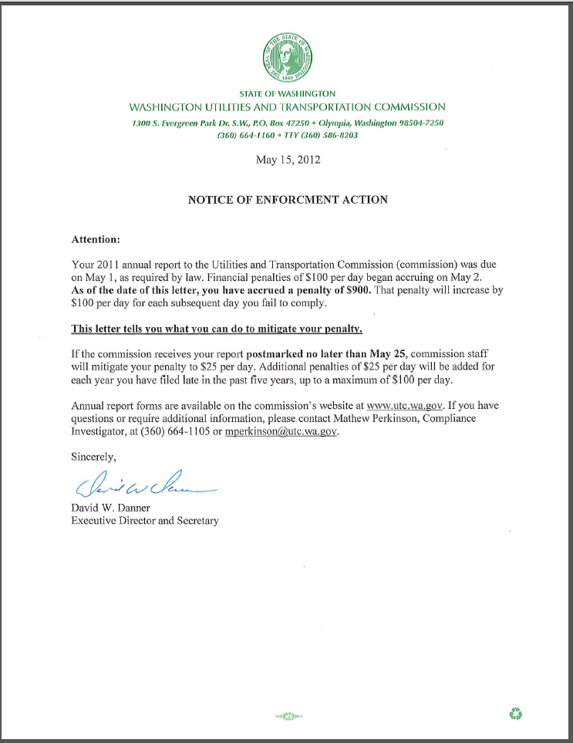

1. See attachment A for a copy of Bellingham Transfer & Storage, Inc. Mitigation Request.
2. See attachment B for a copy of the letter sent to all regulated companies on February 29, 212.
3. See attachment C for a copy of the enforcement letter sent to the company on May 15, 2012.