Agenda Date: November 26, 2008

Item Number: B2

**Docket: TS-081877**

Company Name: Lake Chelan Recreation, Inc.

dba: Lake Chelan Boat Company

dba: Lake Chelan Boat Co.

Staff: David Gomez, Deputy Assistant Director

Dennis Shutler, Consumer Protection Staff

**Recommendation**

Issue a Complaint and Order Suspending the Time Schedule Revisions filed by Lake Chelan Recreation, Inc.

**Discussion**

On October 15, 2008, Lake Chelan Recreation, Inc. (LCRI or company) filed with the Utilities and Transportation Commission (commission) a revision to its Time Schedule 34 that would curtail boat service on Lake Chelan as follows:

**January 1 to March 14:** Delete Sunday service. Service would still be provided on Mondays, Wednesdays, and Fridays (10 days removed from schedule).

**March 15 to March 31**: Delete Tuesday, Thursday, Saturday and Sunday service. Service would still be provided on Mondays, Wednesdays and Fridays (10 days removed from schedule).

On August 28, 2008, in Docket TS-081453, the commission approved the company’s request to reduce its Time Schedule by 18 days:

**Summer Schedule:** No express service from the 4th Monday of September through the last day in September (end of the current summer service schedule). This reduced service a total of 13 days.

**Winter Schedule:** No express service every Tuesday and Thursday from October 16th through October 31st. This resulted in a total reduction of 5 days from the express winter schedule.

Together, these Time Schedule changes will reduce annual operating days by 7 percent (see Figure 1 below).

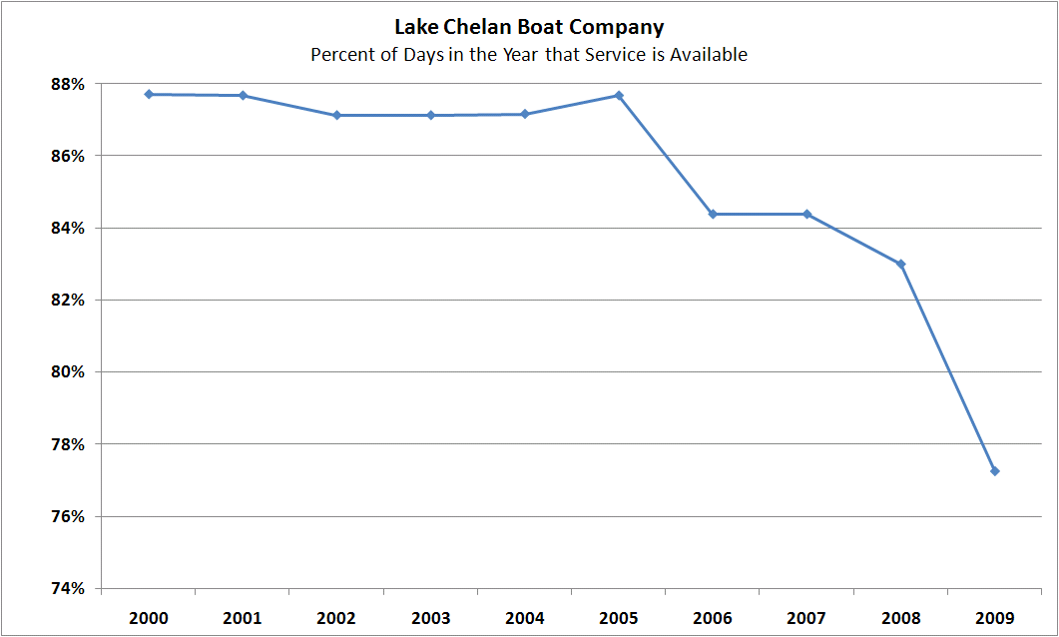

Figure 1, Percent Operating Days versus Total Calendar Days

LCRI operates two boats; the Lady II and the Lady Express. The Lady Express provides round trip express boat service between the company’s dock in Chelan up-lake to the town of Stehekin. The Lady II provides service between the same two points as the Lady Express, serving additional intermediate and flag stops along the way. During the winter months, the Lady Express is the only boat in operation.

The tables below show the full itinerary proposed by the company:

**Lady II Itinerary; Summer Schedule**

|  |  |
| --- | --- |
| **May 1 through October 15 Daily** | |
| Leave Boat Company Dock | 8:30am |
| Fields Point | 9:45am |
| Prince Creek | 11:00am |
| Lucerne (Port of Holden) | 11:45am |
| Moore Point | 12:15pm |
| Arrive Stehekin | 12:30pm |
| 90 Minute Layover in Stehekin | |
| Leave Stehekin | 2:00pm |
| Moore Point | 2:15pm |
| Lucerne (Port of Holden) | 2:30pm |
| Prince Creek | 3:15pm |
| Fields Point | 4:45pm |
| Arrive Boat Company Dock | 6:00pm |

**Lady Express Itinerary; Summer Schedule**

|  |  |
| --- | --- |
| **May - Saturday & Sunday only June 1 through September 21 - Daily** | |
| Leaves Boat Company Dock | 8:30 am |
| Fields Point | 9:20 am |
| Arrive Stehekin | 11:00 am |
| ****60 Minute Layover in Stehekin**** | |
| Leave Stehekin | 12:00 pm |
| Lucerne (Port of Holden) | 12:20 pm |
| Fields Point | 1:45 pm |
| Arrive Boat Company Dock | 2:45 pm |

**Lady Express Itinerary; Proposed Winter Schedule**

|  |  |
| --- | --- |
| **October 16 - October 31 - Mon, Wed, Fri, Sat, Sun Nov 1 - Dec 31 - Mon, Wed, Fri, Sun**  **Jan 1 – Mar 31 – Mon, Wed, FriApr 1 - Apr 30 - Daily Service** | |
| Leave Boat Company Dock | 10:00 am |
| Fields Point | 10:50 am |
| Lucerne | 12:00 pm |
| Arrive Stehekin | 12:30 pm |
| **60 Minute Layover in Stehekin** | |
| Leave Stehekin | 1:30 pm |
| Lucerne (Port of Holden) | 1:50 pm |
| Fields Point | 3:10 pm |
| Arrive Boat Company Dock | 4:00 pm |

The company states that the proposed schedule change is prompted by higher costs for fuel and labor coupled with fewer passengers expected during the winter months due to the National Park Service (NPS) concession being closed since October 31, 2008, at the request of the concession operator.

The NPS concession, also called the Stehekin Landing Resort, has been operated for the last three years under a temporary contract with the NPS. The NPS attempted to rebid a new long-term 10-year contract for the operation of the concession but received no proposals. As a result, the NPS had to close the concession entirely or re-negotiate to resume a temporary contract to operate the concession. The NPS concession is expected to resume operation by March 1, 2009. The concession will operate within a reduced season under a new temporary contract and the NPS believes that by focusing energy on the main summer season, the Stehekin Landing Resort and the NPS will build a sustainable, economically viable business that provides quality visitor services.

In Docket TS-081453, LCRI provided revenue and expense impacts of the proposed schedule change. The company estimated the net impact would offset $13,547 from the company’s projected 2008 loss of $78,420. Staff concluded that the company would not need to reduce fares as a result of the schedule change.

In this filing, staff asked LCRI to provide updated cost information from 2008 and a pro forma income statement for 2009 based on the proposed reduced winter schedule. The updated information demonstrates net income of $34,775 for 2008, which represents a 94 operating ratio[1]. LCRI’s pro forma income statement for 2009 projects a $61,649 operating loss, which result in an operating ratio of 104. The company’s projected loss for 2009 assumes that expenses will remain the same even though operations have been curtailed by 7 percent. For example, LCRI assumes fuel consumption in its 2009 pro forma is the same as its 2008 actual.

On October 15, 2008, the company notified its customers of the proposed new Time Schedule via notices posted at the company’s docks, offices and on its website. The commission has received two customer comments as of November 17, 2008. One customer believes that it is no longer feasible to operate LCRI’s existing fleet of boats. The customer feels it is time to consider allowing other operators to propose service on the lake. The other customer resides in Stehekin and is a member of the school board. The customer is concerned that reduced service will mean that children who live in Stehekin but have traveled down-lake for the weekend will miss school on Mondays if there is no Sunday service.

**Conclusion**

Staff believes the issues raised in this docket require additional review and investigation. The company has not demonstrated that the proposed changes are reasonable. Therefore, staff recommends that the commission issue a Complaint and Order Suspending the Time Schedule Revisions filed by Lake Chelan Recreation, Inc., in Docket TS-081877.

1. Operating ratio means operating expenses before interest and federal income taxes divided by revenue.