**Solar Energy in Washington State:**

**A Starting Point to Significantly Expand Solar Projects in Our State**

**Prepared by:**

Washington State University Energy Program

**Prepared for:**

Washington State Utilities and Transportation Commission

Washington State Department of Commerce

Utilities, Solar Companies, Solar Installers

**Stakeholders meeting:**

10 to 11:30 a.m., June 30, 2014

Hosted by Jake Fey, Director, WSU Energy Program

at the Utilities and Transportation Commission Office, Olympia, WA

****

**June 25, 2014**

© 2014 Washington State University Energy Program

This publication contains material written and produced for public distribution. Permission to copy or disseminate all or part of this material is granted, provided that the copies are not made or distributed for commercial advantage and that they are referenced by title with credit to the Washington State University Energy Program.

Visit our website at [www.energy.wsu.edu](http://www.energy.wsu.edu).

WSUEEP14-009 • June 2014

**Contents**

[Purpose 1](#_Toc391458537)

[Part One 2](#_Toc391458538)

[Current Status of Solar Energy 2](#_Toc391458539)

[International 2](#_Toc391458540)

[United States 2](#_Toc391458541)

[Washington 3](#_Toc391458542)

[Solar Hot Water in Washington 4](#_Toc391458543)

[Solar Companies and Installers 4](#_Toc391458544)

[Policies, Economics and Incentives Driving Solar Energy Projects 6](#_Toc391458545)

[Incentives Available to Support Solar Energy Projects in Washington 7](#_Toc391458546)

[Net Metering 7](#_Toc391458547)

[Initiative 937 8](#_Toc391458548)

[Renewable Energy System Cost Recovery Program 8](#_Toc391458549)

[Additional State Support for Solar Energy 10](#_Toc391458550)

[Part Two 1](#_Toc391458551)

[State Financial Support for Manufacturing 1](#_Toc391458552)

[State Financial Support for Residential-Scale Solar PV System Installation 1](#_Toc391458553)

[State Financial Support for Larger Solar PV System Installation 2](#_Toc391458554)

[Eligibility for State Financial Incentives 2](#_Toc391458555)

[Program Incentive Costs 2](#_Toc391458556)

[Solar Water Heating Incentives 3](#_Toc391458557)

[Market Support, Oversight, and Reporting 3](#_Toc391458558)

[Utility Role 3](#_Toc391458559)

**Tables**

[Table 1. Solar Companies and Their Primary Markets for Washington State Solar Facilities 5](#_Toc391458758)

[Table 2. Solar PV Installations in Four States – 2013 6](#_Toc391458759)

[Table 3. State and Federal Solar Incentives 7](#_Toc391458760)

[Table 4. Net Metering Status 8](#_Toc391458761)

[Table 5. Annual Incentive Payment Calculation Table for Non-Community Projects 9](#_Toc391458762)

[Table 6. Annual Incentive Payment Calculation Table for Community Solar Projects 9](#_Toc391458763)

**Figures**

[Figure 1. Global Solar PV Installation, 2000-2013 (MW) 2](#_Toc391458578)

[Figure 2. U.S. Solar PV Installation and Average System Price, 2000-2013 (MW) 2](#_Toc391458579)

[Figure 3. Number of Washington Solar PV Installations 3](#_Toc391458580)

[Figure 4. Washington Installed Solar PV Capacity 3](#_Toc391458581)

[Figure 5. Over 5,500 Solar PV Systems Installed within the CRP, July 2005-June 2014 4](#_Toc391458582)

[Figure 6. Solar Energy Value Chain 5](#_Toc391458583)

# Purpose

Governor Jay Inslee, in Executive Order 14-04, requests that the Washington State University (WSU) Energy Program work with the Washington State Utilities and Transportation Commission (UTC), the Department of Commerce, and other state agencies and stakeholders (including utilities, solar manufacturers, and installers) to develop recommendations to ***significantly expand the use of solar energy in the State of Washington***.

This paper, prepared to support that effort, consists of two parts:

* **Part One** addresses:
  + Current status of solar energy projects in other countries, other states, and Washington, including a look at our state’s solar-related companies.
  + Existing policies, economics, and incentives that support the solar industry.
* **Part Two** identifies:
  + Some of the features and issues that affect the current and expanded use of solar energy in Washington. Stakeholder input will further inform this effort.

The WSU Energy Program will use these data, along with input from the agencies and stakeholders mentioned above, to develop recommendations to help promote and expand the use of solar energy in the state. Specifically, we will focus on how to:

* Ensure effective state financial incentives, consistent with the benefits and costs of solar energy
* Better target those incentives to a wider range of project sizes and owner types
* Ensure consumer protection
* Ensure continued grid reliability

While the primary focus of Part One is the solar photovoltaic industry, the installation of solar hot water systems is also examined. Although there is less data available on the solar water heating industry in Washington, it is clear that there is a growing presence of this component of the industry in the state.

# Part One

## Current Status of Solar Energy

Solar is a growth industry – internationally, nationally, and within Washington. Solar photovoltaic systems (solar PV), which convert sunlight to electricity, can be developed at residential, commercial, and utility scales.

|  |
| --- |
| Figure . Global Solar PV Installation, 2000-2013 (MW)  _:Users:phillou:Desktop:Screen Shot 2014-06-03 at 2.05.55 PM.png  Source: European Photovoltaic Industry Association |
| |  | | --- | | Figure . U.S. Solar PV Installation and Average System Price, 2000-2013 (MW)  _:Users:phillou:Desktop:Screen Shot 2014-06-03 at 2.12.39 PM.png  Source: GTM Research/Solar Energy Industries Association, LBNL | |

Much of the growth of the solar PV industry nationally and internationally can be traced to financial incentives provided for the installation and use of solar PV systems. These incentives can be structured in a number of ways, and are typically provided by a government agency or the electric utility industry (often under the direction of national or state policy). The graphs provided here indicate robust growth of solar PV since 2000.

### International

Globally, 37,007 MW of solar PV was installed in 2013 – a 24% increase from 2012 (Figure 1).

At the end of 2013, global cumulative installed capacity was 136,447 MW.

### United States

In 2013, 4,751 MW of solar PV was installed – a 41% increase from 2012.

Cumulative installed capacity from 2000-2013 was 12,109 MW (Figure 2).

Also during this timeframe, the average price of systems dropped by over 60%.

|  |  |
| --- | --- |
| Washington Figure 3 illustrates the recent growth in the number of solar PV installations through the Renewable Energy System Cost Reduction Program (CRP) from 2005-2013.  In 2013, 8 MW of solar PV were installed in the state within the CRP – a 54% increase from 2012.  The cumulative installed capacity of more than 5,600 systems in the CRP is 29 MW.  Systems outside the CRP account for about 2.3 MW of capacity, of which about 0.63 MW are third-party owned or leased systems, and therefore not eligible for incentives under the CRP.  Off-grid systems, which are not connected to any electric utility system, are not included in this total. | Figure . Number of Washington Solar PV Installations  Approved Under the CRP, 2005-2013  _:Users:phillou:Desktop:Screen Shot 2014-06-03 at 2.19.01 PM.png |
| Washington’s solar PV is installed primarily in residential settings, as shown in Figure 4. The makeup is approximately 79% residential and 21% commercial.  Larger commercial installations include:   * Century Link Field, Seattle (783 kW) * Wild Horse, Vantage (500 kW) * Finn Hill Middle School, Kirkland (335 kW)   Washington does not currently have utility-scale PV installations (defined as larger than 1 MW by the Solar Electric Industries Association). | Figure . Washington Installed Solar PV Capacity  Approved Under the CRP – Residential and Commercial |

The broad distribution of solar PV installations across the state is shown in Figure 5.

Figure 5. Over 5,500 Solar PV Systems Installed within the CRP, July 2005-June 2014

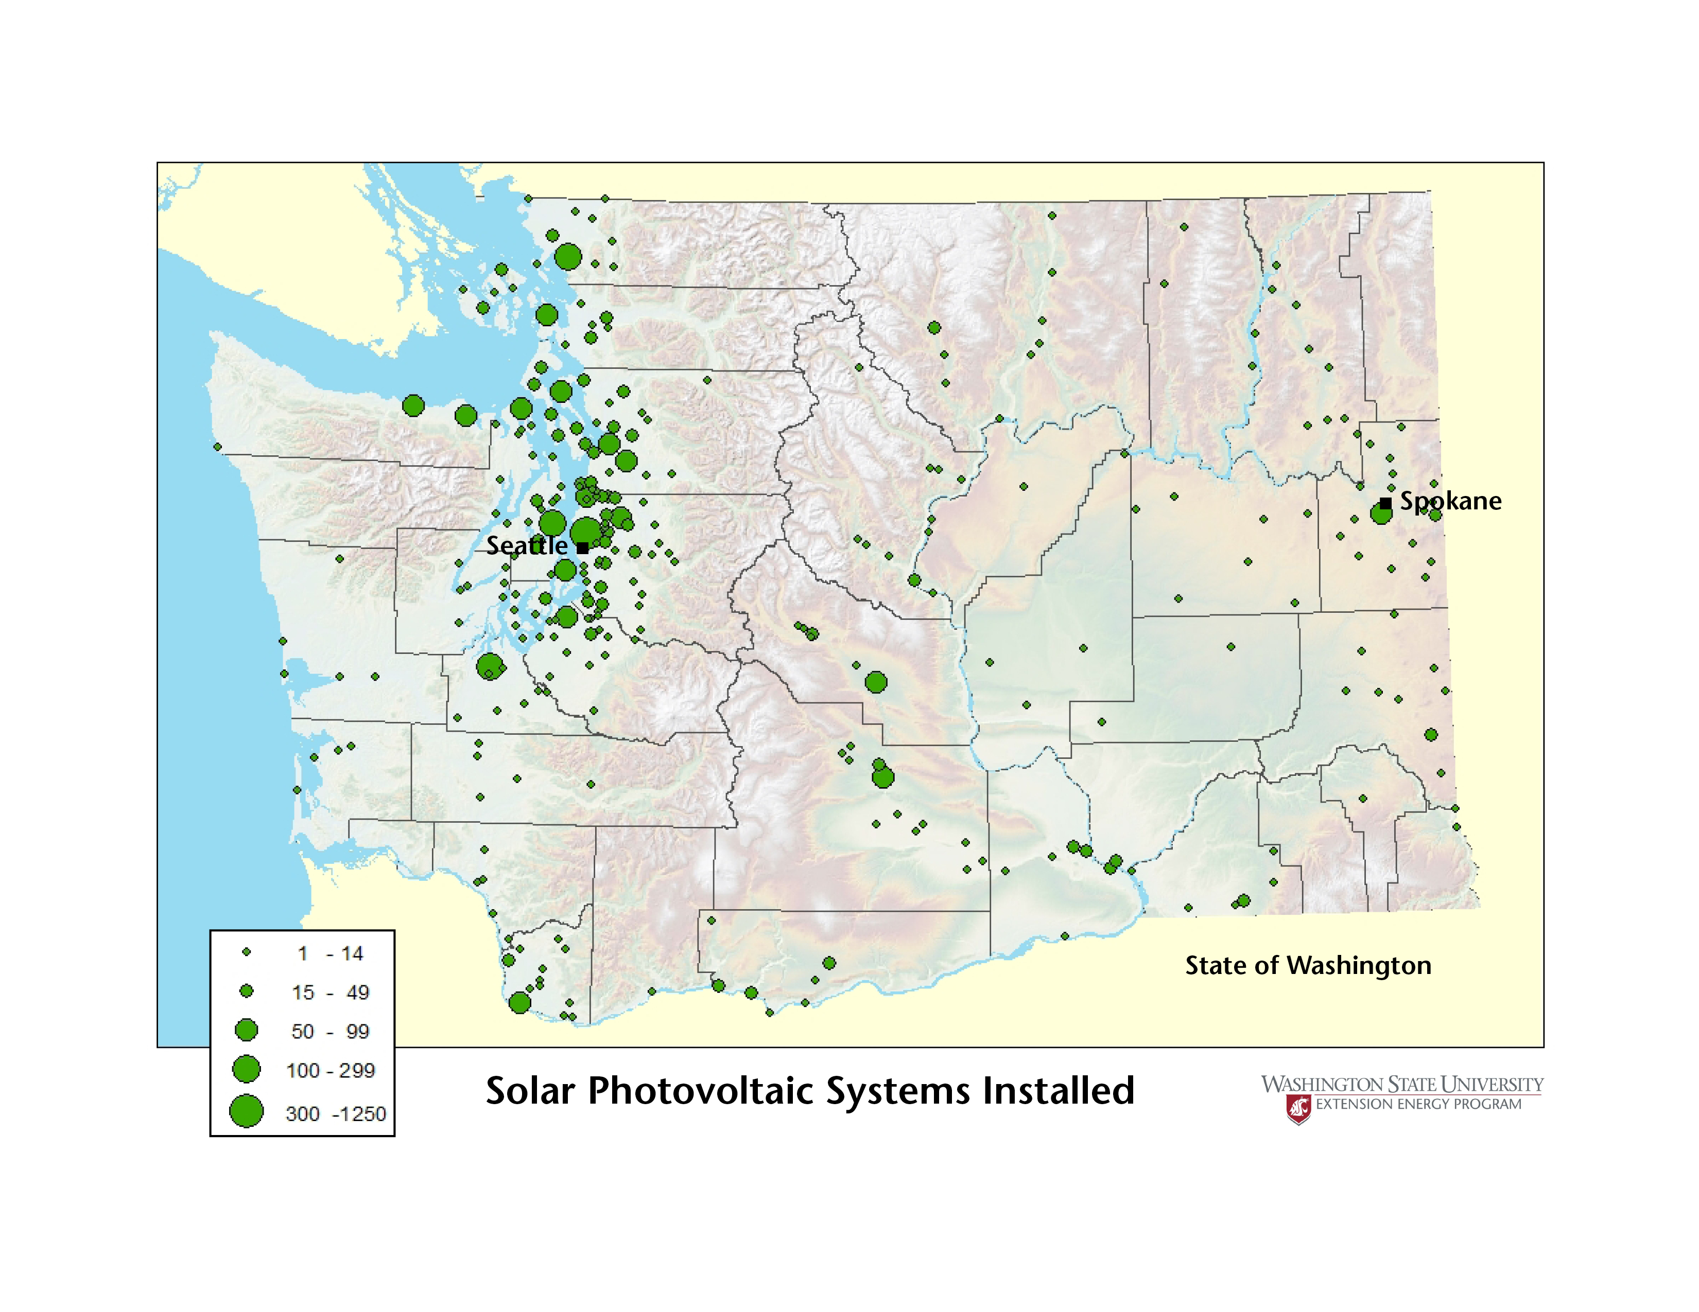

## 

### Solar Hot Water in Washington

Because solar water heating systems are not eligible for financial incentives under the CRP, information about these installations is not reported to a central tracking entity. Therefore, less is known about the scale of solar hot water in the state. But even with incomplete data, it is clear that solar hot water is a growth industry, with about 700 installations totaling more than 9.4 billion BTU/year of installed capacity, or equivalent to 2.8 million kWh. Available data suggest that these solar hot water installations are largely concentrated in three areas: southeast Washington (west of the Tri-Cities area), the Puget Sound basin, and the Spokane area.

### Solar Companies and Installers

Worldwide, companies that are based in or have significant facilities in China and other Asian countries are increasingly dominating key steps in the solar energy value chain (Figure 6). For example, approximately half of the world’s solar module production capacity is currently located in China. Many of these facilities are very large factories, and the combination of scale, subsidies, and market pressures have led solar PV module prices to be substantially less than prices of modules made in Washington. The United States, in contrast, has experienced facility closures even as the demand for solar PV systems continues to grow.

However, Washington has experienced growth in key aspects of the solar industry. Since the beginning of the CRP in 2005, two manufacturers of solar modules began to operate in the state, largely catalyzed by the presence of the CRP, and each has also started manufacturing inverters. Other companies in Washington also manufacture inverters, and still others participate in steps in the value chain, such as REC Silicon, which manufactures polysilicon. Washington does not currently have facilities involved in wafer or cell production.

Figure 6. Solar Energy Value Chain

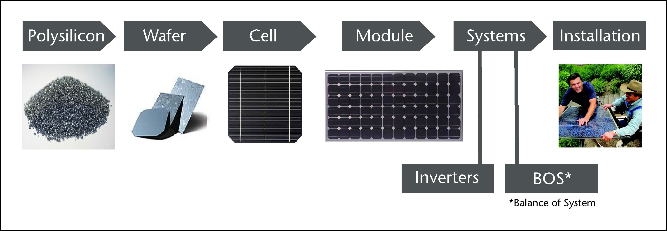

Washington state solar PV and solar hot water companies are listed in Table 1. From 2011 to present, 167 installers of solar PV installed systems under the CRP, and there were at least seven active installers of solar hot water systems.

Table 1. Solar Companies and Their Primary Markets for Washington State Solar Facilities

| **Company** | **Primary Market** | | | | |
| --- | --- | --- | --- | --- | --- |
| **WA** | **U.S.** | **International** | **Marine/ RV/Off Grid** | **Solar Hot Water** |
| **Polysilicon** | | | | | |
| REC Silicon |  |  | x |  |  |
| **Wafer** | | | | | |
| *none* | | | | | |
| **Cell** | | | | | |
| *none* | | | | | |
| **Modules** | | | | | |
| Itek Energy | x |  |  |  |  |
| Silicon Energy | x |  |  |  |  |
| Aurinco | x | x | x | x |  |
| **Systems – Inverters** | | | | | |
| Itek Energy | x |  |  |  |  |
| Silicon Energy | x |  |  |  |  |
| Blue Frog Solar | x | x |  |  |  |
| Outback Power |  | x | x | x |  |
| Magnum Energy |  | x | x | x |  |
| **Systems/Balance of System** | | | | | |
| Alpha Technologies |  | x | x | x |  |
| MidNite Solar |  | x | x | x |  |
| SunModo |  | x | x | x | x |
| Silk Road |  |  |  |  | x |

## Policies, Economics and Incentives Driving Solar Energy Projects

Through 2012, the international market for solar PV was driven by demand in the European market, particularly Germany and Spain. These large markets resulted from government policies that led to robust financial incentives for the installation of solar PV systems. Reductions in the level of incentives in Europe have resulted in the corresponding decline in 2012 and 2013 of new installed capacity.

Economics also play a role in the size of the market for solar systems. For example, a standard solar PV system in Phoenix, Arizona will produce over 50% more electricity than the same system in Western Washington,[[1]](#footnote-1) and 33% more than that same system in Eastern Washington, because of the increased availability and intensity of unfiltered sunlight. Higher electricity rates in some of the sunnier parts of the country make that solar output more valuable, further improving the economics of solar PV in some parts of the country over Washington.

In the United States, different state policies have incentivized and prompted growth in different segments of the solar PV market (residential, commercial, and utility-scale). This is illustrated by data from the four states included in Table 2. While each of the states noted below saw the bulk of their solar PV installations (by number) in the residential sector, there are significant differences in the actual installed electricity production capacity by sector. The 2013 data for new generating capacity in each state indicates that policies and economics in:

* California led to utility-scale installations dominating the new capacity growth
* New Jersey led to commercial installations dominating the new capacity growth
* Washington and Oregon led to residential installations dominating the new capacity growth

Table 2. Solar PV Installations in Four States – 2013

|  |  |  |  |  |  |  |  |
| --- | --- | --- | --- | --- | --- | --- | --- |
| **Total**  **Installations by State** | | **Residential** | | **Commercial** | | **Utility-Scale** | |
| **Installations** | **% of Total** | **Installations** | **% of Total** | **Installations** | **% of Total** |
| California | 73,001 | 71,078 | 97% | 1,871 | 3% | 52 | 0.1% |
| New Jersey | 6,123 | 4,584 | 75% | 1,534 | 25% | 5 | 0.1% |
| Oregon | 1,206 | 1,132 | 94% | 74 | 6% | 0 | N/A |
| Washington | 1,500 | 1,453 | 97% | 47 | 3% | 0 | N/A |
| **Total MW by State** | | **MW** | **% of Total** | **MW** | **% of Total** | **MW** | **% of Total** |
| California | 2,621 | 410 | 16% | 293 | 11% | 1,918 | 73% |
| New Jersey | 236 | 38 | 16% | 189 | 80% | 8 | 3% |
| Oregon | 7 | 6 | 86% | 1 | 14% | 0 | N/A |
| Washington | 8 | 7 | 88% | 1 | 13% | 0 | N/A |

### Incentives Available to Support Solar Energy Projects in Washington

The state and federal incentives available in Washington are listed in Table 3. The top policies responsible for driving solar PV and solar hot water installations in the state are discussed in more detail below.

Table 3. State and Federal Solar Incentives

| **Incentive** | **Eligible Technology** | **Current Statute**  **End Date** |
| --- | --- | --- |
| **Washington** | |  |
| Net Metering | PV | na |
| Renewable Energy System Cost Recovery Program | PV | 6-30-2020 |
| Sales/Use Tax Exemption | PV, SHW | 6-30-2018 |
| B & O Tax Reduction | PV | 6-30-2017 |
| Manufacturer’s Sales/Use Tax Exemption for Machinery and Equipment | PV | 1-1-2020 |
| Rural County B&O Tax Credit | PV, SHW | na |
| Initiative 937 | PV | na |
| **Washington Utilities** | |  |
| Snohomish County PUD – loan/rebate | PV, SHW | - |
| Clallam County PUD – loan | PV | - |
| Clark County PUD – loan/rebate | SHW | - |
| City of Port Angeles – loan | PV, SHW | - |
| City of Richland– loan | PV, SHW | - |
| Chelan County PUD – production incentive | PV | - |
| Okanogan County PUD – production incentive | PV | - |
| OPALCO – production incentive | PV | - |
| **Federal** | |  |
| Residential Renewable Energy Tax Credit | PV, SHW | 12-31-2016 |
| PowerSaver Loans | PV, SHW | na |
| Business Energy Investment Tax Credit | PV, SHW | 12-31-2016 |
| Modified Accelerated Depreciation | PV, SHW | none |
| Misc. commercial tax deductions | PV, SHW | none |
| USDA Rural Energy for America Program – grants and loans | PV, SHW | na |
| Tribal Energy Program | PV, SHW | na |
| LEED points (EA Credit 2 ) for onsite renewable energy generation | PV, SHW | none |

#### Net Metering

*Reference: RCW 80.60*

Net metering was enacted in June 1998 (House Bill 2773). This interconnection policy/billing mechanism allows an electric customer with eligible onsite generation (hydro, wind, solar PV, or biogas from animal waste as fuel) to interconnect to the utility grid. The generated electricity offsets the customer’s utility load; energy that is not used by the electric customer as it is produced is exported to the utility. This electricity is “stored” on the utility system for use by the electric customer at a time when the customer’s electricity use is greater than the output of the onsite generating system. The customer’s utility account is reconciled annually on April 30. The customer pays for the net of imported and exported energy. Under the policy, the utilities are not permitted to charge the net-metered customer for the right to use the utility’s electric system to store and reclaim the excess energy.

|  |  |  |  |  |
| --- | --- | --- | --- | --- |
| Table . Net Metering Status | | | | |
|  | **1996 Peak**  **MW** | **0.5%** | **Current Output – Net-Metered Systems\***  **(6-24-14)** | **%** |
| Puget Sound Energy | 4,480 | 22.4 | 11.4 | 51% |
| Seattle City Light | 1,950 | 9.8 | 7.6 | 78% |
| Avista | 1,777 | 8.9 | 0.9 | 10% |
| Snohomish County PUD | 1,480 | 7.4 | 2.8 | 38% |
| Tacoma Public Utilities | 1,040 | 5.2 | 0.5 | 10% |
| Clark County PUD | 1,033 | 5.2 | 0.6 | 12% |
| PacifiCorp | 910 | 4.6 | 1.5 | 33% |
| Benton PUD | 378 | 1.9 | 0.3 | 16% |
| Inland Power and Light Co. | 187 | 0.9 | 0.4 | 44% |
| Clallam County PUD | 168 | 0.8 | 0.7 | 88% |
| Peninsula Light Co. | 131 | 0.7 | 0.2 | 29% |
| Benton REA | 99 | 0.5 | 0.2 | 40% |
| \* These numbers have been rounded and may not precisely match current utility records. | | | | |

The Legislature directed that 0.5% of a utility’s peak 1996 load be reserved for eligible systems that are 100 kW or less. Some utilities are approaching their net metering threshold (Table 4). Net-metered solar PV systems are in 44 utility service territories across the state.

#### Initiative 937

*Reference: RCW 19.285.040*

Initiative 937 (the Clean Energy Initiative), passed by voters in November 2006, requires large utilities to obtain 15% of their electricity from new renewable resources such as solar and wind (excluding hydro) by 2020, with incremental steps of 3% by 2012 and 9% by 2016. It also requires that utilities undertake cost-effective energy conservation measures. This initiative further supports the increased adoption of solar energy production by crediting the output of solar PV systems at double their actual output to satisfy their renewable portfolio standard requirements.

#### Renewable Energy System Cost Recovery Program

*Reference: RCW 82.16.110*

In 2005, Senate Bill 5101 – the Renewable Energy System CRP – was passed, which established production-based incentives to owners of systems that generated electricity from wind, solar power, or anaerobic digesters. These rules were clarified in WAC 458-20-273. Further legislation in 2009 and 2010 created community solar projects and increased program utility tax credit limits.

The CRP is administered by utilities, the Department of Revenue, and the WSU Energy Program, as follows:

* Utilities: Provide program agreement, system inspection, production meter installation (concurrent with net meter agreement), annual kWh accounting, incentive payment, credit deduction, and record keeping.
* Revenue: Processes program applications, verifies program requirements, and audits utility credit taken.
* WSU Energy Program: Provides technical review of applications, support to DOR and others, and data collection.

The annual incentive payment rates, as defined in WAC 458-20-273, are reproduced here as Tables 5 and 6. Annual incentive payments are made by participating utilities and an equal amount is taken as a credit against their Public Utility Tax (PUT). The incentive payable (PUT credit) per fiscal year is limited to 0.5% of a utility’s power sales or $100,000, whichever is greater. Program participation by utilities is voluntary.

While the CRP primarily assists with cost recovery for solar development, it has also assisted with cost recovery for over 100 small wind projects and fewer than five anaerobic digesters to date.

Table 5. Annual Incentive Payment Calculation Table for Non-Community Projects

|  |  |
| --- | --- |
| **Customer-generated**  **power applicable factors** | **Base rate (0.15) multiplied by applicable factor equals incentive payment rate** |
| Solar modules or solar stirling converters manufactured in Washington state  **Factor: 2.4** (two and four-tenths) | $0.36 |
| Solar or wind generating equipment with an inverter manufactured in Washington state  **Factor: 1.2** (one and two-tenths) | $0.18 |
| Anaerobic digester or other solar equipment or wind generator equipped with blades manufactured in Washington state  **Factor: 1.0** (one) | $0.15 |
| All other electricity produced by wind  **Factor: 0.8** (eight-tenths) | $0.12 |
| Both solar modules and inverters manufactured in Washington state.  **Factor:** (2.4 + 1.2) = 3.6 | $0.54 |
| Wind generator equipment with both blades and inverter manufactured in Washington state.  **Factor:** (1.0 + 1.2) = 2.2 | $0.33 |

Table 6. Annual Incentive Payment Calculation Table for Community Solar Projects

|  |  |
| --- | --- |
| **Customer-generated**  **power applicable factors** | **Base rate (0.30) multiplied by applicable factor equals incentive payment rate** |
| Solar modules or solar stirling converters manufactured in Washington state  **Factor: 2.4** (two and four-tenths) | $0.72 |
| Solar equipment with an inverter manufactured in Washington state  **Factor: 1.2** (one and two-tenths) | $0.36 |
| Other solar equipment  **Factor: 1.0** (one) | $0.30 |
| Both solar modules and inverters manufactured in Washington state.  **Factor:** (2.4 + 1.2) = 3.6 | $1.08 |

The incentive structure set forth in Tables 5 and 6 suggests that the program focuses on three goals:

1. Provide support to consumers and the solar installer community through the use of financial incentives to bring down the cost of solar systems to those consumers.
2. Support manufacturing of key components of solar systems in Washington by providing higher consumer incentives for using solar modules and inverters that are made in Washington.

At the time the law was originally passed, there was no in-state manufacturing of solar modules, and the inverters manufactured in Washington were largely targeted at market segments other than the standard, grid-tied system that prevails in the market today.

1. Create a path for eligible participants who do not qualify or are not good candidates for the incentive program to participate in a community solar project as an investor (per the 2009 and 2010 amendments to the law).

Eligibility criteria differ among the community solar and non-community solar elements of the program. To be eligible for the non-community solar incentives, the utility customer receiving the incentive payment must be the owner of both the property on which the system is installed and of the solar system itself. As a result, leased systems are not eligible for the incentive payments under the CRP, nor are systems installed on buildings that are on leased land.

These restrictions are not present in some of the nation’s largest solar markets. In California, for example, over two-thirds of the residential sector capacity installed in 2013 is actually owned by a third party and leased to the consumer/host. In Washington, community solar project participation allows those who do not own property that is a good candidate for solar installation to still invest in solar and participate in the program through ownership of a portion of a qualifying system at a qualifying site.

The maximum annual incentive is $5,000 per eligible participant. Qualifying for that level of incentive in Western Washington for a non-community solar participant would require a system over 9 kW in capacity (with Washington-made inverters and modules), which is about 75% larger than the size of the standard residential system being installed in the state today. The cost for such a system would be $40,000 or more, depending on the equipment selected and the difficulty of the installation.

Annual production payments provided under the program end on June 30, 2020. Therefore, systems installed July 1, 2014 would be eligible for the production incentives for six years, but those installed a year later would be eligible for payments for only five years.

The number of solar PV installations significantly increased when the CRP was enacted in 2005. A total of 43 out of the 61 utilities in the state participate in the CRP. These CRP utilities operate in 284 cities – from Aberdeen to Zillah – and in 36 out of the state’s 39 counties.

Through the CRP, more than 5,600 systems have been installed totaling 29 MW in solar capacity. Included in that total are 28 community solar projects in 10 utility service territories with 0.8 MW of capacity and over 1,050 participants. Well over half of the installed capacity from 2011 through 2013 used modules and inverters produced in Washington. In 2013, more than 90 contractors were on record for the solar PV systems installed under the program. About 17 of these are classified as “solar PV-specific” contractors.

#### Additional State Support for Solar Energy

In addition to the incentives identified in Table 3, the state has engaged in a number of activities intended to support the state’s solar industry. These include:

* Clean Energy Revolving Loan Fund Grants through Craft3 and the Puget Sound Cooperative Credit Union
* Energy Efficiency and Solar Grants for Public Buildings:<http://www.commerce.wa.gov/Programs/services/CapitalFacilities/Pages/EnergyEfficiencyGrants.aspx>
* Code Compliance Credits under the Washington State Energy Code, Table 406.2: <http://www.energy.wsu.edu/Documents/Table_406_2_Energy_Credits_2012_WSEC.pdf>
* Evergreen Sustainable Development Standard: <http://www.commerce.wa.gov/Documents/ESDS-2.2.pdf>

Perhaps the most significant of these support efforts is a federal grant-funded project led by the Energy Office in the Washington State Department of Commerce. This project, funded under the U.S. Department of Energy’s Sunshot Initiative, is focused on bringing down the “soft costs” of solar system installation. The project has a number of facets, perhaps the most significant of which is an effort to further standardize and streamline government permitting and utility interconnection in the state.

# **Part Two**

A number of choices shape a policy and the program, or set of programs, that implement the policy. The Governor has set forth a policy goal of significantly expanding the use of solar energy in the State of Washington. The current incentive program has been a market catalyst, but there are concerns about many features of the program as it stands. For example, many of the advocates for the current system are concerned that the 2020 end date for incentives will soon have impacts on the market uptake of the program. Others express concern that the incentives for systems with in-state modules and inverters are too high and cannot be justified by the job impacts, and that the incentive program provides little support for larger systems. These and other issues identified below will be considered as the recommendations are developed.

We understand that these questions will cause some concern among stakeholders. But we are asking these tough questions because they have been considered by other states as they developed programs to promote solar energy. This body of questions is not exhaustive and is not indicative of any specific policy recommendation that will be proposed to promote solar energy in Washington.

## State Financial Support for Manufacturing

* Should Washington continue to provide incentives for manufacturing modules and inverters in Washington?
  + If so, are the current B&O and use tax exemptions sufficient?
  + If other manufacturing incentives are desired, should they be designed to comply with World Trade Organization (WTO) rules or should we continue to risk sanctions?
  + If WTO compliance is not a concern, should the incentives continue to be reflected in the incentive to retail customers or should they be applied directly to manufacturers as output incentives?
  + Should any additional incentives for manufacturing in Washington be tied to sales outside of the state to support regional, national and international market development?
* Should Washington provide incentives for manufacturing for the solar industry beyond modules and inverters?
  + If so, what other elements of the solar PV supply chain are appropriate for support?
  + Should there be incentives for manufacturing components for solar hot water systems and other non-solar PV applications of solar energy?
* Should manufacturing incentives be phased out?
  + If so, should they be phased out over time?

## State Financial Support for Residential-Scale Solar PV System Installation

* Should Washington continue to provide incentives for the installation of residential-scale systems?
  + If so, should the incentives continue to be in the form of a production incentive paid out over time or should they be a one-time offset to the purchase price of a system?
  + How much of the system cost is it appropriate to cover with incentives, either up front or over time?
  + Should the incentives be adjusted and, if so, what should be the basis of any adjustment?
  + Should the program continue to let consumers “keep” the output of their systems in addition to the incentives, or should the state or serving utility get the output or the Renewable Energy Credits?
  + Should the state sales tax exemption continue to be part of the incentive structure for the solar PV industry and, if so, should the scheduled reduction in the exemption in 2018 be modified?

## State Financial Support for Larger Solar PV System Installation

* Should the current community solar program component be revised or replaced?
  + If so, what should be the goals of this component of the program?
  + How can it be designed to support those goals without complexity that causes marketplace confusion?
  + How should the level and type of incentive compare with that for residential-scale systems?
* Should larger systems of the scale appropriate for warehouses and other commercial buildings be eligible for incentives?
  + If so, should there be caps on the size of the project or the incentive available?
  + Should the basis of the incentives be the same as that for residential-scale systems?
  + How should the level and type of incentive compare with that for residential-scale systems?
* Should the state provide financial support for utility-scale systems?
  + If so, what types of financial incentives are appropriate?
  + Should the state guarantee a market for utility-scale systems, either by requiring utilities to take the power or acquiring it directly?

## Eligibility for State Financial Incentives

* Should the program be expanded to include properties that are on leased land?
* Should the program be expanded to provide incentives for the installation of systems on apartment buildings where the systems provide electricity for tenants?
* Should the program be expanded to provide incentives for systems that are owned by entities other than the owner of the real property benefitted, such as leased systems or systems owned by utilities?
* Should small wind systems and anaerobic digesters continue to be eligible for incentives?

## Program Incentive Costs

* Should the program cost to the state be capped, either over the program life or by year?
  + If there are annual program caps, should they be for the overall program or should there be caps for specific components (such as commercial-scale projects)?
  + If there are annual caps, should the program proceed under a first-come, first-served model; a bidding model; or some other system?
  + Should the caps apply at the state level, utility level, specific markets or some other method?
* How should the program incentive levels be adjusted over time?
  + Should incentive levels be adjusted based on achieving certain market targets, the price of installed systems, or the state or world market for key components?
  + Should specific dates be identified when an incentive adjustment will be considered?

## Solar Water Heating Incentives

* Should solar water heating be included in the program?
  + If so, what is an appropriate basis for incentives for solar water heating systems?
  + Should there be system size or incentive limits for solar water heating?

## Market Support, Oversight, and Reporting

* Should there be a consumer protection component to the program?
  + If so, what should it cover?
  + Are there consumer protections that are appropriate specifically for leasing programs?
  + Should installers be required to be certified as solar installers through a state or national certification system?
* Should there be a marketing component to the program through which the state helps promote the use of solar systems?
* Are there additional permitting or land use issues that the state can address to facilitate the installation of more systems or to protect solar access for those systems that are installed?
* Should the program be revised to be implemented as a single program with a single administrator, or should there continue to be a diffused implementation with utilities and different state agencies assuming the responsibility for different components?
* Should the program continue to have utility-based, decentralized record keeping on the installation of systems, or should there be a central tracking system for solar installations (or at least those installed under the incentive program)?

## Utility Role

* Should the law be changed so incentives are funded by utilities instead of by the state?
  + If so, should the state adopt a feed-in tariff model that requires utilities to take the solar system output?
  + If utilities provide incentives, should they continue to receive I-937 credit for the solar systems for which they provide incentives?
* Should utilities continue to be able to opt out of the program and thereby prevent the consumers in their service territories from receiving incentives?
* Should utilities continue to be the primary implementers and record-keepers of participation in the incentive program?
* Should utilities be able to charge participants an administrative fee to support the cost of the program?
* If net metering continues to be a feature of the Washington state solar support system, should the current utility limits on the amount of net-metered solar PV they must allow be raised?

1. From PVWatts, National Renewable Energy Laboratory [↑](#footnote-ref-1)