**AVISTA CORP.**

### RESPONSE TO REQUEST FOR INFORMATION

# JURISDICTION: WASHINGTON DATE PREPARED: 06/09/2016

# CASE NO.: UE-160228 & UG-160229 WITNESS: Heather L. Rosentrater

# REQUESTER: Public Counsel/Energy Project RESPONDER: Curt Kirkeby / L. La Bolle

# TYPE: Data Request DEPT: State & Federal Regulation

# REQUEST NO.: PC/EP – 061 - Revised TELEPHONE: (509) 495-4710

EMAIL: larry.labolle@avistacorp.com

**REQUEST:**

With regard to Public Counsel and The Energy Project Joint Data Request No. 29, provide any studies relied upon by Avista for these estimated conservation results for each of the scenarios included in the CVR business case, whether done internally or by other utilities.

**RESPONSE:**

As noted in the Company’s responses to PC/EP DR-028, 030, 059, and elsewhere, the concept of achieving energy savings for our customers through conservation voltage reduction was proven in Avista’s Smart Grid Projects, and the accuracy of the Company’s approach to measuring the energy savings expected to be achieved was confirmed by an independent, third-party consultant (Navigant). In the study evaluated by Navigant, Avista used smart devices located at midpoints[1] on the feeders to provide the voltage readings used in determining the level of the voltage reduction that could be achieved (2.02% on average). This configuration of endpoints accounts for the fact that the actual voltage at each customer’s service is not known, so the remaining voltage buffer[2] must still be large enough to account for this uncertainty while ensuring we meet our minimum voltage requirements.

With advanced metering, the endpoints consist of the actual voltage levels measured at every customer’s service on the feeder. In this configuration, there is little uncertainty in the voltage level being delivered to each customer. For its 2015 business case for the Washington advanced metering project, Avista conservatively judged that it could use voltage readings from the advanced meters to further lower the voltage on the feeder by 0.5% (in addition to the 2% already reduced, as noted above). For its current business case, the Company used its advanced metering system in Pullman to model the additional savings[3] that could be achieved by relying on voltage readings taken at each customer’s service as the basis for further lowering the voltage on the feeder, while still maintaining the required minimum voltage.

To verify the additional Conservation Voltage Reduction (CVR) savings enabled by advanced metering, Avista measured and recorded actual voltage levels taken at each customer’s service on each feeder during periods of time when the conservation voltage operation was enabled or “turned on,” and in periods when the conservation voltage operation was not engaged or “turned off.” The Company applied two levels of conservation voltage reduction to the feeders during this evaluation: the first level reduced the feeder set-point voltage by 2 volts (attained by using only feeder regulator and midline voltage readings), and the second level reduced the feeder set-point voltage by an additional increment of 2 volts (relying on the actual voltage levels at each customer’s service, as provided by the advanced metering system). Through this work, Avista determined that the additional average voltage reduction it could achieve through the deployment of advanced metering was 2%.

Results of these conservation voltage trials are provided in PC/EP DR-061 Revised Attachment A. The feeder tab labeled “TUR117” contains the voltage readings measured at every customer’s service at five minute intervals under the two levels of conservation voltage reduction (set-point reductions of 2 volts and 4 volts). The voltage readings in column B were taken during the evaluation of the 2-volt reduction during periods when the CVR operation was enabled, or “turned on,” and in periods when the CVR operation was not engaged, or “turned off.” The voltage readings in column C were recorded during the period when the additional 2 volt reduction (4 volt total) was enabled. The chart below shows the distribution of voltage readings during the 2 volt conservation voltage reduction. The peak on the left represents the predominant customer voltages with CVR turned off, [4] and the peak to right, represents the predominant voltages at each customer’s service with the CVR operation turned on.

The chart below shows the distribution of voltage readings during the additional 2 volt conservation voltage reduction (4 volts total). The peak on the left represents the predominant customer voltages with the initial 2 volt CVR turned on,[5] and the peak to right, represents the predominant customer service voltages with the additional 2 volt CVR operation turned on.

Voltage Levels Taken at Each Customer's Service on the

The important part of this work is identifying the number of customers who experienced voltage levels during the tests that were below the minimum required of 114 volts. The chart below shows the number of individual customers who experienced low voltage levels during the tests on the feeder (TUR117), as described above.

In addition to being able to identify individual customers with below-minimum voltage using data in the Company’s metering system, Avista is also able to integrate that data with its Geographic Information System to graphically display its conservation voltage results, as shown in the illustration below.

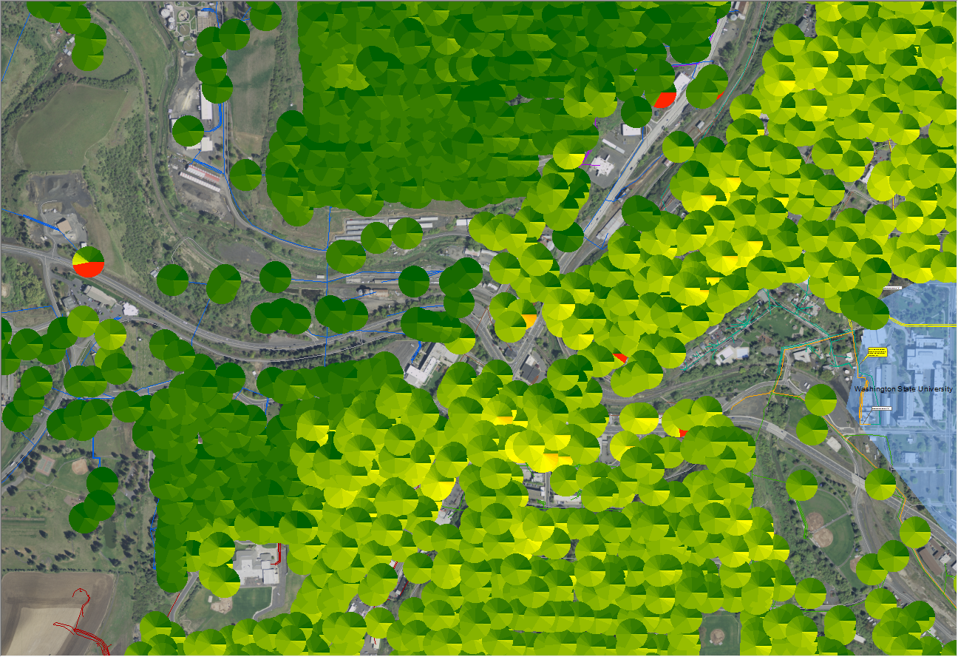

In this illustration, the individual circles represent the voltages experienced by individual customers measured over time. The darker green color represents voltages in the range of 121-124 volts. Lighter green to yellow show voltages in the range of 116-121 volts, while the yellow to slightly orange colors represent voltages in the range of 114-115 volts. The darker orange to red colors represent voltages below 114 volts. Circles that contain a range of colors, reflect variations in the actual voltage level measured at that customer’s service over time. As explained in Exhibit No. HLR-3 and in the Company’s responses to PC/EP DR-028 and 062, Avista has included the cost of remediating these below-voltage services as part of achieving the conservation voltage benefits quantified in its business case.

Of interest in the illustration above, the darkest green circles, those which fall predominantly above the diagonal white line, represent individual customer services served from a feeder where the CVR operation is not active, or “turned off,” while those circles that are predominantly below the line are served from a feeder where the conservation voltage operation is active, or “turned on.” Additionally, as shown in the illustration above, advanced metering provides the Company the ability to ensure that the voltage provided to each customer is adequate, irrespective of any CVR operations. As visible in the services above the diagonal line, the results identify three services where voltage levels are inadequate (red color) even under conditions of normal operation (no conservation voltage reduction in place). Avista would have no other way to determine and remediate these low-voltage issues absent its advanced metering system in Pullman.

1. Avista used actual voltage readings at the feeder breaker and midline to calibrate a power flow calculation for each feeder. This calculation estimates the expected voltages to the high side of the distribution transformer. Since the endpoint voltage (at the customer’s meter) is not known, the voltage buffer must be sufficiently large to account for the uncertainty in end-point voltages while ensuring we meet our minimum voltage requirements to the customer.
2. Please see Avista’s response to PC/EP DR-028.
3. Savings that are above and beyond the initial 2% savings that are achieved on “smart grid” or “grid mod” feeders as verified in the Navigant study.
4. For this test, Avista capped the voltage readings at 124 volts (the approximate peak of the voltage readings under normal operation – i.e. no conservation voltage reduction applied).
5. For this test, Avista capped the voltage readings at 122 volts (the approximate peak of the voltage readings with the initial 2 volt CVR operation enabled).