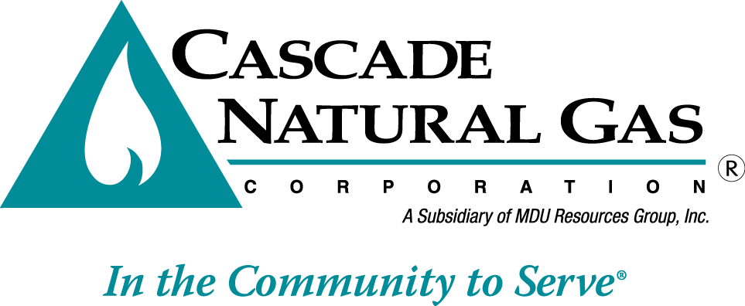 | 8113 W. GRANDRIDGE BLVD., KENNEWICK, WASHINGTON 99336-7166  TELEPHONE 509-734-4500 FACSIMILE 509-737-7166  www.cngc.com
VIA ELECTRONIC MAIL
records@utc.wa.gov

June 25, 2015

Records Center
Washington Utilities and Transportation Commission
1300 S. Evergreen Park Drive SW
Olympia, WA 98504

Re: Tariff Revisions in Compliance with ALJ Order in UG-140381
Advice No. CNGC/W15-06-02 – Replacement filing

Cascade Natural Gas Corporation (Cascade or the Company) submitted Advice No. CNG/W15-06-02 on June 25, 2015. The Company herewith replaces that filing in its entirety and files the following revisions to its Tariff WN U-3, stated to become effective with service August 1, 2015:

Tenth Revision of Sheet No. 9
Eleventh Revision of Sheet No. 10
Eighth Revision of Sheet No. 10-A
Second Revision of Sheet 10-B
Second Revision of Sheet No. 200

The purpose of this replacement filing is to revise tariff sheets to include the language agreed upon by parties in UG-140381 and as requested by Administrative Law Judge Order No. 3 in the same docket. The revisions clarify the application of the Company’s late payment charge and state that the disconnect visit charge will only be assessed when the visit does not result in disconnection of service.
This replacement filing includes sheets 10-A and 10-B which are revised due to content moving from prior pages.

Also included with this filing is an application for waiver requesting that the revised tariff sheets become effective with less than statutory notice on July 10, 2015.

If you have any questions regarding this report, please contact me at (509) 734-4593.

Sincerely,

Michael Parvinen
Director, Regulatory Affairs

