June 25, 2014

Steven V. King, Executive Director and Secretary
Utilities and Transportation Commission
1300 S. Evergreen Park Dr. SW
P.O. Box 47250
Olympia, WA 98504-7250

RE: Washington Utilities and Transportation Commission v. Corporate Moving Systems, Inc.

Commission Staff’s Response to Application for Mitigation of Penalties TV-140952

Dear Mr. King:

On June 4, 2014, the Utilities and Transportation Commission issued a $1,000 Penalty Assessment in Docket TV-140952 Corporate Moving Systems, Inc. for 10 violations of Washington Administrative Code (WAC) 480-15-480, which requires household goods carrier companies to furnish annual reports to the commission no later than May 1 each year.¹

On June 11, 2014, Corporate Moving Systems, Inc. wrote the commission requesting mitigation of penalties (Mitigation Request).² In its Mitigation Request, Corporate Moving Systems, Inc. does not dispute that the violation occurred. The company states, “The Controller for Corporate Moving Systems retired at the end of January 2014 and it has taken me some time to review where he left off on preparing the financials records for the year-end and to ensure we had the proper information to file the annual report. I’ll ensure that all future filings are done in a timely manner.”

It is the company’s responsibility to ensure that the regulatory fee is paid and the annual report is filed by the May 1 deadline. On February 28, 2014, Annual Report packets were mailed to all regulated household goods companies. The instructions for annual report completion page of the annual report informed the regulated company that it must complete the annual report form, pay the regulatory fees, and return the materials by May 1, 2014, to avoid enforcement action.

UTC Annual Reports
June 25, 2014
Page 2

On May 27, 2014, Corporate Moving Systems, Inc. filed the 2013 annual report and paid the required regulatory fees and late payment penalty. The company has been active since January 29, 1999. No previous violations of WAC 480-15-480 are on commission record. Staff supports the company’s request for mitigation as this is the company’s first delinquent filing. Staff recommends a reduced penalty assessment of $200.

If you have any questions regarding this recommendation, please contact Amy Andrews, Regulatory Analyst, at (360) 664-1157, or aandrews@utc.wa.gov.

Sincerely,

Sondra Walsh, Director
Administrative Services

ATTACHMENT A
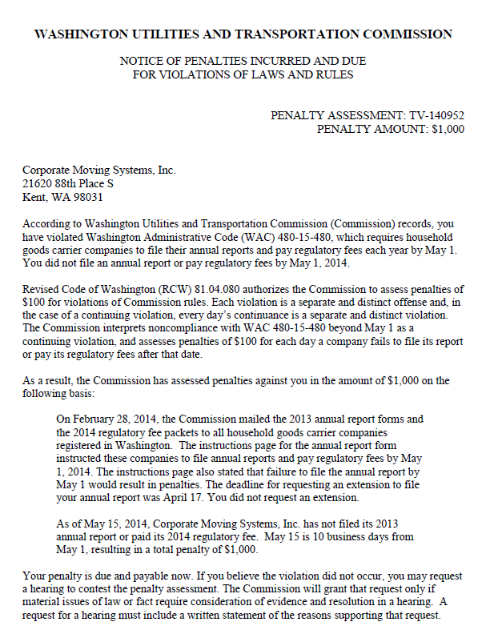

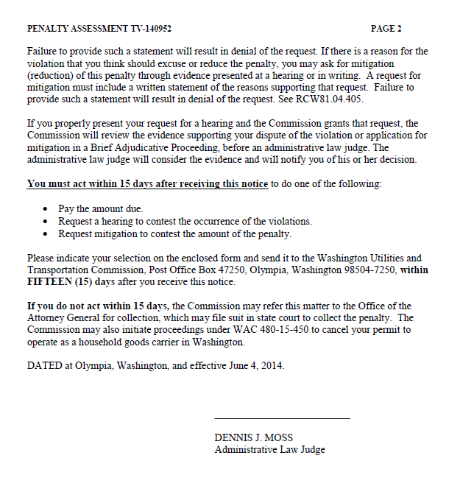

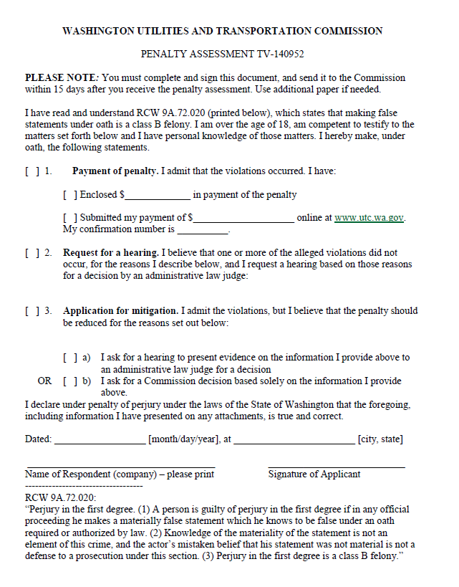

ATTACHMENT B
