

**STATE OF WASHINGTON**

WASHINGTON UTILITIES AND TRANSPORTATION COMMISSION

***1300 S. Evergreen Park Dr. S.W., P.O. Box 47250 ● Olympia, Washington 98504-7250***

***(360) 664-1160 ● TTY (360) 586-8203***

March 21, 2013

Steven V. King, Acting Executive Director and Secretary

Washington Utilities and Transportation Commission

1300 S. Evergreen Park Dr. SW

P. O. Box 47250

Olympia, Washington 98504-7250

RE: *Washington Utilities and Transportation Commission v. Excalibur Limousine, LLC d/b/a Seattle Green Limo*

Commission Staff’s Response to Application for Mitigation of Penalties

Docket TE-130198

Dear Mr. King:

On March 4, 2013, the Washington Utilities and Transportation Commission issued a $1,800 Penalty Assessment in Docket TE-130198 against Excalibur Limousine, LLC d/b/a Seattle Green Limo (Excalibur) for 18 violations of WAC 480-30-071, which requires Charter and Excursion companies to file annual safety reports with the commission by December 31 each year; and WAC 480-30-076, which requires such companies to pay regulatory fees annually on that date. [1]

On March 11, 2013, Excalibur responded to the commission, requesting a hearing. In its Hearing Request, Excalibur disputes that the violation occurred. The company states, “I received a notice of penalty stating that I have not sent in my 2012 safety report or filed my 2013 fees. I am requesting a hearing, although I don’t believe a hearing will even be necessary as this appears to be more of a paperwork mix-up. The UTC does have my 2012 Safety Report. I called just a couple of days ago to confirm this. I am no longer in operation and therefore won’t be registering or paying for vehicles as I have none to pay for. The vehicles have all been sold or are for sale. The confusion may have arises as, back in December, I worked with Rick Smith to shut the company down. He instructed me to fill out a number of forms and send them in. I did not realized [sic] at the time that the forms were all Federal, and not the UTC forms. At the time I assumed Mr. Smith was making notations in my file that I was halting business as of 2012. About a week into 2013 I received the Safety report and 2013 regulatory fees. I called in and spoke to Rae Lynn Carnes, explaining I was no longer in business and didn’t think I had to send in the Safety Report since I had ended business before 2012 was over. She explained that I did so I sent in the Safety Report section. At the time I still had all my vehicles as the sales had fallen through a couple of times so I told Rae Lynn that I might send in the regulatory fees if I couldn’t sell the cars and decided to start the business up. As interest in the vehicles picked up, after listing them nationally, about a week after that I faxed the Voluntary Cancellation Form. Again, I won’t be doing any business in 2013 or beyond. If that changes I understand that I will have to reapply with the commission. Please let me know if you are able to locate the Safety Report and if a hearing is necessary. Also, please be aware that the company number, 206-407-3656, no longer goes to me. Thanks for your time and good luck in the future.”[2]

It is the company’s responsibility to ensure that the regulatory fee is paid and the annual report is filed by the December 31 deadline. On November 15, 2012, the Commission mailed 2012 Annual Safety Report forms and 2013 regulatory Fee packets to Charter and Excursion companies registered in Washington state. A letter from the commission’s Assistant Director for Transportation Safety, David Pratt, instructed these companies to file annual reports and pay regulatory fees by December 31, 2012. The letter stated failure to file the annual report by December 31 would result in a penalty and possible cancellation of the company’s permit to operate in Washington. Those companies wishing to request an extension to file the annual report were asked to do so prior to December 31, providing a reason for the requested extension. No extension was requested.[3]

On January 7, 2013, the commission issued a notice to companies that had not yet filed their annual report and paid regulatory fees, informing these companies that they were subject to enforcement action, including the assessment of penalties beginning to accrue on that date. Companies that filed their annual reports and paid regulatory fees after January 7, 2013, but on or before January 18, 2013, are subject to penalties that the commission uses its discretion to mitigate to $25 per day if the company had not made these filings late in prior years. Companies that were late in prior years are subject to an additional $25 per day for each year in which they were late up to a total of $100 per day. For first time late-filers who filed their report after January 18, the commission will mitigate the penalties to 50 percent of the maximum permissible amount. No further mitigation will be granted unless the company provides new information that is unrelated to these factors. Mitigation will not be granted on the basis that a company was unaware a report must be filed.[4]

On January 11, 2013, Excalibur submitted a letter to the commission stating, “As of the middle of December 2012 I was working with Rick Smith and submitted paperwork stating that [sic] company was no longer operational. However, that was on a Federal level and I didn’t realized [sic] there was separate paperwork to submit for the State and since we were out of operation at the end of the year and had no accidents to report, no safety report was submitted. The sale of the company in December ended up falling through and, after calling into the UTC and talking to Trina subsequent to receiving notice that our safety report had not been turned in, it has become known to use [sic] that the UTC considers Excalibur still in operation. I spoke to Rick Smith again today who informed me that we’ll have to get a new DOT number if we plan to continue operations, now that we are still with vehicles. We will evaluate our current standing and future prospects over the weekend and getting all that information into the UTC early next week. In the meantime I wanted to get the record of the safety report, showing zero accidents, into the UTC asap.”[5]

As of March 13, 2013, Excalibur has failed to complete the annual safety report. The company must complete page four of the annual safety report form, complete the regulatory fee sheet and pay the required regulatory fees for 2012. Excalibur operated in 2012 and the companies permit remains active. Excalibur has not submitted a voluntary cancellation form. Rae Lynn Carnes, Commission staff, instructed Excalibur to complete the annual safety report and the regulatory fee sheet on January 22, 2013, and Excalibur failed to do so.

As of January 31, 2013, Excalibur failed to file its 2012 annual safety report or pay its 2013 regulatory fees. That date is 18 business days past the January 7, 2013, notice date when penalties began to accrue, resulting in a penalty assessment of $1,800 ($100 per day times 18 days). Excalibur is not a first time late-filer, having received a penalty for violations of WAC 480-30-071 in 2011. Excalibur therefore, is not eligible for administrative mitigation and is subject to the full penalty assessment of $1,800.

Staff does not support mitigating the assessed penalty of $1,800. In addition to failing to file its 2012 annual safety report timely, Excalibur received penalties for failing to comply with WAC 480-30-071 in 2011. Staff recommends denying the mitigation request.

If you have questions regarding this recommendation, please contact Mathew Perkinson, Compliance Investigator, at (360) 664-1105, or at mperkinson@utc.wa.gov.

Sincerely,

Sharon Wallace, Assistant Director

Consumer Protection and Communications

**Attachment A**

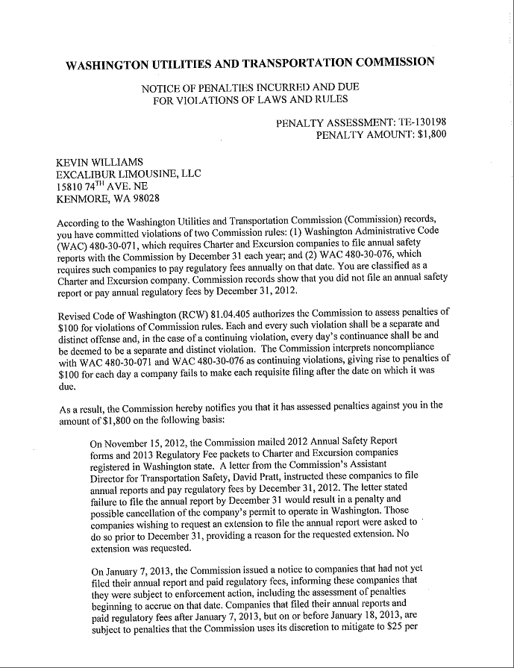

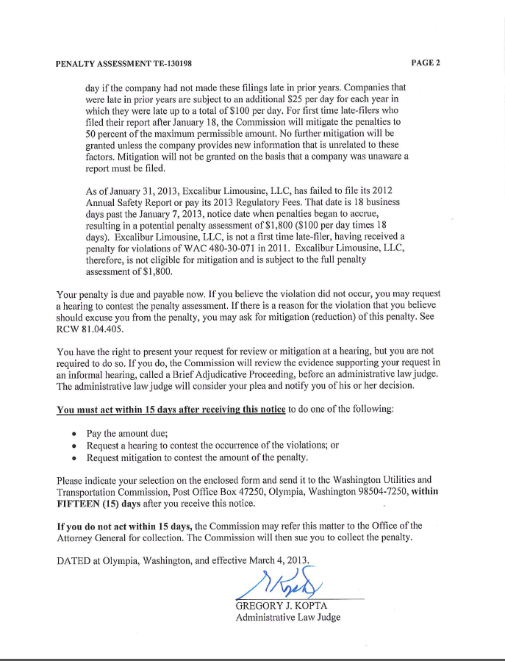

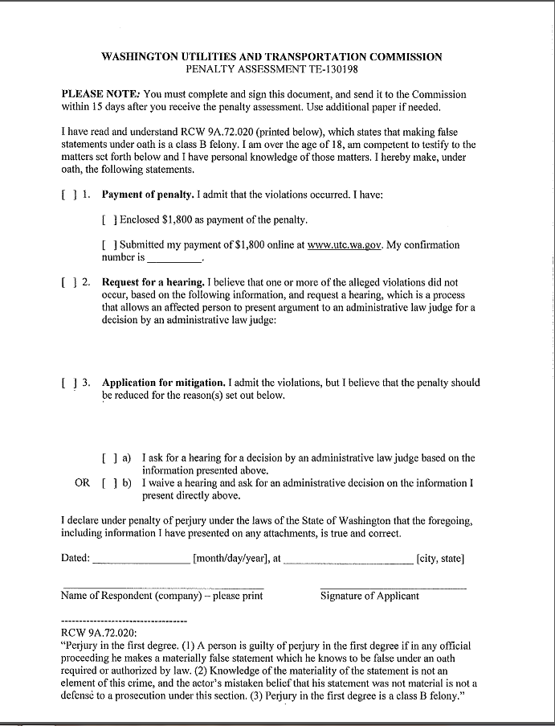

**Attachment B**

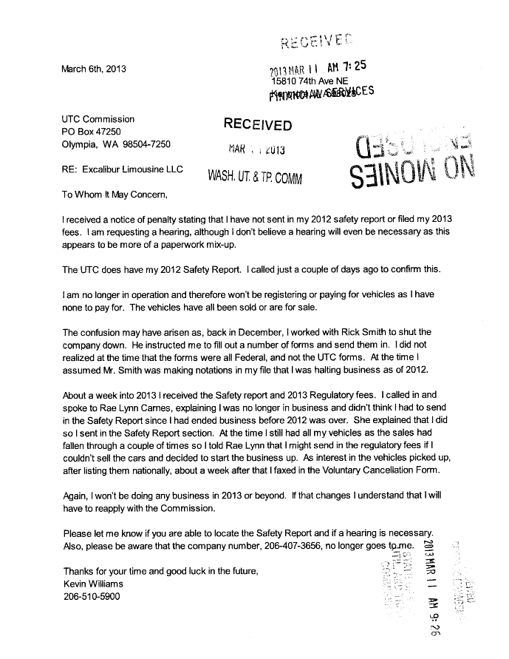

**Attachment C**

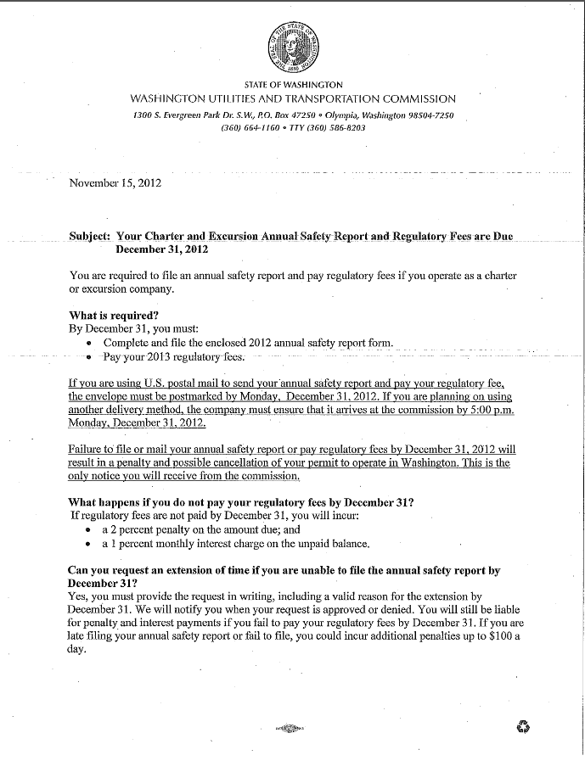

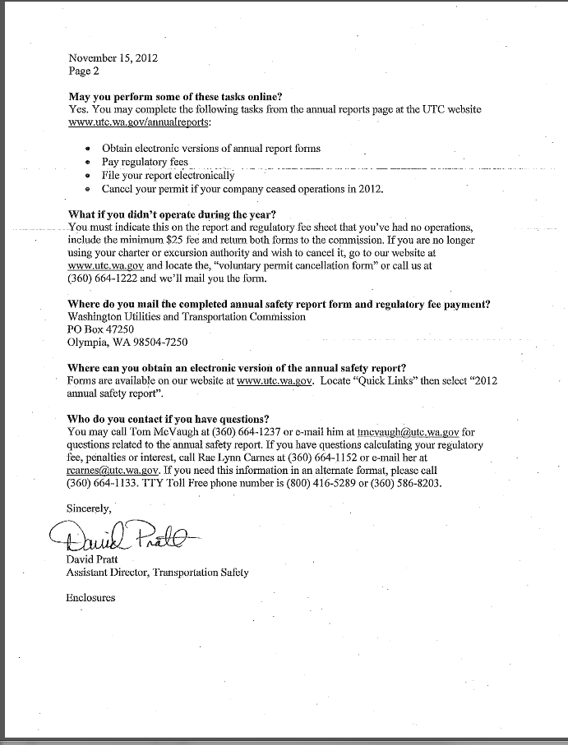

**Attachment D**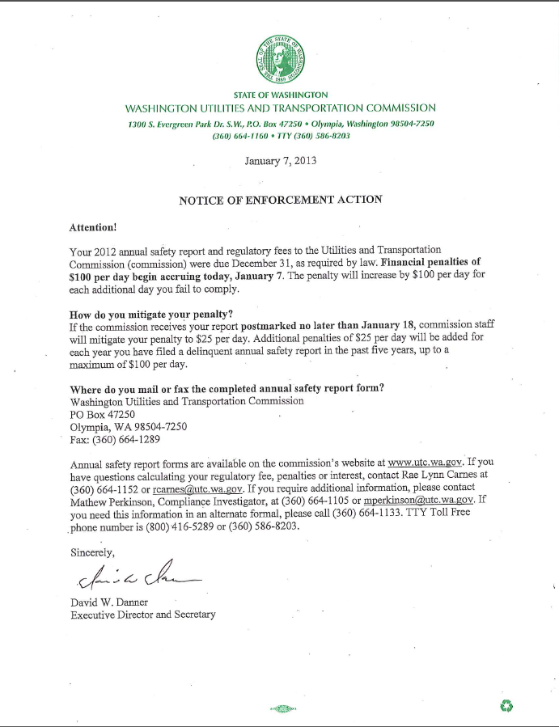

**Attachment E**

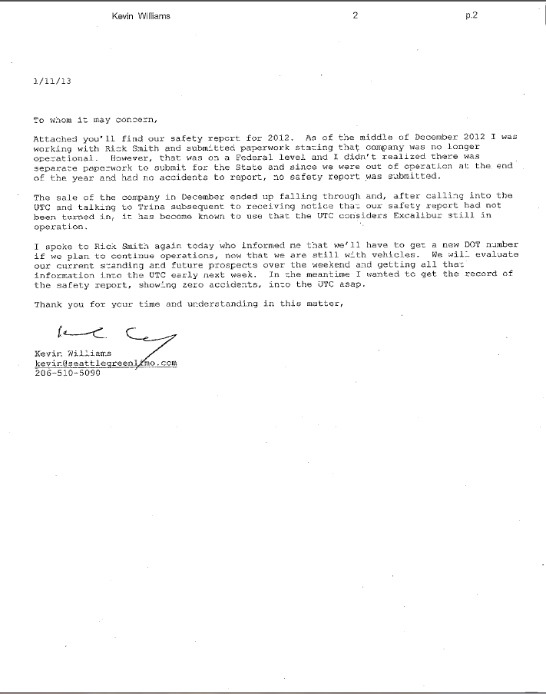

1. See Attachment A for a copy of the penalty assessment sent to Excalibur Limousine, LLC.
2. See Attachment B for a copy of the letter submitted by Excalibur on March 11, 2013.
3. See Attachment C for a copy of the letter sent to all regulated companies on November 15, 2012.
4. See Attachment D for a copy of the Enforcement letter sent to all delinquent companies on January 7, 2013.
5. See Attachment E for a copy of the letter submitted by Excalibur on January 11, 2013.