September 1, 2015

**Via Electronic filing**

Steven King, Executive Director and Secretary

Washington Utilities and Transportation Commission

Attn: Records Center

PO Box 47250

Olympia WA 98504-7250

**RE: Docket No. UT-151715, Ellensburg Telephone Company 477 Data**

Dear Mr. King:

Attached please find 477 information filed with the FCC for Ellensburg Telephone Company. This information is filed confidentialy pursuant to WAC 480-123-130(1)(e). This information contains valuable commercial information, including cost, or financial information, or customer-specific usage and network configuration and design information and as such is also filed confidentially with the FCC.

Please feel free to contact me with any additional questions.

Sincerely,

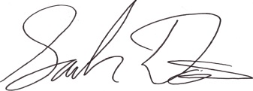

Sarah A. Davis

Senior Director Government Relations

FairPoint Communications

[sdavis@fairpoint.com](mailto:sdavis@fairpoint.com)

(207) 272-7541