**Washington Residential Consumption Survey**

**Key Findings – Residential End Uses**

**Home Heating Energy Source**

* A little more than half of residential customers use electricity as their main heating source.

**Main Water Heating Source**

* Three quarters of residential customers use electricity as their main heating source for water.

**Home Cooling Sources**

* The majority of residential customers have air conditioning in their home, with two-thirds of customers have either electric central air or a heat pump.

.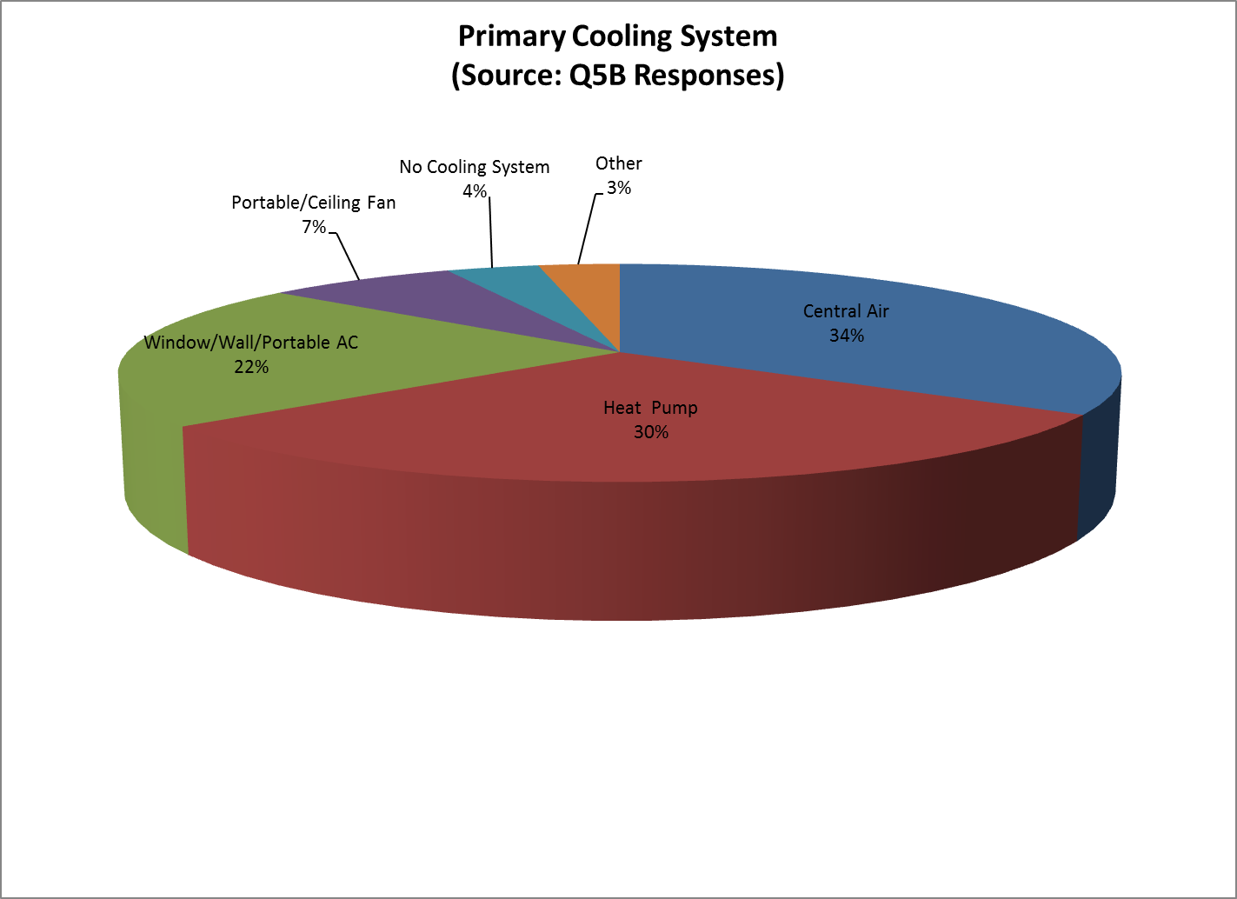

**Appliances Owned**

* One-third of residential customers have more than one refrigerator and one-half have a stand-alone freezer. The majority of customers have electric stoves and electric dryers.