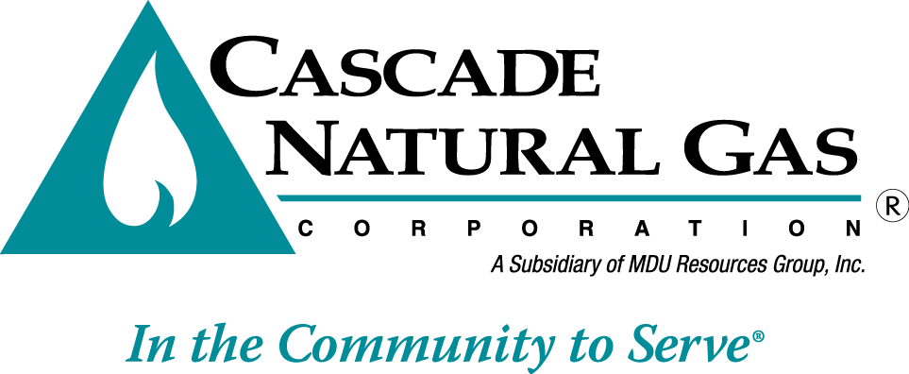 | 8113 W. GRANDRIDGE BLVD., KENNEWICK, WASHINGTON 99336-7166  TELEPHONE 509-734-4500 FACSIMILE 509-737-7166  www.cngc.com

VIA ELECTRONIC MAIL
records@utc.wa.gov

May 15, 2015

Records Center
Washington Utilities and Transportation Commission
1300 S. Evergreen Park Drive SW
Olympia, WA 98504

Re: A-150561 – Cascade Natural Gas’s Comments

Below are Cascade Natural Gas Corporation’s comments issued in response to the Washington Utilities and Transportation Commission’s (WUTC’s) Notice of Opportunity to Submit Written Comments, issued in Docket No. A-150561.

- Please describe your current practice for processing non-cash/non-check payment methods. If you currently accept debit and credit card payments, what are the transaction fees incurred by customers using these methods? Are there any costs incurred by the company?

Response
The table below provides an overview of the payment channels that the Company accepts and the associated transaction fees separated by whether they are charged to the customer or absorbed by the Company. Other costs indirectly incurred by the Company are discussed in response to question No. 2.

PAY CHANNEL | Description | ACCEPTED | CUSTOMER CHARGED  TRANSACTION FEE | COMPANY INCURRED  TRANSACTION  FEES
Online Account Services | CNG processes electronic payments from customers’ U.S. checking accounts that are submitted on the Company’s website. | Yes | - | $1.00
Mail | Customers may pay by mailing checks or money order to the Company. | Yes | - | $0.086
Debit or Credit Card | CNG uses a third party vendor to transact the payments made to credit or debit cards. | Yes | $3.50 | -
Pay Station (cash, check, or money order) | A customer may walk-in to a designated location and pay a bill with cash, a check, or a money order | Yes | - | $1.00
Automated Clearing House (ACH) Financial Transaction | CNG uses a third party vendor to transact the ACH payment made by phone or online, through auto pay or on the company website. | Yes | - $3.50 for phone or online  - No fee for auto pay  - No fee for Company website | - $0.09 per one day transaction n website  - $0.07 per two day transaction through auto pay
Electronic Payment | Third parties such as Checkfree and Metavante allow customers to pay multiple bills from their website or through their customers’ banks’ websites. These payments are remitted electronically. | Yes | No Fee | Fee varies depending on the funding source used by the customer.
Drop Box | Physical boxes for dropping off cash, checks, or money orders. | No | N/A | N/A

2. What transaction costs are involved with the forms of customer payment listed below? Many of these costs may be costs that have been embedded; when reporting these embedded costs, please indicate how you arrived at your calculations.

Response
Transaction fees are specific to payment channels like pay stations or online banking and not by the payment type. The transaction fees for payment channels are provided in response to question number 1, and in each instance, these transactional fees are determined by the Company’s vendor or, for cash and checks, Intermountain Gas Company.

Each payment channel or payment incurs indirect or embedded costs associated with the Company’s handling and recording of payments received. The Company does not track its time associated with handling individual payment types in order to provide an associated embedded cost for each.

3. Please provide an indication of the number of payments, and dollar volumes, made using each method.

Response
The first table below lists the number of payments received by payment channel in 2014. The second table provides the percentage of bills received and the percentage of dollars per payment channel.

PAYMENT CHANNEL | TOTAL  PAYMENTS
AutoPay | 475,371
BillMatrix | 102,633
Third Party Banks | 638,552
Collection Agency | 3,234
Pay Stations | 117,099
Web | 334,958
LiHeap | 3,414
Field Collections | 2,606
Mail | 1,144,065
ACH/Wire | 44,103
TOTAL | 2,866,035

2014 BILLINGS
 | Percent that Payment Channel was used | Percentage of Dollars Received by Payment Channel
Mail | 39.9% | 63.3%
Electronic | 59.8% | 36.4%
Field Collections | 0.1% | 0.2%
Energy Assistance | 0.1% | <0.1%
Collection Agency | 0.1% | <0.1%
 | 100.0% | 100.0%

4. Please provide an indication of the average cost to process a transaction for each of the above forms of transaction. Please also calculate the average bill for each type of payment method.

Response
Direct and indirect costs to process different transaction types are provided in responses to question numbers 1 and 2 above.

The Company does not track the average bill per payment channel, but in general, the average residential customer uses 56 therms for an average monthly bill of $57.75 and the average commercial customer uses 271 therms for an average monthly bill of $260.96.

5. Are measures taken to ensure that processing costs for a particular method of payment are borne exclusively by those specific customers that use those specific methods of payments?

Response
No, the Company is more concerned with cost recovery than ensuring the principle of cost causation. If costs for processing a transaction are incurred by Company employees whose time is recovered in rates, then the costs associated with the transaction are recovered but are not directly passed through to the customer incurring the costs. Most third party transaction fees are currently being directly passed to the customer. A change in practice would need to occur during a rate case,; otherwise the Company is likely to continue passing most third party costs-- for which it does not have embedded cost recovery-- on to the customer incurring the cost.

6. What advantages do you see to making credit and debit card billing options available to customers? What has precluded your company from doing so if it hasn’t already?

Response
The Company currently accepts credit card and debit payments from customers. Associated transactions incur a fee of $3.50 that is charged to the customer. The Company passes the transaction fee through as it does not have Commission approval to socialize the costs amount all customers. Offering this service at no direct cost to customers would likely result in improved customer satisfaction and it may have a small impact on reducing arrearages.

Spreading the costs for credit card transactions to all customers to whom the service is applicable would be beneficial in the same way it is useful to spread the costs of the call center even though many customers will never call with questions. It is in all customers’ best interest if bills are being paid which can be encouraged by reducing the cost or inconvenience associated with a payment channel. Transaction fees and merchant fees associated with taking credit and debit card payments are more cost intensive than other forms of payment. By making the credit or debit option free of charge, customer adoption would likely increase drastically, further increasing the costs borne by this method. Credit card is the preferred payment method by many consumers looking to accumulate points or air miles with the credit card issuer. Removing the convenience fee would result in many customers changing their payment method even if they had no issues with their current payment process.

In addition to an increase in transactional costs for the Company, processing credit card payments would require additional administration for handling complaints and chargebacks as well as additional IT security for addressing requirements to be Payment Card Industry (PCI) compliant.

7. What advantages and disadvantages are there in having card payments processed by a third-party, such as BillMatrix? Is there a better option for processing credit and debit card payments, such as contracting through a bank? What are the costs of these alternative processing methods, and how would they impact the use of credit cards?

Response
By using a third-party vendor to transact credit and debit card payments, the responsibility for safeguarding consumer credit related information is handled by the vendor. Since transacting these payments is their primary business, they are better equipped to oversee the security requirements.

It is possible to set up a merchant account through a bank and transact credit and debit cards as a first party. While most card issuers offer a merchant rate specifically for utilities that is usually under $1.00, the other costs associated with PCI compliance and administration costs associated with directly handling chargebacks and other disputes, increases the overall cost of in-house processing. Coupled with the anticipated increase in adoption of this payment method if it were to be offered free of charge, the overall O&M expense associated with credit and debit card payments could be immense.

8. Should companies charge convenience fees for debit and credit card customers? If not, what is the rationale for recovering the costs associated with debit and credit card payments from rates charged to all customers, including those who do not, and may not ever, use the service?

Response
Please see the Company’s response to question numbers 5 and 6.

Costs and benefits for adopting customers
Some customers may prefer automatic payments using a credit or debit card, as opposed to automatic payments with checks. For instance, some customers are hesitant to provide such access directly to a checking account, without the protection provisions associated with credit cards.

1. What advantages and disadvantages would automatic payments through credit and debit cards provide to your customers?

Response
Fee free payments with credit or debit cards would encourage customers to pay bills in a timely manner, avoiding disconnection or late payment fees. Fee free credit card payments would be a desirable payment channel for customers with limited discretionary cash but adequate credit.

A disadvantage with credit card payments with or without the transaction fee might be that a customer could acquire more debt than he or she would if an inability to pay using other means would have forced a disconnection.

Consumer protection issues
1. Several utilities currently allow customers to sign up for automatic billing through their checking accounts. How are these customers treated and indemnified when there are billing mistakes? For example, does the company provide account credits or refunds to the customers’ checking accounts?

Response
The Company handles all billing errors in the same manner regardless of a customer’s payment channel. If the Company over- or under-bills, it will apply a credit or debit to the customer’s next monthly bill for service.

If the bank acting on behalf of the customer makes an error, the Company will treat the under-or over-payment in the same manner as it would with any other under- or over-payment. The next monthly bill would reflect the amount received. The customer would need to resolve the bank’s error with the bank.

2. What options are available to so-called “unbanked” customers? Many of these customers receive government benefits, or their salary from their employers, in the form of MasterCard or Visa pre-paid debit cards.

Response
Unbanked customers paying with pre-paid debit cards using the third party credit and debit card vendor are subject to the same convenience fee (currently $3.50) as other transactions through this service.

Other payment channels for unbanked customers include using a PIN-based debit card for walk-in payments. This payment option is available at select pay stations at no direct charge to the customer. Additionally, money orders can be purchased with debit cards. The money order can then be mailed to the Company or submitted at a walk-in location.

3. Are pre-paid debit cards, such as those offered by MasterCard or Visa, treated any differently than traditional credit or debit cards?

Response
The Company does not differentiate between prepaid MasterCards or debit cards but handles them as it does traditional credit or debit cards. Transactions are processed through BillMatrix and they incur a charge of $3.50.

4. If the company undertakes its own credit card processing functions rather than using a third party, what protections would be put in place to ensure customer information is kept safe?

Response
The Company would prefer not to process credit card transactions since that activity would make the utility subject to PCI requirements, which have been established to ensure customer data is handled and saved safely. This is a serious responsibility and outside the Company’s expertise.

Thank you for the opportunity to provide comments. If you have any questions, please contact me at (509)734-4593.

Sincerely,

Mike Parvinen
Director, Regulatory Affairs

