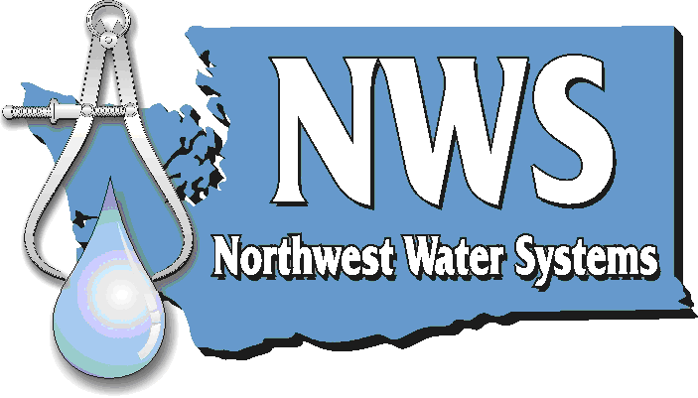 | Planning ● Management ● Engineering  P.O. Box 123 ● Port Orchard, WA 98366 ● 1-888-881-0958

December 20th, 2010

Mr. David Danner, Executive Director and Secretary
Washington Utilities and Transportation Commission
P.O. Box 47250
Olympia, WA 98504-7250

Subject: Country Meadows East #2 Tariff Filing

Dear Mr. Danner:

Staff has requested that use the same name as the original filing on December 20th of 2010. This is because we need to file separately to change the name after this is complete. We are therefore submitting the following pages as replacements for the previous filing. Staff informed us that abbreviating the name would need to be consistent across all documents. We have therefore changed all titles to “Country Meadows E. #2”. Thank you for your time and continued attention to this issue, please address additional request for information to me, Jester Purtteman, at the number above, or at jester@nwwatersystems.com, thank you.

Sincerely

Jester Purtteman, E.I.T.
Northwest Water Systems

Attached:
Revised Tariff

