

**WASHINGTON**

**SERVICE QUALITY **

**REVIEW**

**January 1 – December 31, 2009**

**Annual Report**

# 

# TABLE OF CONTENTS

EXECUTIVE SUMMARY 3

1 Service Standards Program Summary 3

1.1 PacifiCorp Customer Guarantees 4

1.2 PacifiCorp Performance Standards 5

1.3 Reliability Definitions and Service Territory 6

2 CUSTOMER GUARANTEES SUMMARY 9

3 RELIABILITY PERFORMANCE 10

3.1 System Average Interruption Duration Index (SAIDI) 10

3.2 System Average Interruption Frequency Index (SAIFI) 12

3.3 Operating Area Metrics 13

3.4 Cause Code Analysis 14

3.5 Areas of Greatest Concern 17

3.6 Reduce CPI for Worst Performing Circuits by 20% 18

3.7 Restore Service to 80% of Customers within 3 Hours 19

3.8 Telephone Service and Response to Commission Complaints 19

4 CUSTOMER RELIABILITY COMMUNICATIONS 20

4.1 Reliability Complaint Process Overview 20

4.2 Customer Complaint Tracking 21

4.3 Customer Complaints Recorded During the Period 21

5 WASHINGTON RELIABILITY RESULTS DURING 2009 22

5.1 State Reliability 23

5.2 5W106 25

5.3 5Y174 27

5.4 5Y156 29

5.5 5Y141 31

5.6 5Y434 33

5.7 5Y380 35

# EXECUTIVE SUMMARY

During January 1 through December 31, 2009, PacifiCorp delivered reliable service to its Washington customers, in spite of the fact that the level of performance did not meet internal targets, nor levels previously delivered by the Company. The Customer Guarantee program continued to deliver high quality results (in fact, well above 99%) consistent with the prior year’s performance. While PacifiCorp’s reliability results delivered to its Washington customers during 2009 were off the company’s operating plan targets for the year, the service delivered across PacifiCorp’s six state service territory ranks very high when compared across the industry.

The company’s service reliability is impacted by uncontrollable interference events[1], such as car-hit-pole accidents, and by significant events that exceed the normal underlying level of interruptions but that do not reach the qualifying major event threshold for exclusion from the company’s performance metrics. To provide a perspective on their impact this year, the significant events experienced during 2009 are listed in Section 2.1 and 2.2. Consideration of the root causes of these significant days is important when evaluating year-on-year performance. When the Company develops reliability improvement projects it evaluates these root causes and prepares plans that reflect the certainty of repetition of certainty of these events. The outcomes are reflective of the plans outlined in the Areas of Great Concern, shown in Section 3.5.

# Service Standards Program Summary

PacifiCorp has a Service Standards Program comprised of a number of Customer Guarantees[2] and Performance Standards. Regular status reports regarding the program’s performance are provided both internally and externally. These reports detail measures of performance that are reflective of PacifiCorp's reliability in service delivery (of both personnel and the network) to its customers. The company developed these measures after evaluating company and industry standards and practices for delivering, collecting, and reporting performance data. In certain cases, the company chose to adopt a level of performance higher than the industry norm. In other cases, PacifiCorp developed metrics and targets based upon its history of delivery of these measures. The measures are useful in evaluating historical performance and in setting future targets for performance. In its entirety, these measures comply with WAC 480-100-393 and 398 requirements for routine reliability reporting.

In UE-042131, the company applied for, and received approval, to extend the core program through March 31, 2008. During the MidAmerican acquisition of PacifiCorp, in UE-051090, the program[3] was extended again through 2011.

## PacifiCorp Customer Guarantees

|  |  |
| --- | --- |
| Customer Guarantee 1:  Restoring Supply After an Outage | The company will restore supply after an outage within 24 hours of notification from the customer with certain exceptions as described in Rule 25. |
| Customer Guarantee 2:  Appointments | The company will keep mutually agreed upon appointments which will be scheduled within a two-hour time window. |
| Customer Guarantee 3:  Switching on Power | The company will switch on power within 24 hours of the customer or applicant’s request, provided no construction is required, all government inspections are met and communicated to the company and required payments are made. Disconnections for nonpayment, subterfuge or theft/diversion of service are excluded. |
| Customer Guarantee 4:  Estimates For New Supply | The company will provide an estimate for new supply to the applicant or customer within 15 working days after the initial meeting and all necessary information is provided to the company. |
| Customer Guarantee 5:  Respond To Billing Inquiries | The company will respond to most billing inquiries at the time of the initial contact. For those that require further investigation, the company will investigate and respond to the Customer within 10 working days. |
| Customer Guarantee 6:  Resolving Meter Problems | The company will investigate and respond to reported problems with a meter or conduct a meter test and report results to the customer within 10 working days. |
| Customer Guarantee 7:  Notification of Planned Interruptions | The company will provide the customer with at least two days notice prior to turning off power for planned interruptions. |

*Note: See Rules for a complete description of terms and conditions for the Customer Guarantee Program.*

## PacifiCorp Performance Standards[4]

|  |  |
| --- | --- |
| Network Performance Standard 1:  Improve System Average Interruption Duration Index (SAIDI) | The company will maintain SAIDI commitment target during the 3 year-9 month period through December 31, 2011. |
| Network Performance Standard 2:  Improve System Average Interruption Frequency Index (SAIFI) | The company will maintain SAIFI commitment target during the 3 year-9 month period through December 31, 2011. |
| Network Performance Standard 3:  Improve Under Performing Circuits | The company will reduce by 20% the circuit performance indicator (CPI) for a maximum of five under-performing circuits on an annual basis within five years after selection. |
| Network Performance Standard 4:  Supply Restoration | The company will restore power outages due to loss of supply or damage to the distribution system within three hours to 80% of customers on average. |
| Customer Service Performance Standard 5: Telephone Service Level | The company will answer 80% of telephone calls within 30 seconds. The company will monitor customer satisfaction with the company’s Customer Service Associates and quality of response received by customers through the company’s eQuality monitoring system. |
| Customer Service Performance Standard 6:  Commission Complaint Response/Resolution | The company will: a) respond to at least 95% of non-disconnect Commission complaints within three working days, b) respond to at least 95% of disconnect Commission complaints within four working hours, and c) resolve 95% of informal Commission complaints within 30 days. |

*Note: Performance Standards 1, 2 & 4 are for underlying performance days, excluding days classified as Major Events.*

## Reliability Definitions and Service Territory

This section will define the various terms[5] used when referring to interruption types, performance metrics and the internal measures developed to meet performance plans. A map of PacifiCorp’s service territory is included.

**Interruption Types**

***Sustained Outage***

A sustained outage is defined as an outage of equal to or greater than 5 minutes in duration.

***Momentary Outage***

A momentary outage is defined as an outage of less than 5 minutes in duration. PacifiCorp has historically captured this data using substation breaker fault counts.

**Reliability Indices**

***SAIDI***

SAIDI (system average interruption duration index) is an industry-defined term to define the average duration summed for all sustained outages a customer experiences in a given period. It is calculated by summing all customer minutes lost for sustained outages (those exceeding 5 minutes) and dividing by all customers served within the study area. When not explicitly stated otherwise, this value can be assumed to be for a one-year period.

***Daily SAIDI***

In order to evaluate trends during a year and to establish Major Event Thresholds, a daily SAIDI value is often used as a measure. This concept was introduced in IEEE Standard P1366-2003. This is the day’s total customer minutes out of service divided by the static customer count for the year. It is the total average outage duration customers experienced for that given day. When these daily values are accumulated through the year, it yields the year’s SAIDI results.

***SAIFI***

SAIFI (system average interruption frequency index) is an industry-defined term that attempts to identify the frequency of all sustained outages that the average customer experiences during a given period. It is calculated by summing all customer interruptions for sustained outages (those exceeding 5 minutes in duration) and dividing by all customers served within the study area.

***CAIDI***

CAIDI (customer average interruption duration index) is an industry-defined term that is the result of dividing the duration of the average customer’s sustained outages by the frequency of outages for that average customer. While the Company did not originally specify this metric under the umbrella of the Performance Standards Program within the context of the Service Standards Commitments, it has since been determined to be valuable for reporting purposes. It is derived by dividing PS1 (SAIDI) by PS2 (SAIFI).

***CEMI***

CEMI is an acronym for Customers Experiencing Multiple (Sustained and Momentary) Interruptions. This index depicts repetition of outages across the period being reported and can be an indicator of recent portions of the system that have experienced reliability challenges. This metric is used to evaluate customer-specific reliability in Section 4 Customer Reliability Communications.

***CPI99***

CPI99 is an acronym for Circuit Performance Indicator 1999, which uses key reliability metrics (such as SAIDI and SAIFI) to identify underperforming circuits. It excludes Major Event and Loss of Supply or Transmission outages.

***CPI05***

CPI05 is an acronym for Circuit Performance Indicator 2005, which uses key reliability metrics (such as SAIDI and SAIFI) to identify underperforming circuits. Unlike CPI99, it includes Major Event and Loss of Supply or Transmission outages.

**Performance Types & Commitments**

PacifiCorp recognizes two categories of performance: underlying performance and major events. Major events represent the atypical, with extraordinary numbers and durations for outages beyond the usual. Ordinary outages are incorporated within underlying performance. These types of events are further defined below.

***Major Events***

A Major Event is defined as a 24-hour period where SAIDI exceeds a statistically derived threshold value, as detailed in IEEE Distribution Reliability Standard 1366-2003[6].

***Underlying Events***

Within the industry, there has been a great need to develop methodologies to evaluate year-on-year performance. This has led to the development of methods for segregating outlier days. Those days which fall below the statistically derived threshold represent “underlying” performance, and are valid (with some minor considerations for changes in reporting practices) for establishing and evaluating meaningful performance trends over time.

***Performance Targets***

The Company and Commission, in the MidAmerican transaction docket, UE05-01590, agreed to extend Service Standards through 12/31/2011. Within Washington, because performance delivered by the Company falls within industry second quartile performance levels, the Company committed that it will achieve performance by 12/31/2011 that maintains performance targets set in prior Merger Commitment Periods.

**Service Territory Map**

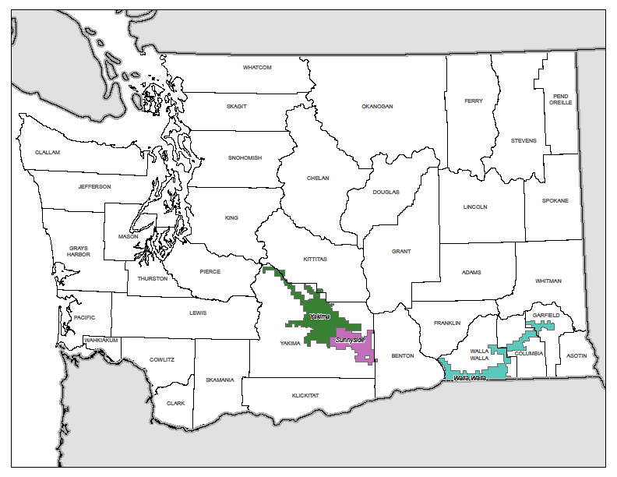

# CUSTOMER GUARANTEES SUMMARY



Overall guarantee performance remains well above 99%, demonstrating PacifiCorp’s continued commitment to customer satisfaction.

Customer Communications: The Customer Guarantee program was highlighted throughout the year in customer communications as follows:

A campaign of radio advertisements are on routine rotation in our major markets.

Performance reports are included in all billing statements.

Performance reports are highlighted in Voices, the company's newsletter.

PacifiCorp’s website outlines the details of the program.

Each new customer is sent a welcome aboard packet that features the program and describes how to file a claim.

(Major Events are excluded from the Customer Guarantees program.)

# RELIABILITY PERFORMANCE

During the reporting period, the company delivered mixed reliability results; while outage duration (SAIDI) was notably higher than internal targets, outage frequency (SAIFI) was only nominally off internal targets. CAIDI in Sunnyside and Walla Walla were very favorable at 79 and 94 respectively, while Yakima’s CAIDI of 209 put Washington overall CAIDI at 155 for the period.

## System Average Interruption Duration Index (SAIDI)

Severe winter weather events in the first eight days of January (significant event days[7] that did not reach the major event threshold for exclusion from performance results) immediately drove the company’s Washington SAIDI so markedly off plan it was unable to recover from the overage in subsequent months; in aggregate these days account for more than 35 SAIDI minutes, and absent them, performance would have been essentially on target. Moreover, eight more additional significant event days during the year only drove it further off target. During the period, there were thirteen dates with a daily underlying SAIDI of 3 minutes or more. These thirteen days account for 84 SAIDI minutes, representing 52% of the total underlying SAIDI (and 76% of the SAIDI target for the year). Only two of these events are considered company controllable (March 3 and December 8 that were equipment-caused events) and they account for only 15% of the total Significant Event Days SAIDI; 85% of the significant event minutes were due to uncontrollable causes. Nonetheless, the Company’s reliability improvement plan will attempt to make facilities more resistant to weather events.



In contrast to numerous Significant Event Days, the company experienced only one major event during the year (October 3-4 due to storms), which was filed for exclusion from network performance metrics. As shown in the table above, at least two of the significant events were very near the major event threshold of 12.16 SAIDI minutes.

|  |  |  |
| --- | --- | --- |
|  | January 1 through December 31, 2009 | |
| SAIDI Actual | SAIDI Goal |
| Washington | 161 | 111 |



## System Average Interruption Frequency Index (SAIFI)

Despite tracking very close to plan throughout the year, a late September emergency transmission outage taken because of the newsworthy Boise Mill fire, followed by December weather and equipment interruptions took performance above target, from which the Company was unable to recover. These caused the company to deliver SAIFI results just off its internal target for the reporting period.

|  |  |  |
| --- | --- | --- |
|  | January 1 through December 31, 2009 | |
| SAIFI Actual | SAIFI Target |
| Washington | 1.04 | 1.00 |



## Operating Area Metrics

Washington operating area performance for the reporting period is listed in the table below. As shown, Sunnyside and Walla Walla experienced good reliability while Yakima experienced much more challenges during the period. Customer Minutes Lost on Significant Event Days in Yakima account for 57% of Yakima’s total operating area SAIDI for the year.

|  |  |  |  |  |  |  |
| --- | --- | --- | --- | --- | --- | --- |
| Jan – Dec 2009 | Including Major Events | | | Excluding Major Events | | |
| Operating Area | SAIDI | SAIFI | CAIDI | SAIDI | SAIFI | CAIDI |
| SUNNYSIDE | 129 | 1.47 | 88 | 108 | 1.37 | 79 |
| WALLA WALLA | 105 | 1.12 | 94 | 105 | 1.12 | 94 |
| YAKIMA | 233 | 1.10 | 213 | 206 | 0.99 | 209 |

## Cause Code Analysis

The table and charts below break out the number of incidents, customer hours lost, and sustained interruptions by cause code. Customer Minutes Lost is directly related to SAIDI (average outage duration); Sustained Interruptions is directly related to SAIFI (average outage frequency). Certain types of outages typically result in high duration, but are infrequent, such as Loss of Supply outages. Others tend to be more frequent, but are generally shorter duration. The pie charts depict the breakdown of performance results by percentage of each cause category. Following the pie charts, a cause category table lists the direct causes with definitions and examples.





|  |  |
| --- | --- |
| **Cause Category** | **Description and Examples** |
| **Environment** | Contamination or Airborne Deposit (i.e., salt, trona ash, other chemical dust, sawdust, etc.); corrosive environment; flooding due to rivers, broken water main, etc.; fire/smoke related to forest, brush or building fires (not including fires due to faults or lightning). |
|  |  |
| **Weather** | Wind (excluding windborne material); snow, sleet or blizzard; ice; freezing fog; frost; lightning. |
|  |  |
| **Equipment Failure** | Structural deterioration due to age (incl. pole rot); electrical load above limits; failure for no apparent reason; conditions resulting in a pole/cross arm fire due to reduced insulation qualities; equipment affected by fault on nearby equipment (i.e. broken conductor hits another line). |
|  |  |
| **Interference** | Willful damage, interference or theft; such as gun shots, rock throwing, etc; customer, contractor or other utility dig-in; contact by outside utility, contractor or other third-party individual; vehicle accident, including car, truck, tractor, aircraft, manned balloon; other interfering object such as straw, shoes, string, balloon. |
|  |  |
| **Animals and Birds** | Any problem nest that requires removal, relocation, trimming, etc; any birds, squirrels or other animals, whether or not remains found. |
|  |  |
| **Operational** | Accidental Contact by PacifiCorp or PacifiCorp’s Contractors (including live-line work); switching error; testing or commissioning error; relay setting error, including wrong fuse size, equipment by-passed; incorrect circuit records or identification; faulty installation or construction; operational or safety restriction. |
|  |  |
| **Loss of Supply** | Failure of supply from Generator or Transmission system; failure of distribution substation equipment. |
|  |  |
| **Planned** | Transmission requested, affects distribution sub and distribution circuits; company outage taken to make repairs after storm damage, car hit pole, etc.; construction work, regardless if notice is given; rolling blackouts. |
|  |  |
| **Trees** | Growing or falling trees. |
|  |  |
| **Other** | Cause Unknown. |

## Areas of Greatest Concern

During 2009, reliability continues to focus on improved system hardening and protection, including replacement of hydraulic reclosers, upgrades of substation breakers and/or relays and coordination of circuit protection devices, such as fuses and reclosers. The company has found substantial improvements in performance by focusing on circuits that do not appear to be well coordinated. Additionally, it has continued its circuit hardening efforts by strategic deployment of circuit inspection, pole and/or crossarm replacement and vegetation hot spotting. Along with circuit hardening and protection efforts, it has reviewed opportunities for localized activities such as feeder ties and cable replacement activities. Further, the company has piloted additional circuit hardening technologies that are radio frequency-based. This technology complements circuit hardening inspections performed via the company’s Saving SAIDI program. While conclusive evidence has not been obtained, it appears use of key tools may improve the quality of delivered circuit hardening activities.

The table below lists reliability projects currently underway for Washington’s Areas of Greatest Concern.

|  |  |  |  |
| --- | --- | --- | --- |
| **Circuit** | **Actions** | **Status** | **Target Date** |
| 5Y174  Mabton Express | Coordinate circuit protection  Determine if it is feasible to collect and investigate data for 2 line reclosers on a periodic basis | Coordination plan prepared; coordination in progress | 12/31/2010 |
| 5W106  Ferndale | Coordinate circuit protection  Determine if it is feasible to collect and investigate data for 4 line reclosers on a periodic basis | Coordination plan prepared; coordination in progress | 12/31/2010 |
| 5Y141  Washington | Coordinate circuit protection | Coordination plan prepared; coordination in progress | 12/31/2010 |
| 5Y434  Dazet | Coordinate circuit protection | Coordination plan prepared; coordination in progress | 12/31/2010 |
| 5Y156  Draper | To be determined | Evaluation in progress | 12/31/2011 |
| 5Y380  Tampico | Correct bad cross arm and pole conditions  Determine if it is feasible to collect and investigate data for 7 line reclosers on a periodic basis | Conditions have been identified | 12/31/2010 |

## Reduce CPI for Worst Performing Circuits by 20%

On a routine basis, the company reviews circuits for performance. One of the measures that it uses is called circuit performance indicator (CPI), which is a blended weighting of key reliability metrics covering a three-year time frame. The higher the number, the poorer the blended performance the circuit is delivering. As part of the company’s Performance Standards Program, it annually selects a set of Worst Performing Circuits for target improvement. The improvements are to be completed within two years of selection. Within five years of selection, the average performance must improve by at least 20% (as measured by comparing current performance against baseline performance). Program Years 1-5 met their targets (as filed and approved) and no longer appear in the table below.

|  |  |  |
| --- | --- | --- |
| **WASHINGTON WORST PERFORMING CIRCUITS** | **BASELINE** | **Performance 12/31/2009** |
| PROGRAM YEAR 10: | | |
| Boyer | 38 |  |
| Mount View | 89 |  |
| Occidental | 44 |  |
| Memorial | 61 |  |
| 13th Street | 55 |  |
| TARGET SCORE = 46 | 57 |  |
| PROGRAM YEAR 9: | | |
| Garden 5W154 | 109 | 215 |
| Hay 5Y131 | 166 | 129 |
| Rivard 5Y148 | 81 | 94 |
| Franklin 5Y448 | 82 | 81 |
| Boulevard 5Y610 | 41 | 40 |
| TARGET SCORE = 77 | 96 | 112 |
| PROGRAM YEAR 8: | | |
| Zillah 5Y245 | 114 | 82 |
| Gurley 5Y358 | 87 | 72 |
| Stone Creek 5W19 | 135 | 215 |
| Nile 4Y1 | 760 | 894 |
| Highland 5Y93 | 247 | 143 |
| TARGET SCORE = 215 | 269 | 281 |
| PROGRAM YEAR 7: | | |
| West 5Y149 | 210 | 123 |
| Granger 5Y357 | 116 | 298 |
| Russell Creek 5W121 | 149 | 72 |
| Tampico 5Y380 | 140 | 322 |
| Gore 5Y100 | 56 | 104 |
| TARGET SCORE = 107 | 134 | 184 |
| PROGRAM YEAR 6: | | |
| Nile 4Y1 | 383 | 894 |
| Forney 5Y94 | 246 | 185 |
| Harrah 5Y202 | 220 | 119 |
| Windward 4W22 | 233 | 26 |
| Ferndale 5W106 | 227 | 641 |
| TARGET SCORE = 210 | 262 | 373 |

## Restore Service to 80% of Customers within 3 Hours

|  |  |  |  |  |  |
| --- | --- | --- | --- | --- | --- |
| WASHINGTON RESTORATIONS WITHIN 3 HOURS | | | | | |
| 3-Year Program to Date | | | | 84% | |
| January 1 through December 31, 2009 | | | | 82% | |
| January | February | March | April | May | June |
| 71% | 91% | 63% | 85% | 48% | 86% |
| July | August | September | October | November | December |
| 90% | 88% | 88% | 84% | 80% | 92% |

## Telephone Service and Response to Commission Complaints

|  |  |  |
| --- | --- | --- |
| **COMMITMENT** | **GOAL** | **PERFORMANCE** |
| PS5-Answer calls within 30 seconds | 80% | 82% |
| PS6a) Respond to commission complaints within 3 days | 95% | 100% |
| PS6b) Respond to commission complaints regarding service disconnects within 4 hours | 95% | 100% |
| PS6c) Resolve commission complaints within 30 days | 95% | 100% |

# CUSTOMER RELIABILITY COMMUNICATIONS

## Reliability Complaint Process Overview

The company’s process for managing customers’ concerns about reliability are to provide opportunities to hear customer concerns, respond to those concerns, and where necessary, provide customers an opportunity to elevate those concerns.



## Customer Complaint Tracking

Listed below are the various avenues available to a customer to resolve concerns about reliability performance.

* **Customer Reliability Inquiry**

The company records customer inquiries about reliability as Outage Power Quality transactions in its customer service system, referred to as “OPQ” transactions.

* **Customer Complaint**

If a customer’s reliability concerns are not met through the process associated with the OPQ transaction, a customer can register a 1-800 complaint with the company. This is recorded in a complaint repository from which regular reports are prepared and circulated for resolution.

* **Commission Complaint**

If a customer’s reliability concerns are not met through the process associated with a 1-800 complaint, a customer can register a complaint with the Commission. This is recorded by the Commission staff and also by the company in a complaint repository. Regular reports are prepared and circulated for resolution of these items.

## Customer Complaints Recorded During the Period

Below are reliability-related customer complaints received for Washington services during the reporting period, listed by the recording point.

* **Informal Complaints (1-800 or Customer Assistance Line - CAL)**

There were two Informal Complaints in the reporting period.



* **Commission Complaints**

There were two Commission Complaints in the reporting period.



# WASHINGTON RELIABILITY RESULTS DURING 2009

To geospatially display reliability results, the Company has developed its GREAT tool which blends circuit topology with outage history and uses a variety of industry metrics (differentiated by color) to indicate areas where reliability analysis should be targeted. In the subsequent plots, two important reliability indicators are depicted. First, plots with customers experiencing multiple interruptions (CEMI) are shown. This measure shows how many sustained and momentary outages a given service transformer has experienced. The greater the color intensity, with red as the most severe, the more interruptions the transformer has had. Second sustained interruptions are shown. This measure shows how many sustained outages a service transformer has experienced. Third, service transformer-level SAIDI is shown. While technically SAIDI is a “system-level” metric, the local application of this metric can be revealing in determining service transformers that have had long cumulative durations of outages during the period. As explained previously, the greater the color intensity, the longer the outage duration during the period. (Major events, customer requested and prearranged outages are excluded from underlying results.)

Finally, these graphics superimpose customer reliability inquiries and complaints. When this data is graphically overlaid with transformer performance data, trends can be surfaced that warrant prompt action.

## State Reliability

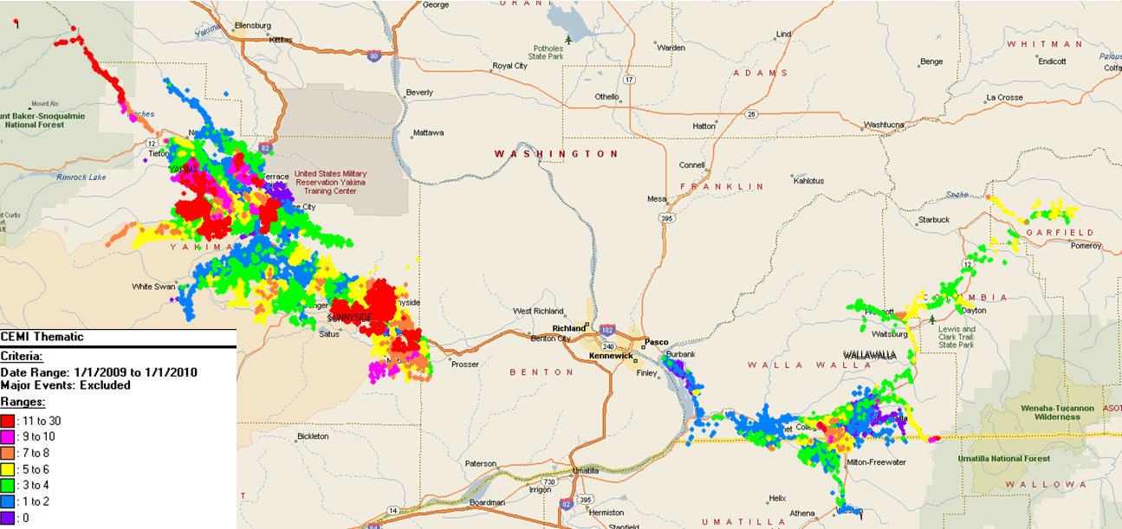

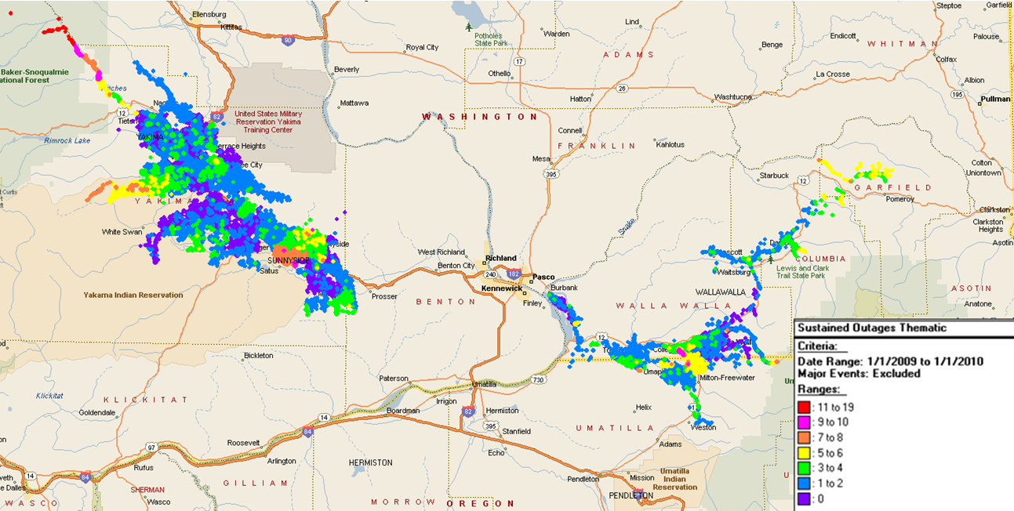

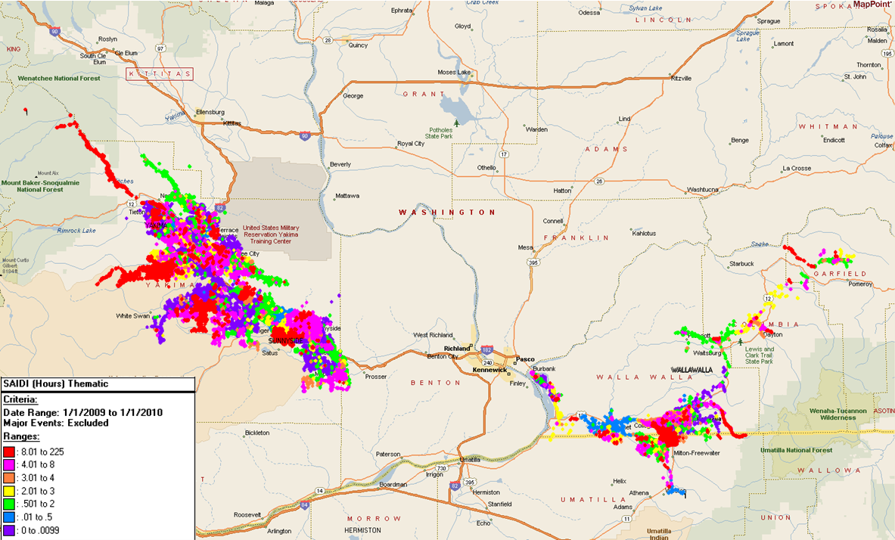

## 5W106

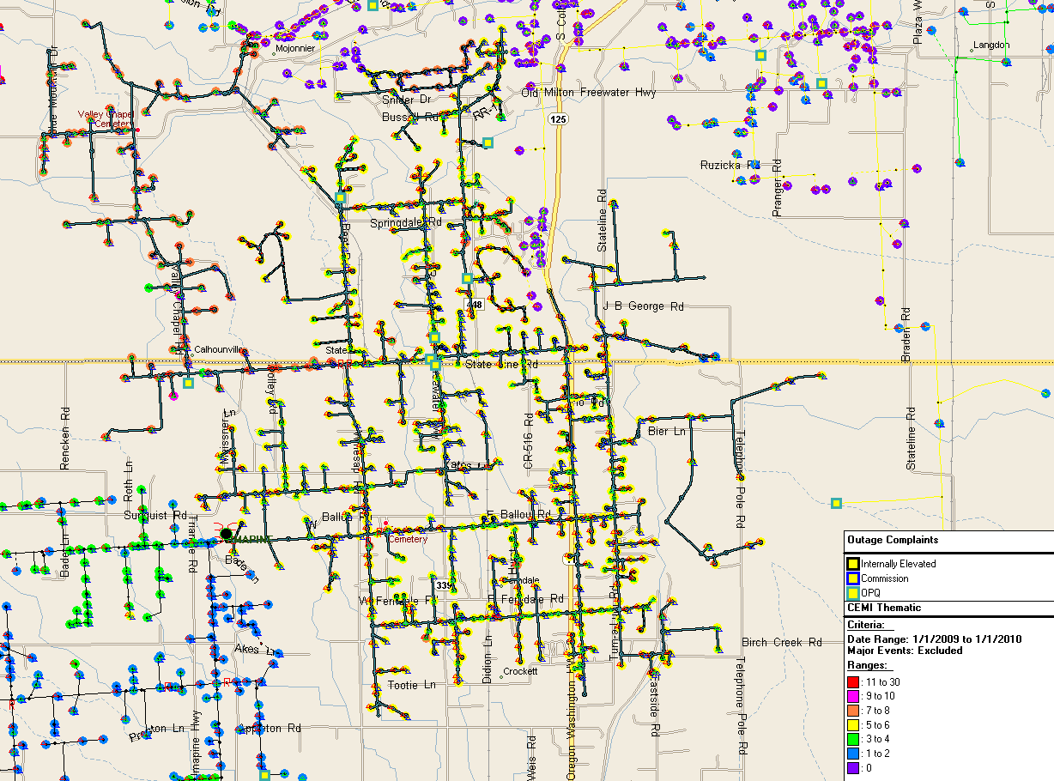

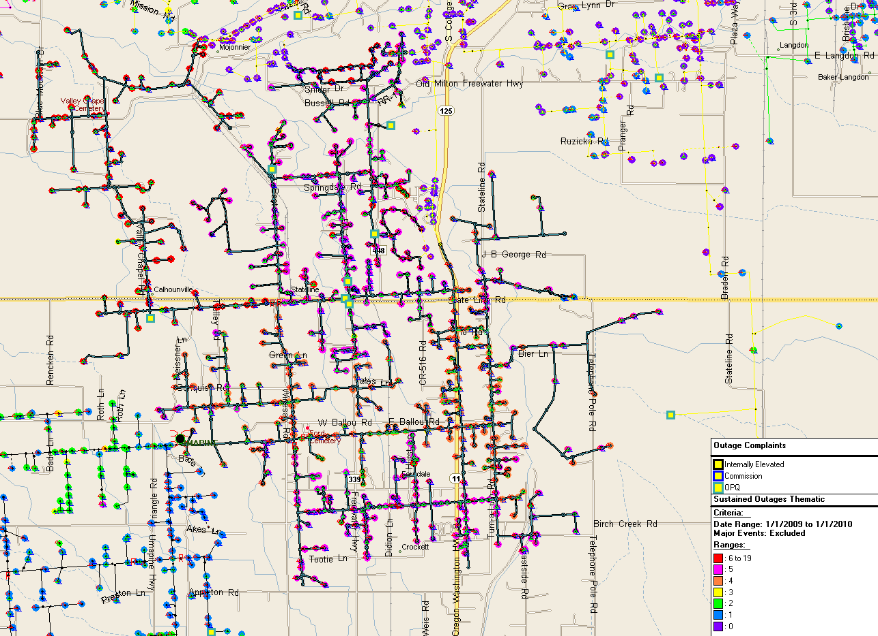

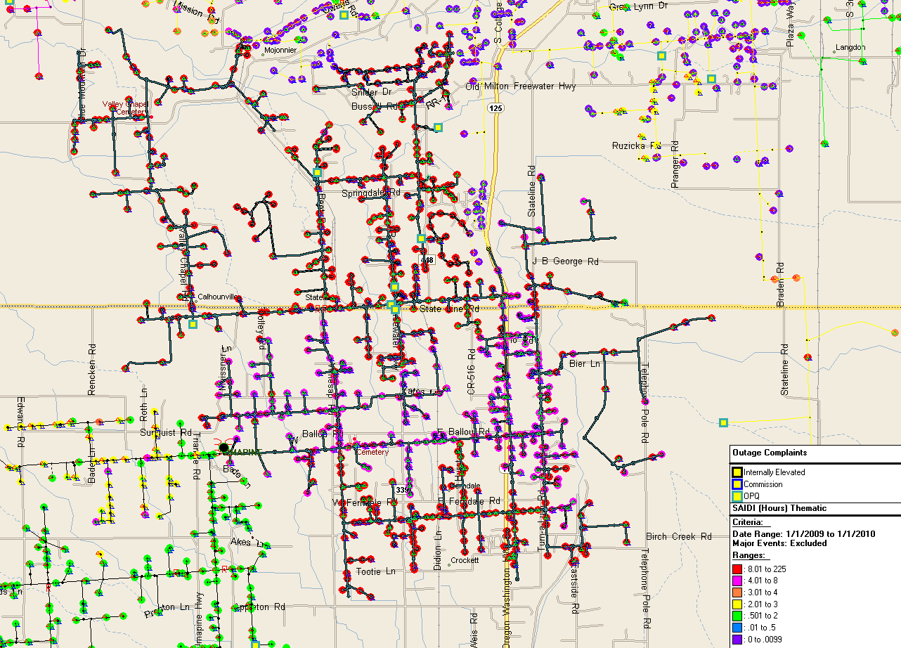

## 5Y174

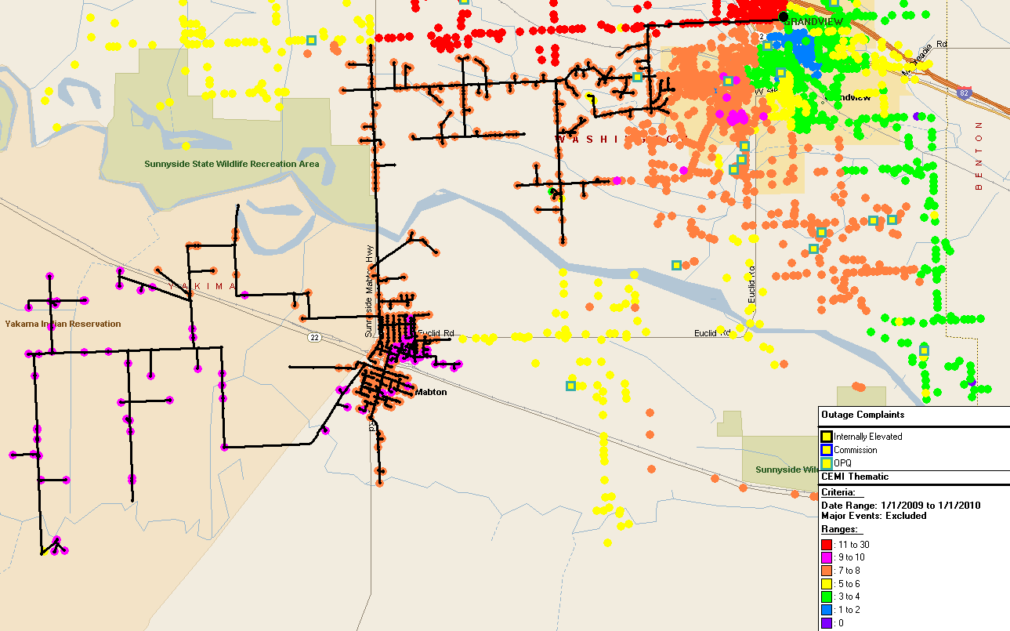

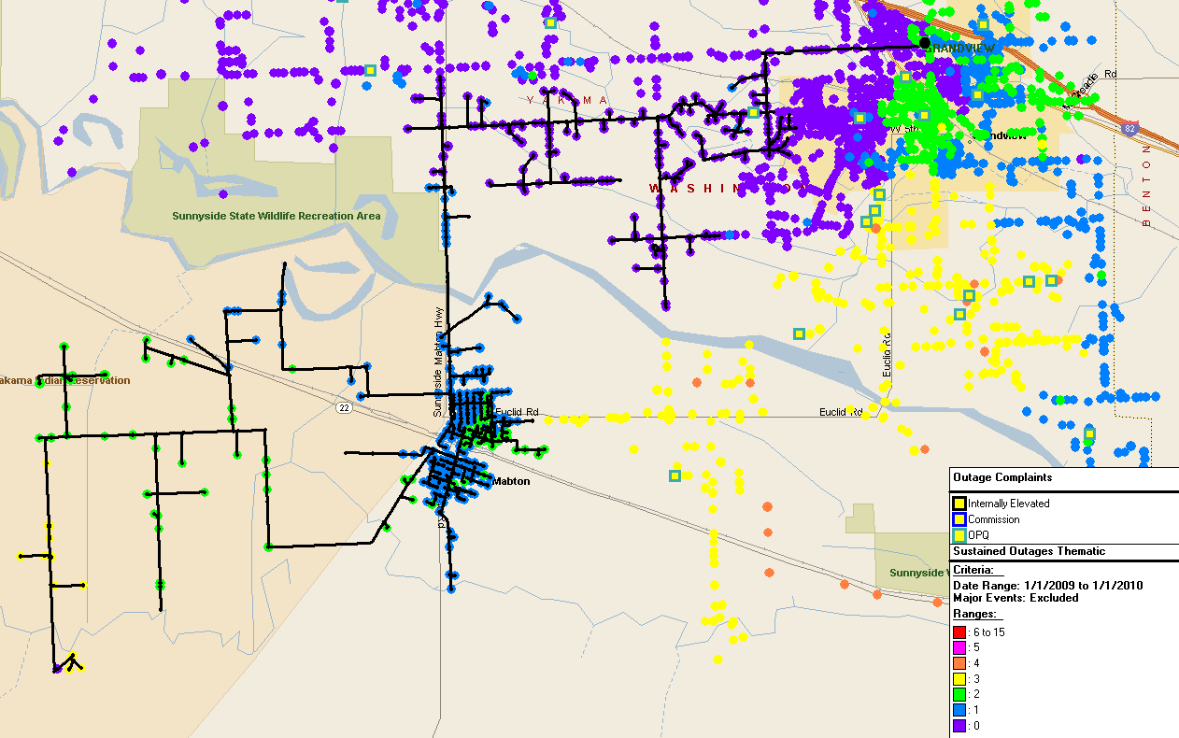

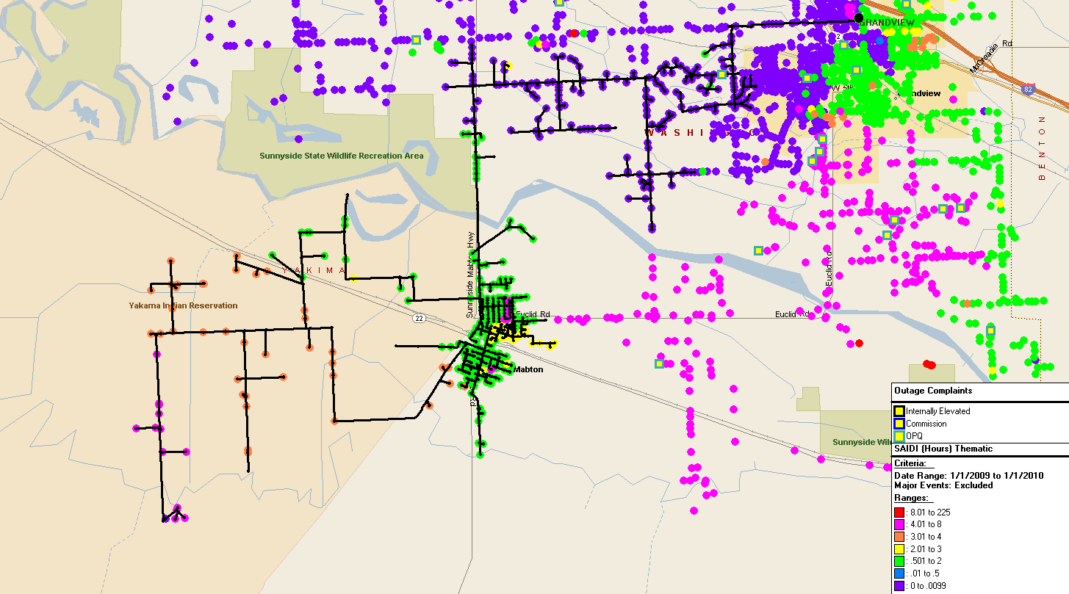

## 5Y156

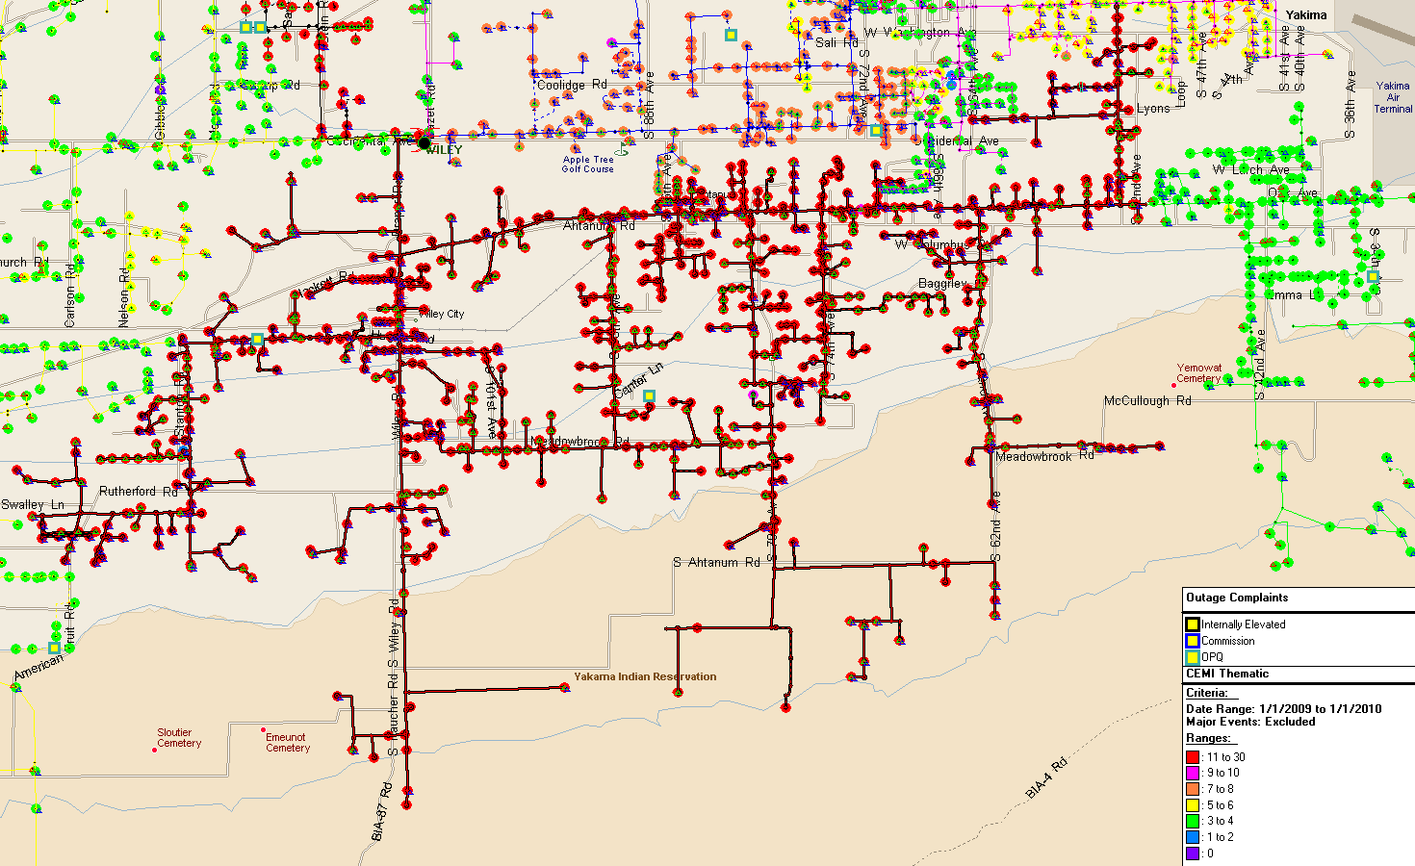

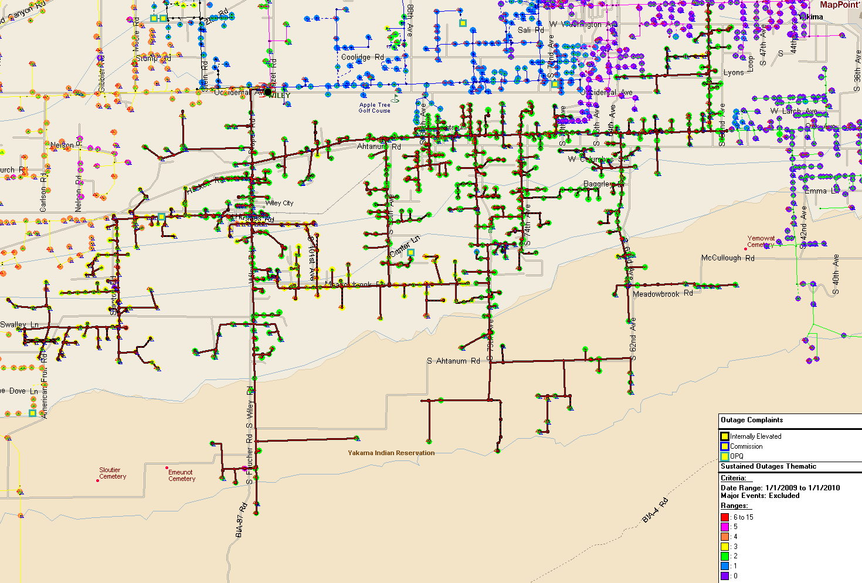

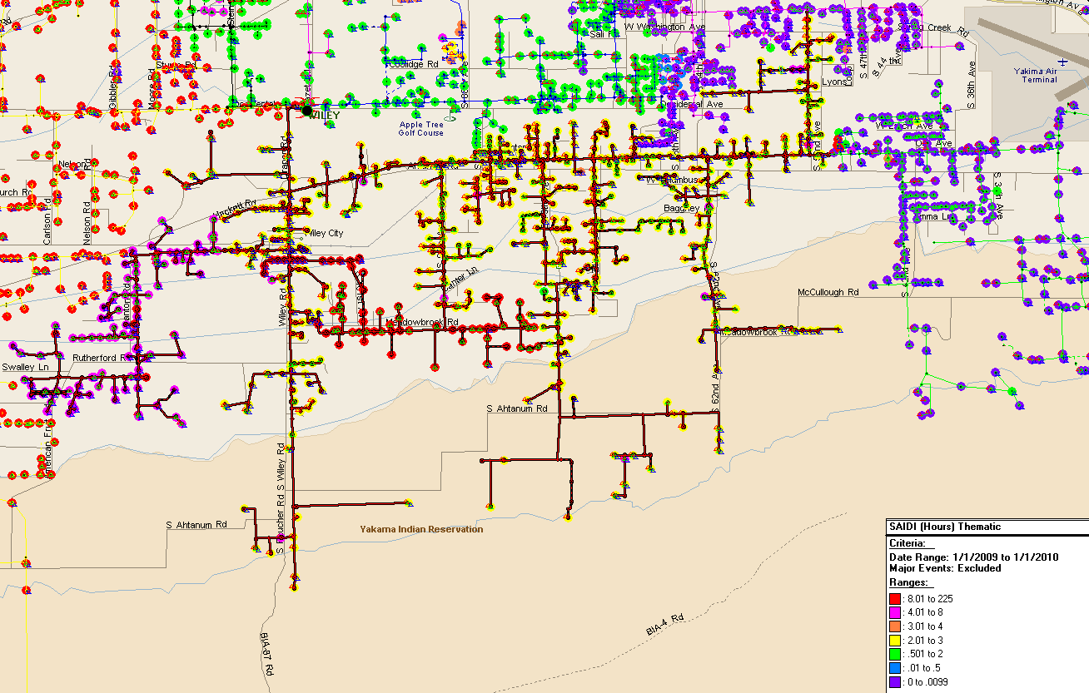

## 5Y141

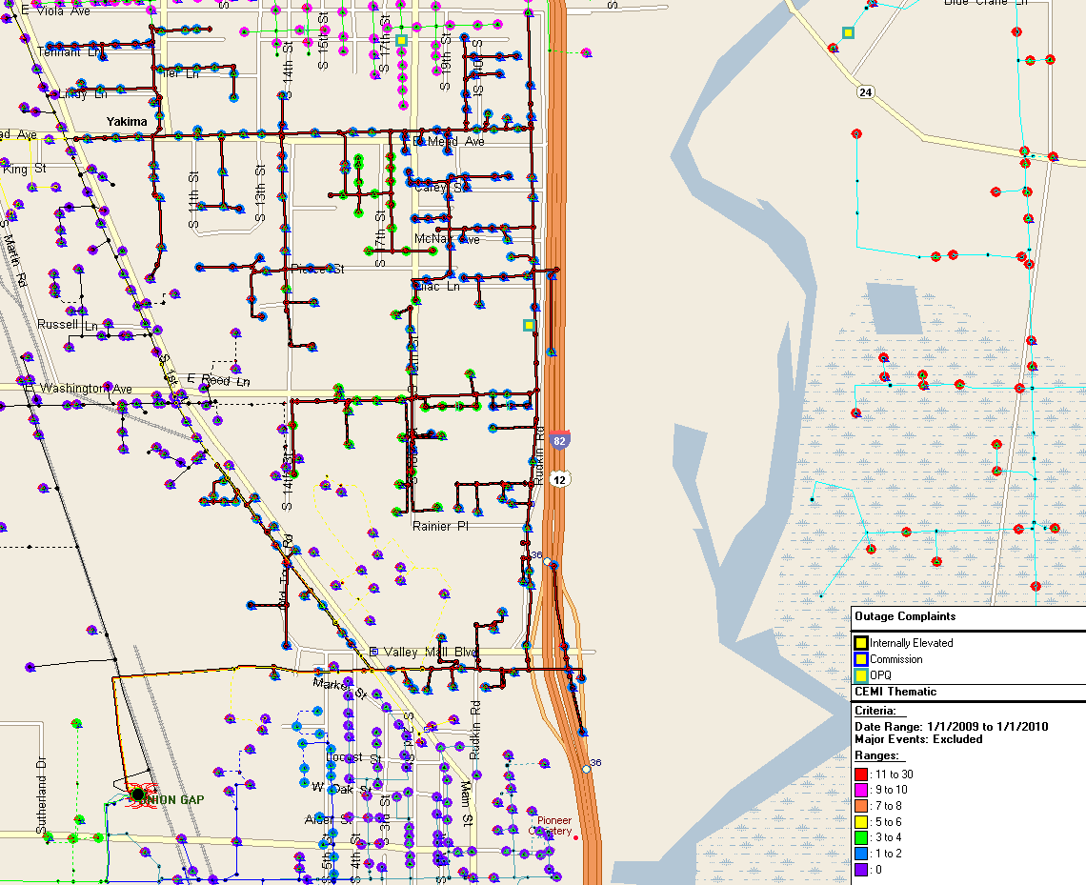

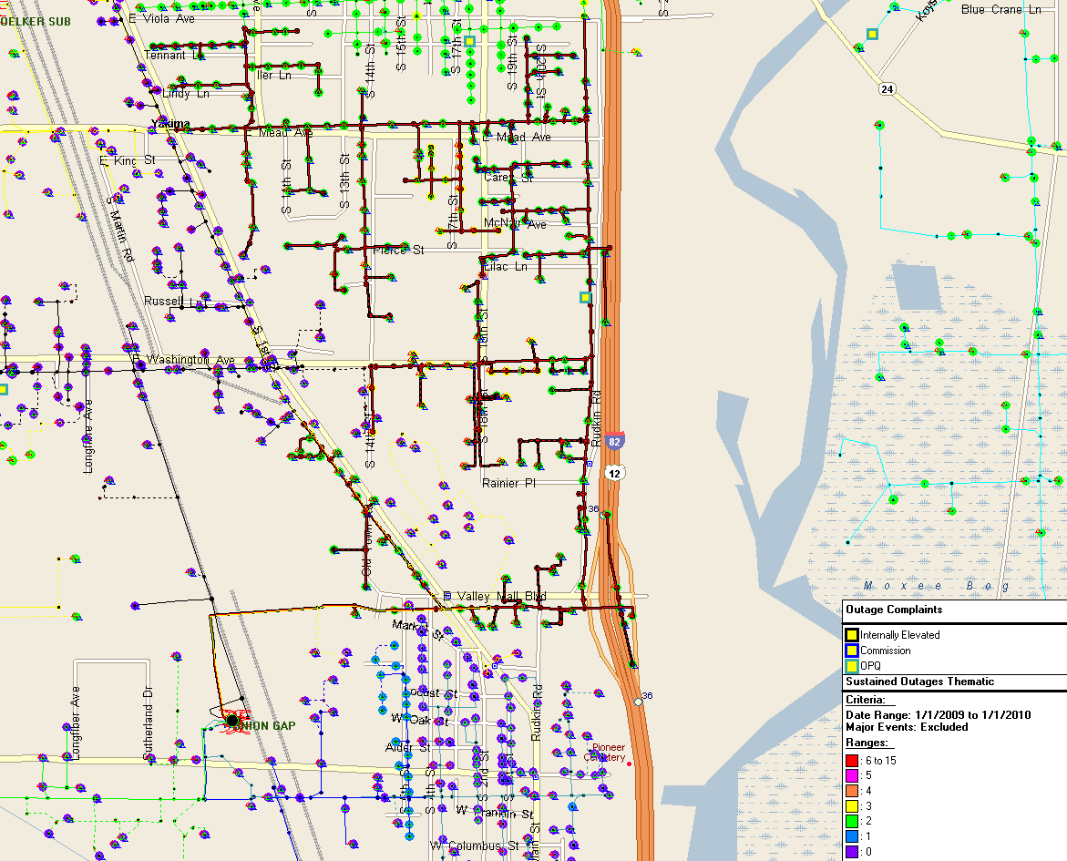

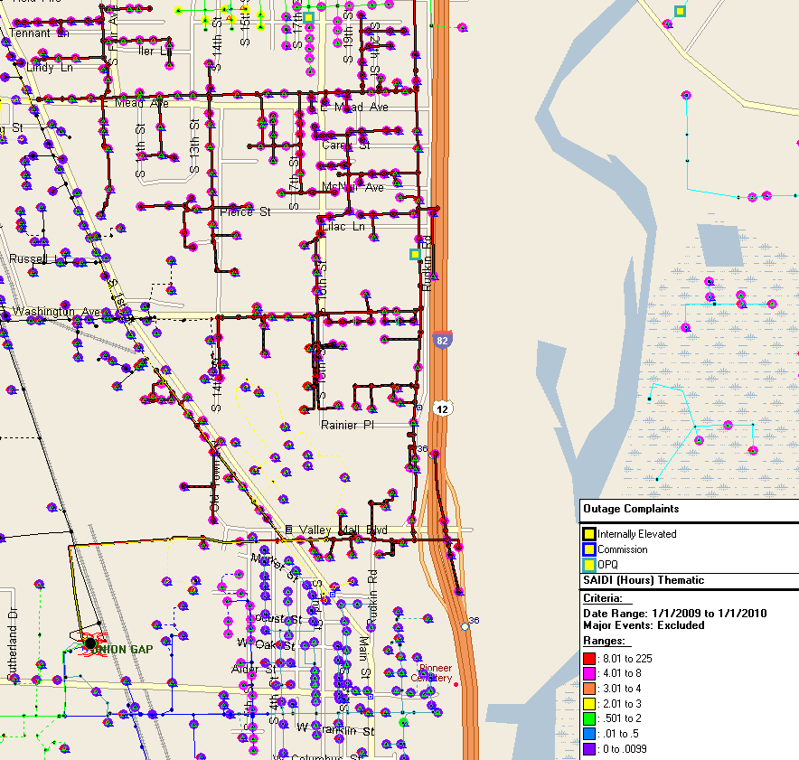

## 5Y434

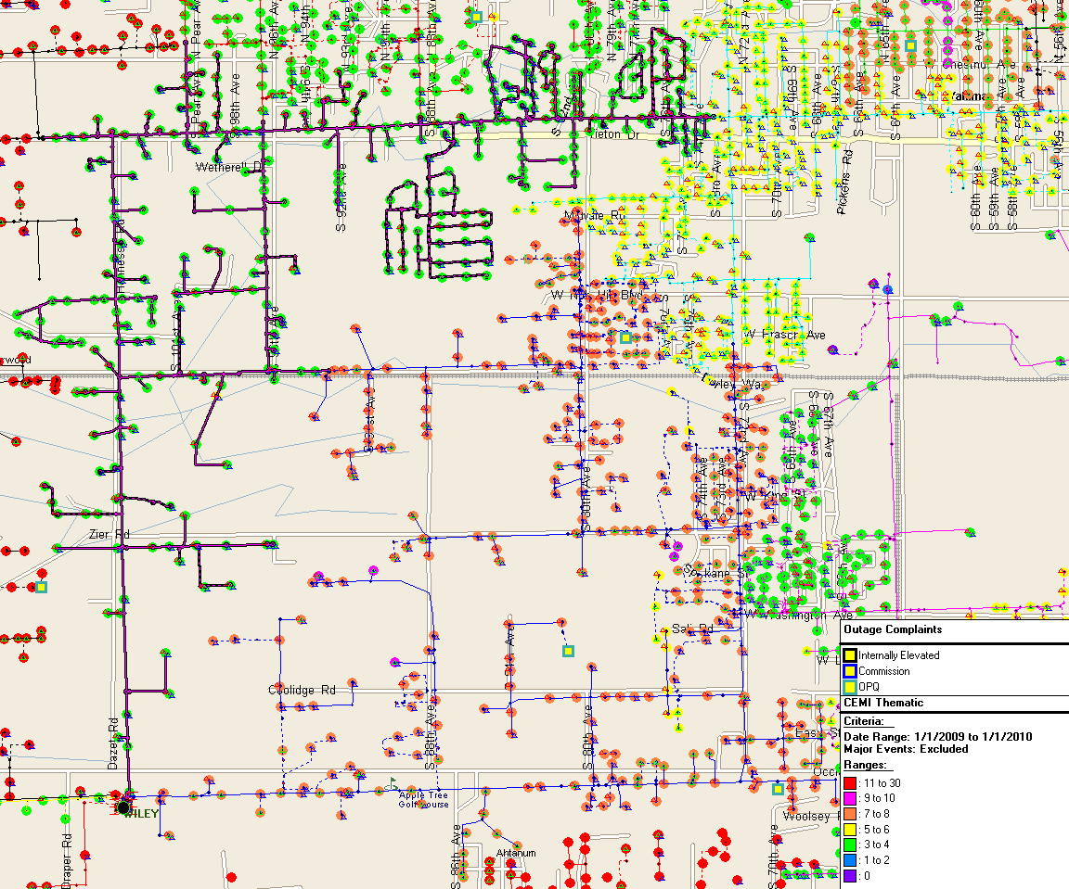

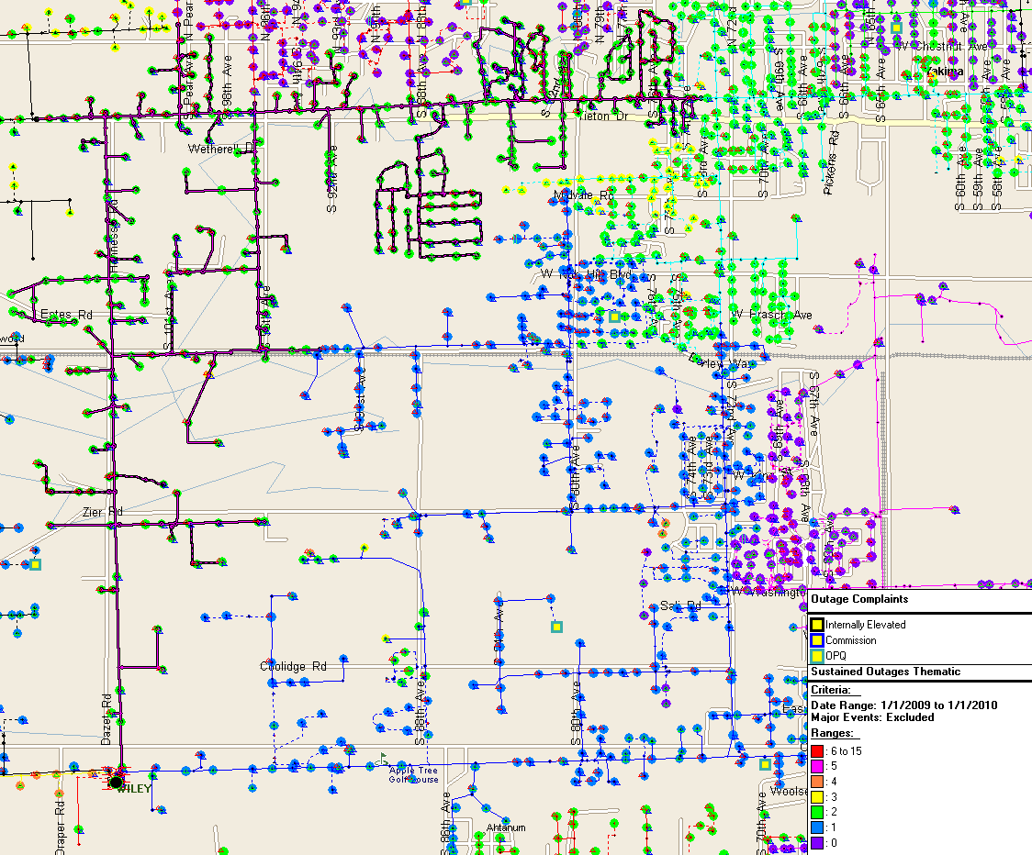

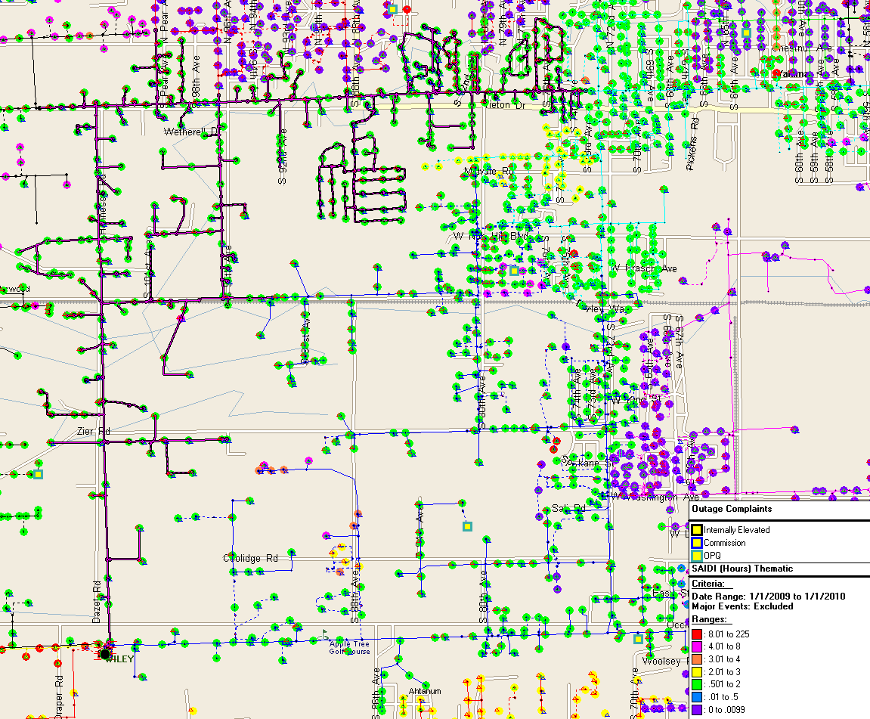

## 5Y380

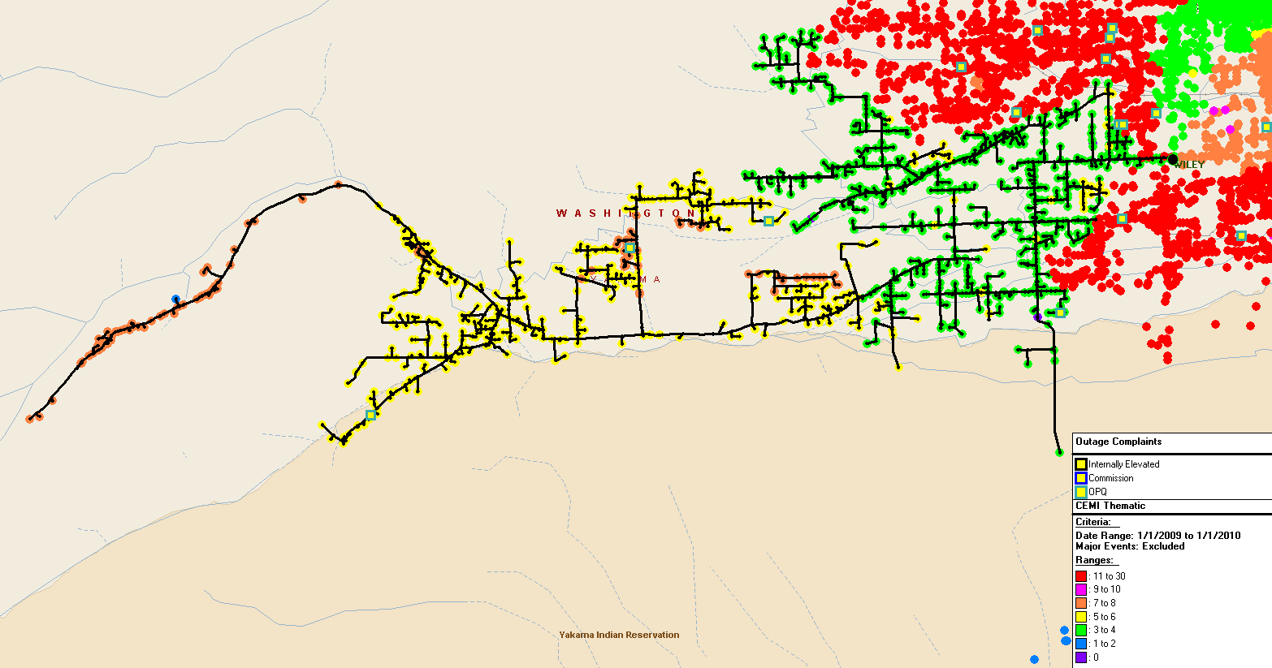

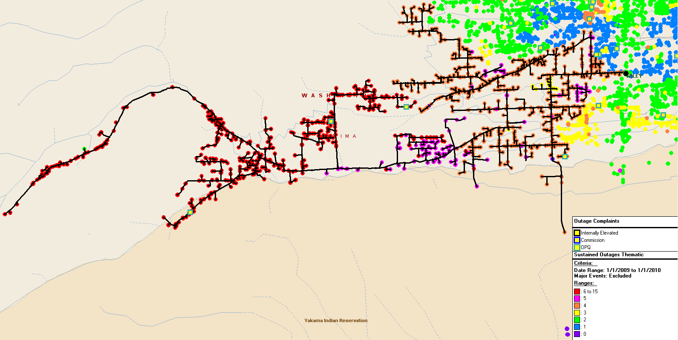

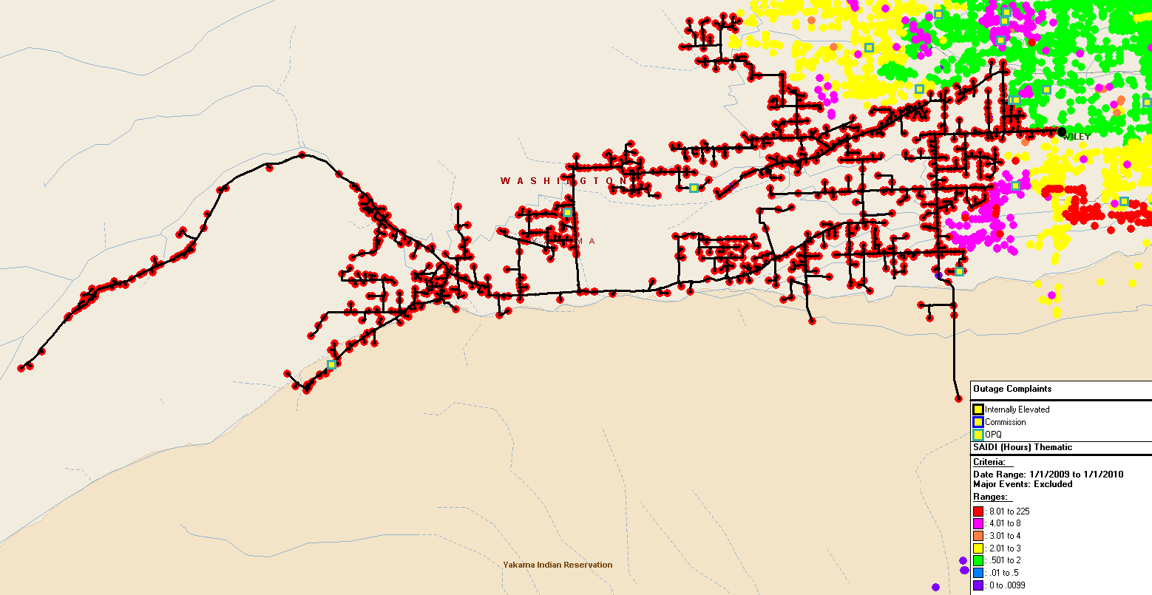

1. The Company previously proposed a minor modification to its Service Standards Program to recognize that many of the outages experienced are beyond the Company’s control, except as to its response. Thus, the frequency of these types of outages may render year-to-year comparisons of service delivered by the Company beyond targets. The use of Controllable Distribution and Non-Controllable Distribution Outage Causes was intended to remedy this anomaly. After discussions with Commission Staff the Company rescinded this filing, but continues to analyze data to ensure that improvement projects developed are done so recognizing costs and probable benefits for the system changes proposed.
2. Customer Service Standards address individual customer transaction performance, while Performance Standards address system-level performance for the average PacifiCorp Washington customer.
3. Commitment 45 states that “MEHC and PacifiCorp commit to continue customer service guarantees and performance standards as established in each jurisdiction, provided that MEHC and PacifiCorp reserve the right to request modifications of the guarantees and standards after March 31, 2008, and the right to request termination (as well as modification) of one or more guarantees or standards after 2011. The guarantees and standards will not be eliminated or modified without Commission approval.”
4. The Company has filed proposed modifications to its Service Standards Program wherein network performance improvement targets would be developed based upon Controllable Distribution causes and the program would be extended through December 31, 2011. The Commission must approve any modifications made to the program.
5. P1366-2003 was adopted by the IEEE Commissioners on December 23, 2003. The definitions and methodology detailed therein are now industry standards.
6. During calendar 2009, the calculated threshold for a major event is 12.16 minutes.
7. A Significant Event Day is 1.75 times the standard deviation of the company’s natural log daily SAIDI results by state.